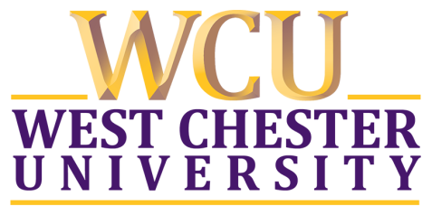

Facilitating and Developing Augmentative Communication Systems for Students with Complex Communication Needs

Nora Connell, M.A., CCC-SLP

April 15, 2016

8:30 a.m. – 4:30 p.m.

West Chester University of Pennsylvania
Graduate Business Center

Facilitating and Developing Augmentative Communication Systems for Students with Complex Communication Needs

REGISTRATION FORM
Name ________________________________________
Organization __________________________________
Address ______________________________________
_____________________________________________
City_________________________________________
State ______________ Zip Code_________________
Work Telephone (___) __________________________
Home Telephone (___) __________________________
E-mail _______________________________________
❑ Check here if Requesting .65 CEU’s
ASHA #______________________________________
❑ Check Here if Requesting ACT48 Credits
Professional ID Number (PIN) _____________________________________________
School District_________________________________
Check one:
❑ Professional Registration: $70
- WCU Graduate Student: Free
- WCU Undergraduate Students: Free
Graduate/Undergraduate Student ID#: _______________________________

Charge my:  VISA  M/C  AMEX
________________________________ _____/______
Account # Exp. Date
Signature_____________________________________

Convenient Ways to Register:
* Register online at the following link: http://www.wcupa.edu/oca/conferenceServices/conferences.aspx
* Make check payable to West Chester University
* Mail payment with registration form to:
Conference Services,
13/15 University Ave.
West Chester University
West Chester, PA 19383

DIRECTIONS TO CONFERENCE

Conference Location:
West Chester University’s Graduate Business Center is located at 1160 McDermott Drive, West Chester, PA, 19380. The Graduate Business Center is easily accessible from the Boot Road exit of Route 202.

From the Commodore Barry Bridge:
Coming from New Jersey across the Commodore Barry Bridge, follow signs for Route 322W. Follow Route 322W to Route 1. Turn left on Route 1. Turn right onto Route 202N. Exit Route 202 at Boot Road. Make a right at the traffic light at the end of the ramp. Make a right at the next traffic light at Greenhill Road.

**Take Greenhill Road for approximately .5 miles. Turn left onto McDermott Dr. The Graduate Business Center is the third building on the right.

From 95 North or South:
Take 95 North or South to Route 202 North (Concord Pike). Follow Route 202 North until the Boot Road exit. Make a right at the traffic light at the end of the ramp. Make a right at the next traffic light at Greenhill Road.
**Follow directions as above.

From Schuylkill Expressway:
Take the Schuylkill Expressway (Rt. 76 West) to Exit 26B. Follow Route 202 South for approximately 20 minutes. Take the Boot Road exit. Make a left at the traffic light onto Boot Road. Make a right at the light onto Greenhill Road.
** Follow the directions as above.

From Pennsylvania Turnpike:
Take the Pennsylvania turnpike to Valley Forge exit #326. Follow Route 202 South for approximately 20 minutes. Take the Boot Road exit. At end of ramp make a left onto Boot Road. Make a right at the light onto Greenhill Road.
**Follow directions from above.
Who Should Attend?
This program is appropriate for speech language pathologists and students enrolled in a speech language pathology program who are interested and/or currently working with students in need of augmentative communication systems.

Program Summary
Students with complex communication needs require highly specialized support and interventions in order to develop functional communication systems. This workshop will focus on skills and strategies SLPs need in order to provide appropriate intervention for this unique population.

Biography
Nora Connell, M.A., CCC-SLP is a Speech Language Pathologist who has worked as a school based clinician for over 25 years. She has experience working in Early Intervention and School Age Programs for students with a wide variety of disabilities. She is currently working as a Professional Development Specialist with the Delaware County Intermediate Unit. Nora has taught Language Acquisition classes for teachers who are working toward the ESL endorsement from the Pennsylvania Department of Education. She has also worked as an adjunct faculty member for LaSalle University’s Speech, Language, and Hearing Sciences Department. Nora has been a guest lecturer at West Chester University, LaSalle University, and Temple University on topics including Augmentative and Alternative Communication, School Based Speech Language Pathology, and Language and Literacy Connections.

Disclosure statement
Relevant Financial Relationship: Ms. Connell will receive financial compensation from WCU for her conference presentation.
Non-relevant Financial Relationship: Ms. Connell has no non-relevant relationship to disclose.
Learner Objectives
Learner Objectives
- Identify key characteristics of students with complex communication needs
- Identify key components in identifying vocabulary for a functional AAC system
- Identify characteristics of low tech, mid tech, and high tech communication systems
- Identify key components of aided language input strategy for facilitating a student’s use of a functional AAC system
- Identify key components of a prompting hierarchy that supports use of a functional AAC system.

Accreditation
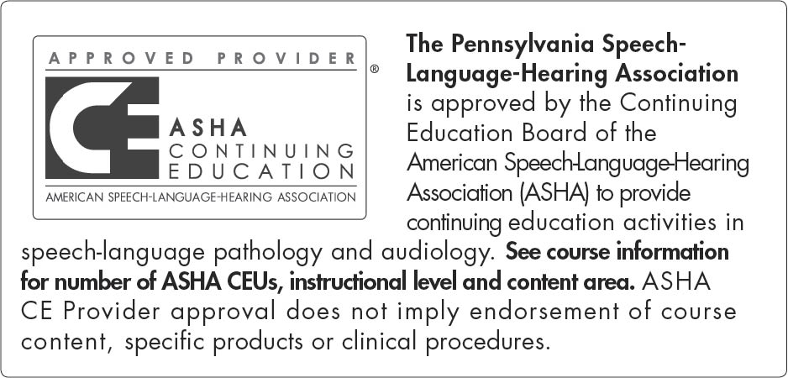
This course is offered for 0.65 ASHA CEUs (Intermediate level, Professional area.)
ACT48 Credits
PSHA is an approved provider by the Pennsylvania Department of Education to sponsor Continuing Education programs as required by ACT 48. This program is offered for 6.5 clock hours. Individuals attending the program must arrive on time and stay the duration of the program in order to receive Act 48 Professional Education hours.
Meals
Your registration fee includes beverages in the morning and lunch. Lunch will be served during the career fair.
Special Needs
Accommodations for individuals with disabilities are available upon request by calling the Office of Conference Services at 610-436-6931. Participants should make their needs known as soon as possible, but not less than one week in advance, to allow time to make the necessary arrangements.

Career Fair
In conjunction with the professional conference, West Chester University and NSSLHA are offering conference participants access to area employers. Participants will have the opportunity to speak with companies who are seeking to hire area professionals. The support and participation of these companies help subsidize the cost of the conference and are the primary reason for the reduced registration fee. Inclusion of these companies, however, does not imply endorsement from West Chester University or NSSLHA. The Department of Communication Sciences and Disorder’s Professional Advisory Board will be meeting during Lunch. All alumni are welcome to attend.

Conference Schedule
8:30-9:00 Registration and Beverages

9:00-10:00 Characteristics of Students with Complex Communication Needs

10:00-10:30 Presuming Competence for Students with Complex Communication Needs

10:30-10:45 Break

10:00-12:00 Developing Functional Communication Systems Using Core Vocabulary

12:00-1:00 Lunch

1:00-2:15 Low Tech, Mid Tech, and High Tech Communication Systems

2:15-2:30 Break

2:30-3:30 Aided Language Input-Facilitating Use of AAC in Functional Communication Settings

3:30-4:00 Prompting Hierarchy-Supporting Supporting AAC in Functional Communication Settings

4:00-4:30 Questions and Answers

For information on open positions or to submit your resume, please visit our Web site at: www.lucernepublishing.com

