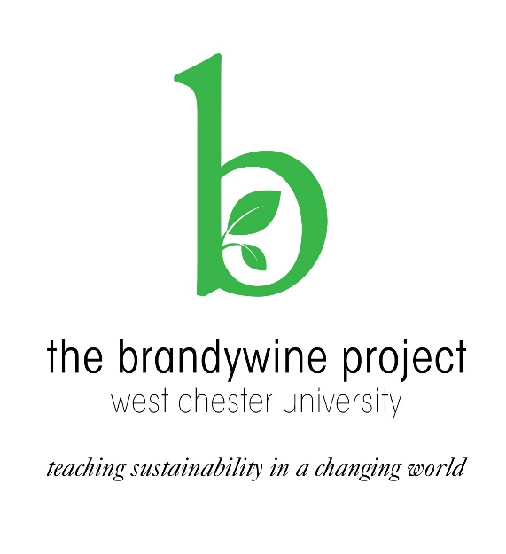

**Brandywine Project**

**2018 Call for Faculty Applications**

The **Brandywine Project** is an exciting opportunity for faculty to develop a new course or modify an existing course to focus on issues of sustainability and environmentalism, surrounded by supportive & creative colleagues. You are invited to participate whether or not you are familiar with sustainability.

**What you’ll do:**

* **Attend** a two-day workshop **January 10-11, 2018** (complete with meals!) – learn about sustainability, explore your discipline, create interdisciplinary connections, & get more informed about WCU’s sustainability actions & opportunities for teaching.
* **Prepare** a new or revised course syllabus over the spring 2018 semester.
* **Meet** as a group once during the spring semester to gain additional resources, ideas, & help.
* **Reconvene** for a celebratory presentation of new/revised courses at end of semester.
* **Deliver** your syllabus.
* **Receive a stipend of $500** for this professional development experience.

WCU’s Strategic Plan lists Sustainability as one of its goals, and it will be incorporated into a general education “pathway.” The Brandywine Project’s curricular work will allow you to contribute to these important institutional priorities, link with community and campus resources, & help to identify possible new research and collaborative directions.

**Sustainability is not just for scientists.** Attaining a sustainable, equitable future will require all fields to understand how their actions shape the planet & affect its many inhabitants. Come meet colleagues from across the disciplines to learn how your field is addressing sustainability & to share this knowledge with your students.

**To apply, complete & send the application below to** [**sustainability@wcupa.edu**](mailto:sustainability@wcupa.edu)

**Deadline: October 6, 2017**

***Need more information?***

Contact Aliza Richman ([arichman@wcupa.edu](mailto:arichman@wcupa.edu)) or Cheryl Wanko ([cwanko@wcupa.edu](mailto:cwanko@wcupa.edu))

**Application – Brandywine Project 2018**

**Due 10/6/17 to sustainability@wcupa.edu**

Faculty who participated in the 2016 Brandywine Project may not reapply.

Name: __________________________________________

Position: __________________________________________

College: __________________________________________

Department: __________________________________________

Contact Information (e-mail and campus telephone): _________________________________

*Please provide a paragraph below explaining your interest in participating in the workshop:*