
Ramsey Hall

275 N. Campus Drive
Built: 1967 | Size: 103,374 sf
Acquired: N/A | Condition: Poor
Last Renovation: 1994 | Function: AUX

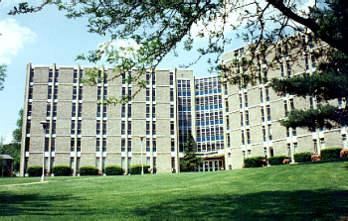

Ramsey Hall is a six-story residence hall on the corner of Sharpless and South New Streets, next to Tyson Hall. It has a central lounge and laundry room on each floor, as well as a computer lab, large recreation room with a kitchen for student’s use, and a space for staff activities on the main floor.

Thorough renovation of this building has been estimated at a cost of $7,500,000. Ramsey Hall was refurbished in 1994 and the interior is in good shape. However, all building systems have deteriorated and a scheduled demolition for no earlier than 2010 has been anticipated. A replacement suite style residence hall structure is being planned at this location.

Present Use: Residence Hall

Disability Access:

Past Projects: 1992 Roof, 1994 General, 2002 LAN/Telephone/CATV & Furniture, 2004 Sprinkler and Fire Alarm upgrades. 2005- Carpet and paint.

Scheduled Projects or Capital Renovations: None

Description of Construction: Reinforced concrete foundation and structure, built-up roof, masonry brick veneer exterior walls, concrete slab floors.

Condition and Use Assessment:
Deferred Maintenance (2007): scheduled for demolition | Est Replacement Cost (2007): $ 21,096,000
Facility Condition Index: 0. | Deficiency/SF: $
Yearly Electric Use Cost: $ | Yearly Water Use Cost $

