
Sanderson Hall

715 S. New Street
Built: 1970 | Size: 93,970 sf
Acquired: N/A | Condition: Fair
Last Renovation: 1992 | Function: AUX

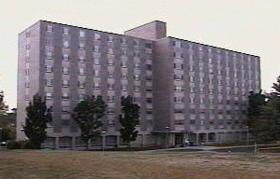

Sanderson Hall is a nine-story residence hall located between Lawrence and Schmidt Halls on South New St. The building has a large lobby and recreation room with a kitchen for student use on the main floor. A laundry is located in the basement, with an interior bike storage room, a staff activities room, a computer lab, and a central lounge on each floor.

Sanderson Hall was refurbished in 1992. The elevators were upgraded in 1993. The recreation area immediately east of Sanderson Hall was upgraded in the summer of 2003. This residence hall will be replaced with a suite-style residence hall structure in the near future.

Present Use: Residence Hall

Disability Access: Full.

Past Projects: 1992 Renovation, 1993 Elevators, 1995 Recreation Area, 1999 Furniture, 2000 Roof, 2002 LAN/Telephone/CATV/Sprinkler & Fire Alarm

Scheduled Projects or Capital Renovations: None

Description of Construction: Reinforced concrete foundation and structure; built-up roof; masonry brick veneer exterior walls; concrete slab floors.

Condition and Use Assessment:
Deferred Maintenance (2007): scheduled for demolition | Est Replacement Cost (2007): $ 19,114,000
Facility Condition Index: N/A | Deficiency/SF: N/A
Yearly Electric Use Cost: $ | Yearly Water Use Cost $

