
25 University Avenue

Built: 1961 | Size: 53,985 sf
Acquired: N/A | Condition: Excellent
Last Renovation: 2007 | Function: E&G

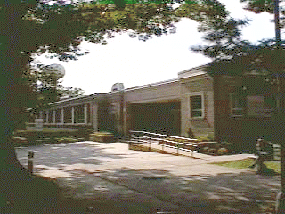

25 University Ave, (formerly Swope Hall), a single-story building, is situated on University Avenue, across the street from Ruby Jones Hall. The building will house the Departments of Math and Computer Science, and the Student Service Offices of the Bursar, Registrar, and Financial Aid in 2008.

This building is in excellent condition after the completion of a complete life-cycle renovation, with new state-of-the-art features and occupancy scheduled in Fall semester 2008. A geothermal heat-pump system heats and cools this building thru heat transfer with the earth in its side yard. A PA Energy Harvest Grant in 2007 funded this new heating and cooling technology.

Present Use: Academic offices and classrooms for the Departments of Math and Computer Science, and Student Service Offices.

Disability Access: Full, with new elevator installed in 2007.

Past Projects: Complete lifecycle renovation in 2007-2008.

Scheduled Projects or Capital Renovations: none.

Description of Construction: Reinforced concrete foundation, built-up roof, masonry brick veneer exterior walls, concrete slab floors.

Condition and Use Assessment:
Deferred Maintenance (2007): $ 0 | Est Replacement Cost (2007): $ 15,447,968
Facility Condition Index: 0. | Deficiency/SF: $ 0
Yearly Electric Use Cost: $ | Yearly Water Use Cost $

