COMPUTER WORKSTATION ERGONOMIC EVALUATION

Employee Name Department Job Title
Phone Extension / Mail Code Location of Evaluation Evaluated by (if not self-evaluation)
Evaluation Date
Chair Acceptable Needs  Improvement |  |  |  |  | Evaluation Comments/ Recommendations:
Seat height Seat back Seat depth Seat pan tilt
Armrest position
Keyboard and Mouse Acceptable Needs
Improvement
Keyboard height
Keyboard-to-user distance
Keyboard slope
Mouse height
Mouse-to-user distance
Monitor Acceptable Needs
Improvement
Monitor height
Monitor-to-user distance
Monitor alignment w/ user
Visual comfort of screen
Environment Acceptable Needs
Improvement
Leg clearance at workstation
Placement of frequently used items
General/ task lighting
Work Practices Acceptable Needs
Improvement
Frequency of microbreaks Keyboarding posture Sitting posture
Phoning posture
Alternate tasks
Required Items: Proper Workstation Setup:
Adjustable ergonomic chair Adjustable keyboard/mouse tray Lumbar support cushion  Monitor riser Foot rest Mouse bridge Wristrest pad  Anti-glare screen, or screen hood Reference document holder Slantboard for reading  Telephone headset  Office ergonomics training (EHS 3400) Other |  |  |  |  | 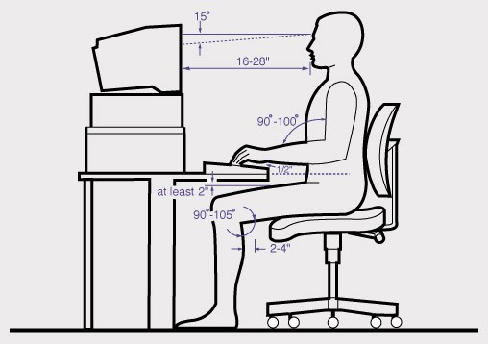

Employee Signature
Evaluator Signature
(if not self-evaluation)

ERGONOMIC EVALUATION GUIDELINES
1. Chair
Seat height | Adjust seat height so feet are flat on the floor or footrest, knees are bent at right angles and thighs are horizontal to floor.
Seat back | Adjust seat back so it supports the lumbar curve of the spine.
Seat pan depth | Adjust seat pan depth so seat cushion is about 1 - 4” from the backs of knees.
Seat pan tilt | Adjust seat pan tilt so hips and tops of thighs are at right angles or greater.
Armrest position | Adjust armrests so that they are out of the way while typing, but may provide support during other activities (i.e. phone use, meetings, etc.).
2. Keyboard and Mouse
Keyboard height | Adjust keyboard height so arms and forearms are at right angles or slightly greater and forearms and hands form straight lines.
Keyboard-to-user distance | Keyboard-to-user distance should allow user to relax shoulders with elbows hanging close to body.
Keyboard slope | Position keyboard a flat or slightly negatively sloped.
Mouse-to-user distance | Mouse should be directly next to the keyboard.
Mouse height | Adjust mouse so it is close to and on the same level as the keyboard.
3. Monitor
Monitor height | Adjust monitor height so top of screen is at or slightly lower than eye level.
Screen-to-user distance | Viewing distance is approximately arm’s distance away (16”- 28”).
Monitor alignment w/  user | Monitor and keyboard should be placed directly in front of user.
Visual comfort of screen | Monitor should be positioned to avoid glare (perpendicular to window/ strong light source)
4. Work Environment and Work Surface
Leg clearance at workstation | Width = 2” + hip width, Height= Highest point of thighs or higher, Depth= Allows proper sitting position while giving foot/knee clearance
Placement of frequently used items | Advise employee to keep frequently used items (i.e. phone) close at hand
General task lighting | Ensure lighting is not direct or overly bright.
5. Work Practices
Frequency of microbreaks | Get out of chair at least once per hour, microbreak every 30 min of keyboarding
Keyboarding posture | Keep wrists straight, avoid supporting wrists on any surface while typing
Sitting posture | Upright or slightly reclined posture, maintain hollow in lower back.
Phoning posture | Avoid tilting head/neck to cradle the phone. Use hand to hold receiver.
Alternate tasks | Break up long periods of continuous computer use by performing small tasks/ errands.

