
Interview Assignment Instructions for STUDENTS
- Access your account on Big Interview: wcupa.biginterview.com
- Be sure to login using your wcupa.edu email address and password to login to the homepage: 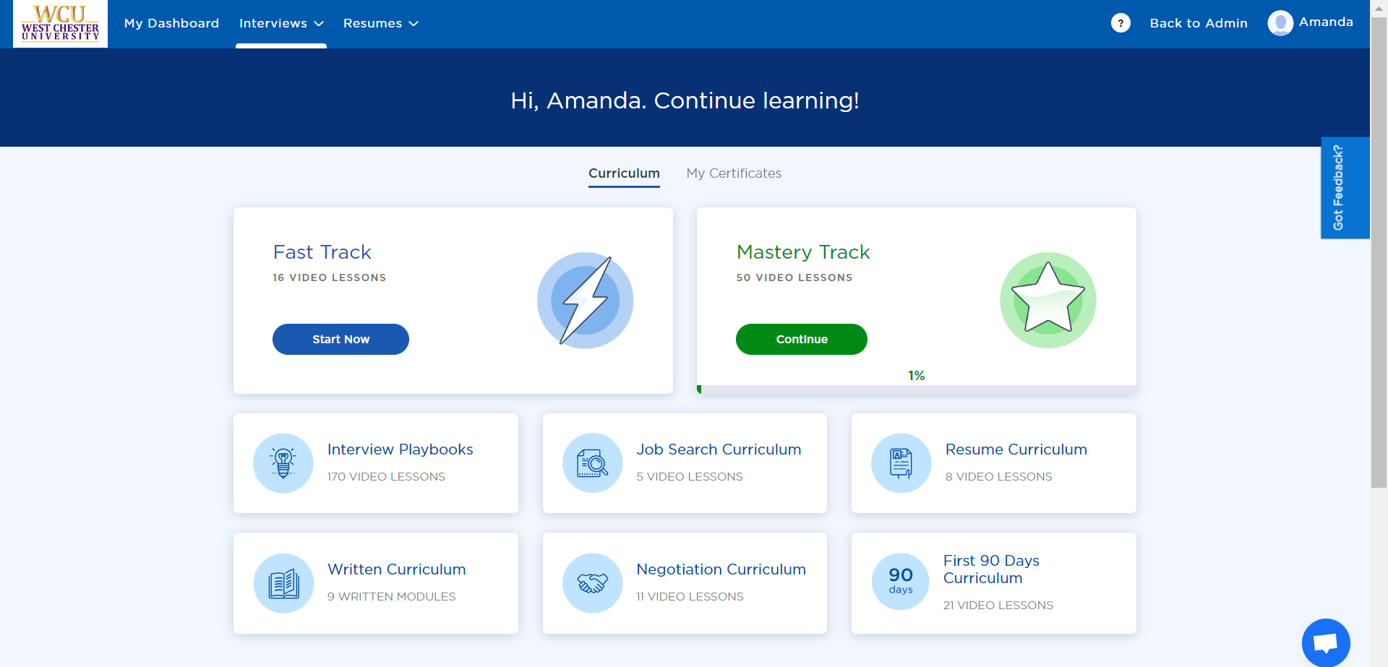
- To find your course assignment, click on Interviews in the blue bar, and then “Interview Assignments” highlighted in gray below: 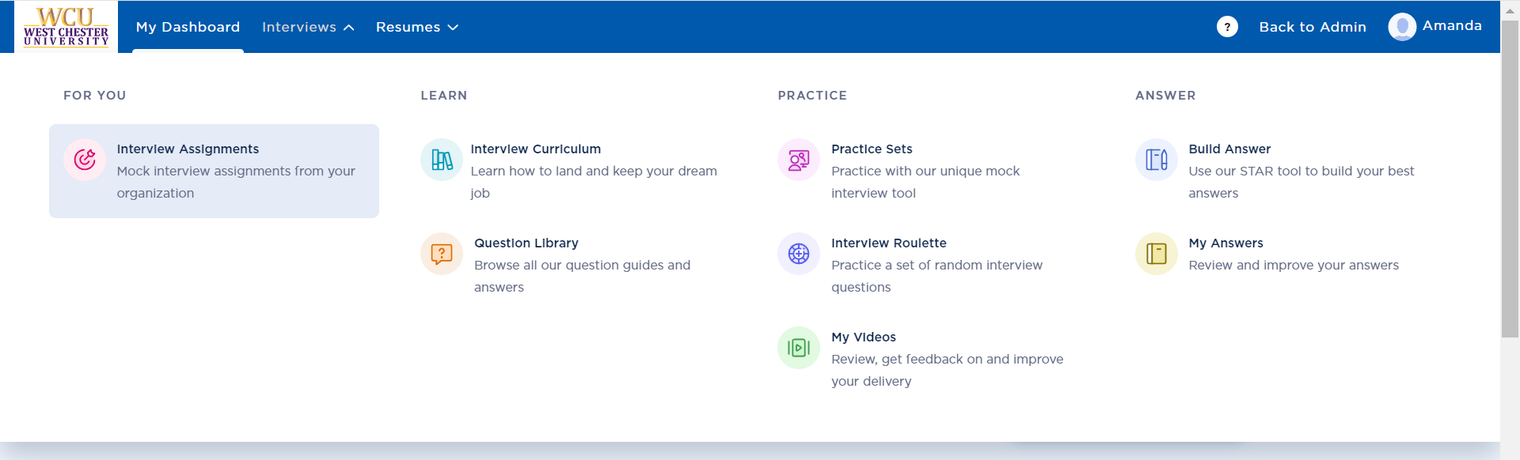
- If your faculty added you to an assignment, then it will appear on the next screen. If not, then enter your course “Assignment Code” in the blue box. It will look something like this: 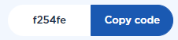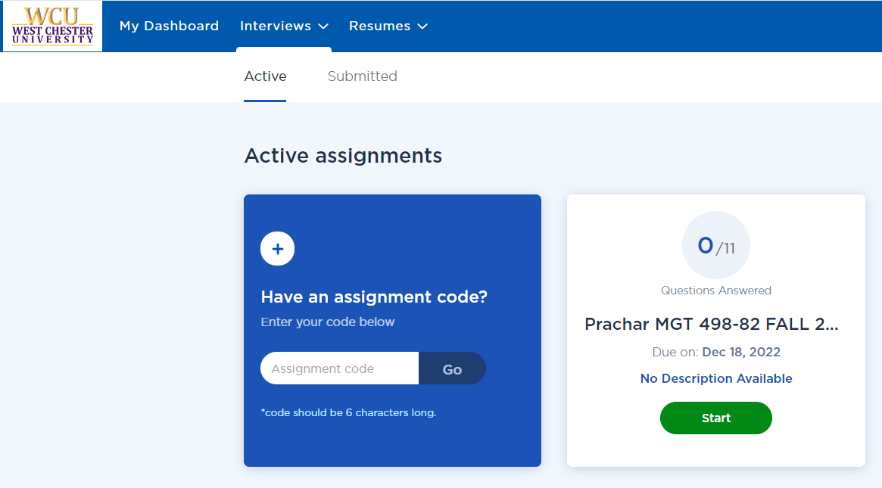
- If you have questions, then click on the light blue circular box in the upper right-hand corner of your screen: “How to Use Assignments,” where you can find a quick tutorial video. You can also click on the white question mark for the complete BigInterview Learning Center anytime. 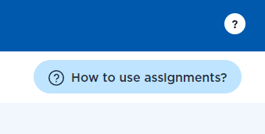
- Your assignment screen will look like something like this – be sure that it can access your camera: 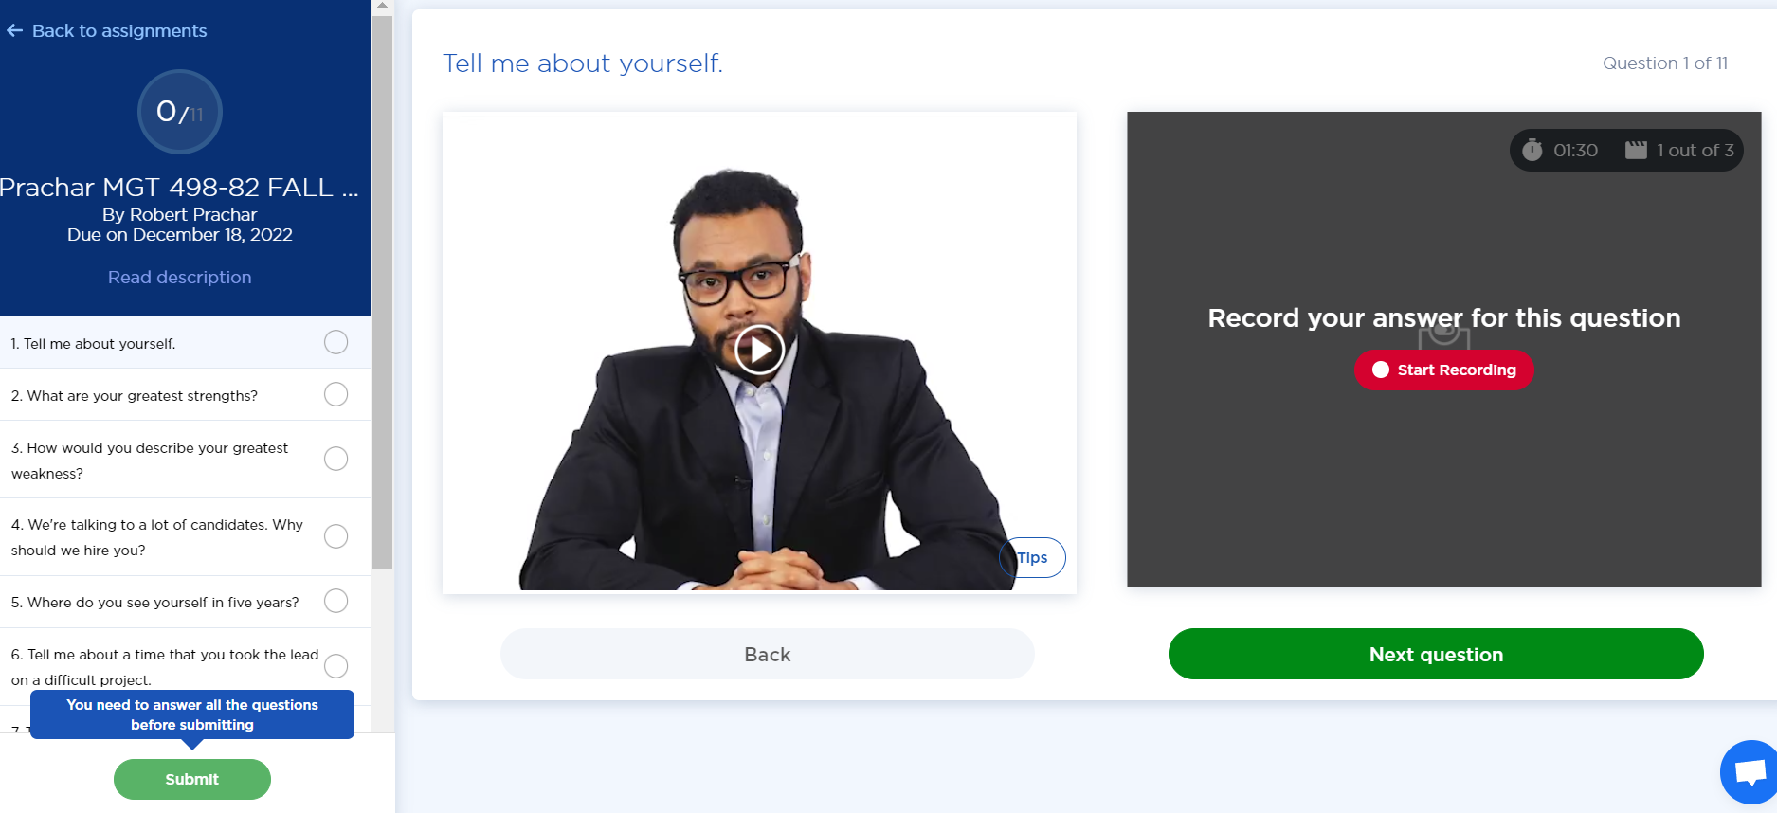
- Click “Play” on the question prompt and listen fully to the question prior to responding. If you are looking for tips on how to best answer, refer to the “tips” box in the bottom right corner of the video.
- Record your answer to the associated interview question and click SAVE ANSWER prior to going on to the next question. If you do not save, your response will be lost.
- Answer all questions. You will not be able to submit the assignment if all questions are not answered.
- Once you have answered all questions, press the green “Submit” button at the bottom right.
- Once you hit submit, you will be taken to a “review answers” page. You can review and/or re-record all your answers.
- Scroll down and click the green “Submit Final Answers” button. 
- Once you submit final answers, you will see a green bar appear saying “You have successfully submitted your assignment.”
- You will be directed back to the main “Assignments” page, where you can view the “Submitted” tab.
- If you need support in Big Interview, use the blue chat feature at the bottom right of your page.
- A student guide is available here: https://resources.biginterview.com/big-interview/student-guide/
 225 Lawrence Center cdc@wcupa.edu www.wcupa.edu/cdc

