

**Instructions for STUDENTS**

**Login:**

* Students access their account on Big Interview: [wcupa.biginterview.com](https://wcupa.biginterview.com/)
* Select Login, you will be directed to WCU single sign-on
* Once logged in**,** you may need to toggle to Big Resume by selecting the top left square menu button

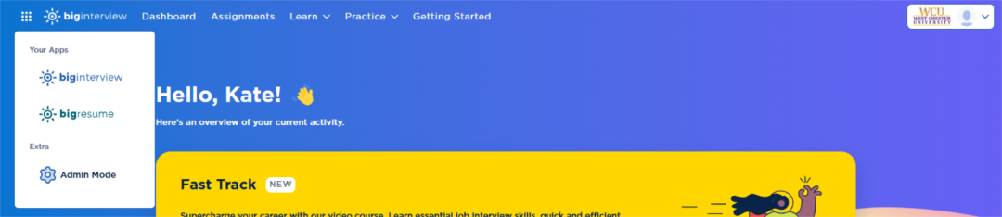

1. **To begin, Scan > ResumeAI > Scan My Resume Now.**
2. Under Step 1: Select the scoring guide that is the best fit for you.
   1. Note: You do NOT need to ‘Join by Code’ if selecting a general scoring guide.

1. Special note: Once you select a Scoring Guide you will see an option titled ‘Add Job Description’. This allows you to add any job description you wish, and the system will provide feedback on how well your resume matches the skills and abilities of that position. This is optional and can be left blank.
2. Under Step 2: Choose a resume document and select Scan Resume
3. It will take 2-3 minutes for your resume to scan. You can watch the progress online and will receive an email when it is completed. You can scan up to 5 resumes per day.
4. Resumes are given a gold, silver, or bronze medal. Click the View Feedback button for detailed information about your resume and any improvements or suggestions from the platform.

1. If changes are suggested, you can make those changes to the original document on your device and upload another version of your resume, following these same steps.

If you have questions, [click here](https://support.biginterview.com/en/article/scanning-resumes-for-ai-feedback-ul90sh/) for Big Interview Help Center or select the blue circle chat for support.

**After completing an online resume review and making updates, you may wish to speak with someone in the office for additional one-on-one assistance. Please access your** [**Handshake**](https://wcupa.joinhandshake.com/login) **account to schedule an appointment or come to the office during** [**Drop-In Hours**](https://www.wcupa.edu/_services/careerDevelopment/contact.aspx)**.**



225 Lawrence Center | [cdc@wcupa.edu](mailto:cdc@wcupa.edu) | [www.wcupa.edu/cdc](http://www.wcupa.edu/cdc)