

**Resume Assignment Instructions for STUDENTS**

**Video instructions are also available by** [**clicking here**](https://www.youtube.com/watch?v=HPeoWXIZY10)**.**

**Login:**

* Students access their account on BigInterview: [wcupa.biginterview.com](https://wcupa.biginterview.com/)
* Select Login to be directed to WCU single sign on
* Toggle to BigResume by selecting the top left square menu button and clicking BigResume

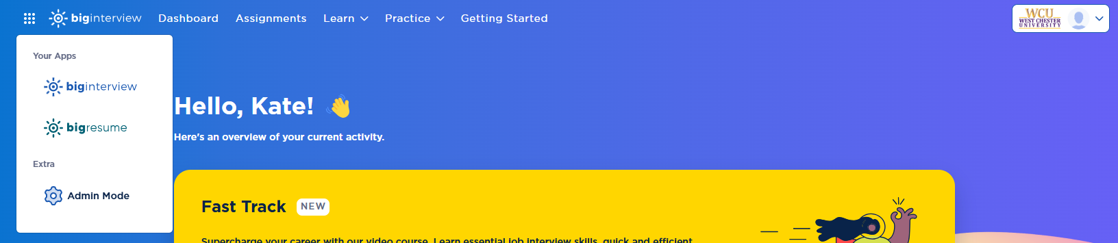

1. Select Scan > ResumeAI> Scan My Resume Now.
   1. In Step 1 you can **enter the code provided to you by your faculty member**. Do NOT select a scoring guide.

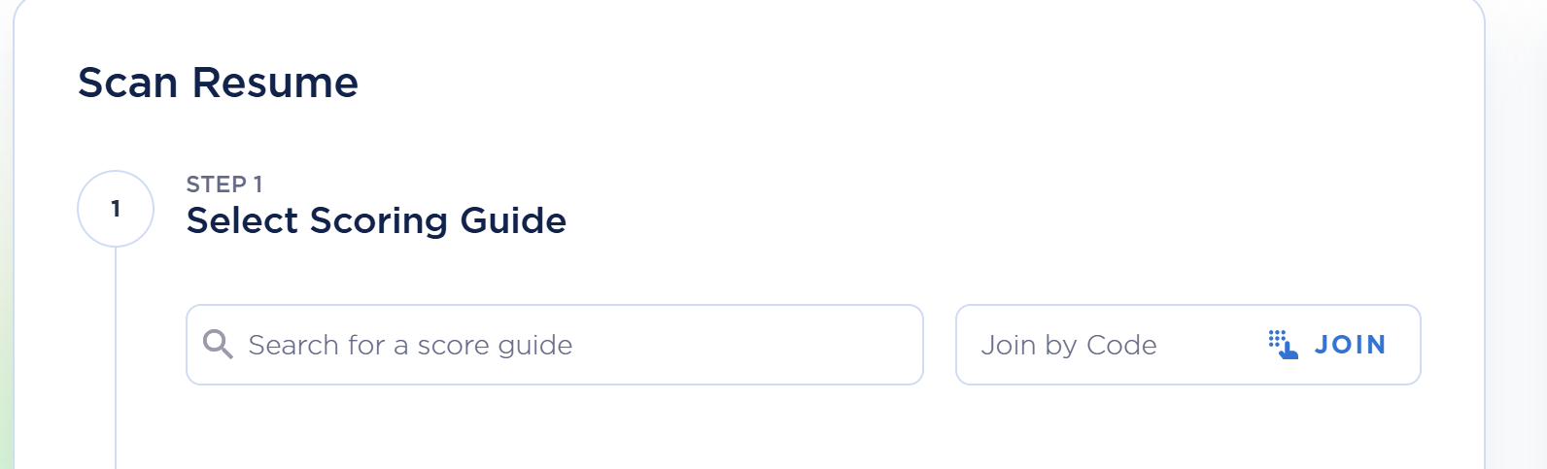

*Special Instructions:*

Your professor may require that you upload a job description for your assignment. If so, choose a job that matches your career interests. If you are unsure where to find a job posting, check out Handshake: <https://app.joinhandshake.com/stu/postings>

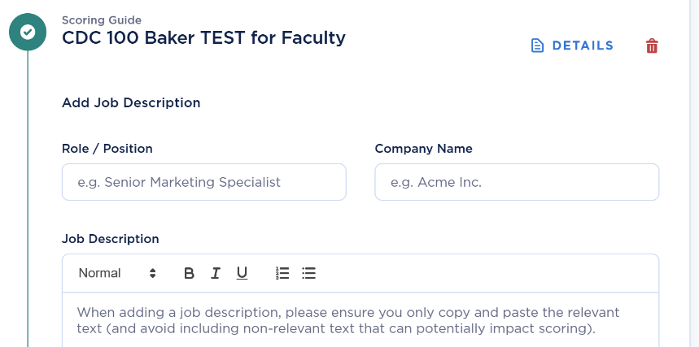

1. Scroll down to upload your resume. Once ready, click SCAN RESUME

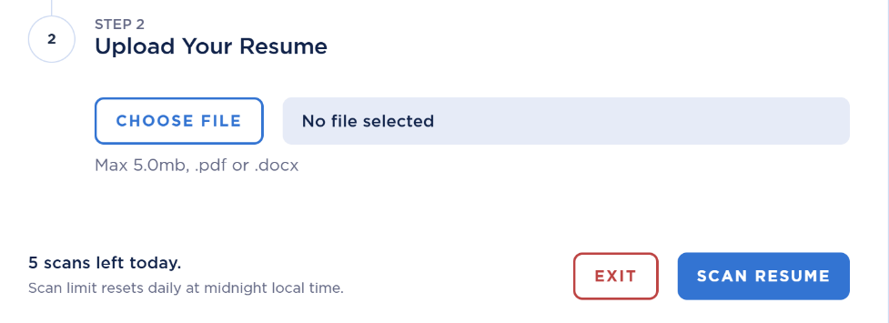

1. It will take 2-3 minutes for your resume to scan. You can watch the progress online. You will also receive an email when it is completed. You can scan up to 5 resumes per day.

**Feedback:**

* Resumes are given a gold, silver, or bronze medal. Click the View Feedback button for detailed information about your resume and any improvements or suggestions from the platform.
* If changes are suggested, then you can make those changes to your original document on your device and upload another version of your resume, following these same steps.
* Feedback will include information on Readability, Credibility, and Format. If you uploaded a job description, you would also have feedback on ATS Fit. We recommend that you read through the feedback and make some improvements. All resumes will be given feedback. If you make the changes suggested, then you will improve your score with the next upload.
* Click on View Detailed Feedback to see all of the details and suggestions.

If you have questions, [click here](https://support.biginterview.com/en/article/scanning-resumes-for-ai-feedback-ul90sh/) for Big Interview Help Center or select the blue circle chat for support.

**After completing an online resume review and making updates, you may wish to speak with someone in the office for additional one-on-one assistance. Please access your** [**Handshake**](https://wcupa.joinhandshake.com/login) **account to schedule an appointment or come to the office during** [**Drop-In Hours**](https://www.wcupa.edu/_services/careerDevelopment/contact.aspx)**.**

 225 Lawrence Center [cdc@wcupa.edu](mailto:cdc@wcupa.edu) [www.wcupa.edu/cdc](http://www.wcupa.edu/cdc)