How to Set Up a Resume Assignment in Big Resume
Within the Big Interview platform is the Big Resume tool that allows students to receive feedback and tips for improvement within minutes and helps students see how a resume will be viewed by an ATS (Applicant Tracking System). Following are directions to set up a Resume Assignment for a class:
- Request a faculty account for BigInterview, if you have not already. You may email your request to the Twardowski Career Development Center at cdc@wcupa.edu.
- Log in to Big Interview at https://wcupa.biginterview.com/ by clicking on the “Login” link in the upper right corner. Do NOT select Admin Login.
- Once logged in, you will likely be directed to the Student View dashboard. To navigate to your Faculty/Admin Dashboard – click on menu bottom int eh upper left and select Admin Mode.
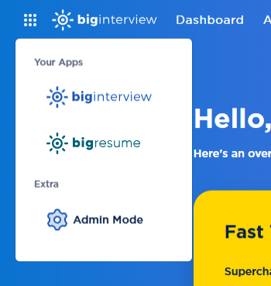

- Click Resumes and then Scoring Guides on the drop-down menu.

PLEASE NOTE: You can choose to create a scoring guide from scratch. In our experience, this takes a MINIMUM of 2 hours. Step-by-step directions for creating a new scoring guide from scratch are available on the BigInterview website here: https://support.biginterview.com/en/article/resumeai-scoring-guides-1ixqxjl/. We STRONGLY recommend that you duplicate one of our SAMPLE scoring guides for your resume assignment. Directions are as follows:

- On the next screen, click the “Main Folder” under Invite-only/Code-based Folders.
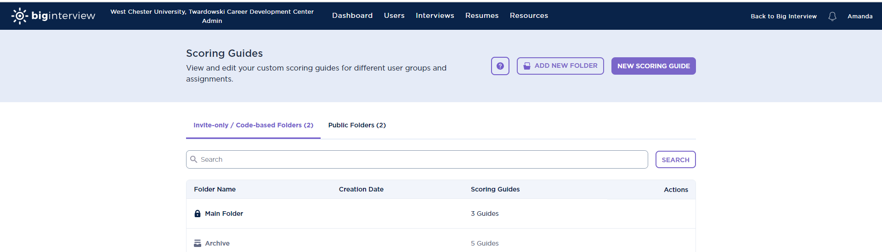
- We have created samples that you can use for your student population. If you don’t see them, search for the word SAMPLE. Please choose the option that most closely reflects your class. If your students are mostly first and second year with little to no experience in their field, then use the “SAMPLE Best for First & Second Year Undergrads.” If your class is mostly upper-level undergraduates getting ready to apply for internships or full-time jobs, then use the “SAMPLE Best for Upper Level Undergraduates or New Professionals.” We strongly recommend that you use one of the SAMPLE assignments!
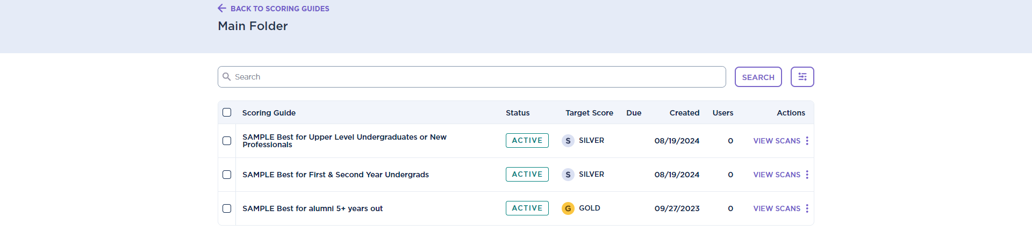
- Click the 3 dots menu on the right-hand side of the screen next to the SAMPLE scoring guide you prefer. Then click on the menu option to duplicate that sample.
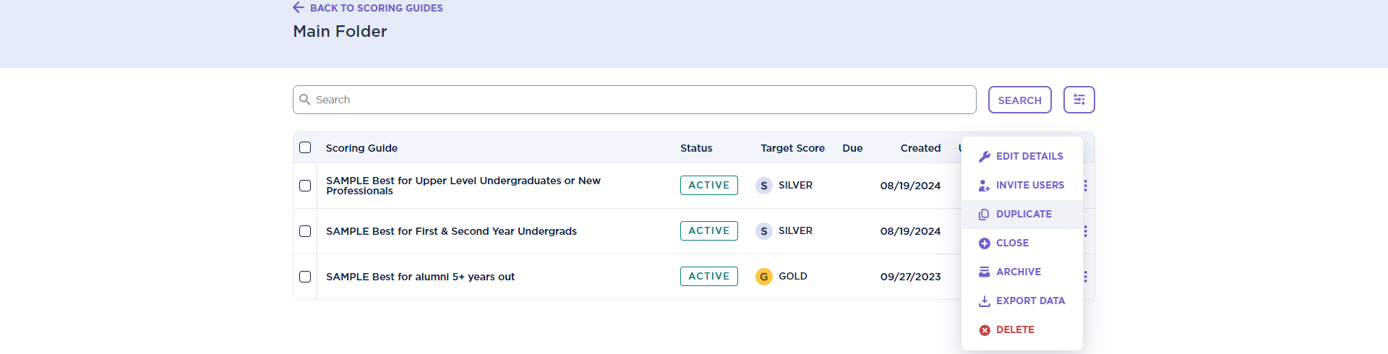

- You will come to the following screen. Complete steps 1 through 5 below:
- Change the name of the scoring guide to your class number and last name (e.g. SPK203-02 Baker Resume Assignment).
- Add a due date, if applicable.
- Update the description of the assignment.
- We recommend leaving all other settings as they are.
- Click the purple Next Step button at the bottom to save.

- On the next screen, click Exit and then click OK on the pop-up window. You will be taken back to the Scoring Guides screen. Click on the Main Folder to see your assignment in the list.

- Click on the three dots menu to Invite Users to the assignment.

- You can email your students with the resume assignment instructions using Big Interview, but this step is completely optional. If you’d like Big Interview to notify your students, you can upload a CSV file with your students’ names and email addresses. You can also manually add students by clicking on the Add button towards the top. You can also edit the invitation message.

- If you do NOT want Big Interview to email your students, then scroll down to copy the assignment access code. PLEASE NOTE: Your students MUST have the code to access the assignment. Some faculty choose to copy/paste the code into the D2L assignment instructions. Your code will differ from the one below!
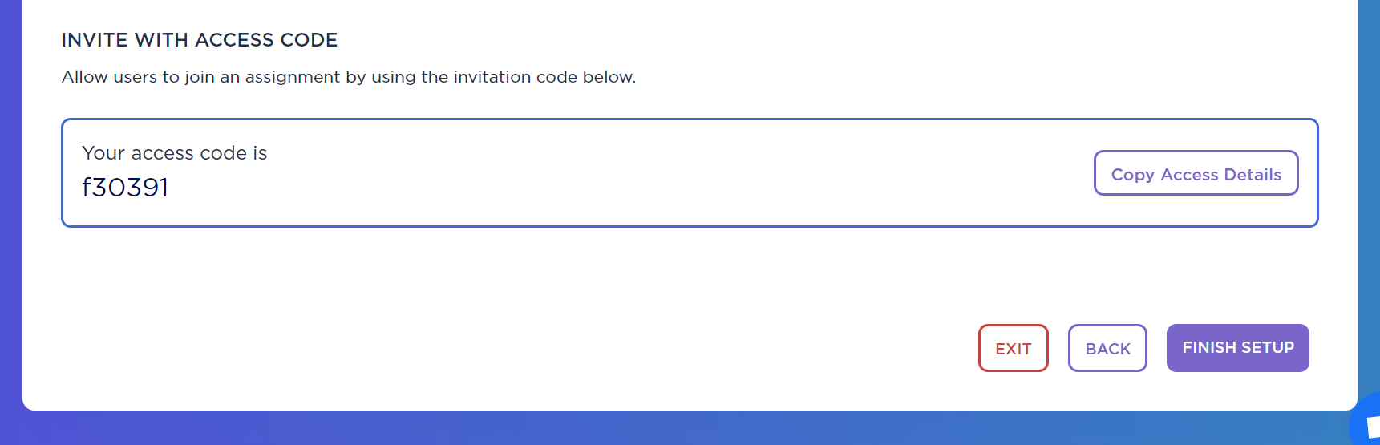

- Then click the purple Finish Setup button.

- Be sure to click on the Main Folder to find your assignment. Use the search button to find your assignment by your last name or class number.

- You can click on VIEW SCANS to see your students’ results. You can also opt to have students screenshot their results and upload them into D2L. You will be able to see which students have completed the assignment and which have not. You can click on view results next to the student’s name to see the uploaded resume and the feedback that the student received.
