How to Set Up an Interview Assignment in Big interview
Big Interview is an online mock interview tool that combines training and practice to help improve interview skills and build confidence. The following are directions to set up an Interview Assignment for a class, a video tutorial can also be found here: https://support.biginterview.com/en/article/creating-an-assignment-qhny7/

- Request a faculty account for BigInterview, if you have not already. You may email your request to the Twardowski Career Development Center at cdc@wcupa.edu.
- Log in to Big Interview at https://wcupa.biginterview.com/ by clicking on the Login link in the upper right corner. 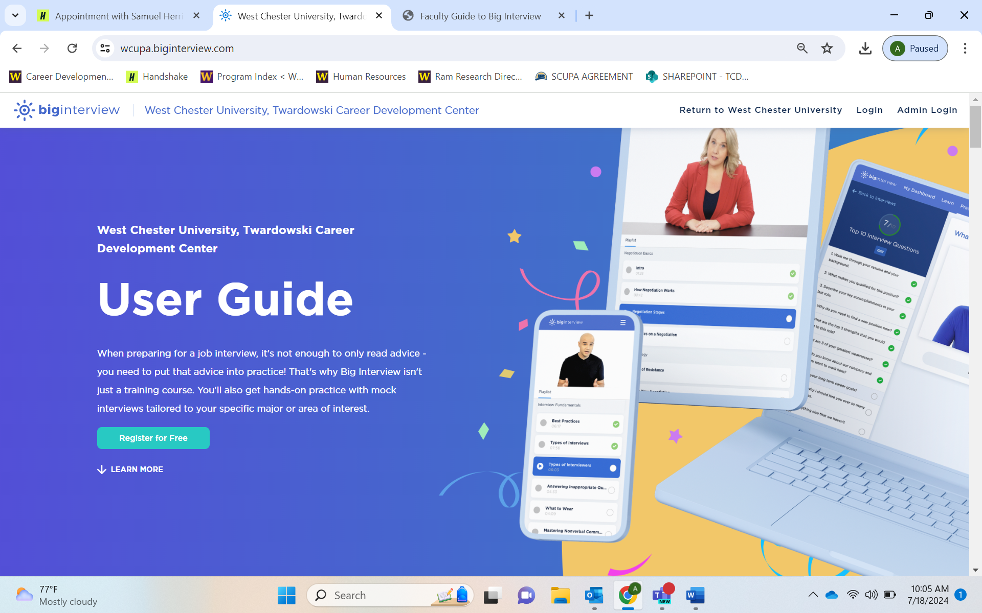

- Once logged in, you will likely be directed to the Student View dashboard. To navigate to your Faculty/Admin Dashboard – click on “Back to Admin” button in the upper right.
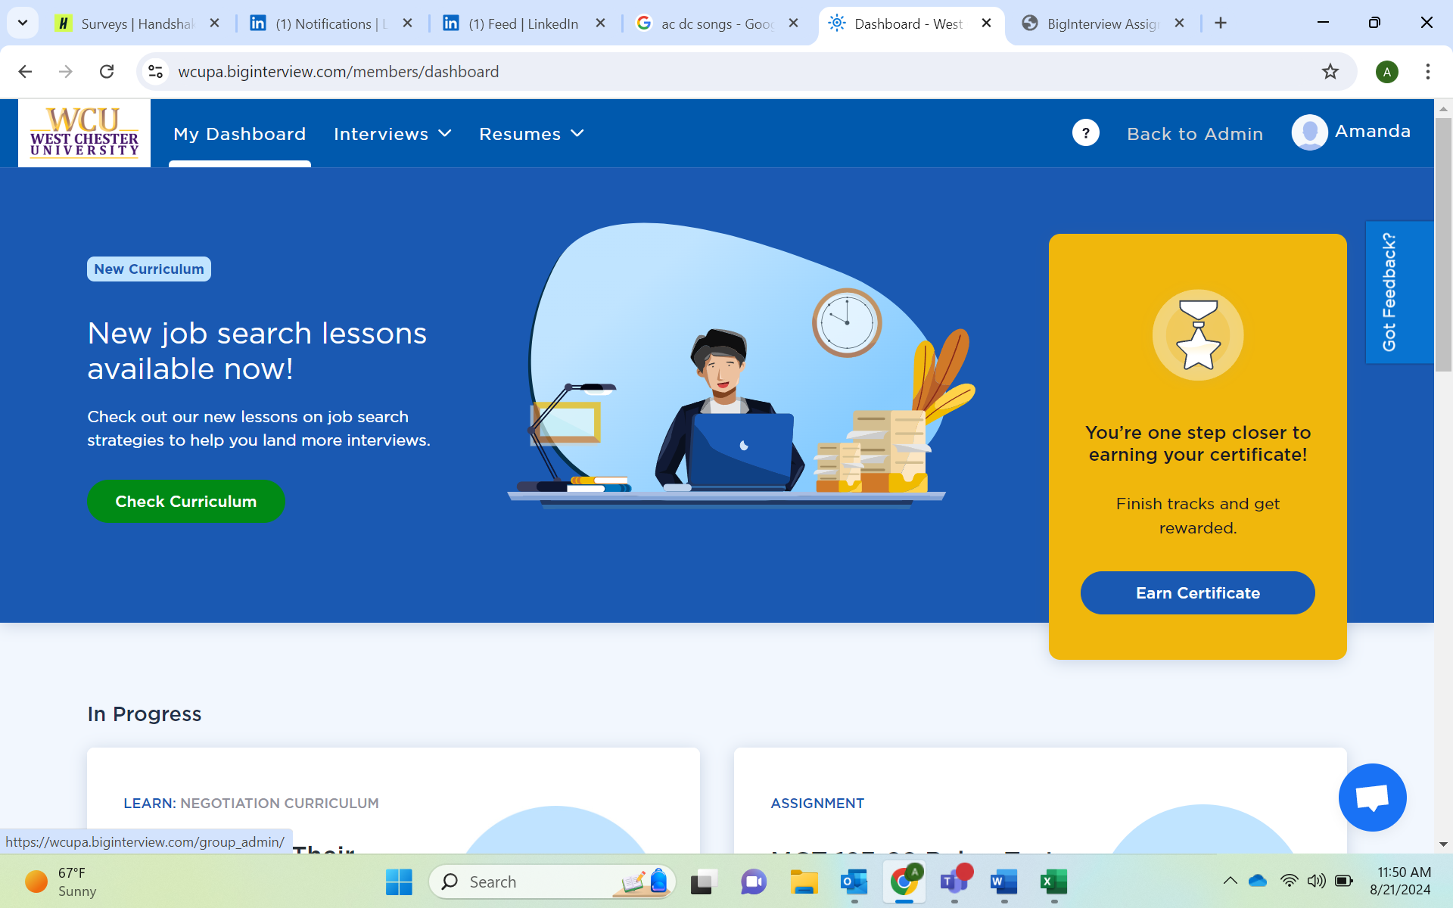
- If you wish to use a past assignment, search the list of assignments for your class number or last name to find an old assignment.
  - When you find the one you want to use, click the gray Actions button on the right, then click Duplicate in the drop-down menu
  - The copy will open. Click the “Edit Details and Settings” link at the top to get started.
  - At a minimum, you will want to change the name of the assignment and the due date. IMPORTANT: Please use your course abbreviation, course number, last name, and semester to name your assignment (e.g. MGT 498-03 Prachar Fall 2024 Interviews OR SPK 230 Kaminski Summer 24 Assignment).
  - You can update or edit any other details of the assignment. Please be sure to copy the new access code for your students! 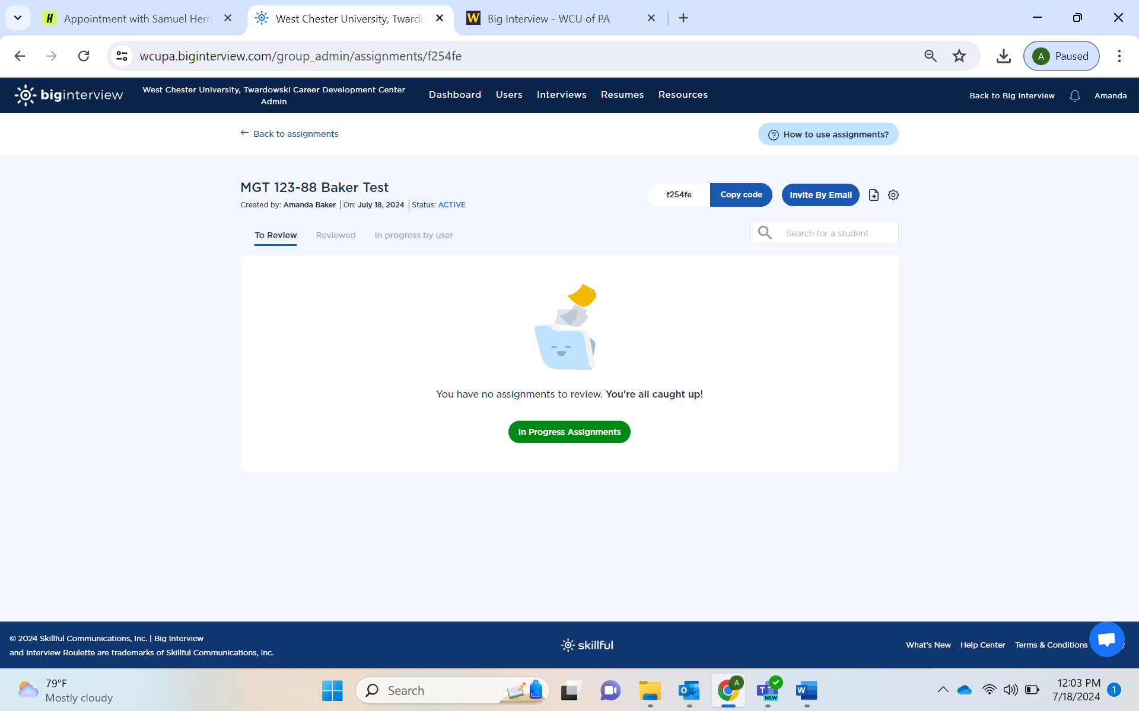
- If you are starting from scratch, then click the green “Add New Assignment” button 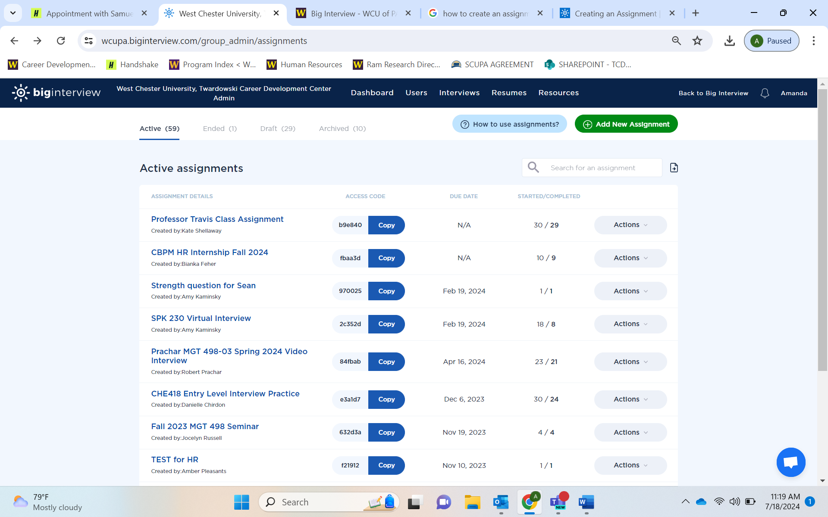to get started.
- Add all your assignment details and follow the automated path to create the assignment. 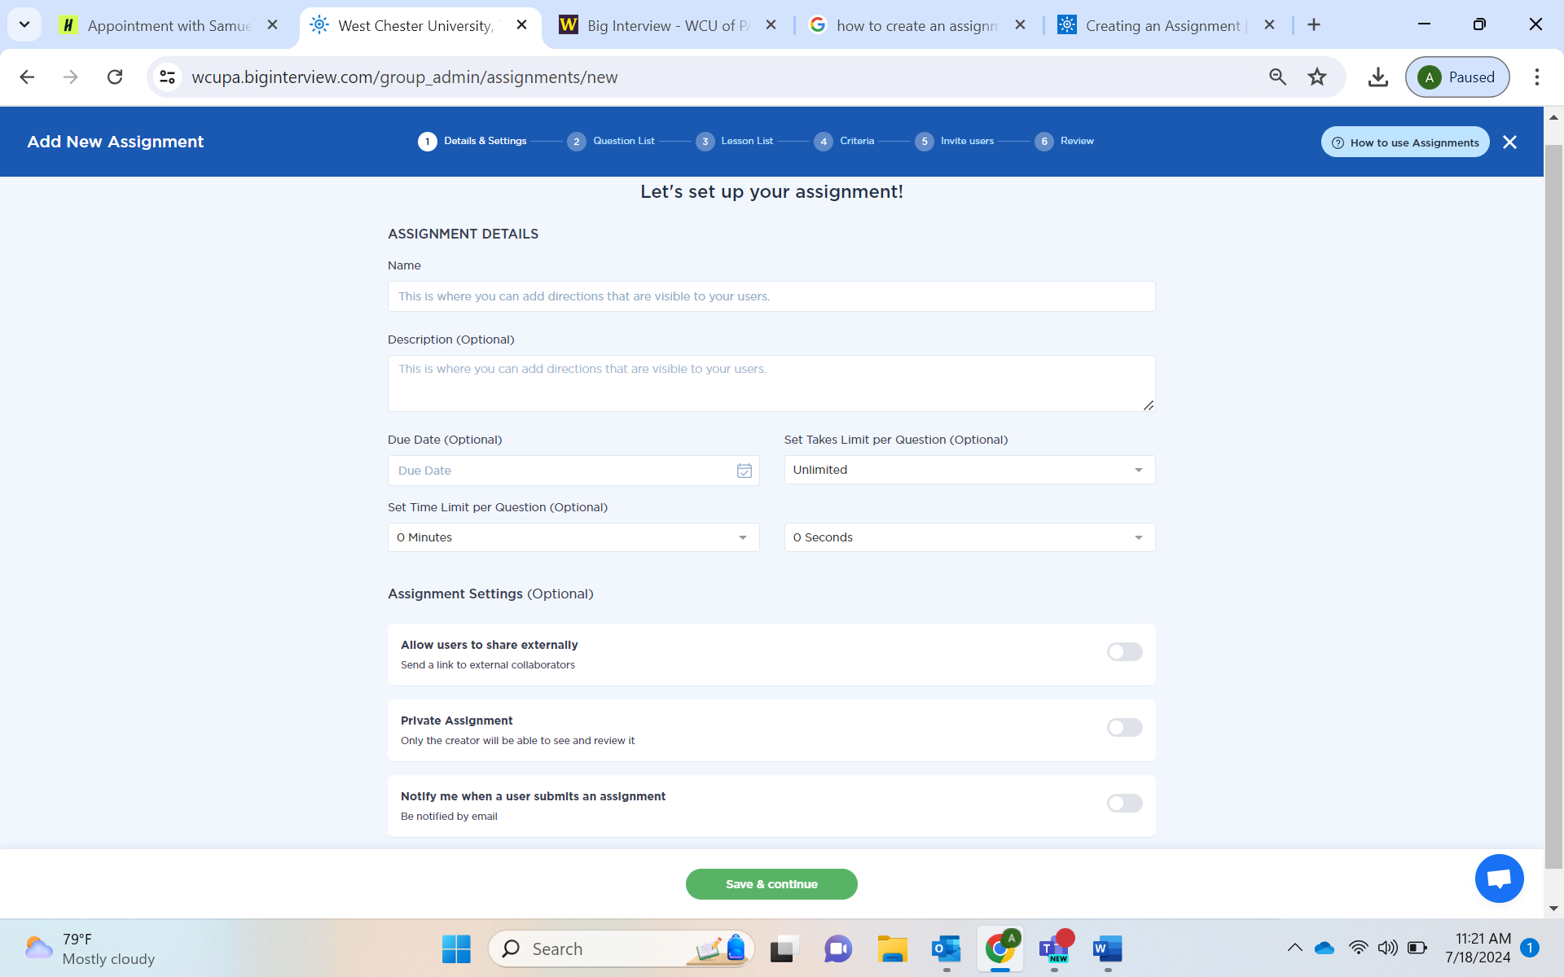
- IMPORTANT: Please use your course abbreviation, course number, last name, and semester to name your assignment (e.g. MGT 498-03 Prachar Fall 2024 Interviews OR SPK 230 Kaminski Summer 24 Assignment).
- In step 3 (optional), you can assign lessons to your students which is learning content developed by BigInterview.
- In step 4 (optional), you can add or change the criteria used to score the interviews. After your students complete their assignments, you can use these criteria to review and add feedback to their interviews.
- In step 5 (optional)
  - You can manually add users by typing their name and email address and clicking the plus sign.
  - You can upload a CSV file of your class list by clicking on the blue “Import Users from CSV” button at the bottom of the page. The CSV file should have three columns as seen in the table below: First Name, Last Name, and Email. Keep in mind that the first row is the CSV header row. Also, if you upload a second file it will replace ALL the users from the first upload.
  - Edit the invitation message with whatever text you want to add. As soon as you click the green Save Detials button, an email will go out to all of the students that you added to the list.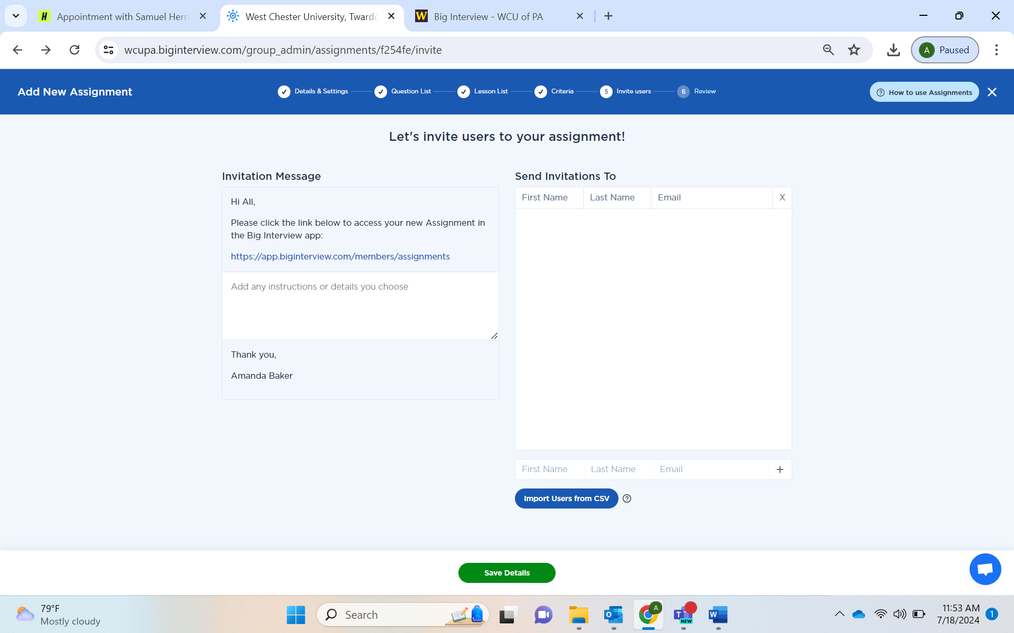
- You should come to a screen with an access code. If you have chosen NOT to upload users, then you can share the access code with the students in your class. They will simply login to BigInterview and enter the access code to get started. It will look something like this:

