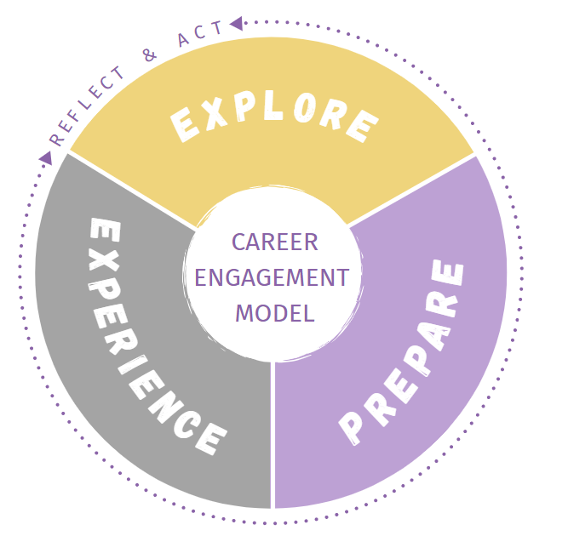As you ***explore* majors**, it can be helpful to take note of certain information relating to each major that you are considering. Complete the following information for 3-5 of the majors that are of interest to you:

**Name of Major: _____________________________________**

* List any concentrations/tracks within this major:
* What are some of the topics and information covered in this major?
* What are some of the required courses in this major?
* What are other requirements of this major (labs/field experience/ internships/etc.)?
* What is a student organization related to this major?
* What interests you most about this major?
* What concerns do you have about this major?
* List any careers you believe you could pursue with this major. *Hint: Major does NOT equal career.*

*Check out ‘What Can I do with this Major’ resource listed on CDC website.*

* Who could you talk to and where else could you look to learn more about this major?