***Directions: Student Success Survey***

***Saturday August 25th, 2018***

All First-Year Students need to take the Student Success Survey during the designated time frame on their Part 2 Weekend Schedules.

1. Go to:   <http://successnavigator.ets.org/>

Confirm the above link and Below screen shots

1. Input session number:  **207298-149700188**

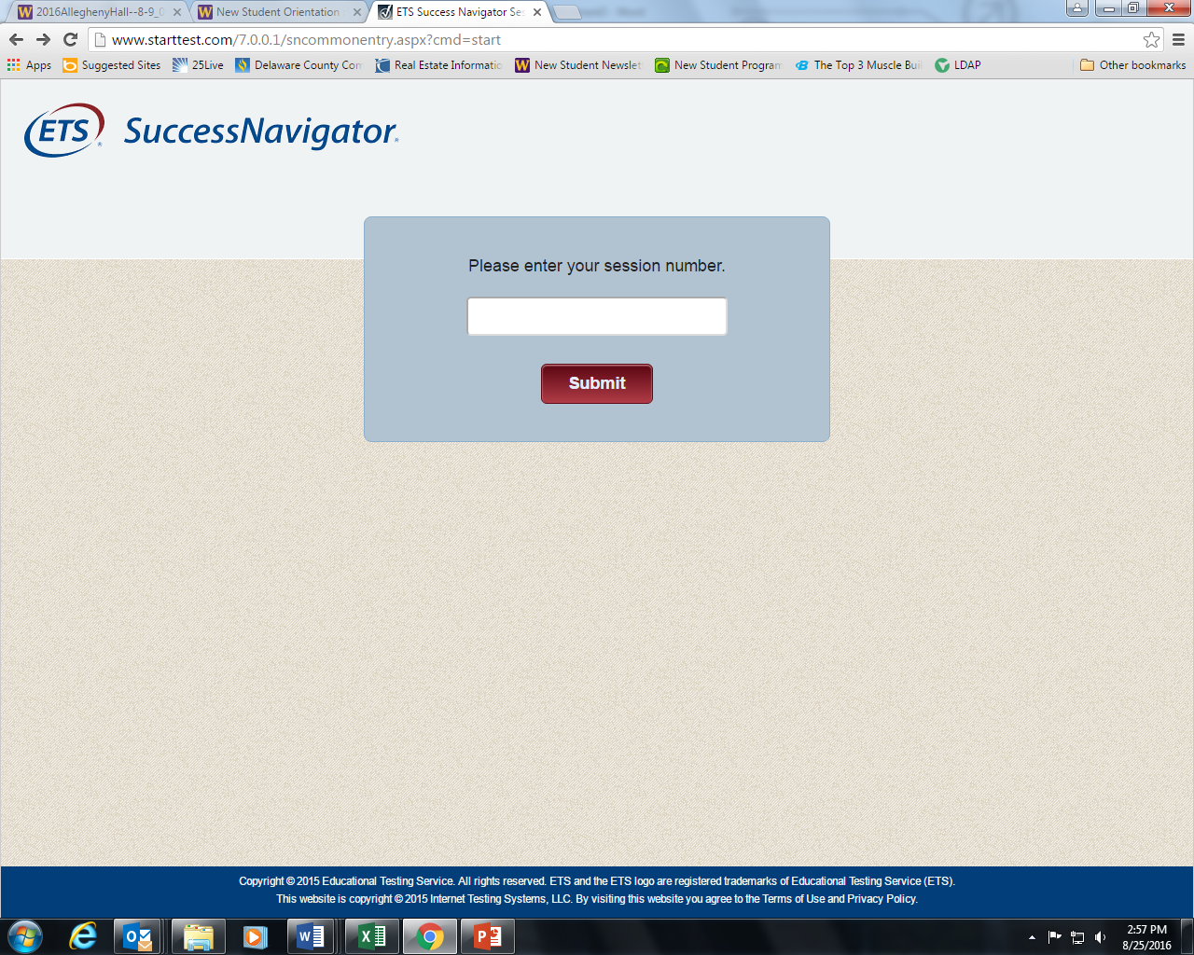

1. Enter your WCU Email

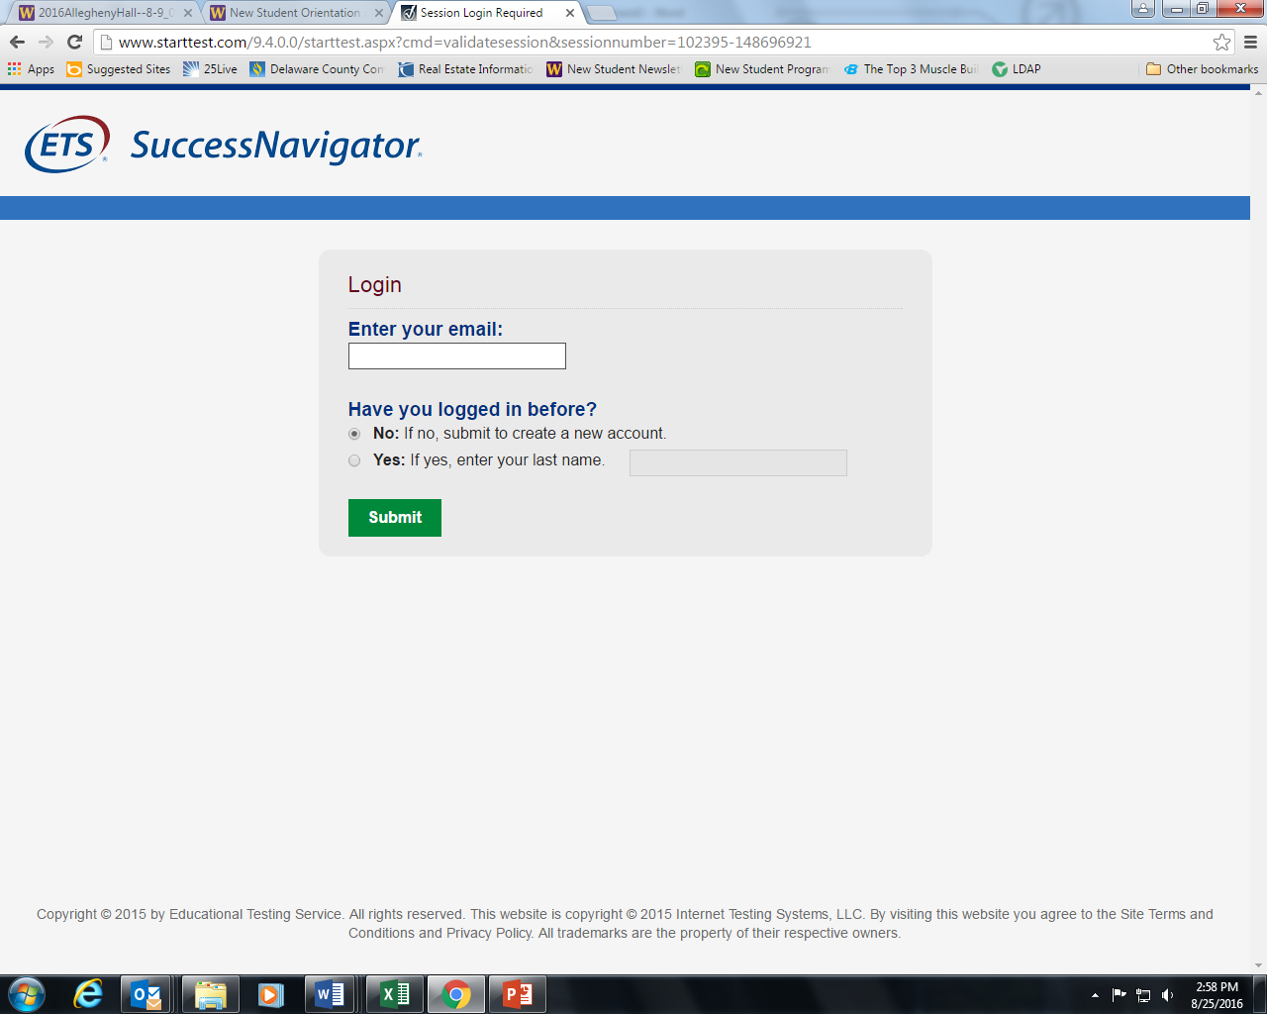

1. Input your WCU email, WCU ID Student ID (i.e., without initials just your 6 digits), and First Name/Last Name

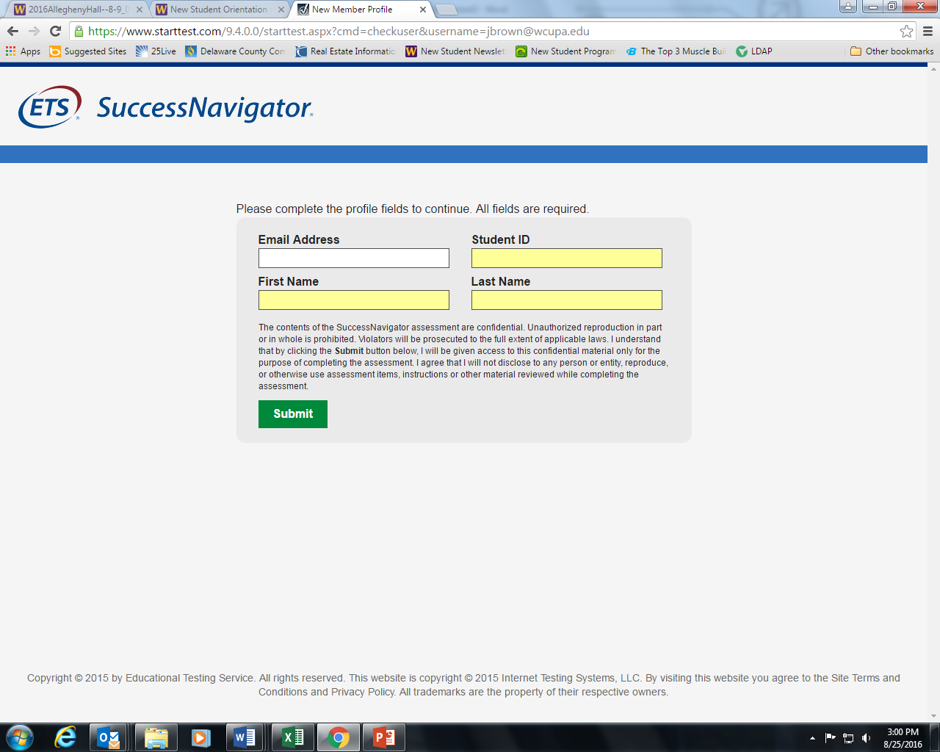

1. Click on Start Test and complete the survey

