**Social Security Number Update**

*Last edit date: 5/10/2024*

This document provides instructions for newly admitted students to update their social security number.

**Navigation: RamPortal homepage> WCU link > Additional Information tile > Self Service Document Upload Form**

**Navigation:**

* Log in to the RamPortal home page at [ramportal.wcupa.edu](http://ramportal.wcupa.edu)
* Click the “myWCU App” box on the myWCU card.

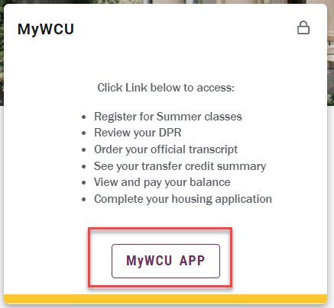

* Once in myWCU, click the “Additional Information” tile.

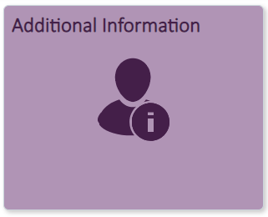

* Then, select the Self-Service Document Upload Form.

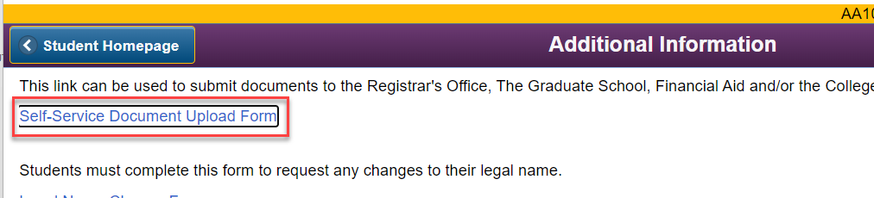

* Next, in the “Document Upload” section, choose:
  + “Registrar” from the office for which you are uploading a document
  + “Registrar Social Security Number Update” for the document type you wish to upload.

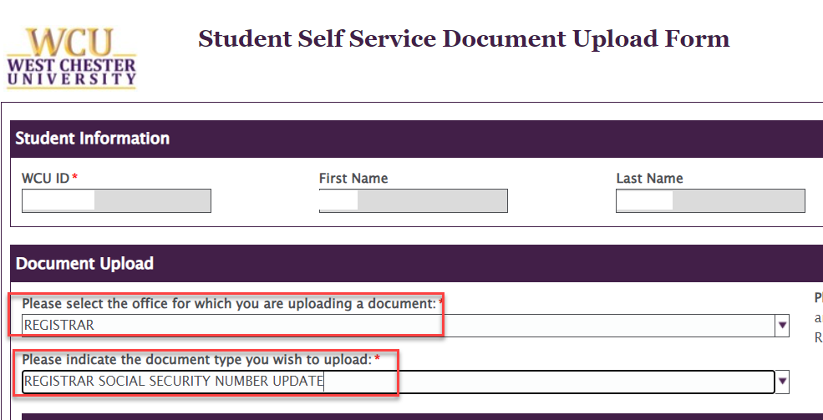

* + Attach your document using the “Attach” button, then choose “Upload” on the bottom left.