|  |
| --- |
|  |
| **Add Classes** |
| Student may add classes to their schedule through the course add/drop deadline. The last day to add a course varies based on the session/course start date. Add deadline can be found in academic calendar and within Class Search.  *Tile navigation: Classes > Add Classes* |
| * You may need to select the term in which you want to enroll then click Continue. * Identify the number of credits you plan to schedule by selecting a credit range from the drop-down menu and click Submit. * Search for classes, via Class Search, by clicking the Search button. |
|  |

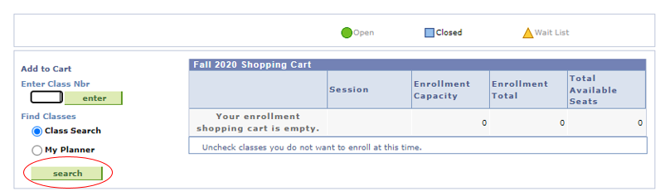

* Click Select to review the Class Details

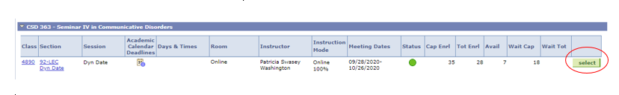

* Click Select Class to add the class to review Enrollment Preferences

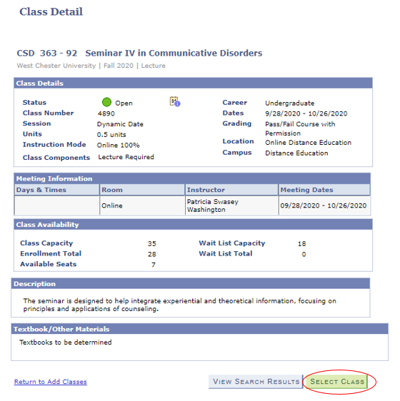

* Click Next to add the class to your Tentative Classes list.
  + Check the “Wait List if class is full” for courses in Wait List Status.
* Once you have classes on your Tentative Classes list and you are ready to enroll, click on the Proceed to Step 2 of 3 button.

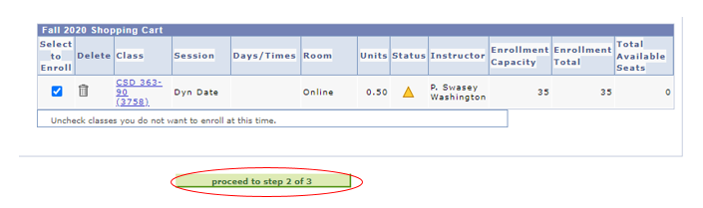

* On the next page, click on the green “Finish Enrolling” button.
* You will see a red “X” or a green “check mark” next to each class.
  + A red “X” means you did not get into the class and there will be a message explaining why.
  + A green check means you are successfully enrolled in the class.

Content Manager: Registrar’s Office

Last Updated: 9/10/2020