|  |
| --- |
|  |
| **Establish a Preferred Name** |
| Students and employees wishing to establish a preferred name to be used in place of their legal name in select University related systems and documents may submit their request within myWCU.  *Tile navigation: Personal Info > Establish a Preferred Name* |
| * Review additional information about the use of preferred and legal names by the University and within various University systems. * Select a reason from the Name Change Reason drop down * Type your preferred first name in the First Name text box. |
|  |



* Click Finish to submit
* You will be routed to the *View Change of Name Request* page where you may review and/or cancel your submitted request.

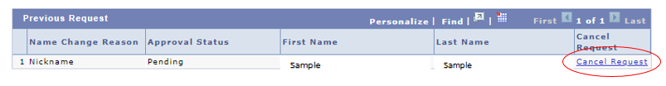

You may not submit multiple requests. If you already have a request pending and click the link: *Establish a Preferred Name* you will be routed again to the *View Change of Name Request* page.

Content Manager: Registrar’s Office

Last Updated: 9/10/2020