|  |
| --- |
|  |
| **Order an Official Transcript** **For students who attended WCU *during* or after 1985** |
| Current and former students (who attended during/after 1985) must log into myWCU to order an official transcript. Student will access the Parchment storefront from myWCU.  *Tile navigation: Academic Records > Order Official Transcript* |
| * This link will open the Parchment storefront in a new browser tab. |
| *Students with certain holds on their account will not be able to access the ordering page until the holds are removed.* |

## First Time Accessing Order Page

* Students accessing the ordering page for the first time will be asked to review and/or update name and contact information.

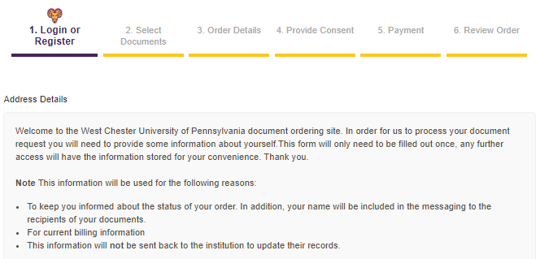

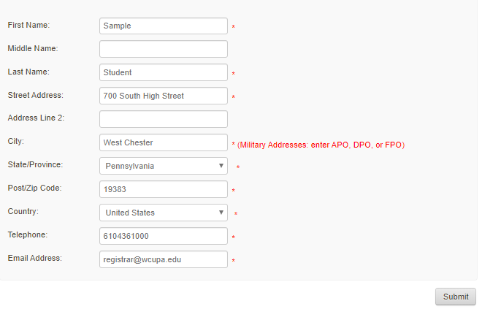

## Select Document Type

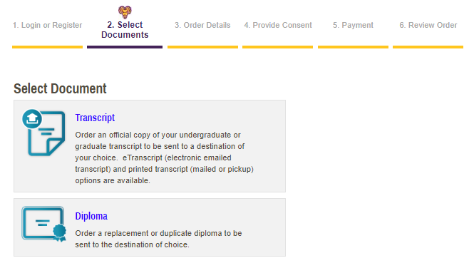

## Order Official Transcripts

Search for the recipient or the destination you’d like your document sent or click the link under the search box to manually enter the name and address of your recipient.

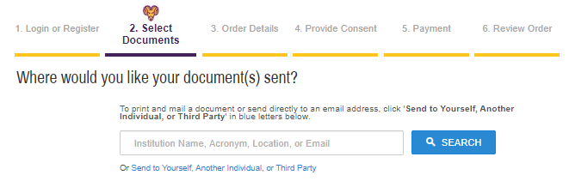

### Search for your destination

* Within the search box, enter the name, part of the name, or the abbreviation of the organization or institution where you would like your transcript sent.
* Click Search

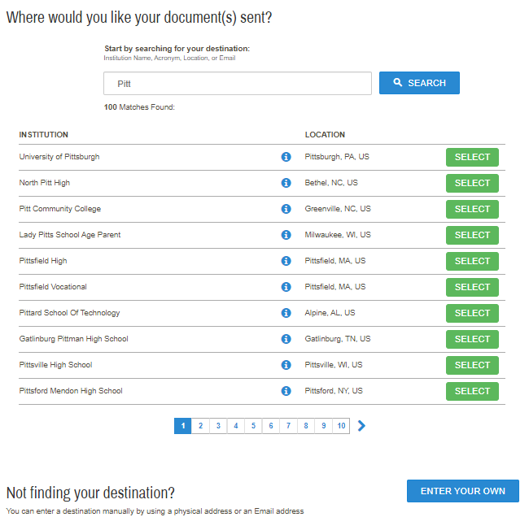

* Review/Select from the available options.
  + If you do not see your destination, click “Enter your Own” to manually enter the name/contact information of your recipient.
* Review information about the product/transcript you are having sent, review the destination of your document, identify the reason for your request, and click Continue.
  + If you need to attach a document to your order, click “Choose File” at the bottom of the page.

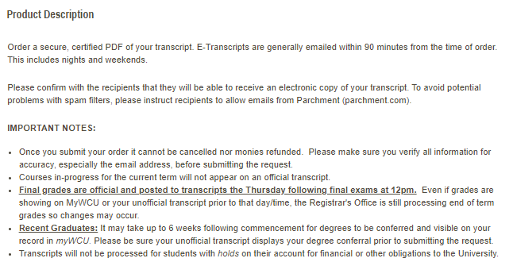

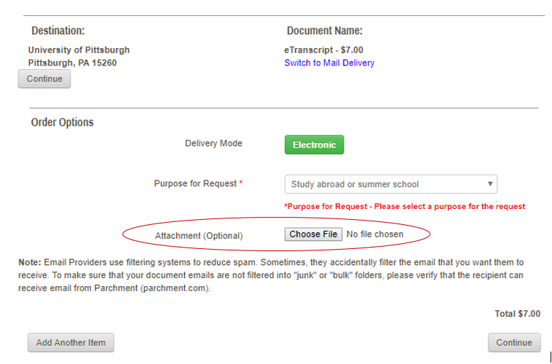

### Enter your Destination/Recipient Information

* Click “Send to Yourself, Another Individual, or Third Party” located under the search box or “Enter Your Own” on the search results page.

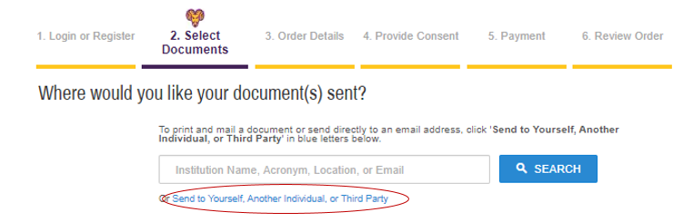

* Select from the available document types: eTranscript, Paper Transcript – Mailed, Paper Transcript – Pickup

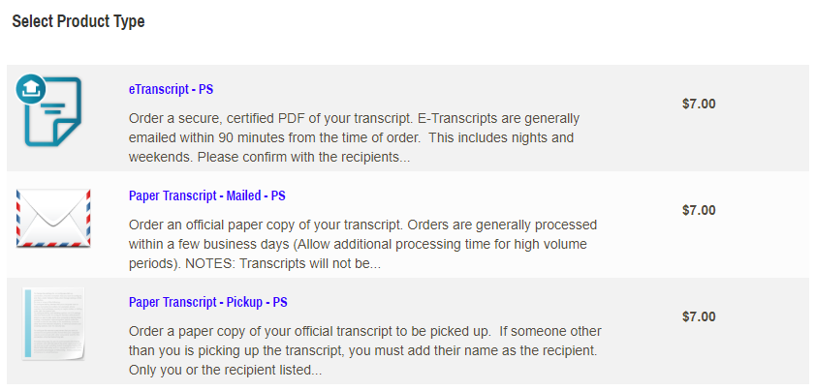

* Review product information, enter recipient name and email or physical address, identify the reason for your request, and click Continue.

### Attachments

Students ordering eTranscripts and Paper Transcripts – Mailed have the option to include an attachment to be sent with their official transcript.

* Under Order Options, view Attachment (Optional)
* Click Choose File: search files from your device
* Identify Attachment Type

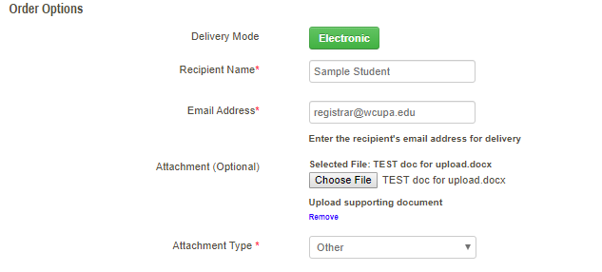

### Paper Transcript – Mailed: Fed Ex Option

Students ordering paper transcripts to be mailed now have the option to overnight their order via Fed Ex

* Under Order Options, view Mailing Method
  + The dropdowns vary for the Mailing Country: domestic or international.
* Select Fed Ex delivery

*To ensure next day delivery, orders must be placed by 4 pm eastern time.*

## Provide Consent

First time requestors who have not previously signed the FERPA consent page will be directed to do so. Please review the policy and using your mouse sign in the box provided.

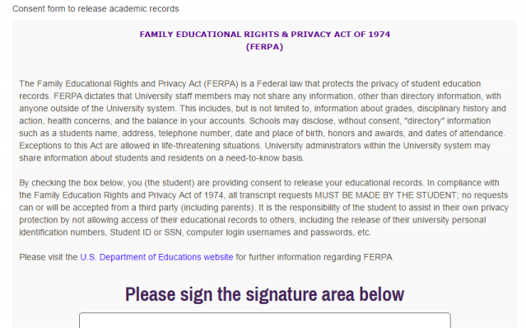

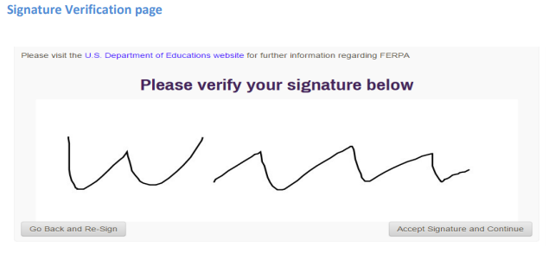

Returning requestors will see the following:

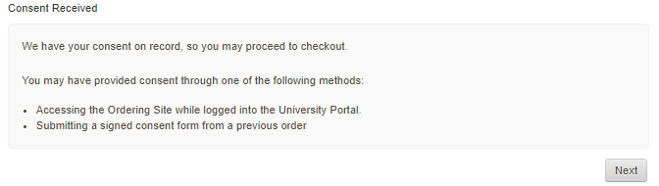

## Payment

Enter payment information and confirm/update billing address.

## Review Order & Confirm

Review your order and payment information. Click confirm to submit your order.

Content Manager: Registrar’s Office

Last Updated: 9/10/2020