Orientation Registration
All new first-year and transfer students are required to complete orientation programming. Below are the instructions for how to register for an on-campus orientation session.

From your myWCU homepage, look for Alerts

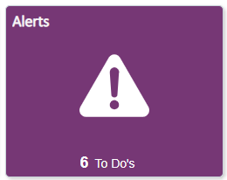

- Click on the Schedule Your Orientation Session Link
- Complete the form by choosing a date from the drop-down, entering the preferred first name you would like on your orientation nametag, and entering any guest data.
- If a date is not available in the drop down, it means that session is full and no longer available, so please chose an alternate date.
- Save your form. If you wish to change your orientation date, return to the link and select a new date from the available options.
- If you do not receive an automated confirmation of your orientation registration, or if you have any questions, contact New Student Programs at orientation@wcupa.edu or (610) 436-3305.

Content Manager: New Student Programs
Last Updated: 9/10/2020

