# Class Schedule Report with Class Roster Information

*Last edit date: 05/30/2025*

This document provides instructions for viewing the new Class Schedule and Class Roster reports within RamPortal.

**CONTENTS**

Navigation

Running the Class Schedule Report

[View Class Rosters](#_VIEW_CLASS_ROSTERs )

Further Refine Your Report Output

## Navigation

* Log in to RamPortal at [ramportal.wcupa.edu](http://ramportal.wcupa.edu/)
* From the Homepage, locate the Academic Department Resources card, click on the “Reports” dropdown and choose “Class Schedule Report”.

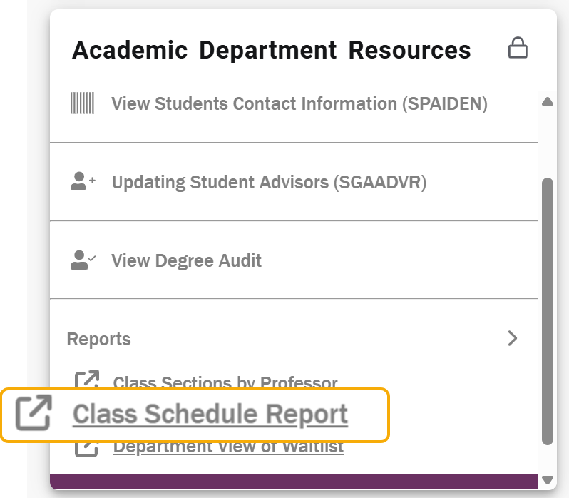

* The “Class Schedule Report” link is also accessible from the hamburger menu in the top left corner of the page, within the “Reporting” section.

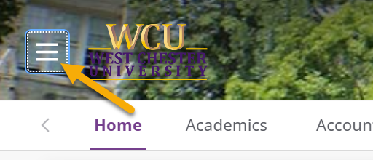

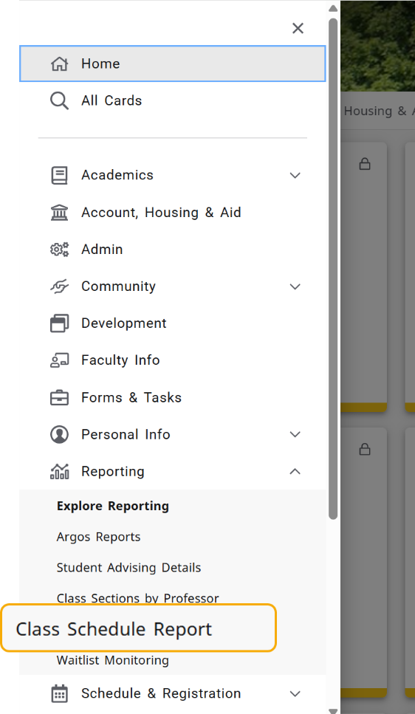

* After clicking the Class Schedule Report, a new browser tab will open displaying a log in screen for evisions. Click the “Use single Sign-On" button.

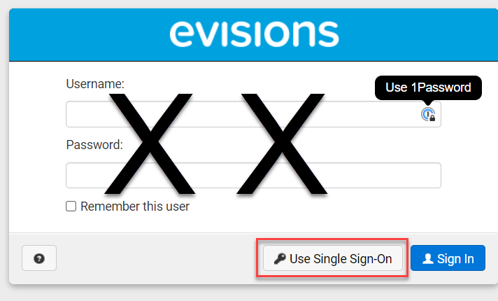

## Running THE Class Schedule REPORT

* Select a term from the drop down and click “Search” or select other prompts from the drop-down menus to further refine your search results.

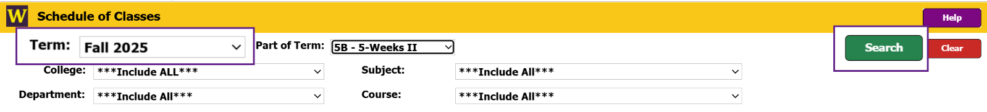

* To search for a specific course, you must first select the College, Department, and Subject from the drop-down and then click “Search”.
* Click the “Include Cancelled Sections” box to include cancelled section in your results.

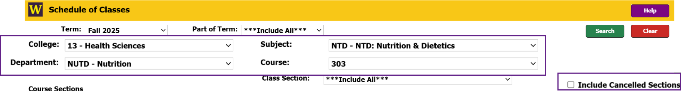

* Results will appear in the Course Sections box, based on your selections.
  + Use the sliders and/or arrows at the bottom and sides of the window to view additional information.
  + Update the order of the information being displayed by clicking on one of the column headers.

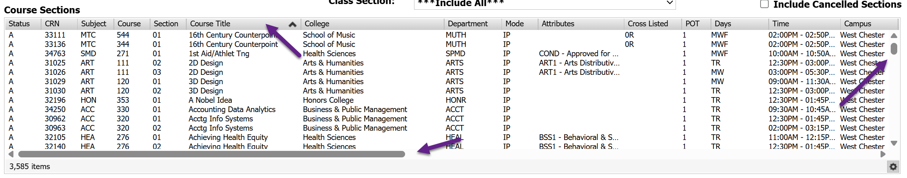

## VIEW CLASS ROSTERs

* To access the Class Roster, click on the course within the Course Sections output. Information about the students enrolled in the selected course will appear in the Section Enrollment box below.

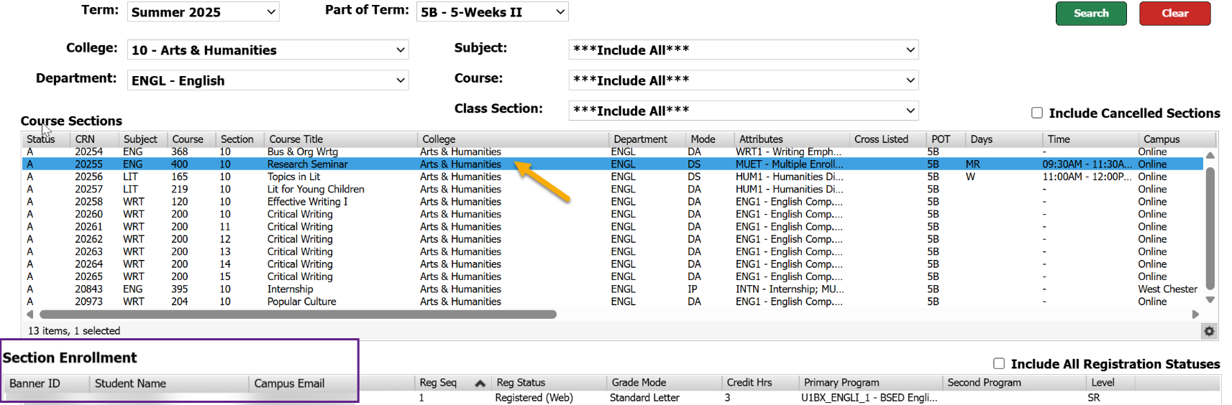

* The display defaults to only showing students registered for the selected course. If you wish to include students who may have dropped the course, check the “Include All Registration Statuses” box.
* Use the sliders and/or arrows at the bottom and sides of the window to view additional information.
* Update the order of the information being displayed by clicking on one of the column headers.

## FURTHER REFINING Your report Output

* The gear icon in the bottom righthand corner of the output section provides options for further refining and/or exporting your search results.

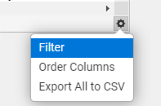

* + Use the “Filter” option to further limit your results by any of the report fields/column headers.
    - Select the field you wish to filter by from the “Available Fields” drop down.
    - Select from the “Operator” drop down to determine how the Field information should be filtered.
    - Enter the "Value” you want to filter the field against.
    - Click the Plus button.
    - Either add additional filters or click “Apply” to see your filtered results.

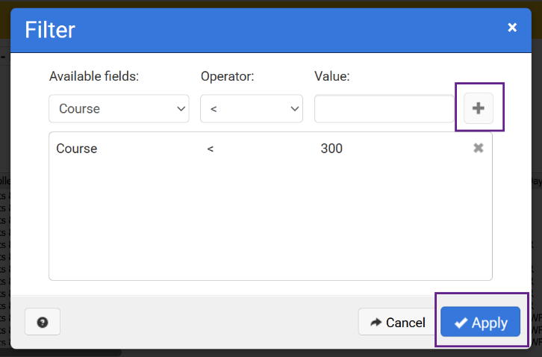

* + Use the “Order Columns” option to change the order of the output columns.
    - Click and drag the column headers to rearrange them and then click “Apply”

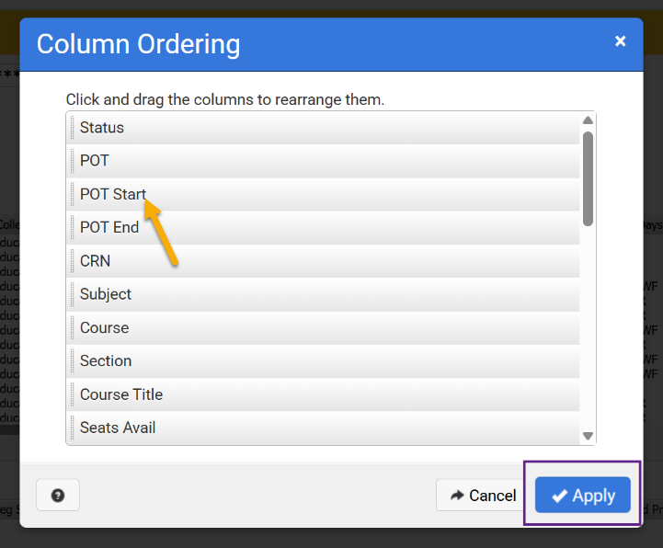

* Use the “Export all to CSV” option to export the output and view in excel.
  + Uncheck any fields you want to exclude from the export, use the arrows to move fields, and/or adjust fields names and then click “Apply”

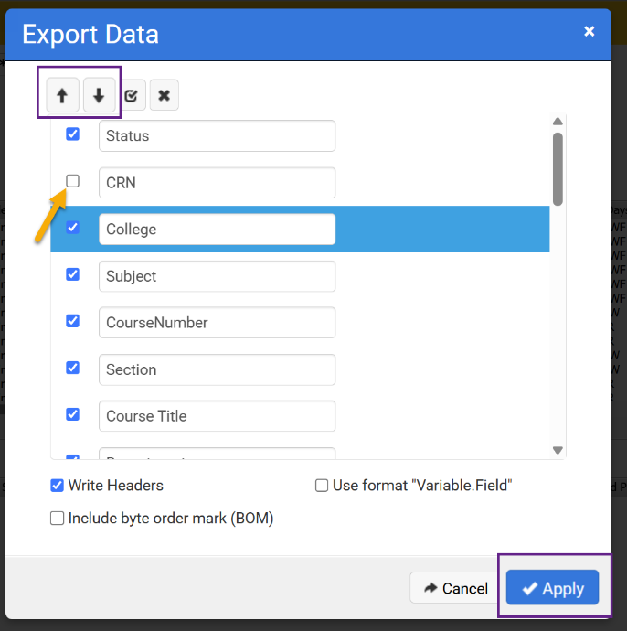

* + Locate the export in the download section of your browser.
* When finished, click “Close” or “Sign Out” located in the top right corner of the screen.