YES Mission  The mission of the Youth Empowerment and Urban Studies program is to provide students, through study and action, a critical understanding of the role youth can play in social change in urban communities. The overall goals of the YES program are to contribute to making real community-based change in our local urban areas, especially the City of Philadelphia, and to develop "change-makers": individuals who have the skills and knowledge to contribute as citizens, including increasing educational and political access for themselves and others.  RUCCAS Mission  The mission of the Rustin Urban Community Change Axis is to support the building of power for Southeastern PA metropolitan communities, specifically but not exclusively global majority/communities of color and low-income urban communities, through providing together new and mid-career urban community change professionals-- particularly urban youth workers, artists, and cross-sector racial and economic justice workers-- credential-bearing educational pathways and supportive, healing spaces and opportunities for renewal.  “No one ever said you can’t have hella style while unionizing” – a Twitter reply to Chris Smalls, Amazon Labor Union lead organizer and the OG of UnionDrip |  |  | YES Graduate Cording Ceremony  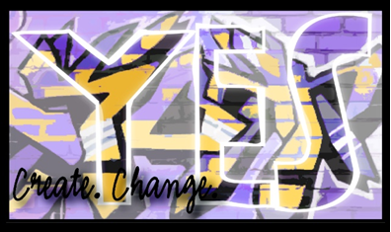  - May 4, 2022

Cording Ceremony  WELCOME!  Enjoy the music & refreshments  OPENING REMARKS  Dr. Hannah Ashley, Director, Rustin Urban Community Change Axis, Professor, Community Change Studies, English  FACULTY SPEAKER  Dr. Laquana Cooke, Associate Professor, Community Change Studies, English, Digital Humanities  PRESENTATION OF HONOR CORDS  Graduates will have honor cords laid on them by either YES faculty or one or two people from their personal, school or professional lives. Those individuals will have the opportunity to say a brief word of private commendation, a wish, a blessing or intention to the graduate, to carry forward in their work and lives toward healing the world alongside young people and urban communities. |  |  | Ana Zavalamartinez, Spanish Education/YES   I will be graduating with a major in Spanish Education and a minor in YES. During my YES courses I felt free to vocalize my ideas and concerns about real world events, our society, and the youth. A quote from my YES program that resonated with me is, “'Knowledge is power.” As an educator I want to provide youth with the support, resources, and skills they need, to be agents of their own development. My goal is to use and share my knowledge and experiences to best teach the youth on how to use their voice as their power. I am proud to soon be a part of the small percentage of Latinas holding a bachelor's degree. I hope to further my education while also advocating for education in higher ed institutions to become more accessible for all.
 |  |  | 5

Brenna Holycross, Early Grades Education/YES  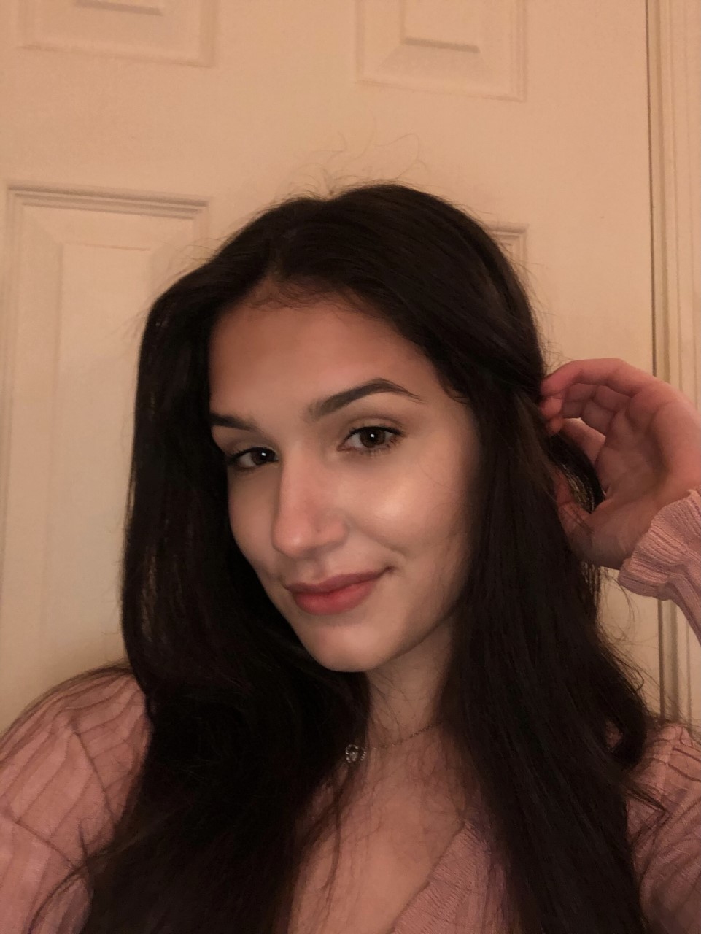 I will be graduating with a Bachelor of Science in Education for Early Grades degree, and a minor in Youth Empowerment and Urban Studies. The YES program made me more passionate about education. I learned that educators must implement pedagogy that helps and empowers youth to dismantle the systems that are harming everyone. Education can help us free each other. Following graduation, I hope to become an elementary school teacher in an urban school district. I am so thankful for the YES Program because it shaped me into the educator I am today.  Brielle Ridgeway, Interdisciplinary Studies/YES/WGS  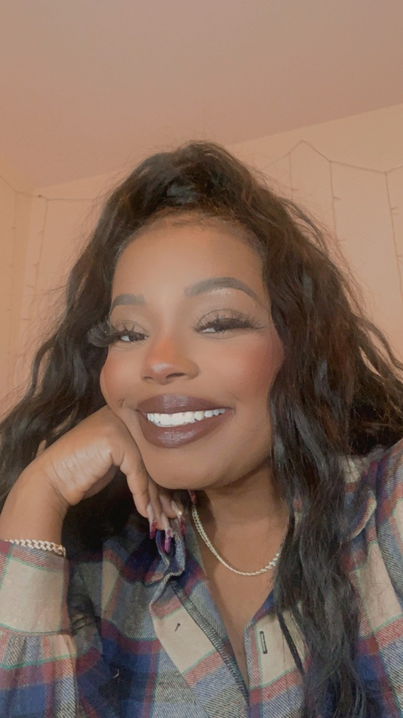 YES to me was a space where I met faculty that were doing youth work in very unique and exciting ways I had never before thought about. I am thrilled to be leaving WCU supplied with the skill set this program has provided me with. |  |  | Keyirah Bortley, Psychology/YES  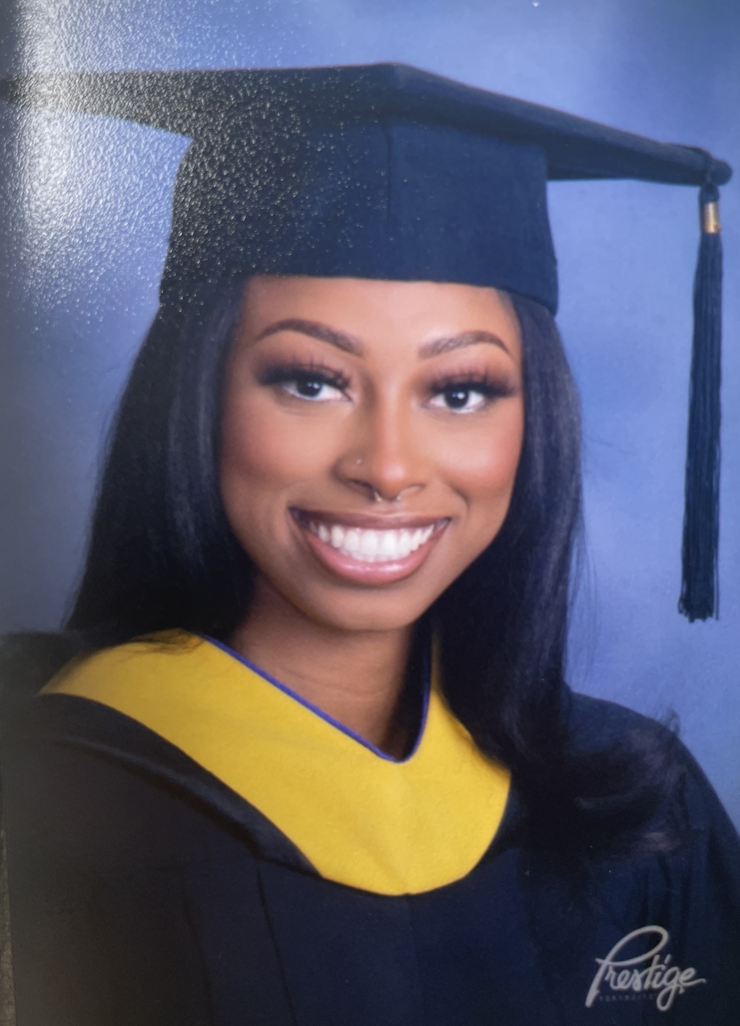 The process as an undergrad is anything but easy. There are plenty of times I just wanted to give up, especially once COVID hit in 2019. But it’s important to remain disciplined and resilient no matter what life may throw your way. The YES program has taught me a lot about the struggle and never giving up. This program means so much to me and has shaped me into a better person, facilitator, and activist for change. I intend to help within my community, probably starting off as a school counselor, as I plan to go back and earn my master’s degree. Here’s to the class of 2022! Stop at nothing to leave your mark on this world!  Grace Soldacki, Anthropology/YES/LAS/GS   I have really enjoyed the YES minor as well as the professors and their passion for advocacy. The passion I have witnessed during their classes is actually why I decided to minor in YES. I was inspired by the way our readings and lectures spoke of youth empowerment and how important it is to listen to and lift youths' voices for social justice and change. I am not sure exactly what I am doing post-grad, but I would like to travel during the summer and just experience different cultures and meet new people! I hope with new experiences and perspectives, it will help broaden my understanding of social justice issues and how to make an intentional and positive impact for change whether it be getting a job right away or going back to school!
4 |  |  | 1

Nia Stevenson, Political Science/YES  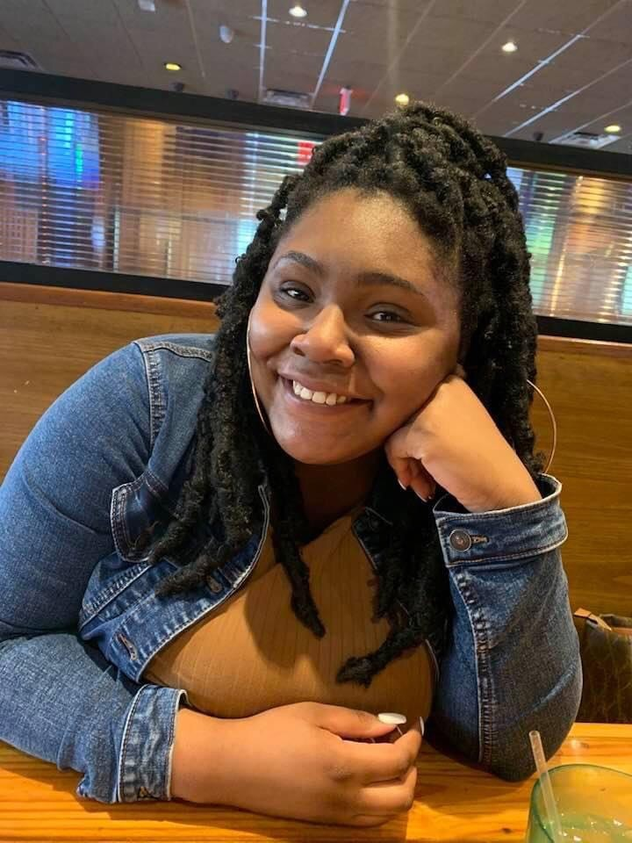 To empower youth to be unapologetically authentic and real is something I grew up with as well as something I want to help and pass down to others. The YES minor and RUX major allow that to happen! Between internships and the tools learned in the classrooms, I have learned so much about the real meaning of inclusivity and what it means to truly be a vessel for youth. You can only be who God called you to be on this earth, so there is no reason to hide that and dim your light and I want to encourage youth to do that. When I graduate, I plan on continuing my education by getting my masters in secondary education to eventually start teaching social studies/government in the classrooms.  Taylor Enterline, Criminal Justice/YES/WGS  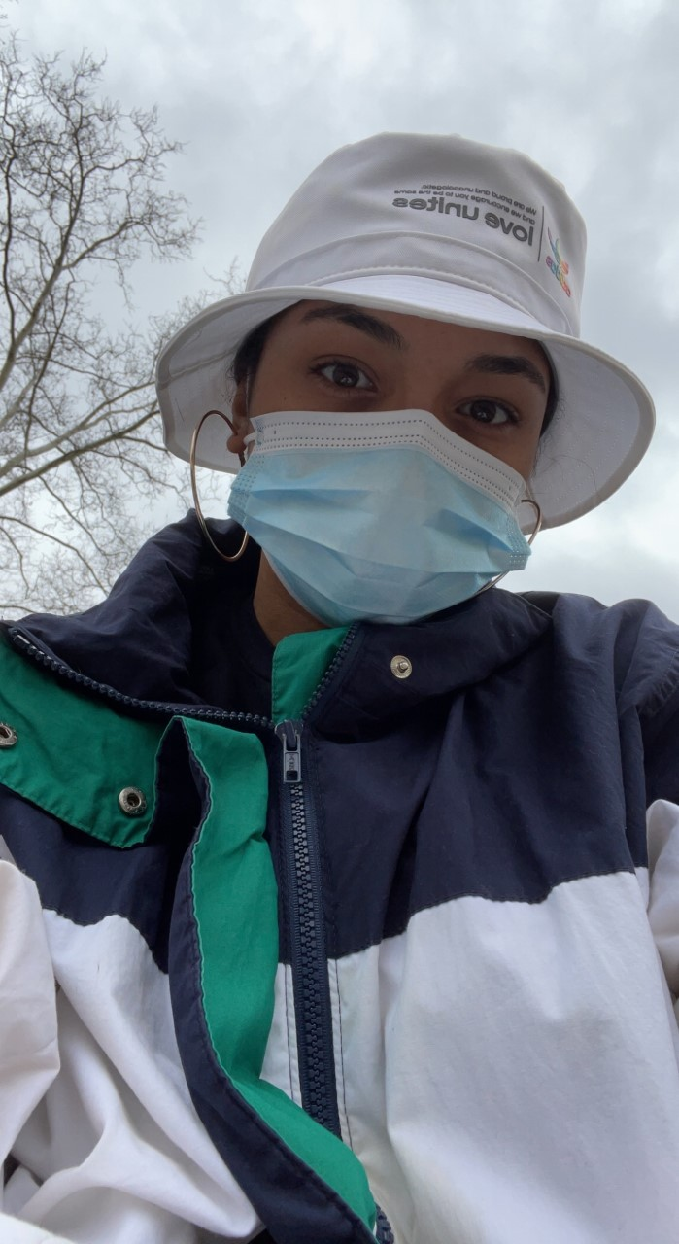 As I walked into the YES office freshman year, I was eager and unaware of the door I had opened for myself. The YES program has helped lift the veil that had been placed on so many of our eyes to hide the injustices in the world. I have formed relationships, mentorships, and security within myself to become and be an angelic guide to troublemakers. May we all find ourselves in good trouble as we embark on this next journey of our lives in creating real change. |  |  | Bailey Karst, Music Ed/YES  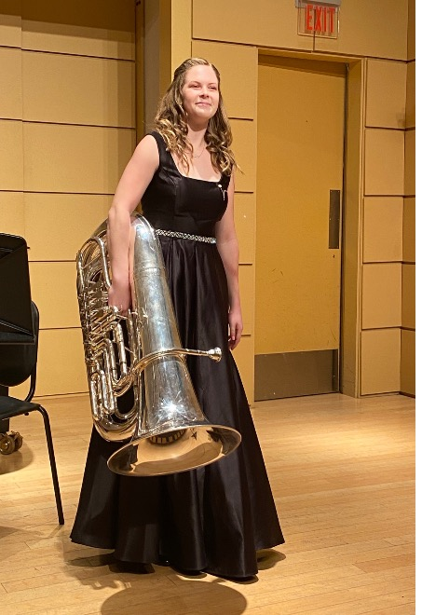 The YES program, to me, means hope for the future. I want a better future for our youth than I had, and I want the youth that I work with to know that they have so much power to make change. They have so much more power than they know, and it is our job as teachers, parents, and social workers to show them that they have that power through our work with them. The YES program has taught me that I will never stop learning from my students and young people. My plans for after graduation are to continue my education and get a master’s in social work degree and eventually a Ed. D., but who knows where life will take me! You can always plan, but life might take you off of that. Taking life moment by moment is a big philosophy of mine, so nothing is ever set in stone.  Jamilah Woodards, Marketing/YES/BL  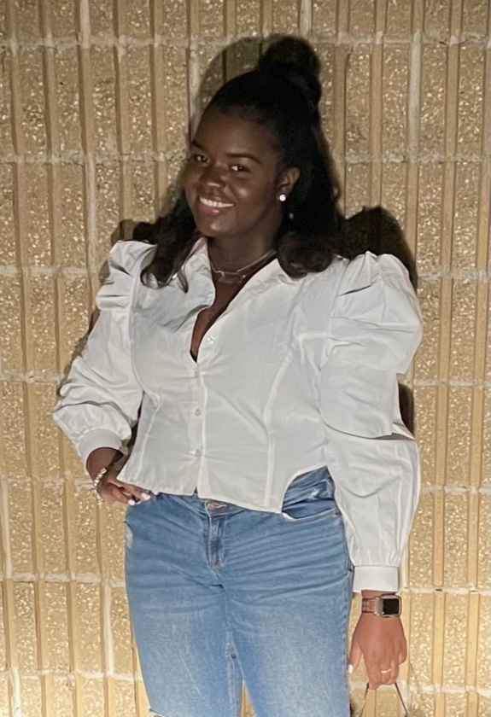 In Spring of 2019, I enrolled in a pop culture writing course taught by one of my favorite professors, Dr. Hall. He encouraged us to think critically and analyze information beyond surface level. After turning in a memoir, I was heavily encouraged to join the YES minor. The program grew to be a comfortable space to discuss the challenges that impact the very place I grew up in and the people who live there. As students, we were able to go out into the world and take action. The YES program allowed me to find solace in the fact that there are people in higher education who truly care about our urban youth. I know for certain everyone can find something greater within the program, and glad that I've gained this experience the past few years.
2 |  |  | 3

