History of Poverty and Homelessness
HIS 397/9
TTH 1pm-5pm
Wayne Hall 104C

*Credits count towards US, Europe, and World History

The History of Poverty and Homelessness will offer an examination of the diverse societal perceptions of homelessness and poverty, and how those perceptions have shifted over time and across distance. Students will also study changes in government policy and how changing policy has affected people experiencing homelessness. It is the intention of this course to provide a framework for understanding the root causes of the expansion of homelessness in the U.S., and to convey a sense of the experience of homelessness and its consequences. To that effect, we will be examining issues surrounding poverty, specifically: race, labor, prison, education, and housing. There will be exploration of the current efforts to meet the immediate needs of the homeless in the US and internationally. The course will empower students to advocate for sustainable changes which can prevent homelessness. Students will glean a deeper understanding of homelessness through readings and class discussions, and optionally through interacting with people who are experiencing homelessness at the Student-Run Emergency Housing Unit of Philadelphia.

Stephanie Sena is a history professor in Villanova University’s Center for Peace and Justice. She is the recipient of The Pohlhaus-Stracciolini Award for Teaching Excellence is presented to an adjunct faculty member who demonstrates a commitment to the life of the mind and to the well-being of students through teaching that is intellectually stimulating, challenging, and accessible, with efforts extending beyond the classroom. Stephanie founded SREHUP- The Student-Run Emergency Housing Unit of Philadelphia in 2011 with a group of Villanovans that wanted to make a difference. The shelter now has over 300 volunteers from over 8 university chapters, houses hundreds of people, and is opening the first pet-friendly shelter on the East Coast. Stephanie travels all over the country and world to learn best practices in fighting poverty. She fights tirelessly to end homelessness in Philadelphia, and makes her world famous Matzah Ball Soup for ardent SREHUP supporters.
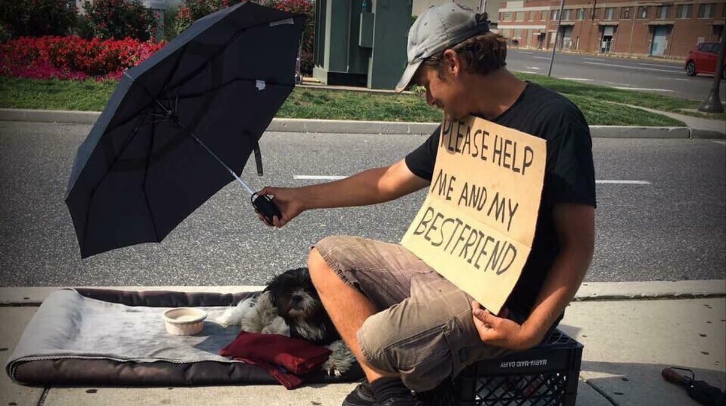

This Student-Run Philadelphia Shelter Wants to ... - Impact
impact.vice.com
At this shelter, the lives of the people experiencing homelessness matter.

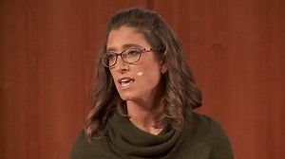

Igniting the social justice generation | Stephanie Sena | TEDxVillanovaU
www.youtube.com
The Social Justice Generation is a talk about the power of engaging the youth of America is the work of ending chronic homelessness. Speaker Stephanie Sena has been ...

