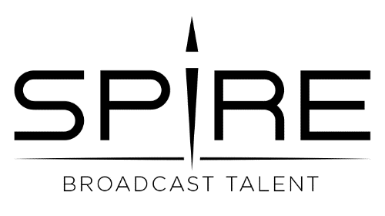

Social Marketing and Operations Intern
Spire Broadcast Talent is seeking a Marketing and Operations Intern.
The primary responsibilities of this position are to expand and maintain the Marketing/Social Media presence of Spire Broadcast talent across multiple platforms and manage ongoing operational processes critical to business continuity.
This is a paid internship at a rate of $10 per/hour. This is a 3-credit, 180-hour internship. The position timeframe is TBD
Principle Duties and Responsibilities:
- Meet virtually with the founders of Spire Broadcast Talent to outline the scope of the project, discuss next steps and set up dates to connect throughout the semester
- Develop and execute a social marketing plan and calendar customized to each social media platform: Instagram, LinkedIn, Facebook
- Create, source and deliver content to increase company collections/followers, attract and promote talent and build online client connections
- Learn and manage operational duties as assigned, including contract management, talent management, accounting and more
- Report status/growth/next steps weekly

Qualifications:
- Marketing or Business Management Major/Minor or Entrepreneurship Minor
- Proficiency in Social Media platforms, Word and Excel a must
- Demonstrated ability to create content
- Strong self-starter and creative thinker
- Excellent written communication skills
- Marketing and entrepreneurship education and/or experience
- Experience a plus

