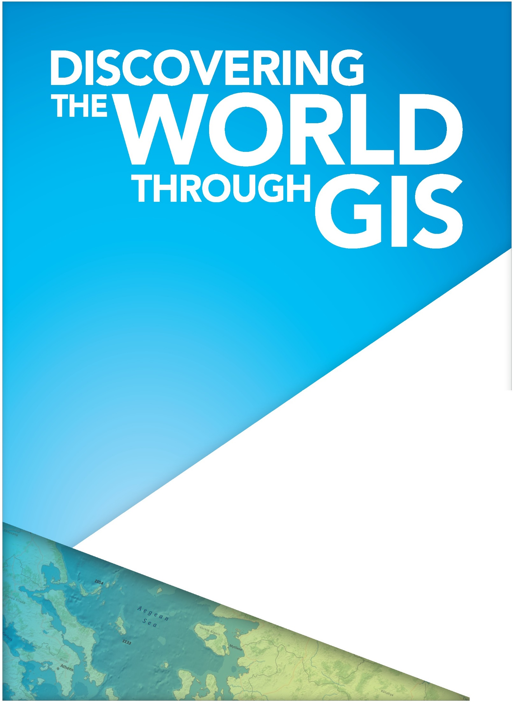

11-12:30pm **Brian Ivey WCU ‘93**

GIS Manager, City of Philadelphia

Talk and Reception

Sykes, Ballroom A

3-4:30pm **GeoScavenge 2016**

Meet on the Quad

GISday

Wednesday, Nov. 16