**CAPC Request: Ethics-Emphasis Course Design Website Information**

**Best Practices**

Getting Started

1. Getting starting is often the hardest part of building a syllabus. Here are some best practices for getting started:
   1. Identify key areas/topics of the course material that raise ethical issues.
   2. Talk to other faculty in and outside of your field to get ideas!
   3. Think of appropriate times in the course in which providing instruction on discipline-specific ethical thinking would be beneficial to your students and the class discussions. Early on, revisiting in the middle, culminating activities/projects. (I.e., what are the ethical questions that are peculiar to your discipline, e.g., treatment of human subjects in social science and biomedical research; treatment of clients in the legal profession; honesty in scientific research; etc.)
   4. Research different types of assignments that seek to engage the class in discussing ethics, while providing guidance in identifying a range of perspectives and different arguments. Then customize for your class.
   5. Read the WCU Ethics-Emphasis Course handbook for guidance and examples.
2. As you are designing activities, build rubrics (or use the Ethics Rubric on the CAPC website) that explicitly state how student assignments or class discussions gauge the competency in ethics (for example, how to judge better and worse answers to an ethical problem). These rubrics can also be included in the CAPC submission.

**CAPC submission**

1. Using the Ethics Emphasis Course Criteria Checklist, describe in detail the specific activities and assignments included in your syllabus that meet the criteria in the checklist. This can be submitted as your narrative. By referencing what specific activities and assignments in your syllabus meet the checklist requirements, the reviewers will more readily be able to identify if your proposed course meets the Ethics Emphasis course standards.
2. It would be helpful if you provide a syllabus with comment bubbles used to connect the checklist criteria with the specifics of the syllabus. An example: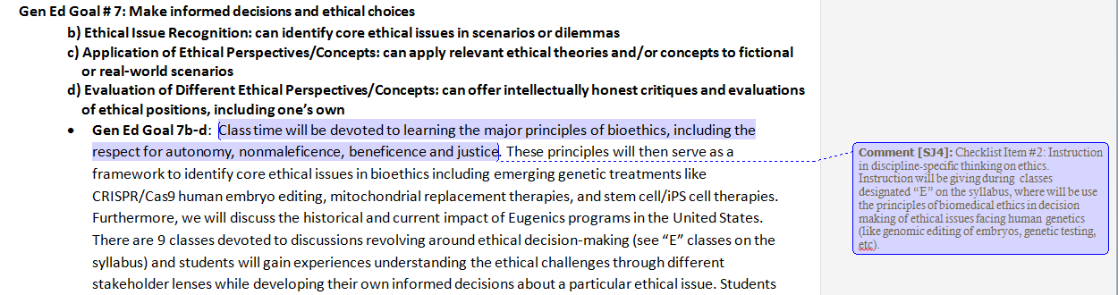
3. Re: required ePortfolio assignment, here’s what is currently being said on the CAPC homepage regarding whether ePortfolio assignments are a requirement: “Not immediately, but we will want to cultivate its use so that we're close to 100% (in Gen Ed courses) by around the 5-year mark. Many universities use electronic portfolios with successful results.”

**FAQs**

*Qualifications/Justification*

1. Am I qualified to teach an ethics-emphasis course?

* If you have been through WCU-led Faculty Seminar or Workshop on Ethics-Emphasis course design or had significant training in ethics in your background.

1. Why do we need Ethics-Emphasis courses? What is the ultimate goal for an E-emphasis course?

* A growing number of colleges and universities are implementing an “Ethics Across the Curriculum” (EAC) approach, e.g., Harvard, Dartmouth, Brandeis.
* Taking a coordinated approach that involves many aspects of university life, EAC recognizes that there are ethical questions and implications associated with all of the disciplines found in institutions of higher learning, and there are a host of approaches to ethics already embedded in many of these curricula. These more discipline-specific treatments of ethics are to be applauded and encouraged. However, in her article “Ethics Across the Curriculum” Nancy Matchett outlines a host of unintended and unfortunate consequences if these are left uncoordinated (*New Directions for Higher Education*, no. 142, Summer 2008).
  + There’s a tendency toward ethical relativism if all we see is more than one right answer in ethics, or that each discipline has their own codes of ethics.
  + There's a tendency to internalize a view of ethics as dependent on an external authority, whether that is an accrediting body, a student code of conduct, or a fiat on a syllabus, which can serve to discourage students from seeing ethical decision making as requiring critical reflection and examination or developing the skills necessary to do so.
  + Finally, we should guard against communicating that ethical reflection is somehow less important than the more “objective” accomplishments related to the particular “content” of a given class.

1. Do students need any prior ethics courses to enroll in an ethics-emphasis course?

* No. But we do hope they have more than one opportunity to ponder the ethical questions related to their life and chosen careers.

*Grading/Assignments*

1. How can I ensure I’m not grading the students on ethics in a subjective way?

* The Ethical Thinking [rubric](https://www.wcupa.edu/viceProvost/capc/documents/2016EthicalReasoningFinalVALUERubric.pdf) available on the CAPC homepage illustrates a way of grading that highlights structure and complexity rather than content.
* The Ethics-Emphasis Handbook list a variety of resources. The Workshops and Seminars D2L site offers additional links. Many of these links offer discipline-specific case studies and instructional tools.
* You might share the Ethical Thinking Value [Rubric](https://www.wcupa.edu/viceProvost/capc/documents/2016EthicalReasoningFinalVALUERubric.pdf) with your students. The Case Study Method explored in the Workshops/Seminars is a robust way to encourage thinking and makes grading obvious and fair.

1. How do I design a really effective course activity or assignment?

* The Workshops and Seminars provide a variety of examples. The handbook also offers some suggestions.

1. What are the basic elements that go into an effective course activity or assignment?

* The literature suggests a combination of different approaches is most fruitful. Students should be given an opportunity to 1) talk out loud, freely discuss, air opinions and hear others’ perspectives; and 2) deliberate and analyze in writing (case study/stakeholder method is known to be particularly fruitful here; writing projects that require an analysis of the ethical aspects of a particular case). Role-playing can be effective; in-class debates; journaling; putting oneself in another’s shoes, practicing seeing from another’s perspective, taking on the side of the debate you least agree with, are all productive ways of engaging effectively with ethical decision-making.

*CAPC Criteria*

1. What has to be in my course to get it through the CAPC approval process?

* Please see the Ethics Criteria Checklist tab.

1. Can particular content and/or activities meet both the ethics requirement (25% of the course) and other student learning outcomes?

* That’s the goal. Ethical deliberation and discipline-specific outcomes *should* go hand-in-hand.

1. Can ethics-emphasis work in large lecture classes?

* The data is sparse on the effectiveness of teaching ethics in large lecture classes.

1. What do you mean by “better and worse answers” in the ethics criteria list? And, how can I communicate to my students that ethics is NOT “anything goes”?

* See answers to #2 and #3 above
* The intention of an ethics-emphasis course is to expose students to a variety of logical, analytical tools for ethical deliberation with the goal of expanding their awareness of the best options for that deliberation. Moral psychologist James Rest argues that there are four components necessary for making ethical choices (e.g., Rest, 1984; Rest, Narvaez, Bebeau, & Thoma, 1999). First, we must have an awareness of a given situation as moral or not moral (*moral sensitivity*). Second, we have to be able to critically deliberate about our options (*moral judgment*). Third, we have to have the incentive to follow through on the option we identify as the best (*moral motivation*). And, lastly, we have to act and that requires the development of character traits like perseverance, or moral backbone (*moral character*). Our courses will be most productive in doing the first and second.