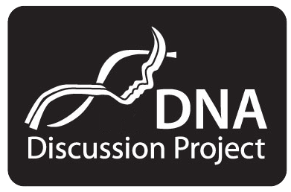

**WEST CHESTER UNIVERSITY 2015**

**INFORMED CONSENT FORM**

This project has been reviewed and approved by the West Chester Institutional Research Review Committee's Human Subjects Subcommittee (HSS). The HSS believes that the research procedures adequately safeguard the subject's privacy, welfare, civil liberties, and rights. The HSS Chairperson may be reached through the Director of Sponsored Research, West Chester University, West Chester, PA 19383 or, by telephone, (610) 436-3310.

## **ONE ANCESTRY, ONE UNIVERSITY: USING ANCESTRY DNA TO SUPPORT A DIVERSE COMMUNITY**

I understand that:

1. The nature and purpose of the project is to explore and record the relationship between family lore related to race/ethnicity and ancestry DNA generated data.

2. The procedures take place over an approximately 6-week period, during which time participants:

1. are given consent and withdrawal forms,
2. are pre-interviewed (in person or written format) for approximately one hour using an interview protocol as a
3. guide,
4. receive a saliva collection kit and fill out an associated release,
5. mail in kits (supervised by investigators),
6. receive profiles from the Principal Investigator (who will receive all results—all results are ancestry related),
7. are photographed (or provide a high quality photograph),
8. are post-interviewed (face to face or in written form) for approximately one hour.

3. No invasive medical procedures are involved in this research project.

4. The central discomfort and risk associated with this project is that a participant might find some unexpected ancestry information. This could be upsetting. In such a case, the participant is encouraged to seek services of the University Counseling Center if the participant is a student. Otherwise, the individual should seek counseling at his or her own expense.

5. The primary benefit associated with this program is its importance for exploring issues of racial identity in a country where race has been a central point of conflict. Finding our human commonality has the potential of changing the conversation about race in America and beyond, which benefits everyone.

6. Participants are not promised confidentiality in regard to their photographic images and associated ancestry profiles. If a participant decides to withdraw from the project, they should contact the Principal Investigator to request removal, and all materials will be removed from public project presentations. All project information is stored in the office of the two project investigators and they alone have access to that information. The Consent Form and the Withdrawal Form are also stored in the office of the Principal Investigator.

7. No compensation is offered for participation. All participants are invited to read materials that are published based on the research project.

In signing this document, I confirm that my participation is entirely voluntary. No coercion of any kind has been used to obtain my cooperation.

Should I have any research-related inquiry the name of the person to contact is

*Principal Investigator, Anita Foeman, Ph.D.*

*Department of Communication Studies*

*College of Arts and Sciences, 508 Main Hall*

*610 436-2283*

*I wish to give my voluntary cooperation as a participant.*

*______________________ ___________________________ __________________________*

*Subject Signature Print Name Date*

*Address/Contact information:*

*____________________________________________________________________________*

*____________________________________________________________________________*

*1 Adopted from L. F. Locke and W. W. Spirduso. Proposals that work., New York; Teachers College, Columbia University, 1976, p. 237.*