FINAL REPORT

Date: April 3, 2010

Report Period: December 18, 2008-January 15, 2010

Grant Project Period:

Grant Recipient: West Chester University of Pennsylvania

Grant Number: 09-DG-114200004-028

Recipient Contact Person: Dr Linda Lamwers

Principal Investigator/Project Director: Gerard D. Hertel

Progress Achieved in Accomplishing Project Goals & Objectives (Goals and objectives should correspond to the goals and objectives in the approved grant application/narrative).

Goal/Objective 1-8 -see attachment #I- Grant Components & Activity Schedule

Difficulties Encountered

Goal/Objective #: 1-8

Problem(s): we shut things down when it seemed that no funds would be available because of funds being used for fires. It took longer than expected to get back on schedule

Resolution/Corrective Action Plan and Schedule:-extension approved

Signature of Authorized Official

____________________________________Date___________________

I. Grant Components & Activity Schedule

Component | Sub components | status
18 forest health monitoring plots-trees  1 a | Finalize baseline data base | Completed 5/09
18 forest health monitoring plots-trees  1 a | Re-measure plots (dbh, mortality, saplings & seedlings) | Completed 8/09
18 forest health monitoring plots-trees  1 a | Add new data to data base | Completed 8/09
18 forest health monitoring plots-trees  1 a | One page summary for public on web site | 11/09
18 forest health monitoring plots-trees  1 a | publication | 12/09 (Appendix A)
18 forest health monitoring plots-trees  1 a | Data on Gordon Area web page | 10/09
18 plots-all other vegetation  1 b | Popular summary on web site | 10/09
18 plots-all other vegetation  1 b | Data base on web site | 9/09
Deer/invasive plants demo area  2 | signs | Completed 6/09  (Appendix B)
Deer/invasive plants demo area  2 | brochure | 1/10  (Appendix C)
Deer population estimate & management plan  4 | Public meeting/contacts | 10/09
Deer population estimate & management plan  4 | Management plan | 12/09
Forest restoration project  6 | Remove all invasives | 10/09
Forest restoration project  6 | Popular brochure on web site | 11/09
Forest restoration project  6 | Purchase more trees | 9/09
Forest restoration project  6 | Data base on web | 9/09
Forest restoration project  6 | signs | Completed 6/09
Protect areas with rare & endangered plants based on 2007 botanical survey  8 | Contract botanist | Field work 9/09
 | Materials  purchased | 11/09  (put up 4/10)

Components from grant narrative in red bold

Narrative:
Components:

- invasive trees: forest health monitoring plots-18
  - trees only (funded by WCU)-2001-2

These plots contain the primary invasive tree species-Norway maple, tree-of-heaven and black locust-found in the area as will as the primary native upland, flood plain and old farm field species. The five year re-measurement of these plots will allow forest ecologists to better grasp the trends and make better management decisions. Popular one-page summaries will be distributed and posted on the Gordon Natural Area website.

Clean up and finalize on-line baseline data from 18 plots -completed
Re-measure plots-completed
Add new data to data base-completed
Prepare one page summary for public-completed
Prepare journal article, publish & reprints-only rough daft prepared (Appendix A)
Put all data and one-pager on-line

  - all other vegetation (funded by USFS & WCU)-2004

Invasive herbs, vines and shrubs continue to take over many of the habitats and the rate must be determined and reported so more aggressive actions can be recommended and taken. Popular summaries of the baseline data will be prepared and the data base will be made public on our web page - completed

- Invasive plants/deer interaction Demonstration Areas-3 (funded by DCNR & WCU)-2007

DCNR funding has allowed for the establishment of the demonstration site(s) and for initial measurements and treatments to be made. Support is needed for technology transfer and maintaining site for two more years. Implement interpretation plan that includes kiosk, signage and brochures - completed

- Garlic mustard mycorrhizal laboratory study (funded by Center for Invasive Plant Management, Bozeman, MT)-2007 - completed

- Deer population estimation (funded by WCU)

A cooperative agreement with USDA-APHIS is in development and will utilize bait station/cameras to estimate deer populations in the area. These estimates will allow us to prepare a management approach to manage our deer population and thus promote native plant biodiversity. Sponsor public meeting based on these data and prepare deer management plan. Deer management plan prepared but decision was made in consultation with PA Fish and game and Environmental Resources Management to not implement a hunting program. We will seek funds through the ERM Foundation to construct five acre + deer exclosures

- Biological Control Demonstration Areas
  - tree-of- heaven (Penn State) (cancelled until 2009)
  - mile-a- minute (University Delaware) (weevils released 8/09)

- Forest restoration project (funded by WCU & Tree Vitalize)-2008

First phase of planting completed by May 9, 2008. Tree diameters and heights collected and put into data base by July 2008. All garlic mustard and vines removed from restoration area signage and popular publications prepared . Purchased trees with FS funds. Tree Vitalize (AQUAPA) funds received 3/10 to purchase 80 more trees.

- Classroom laboratory practical’s

  - carbon storage (GIS field methods)-Dr Fristchle
  - Amur honeysuckle (population dynamics)-Dr fairchild
  - garlic mustard (ecology)-Dr Tiebiut

- Botantical Survey of the Gordon Natural Area-2007 (funded by WCU)
  - Protect area with greatest biodiversity and keep it free of non-native invasive plants-on web page. Fences put up in April 2010.

Other: credit to USDA Forest Service for supporting Gordon Natural Area web site on home page. www.gordonarea.org –see Special announcements

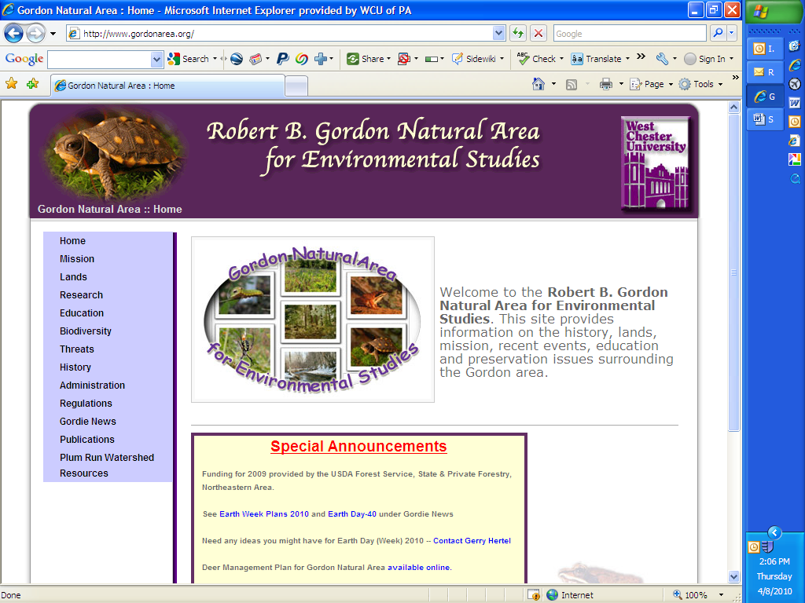
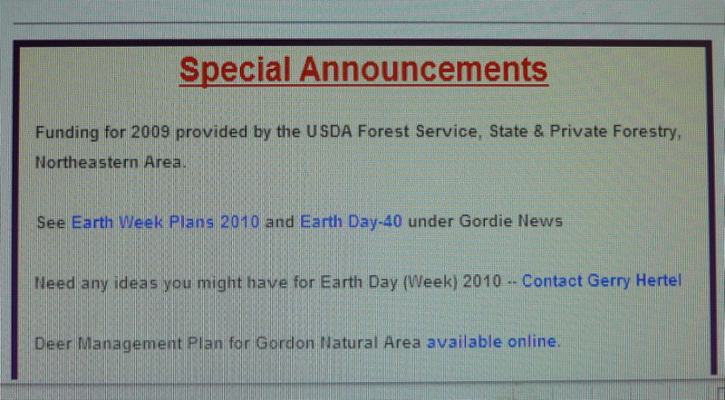

Appendix A.

Analysis of Forest Health in the Robert B. Gordon Natural Area,
West Chester University, Chester County Pennsylvania (2001/2-2009)

Carly Nagle
Gerard Hertel

Purpose, background, intro etc….
- GNA history,background….Study model info….Plot descriptions, data collection methods…
Ex: Trees 5 inches or higher in dbh were counted in 2002, 2003, or 2004, and served as year one (baseline) data. The same trees were evaluated in 2008, year two, for size measurements and status (dead or alive).

Analysis: Trees 5 inches or higher in dbh
In the first year of monitoring, Red maple and White ash were the two most common trees, accounting for 37% of all trees in the study area, and 36% of all live trees. Other significantly numbered species included Tulip poplar, American beech, Norway maple, Tree-of-heaven, Locust, Black cherry, Box elder, Red oak, and Basswood (Table 1, Fig 1).

Table 1. Year one trees >5in dbh
Species | # Alive | # Dead | % of Total live trees
Red maple | 73 | 5 | 18.8
White ash | 66 | 7 | 17.0
Tulip poplar | 47 | 0 | 12.1
American beech | 27 | 0 | 7.0
Norway maple | 27 | 0 | 7.0
Black cherry | 24 | 2 | 6.2
Locust | 22 | 2 | 5.7
Tree-of-heaven | 19 | 0 | 4.9
Box elder | 18 | 0 | 4.6
Red oak | 15 | 2 | 3.9
Basswood | 11 | 1 | 2.8
White pine | 7 | 1 | 1.8
Paulownia | 6 | 0 | 1.5
Mockernut | 4 | 0 | 1.0
Walnut | 4 | 0 | 1.0
Black oak | 3 | 0 | 0.8
Shagbark | 3 | 0 | 0.8
Pignut | 2 | 0 | 0.5
Sugar maple | 2 | 0 | 0.5
Sycamore | 2 | 0 | 0.5
Mulberry | 2 | 0 | 0.5
Willow | 2 | 1 | 0.5
Gum | 1 | 0 | 0.3
White oak | 1 | 0 | 0.3
Total | 388 | 21

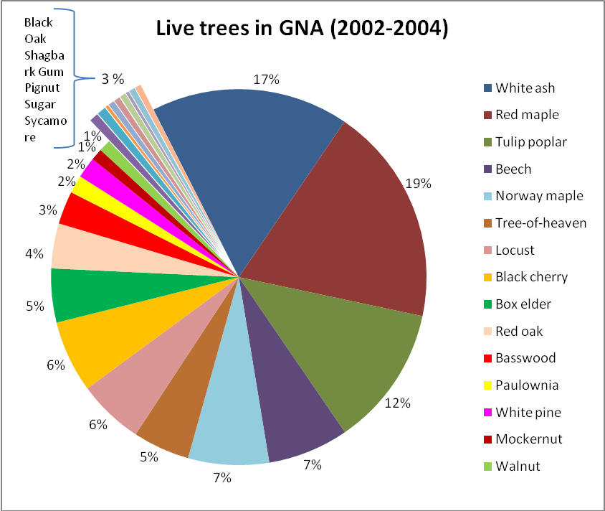
Fig 1. Proportions of species in entire study area, year one.

When re-evaluated in 2008, the relative amounts of each species did not change substantially. Again, Red maple and White ash accounted for about 37% of all trees, and 36% of all live trees (Table 2, Fig 2). Mulberry was eliminated, purposefully, from the study area which resulted in a 100% mortality rate. Willows and Sycamores experienced fairly high mortality rates as well at 67% and 50%, respectively (Fig 3).

Table 2. Year two trees >5in dbh
Species | # Alive | # Dead | % of Total live trees
Red maple | 65 | 13 | 18.3
White ash | 63 | 10 | 17.7
Tulip poplar | 45 | 2 | 12.6
American beech | 27 | 0 | 7.6
Norway maple | 25 | 2 | 7.0
Black cherry | 21 | 5 | 5.9
Tree-of-heaven | 19 | 2 | 5.3
Locust | 18 | 6 | 5.1
Box elder | 17 | 1 | 4.8
Red oak | 15 | 2 | 4.2
Basswood | 10 | 2 | 2.8
White pine | 6 | 2 | 1.7
Paulownia | 4 | 1 | 1.1
Mockernut | 4 | 0 | 1.1
Walnut | 4 | 0 | 1.1
Black oak | 3 | 0 | 0.8
Shagbark | 3 | 0 | 0.8
Pignut | 2 | 0 | 0.6
Sugar maple | 2 | 0 | 0.6
Gum | 1 | 0 | 0.3
Sycamore | 1 | 1 | 0.3
White oak | 1 | 0 | 0.3
Mulberry | 0 | 2 | 0.0
Willow | 0 | 3 | 0.0
Total | 356 | 54

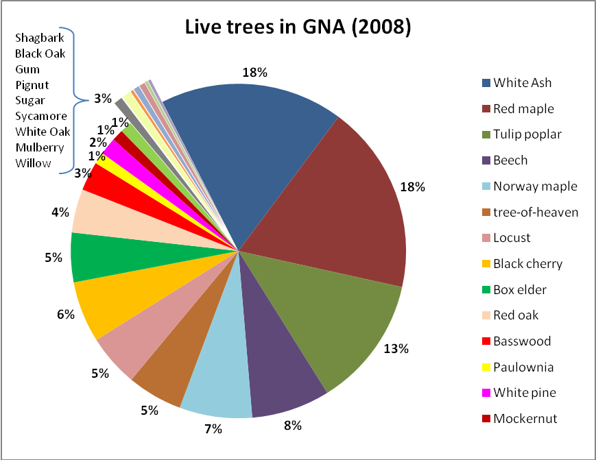
Fig 2. Proportions of species in entire study area, year two.

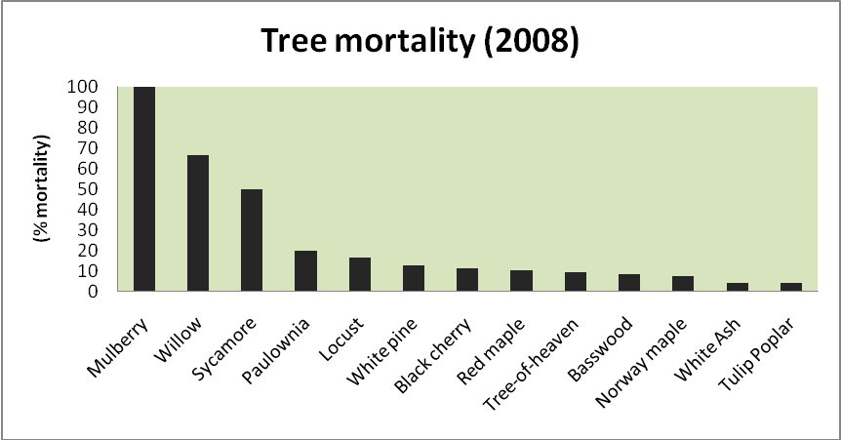
Fig 3.

Appendix B

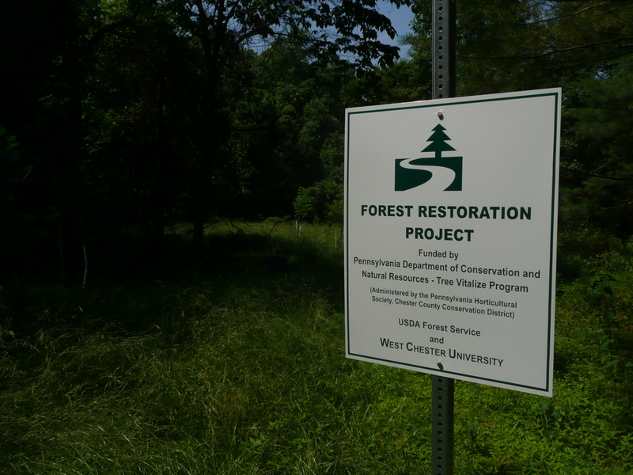
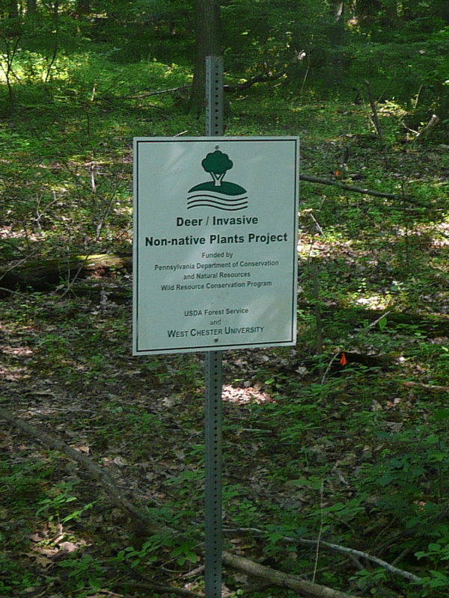

Appendix C

Tour the Gordon #1-late spring & summer
(last modified April 6, 2010)
(from kiosk to the Deer/Non-native Plant Species Demonstration and Restoration sites)
If there is any medical assistance needed during your walk dial 911 (tell them you are on Stadium Rd in the Gordon Natural Area) WCU security will also respond

- START: Welcome to the Gordon Natural Area for Environmental Studies. Dedicated in 1973 (WCU’s support of Earth Day) for the purpose of education, research & protection of biodiversity
Dedicated to those who helped make it happen & then to sustain it:
- Dr Bill Overlease, PhD, deceased, ecology professor (1963-1986)
- Bradley Gottfried, PhD, student at WCU in 1972, now (2010) President, College of Southern Maryland
- Board of Trustees: Mr Hilbush & Mrs Harney; both deceased
- Dr Harry Tiebout, facility administrator
- Sustainability Advisory Council
- Dr Don Barr, Dean
- Dr Lori Vermueulen, Dean
Funding provided by:
West Chester University
USDA Forest Service
Designed by:
Kendra McMillin, Biology 2012
Prepared by:
Gerard Hertel, Stewardship Manager

- Instructions: Please stand on road and look at the information kiosk

Benches (built as part of Eagle Scout project; awarded May 2009 to Grady Stevens)
Kiosk (built by WCU Carpentry Shop)
Sugar maple to the left- A product derived from this tree is maple syrup. Maple syrup is an important part of many agricultural economies in the Northeast. The earliest written accounts of maple sugaring were made in the early 1600s by European explorers who observed American Indians gathering maple sap.
Stream to right (East Branch of Plum Run; originates on WCU campus)-it drains the cleanest tributary in the Plum Run Watershed and in general is in better condition than Plum Run (originates in the Borough and WCU [daylights just south of WCU Parking Lot F on the corner of W. Nields & S. New St] and flows along 52 to the Brandywine). We are in the Plum Run Watershed and it is part of the Brandywine Valley Associations Red to Blue Stream Program.
The Flood Plain behind you is covered by the non-native tallow-flowered lesser celandine in April & May
Follow numbered wooden post on right side of road
(Look up the road and notice the closed canopy [the branches and leaves] over the road. The shade impedes the rapid development of most non-native plants and links the tree canopy (foliage) on both sides of the road. Plants & animals treat this connection as interior forest habitat. A wider public road would adversely effect the ecological services provided by the Gordon Natural Area (GNA).
#1.
This was the original road (Robbins Nest Lane-it stills shows up as open on Google map!) from High St to New St. The University built Stadium Rd in the late 1960’s for better assess from High St for football games and graduation. To your right at the edge of the road is a Pioneer elm planted 3/07. This is a hybrid Elm resistant to Dutch elm disease (that tree disease has pretty much wiped out the American elm in the USA).
The ground is covered (June-Sept) by Japanese stiltgrass (native to tropical Asia; thick mats & thatch prevent establishment of other plants) and in the back ground are hay-scented ferns (this unpalatable fern dominates areas over-browsed by deer in much of PA). Mile-a-minute vine is beginning to cover some of the fern. (An introduction of mile-a-minute somewhere between the late 1930s and 1946 to a nursery site in Stewartstown, York County, Pennsylvania produced a successful population of this plant. It is speculated that the seed was spread with Rhododendron stock. The owner of the nursery was interested in the plant and allowed it to reproduce; subsequent efforts to eradicate it were not successful. The distribution of mile-a-minute has radiated from the York County site into neighboring states. 55 years after its introduction, the range for this plant in the United States had extended as far as 300 miles (480 km) in several directions.)
A biological control agent (a weevil, Rhinocominus latipes Korotyaev) was released (400) in the GNA August 6, 2009 ( in cooperation with the University of Delaware) to supplement the existing population of weevils that have migrated in from other release sites in Chester Co
.
#2.
Basswood (native tree planted in 5/08) - The timber from this tree is soft, easily worked, and has very little grain, so it is a popular wood for model building and intricate carving. Ease of working and good acoustic properties also make it popular for electric guitar and bass bodies and wind instruments such as recorders. It is also the wood of choice for the window-blinds and shutters industries.
Look on the ground: Garlic mustard (native to Europe & introduced in 1868 as herb for cooking; effects tree root fungi associations) [the GNA has had an annual garlic mustard pulls since 2007] ; multifloral rose (introduced about 1886 from Asia & promoted between 1930-1940 by governmental agencies as living fence; soil stabilizer & wildlife food/cover) ; oriental bittersweet (native to Japan, Korea & Korea-introduced in 1860)[GNA volunteers cut all large vines in 2005/6 thus eliminating a local seed source]. These large vines were braking out the limbs of 60-80ft tall trees and providing infection courts for tree diseases. Their leaves can also cover the trees leaves thus affecting the trees ability to produce its own food. Vines can strangle small trees.
Long-bristled smart weed is native to Asia and occurs in disturbed habitats such as along roadsides and in pastures. It has the potential to invade shaded natural areas and out-compete other native species that thrive in moist, shaded habitats.

-Major trail to left-please obey the rules

#3

Old washed out (potential Grand Canyon of the GNA!) trail use to start here. As part of Eagle Scout project (Bryan Stevens made an Eagle Scout May 2007) it was closed and filled with forest debris in 2007.
Look on the ground:
Invasive plant-wineberry (native to Japan, Korea & China). Known as blackberry with purple hairs [stem has hairs & spines]. Leaves are white on the underside; introduced in 1890 as breeding stock for native berries; can grow into dense thickets & crowd out native plants. Use this common Asian fruit the same way you’d use commercial raspberries. They’re juicier and more sour, with more flavor than most of their relatives. The seeds are hard, so if you’re using the berries puréed, it’s better to strain them out.
Service berry –two trees closest to post with white stem protectors--The fruit of several species are excellent to eat raw, tasting like a slightly nutty blueberry, though their popularity with birds makes harvesting difficult. Fruit is harvested locally for pies and jams. The Native American food pemmican was flavored by shadbush fruits in combination with fat and dried meats, and the stems were made into arrow shafts. Several species are very popular ornamental shrubs, grown for their flowers, bark, and fall color. ( planted 5/08)

#4-all native trees here!

Hickories
Mockernut - Mockernuts are preferred mast for wildlife, particularly squirrels, which eat green nuts. Black bears, foxes, rabbits, beavers, and white-footed mice feed on the nuts, and sometimes the bark. The white-tailed deer browse on foliage and twigs and also feed on nuts. Hickory nuts are a minor source of food for ducks, quail, and turkey.
True hickories provide a very large portion of the high-grade hickory used by industry. Mockernut is used for lumber, pulpwood, charcoal, and other fuelwood products. Hickory species are preferred species for fuelwood consumption. Mockernut has the second highest heating value among the species of hickories. It can be used for veneer, but the low supply of logs of veneer quality is a limiting factor.
Mockernut hickory is used for tool handles requiring high shock resistance. It is used for ladder rungs, athletic goods, agricultural implements, dowels, gymnasium apparatus, poles, shafts, well pumps, and furniture. Lower grade lumber is used for pallets, blocking, and so on. Hickory sawdust, chips, and some solid wood are often used by packing companies to smoke meats, and mockernut is the preferred wood for smoking hams. Though mockernut kernels are edible, because of their size they are rarely eaten by humans.
shagbark -Shagbarks are easy to recognize because, as their name implies, they have shaggy bark. This character is however only found on mature trees. The nuts are edible with an excellent flavor, and are a popular food among those who know them. The trees bear too seldom for them to be grown commercially. Shagbark Hickory wood is used for smoking meat and for making the bows of Native Americans of the northern area. "Hickory" is derived from pawcohiccora, an Algonquin Indian word for the tree's oily nutmeat. The nuts were a food source for Native Americans

boxelder - It is still very common there, perhaps more so because it is well adapted to the many highly disturbed forests. It has also become a common invader of a wide variety of disturbed upland sites, including abandoned fields, open ground in cities, rights-of-way and fence rows. Where large populations are present in the area, seedlings can be found in nearly any habitat except for the wettest and driest
red maple -it is thought that the pre-European forest of eastern North America contained far fewer red maples than at present. Most diversity surveys conducted in eastern forests prior to their large scale exploitation showed the red maple representing under 5% of all tree species and it was furthermore mostly confined to poorly drained areas. The density of the tree in many of these areas has increased 6 to 7 fold and this trend seems to be continuing (the GNA contains @ 18%) . A series of disturbances to the oak and pine forests since European arrival, such as the suppression of forest fires and global warming, are most likely responsible for this phenomenon. Concern has been expressed, as the ongoing spread of the red maple is changing the nature of eastern forests by reducing the number of oaks and pines that would otherwise dominate.

#5

New trail exit constructed as part of Eagle Scout project in 2007
Red maple overhangs sign; up hill behind sign is a white oak & to its left a red oak (large poison ivy vine growing on this tree (Poison ivy-our favorite native plant! Research shows that this plant will grow with more vigor with higher levels of CO2)
.
#6

Burning bush (non-native) can invade a variety of disturbed habitats including forest edges, old fields, and roadsides. Birds readily disperse the seeds, allowing for many long dispersal events. Once established, it can form dense thickets that displace native vegetation. It is native to northeastern Asia and was first introduced into North America in the 1860s for ornamental purposes. It currently continues to be sold and planted as an ornamental or roadside hedge.
Black locust (non-native) directly overhead- Once introduced to an area, black locust expands readily into areas where their shade reduces competition from other (sun-loving) plants. Dense clones of locust create shaded islands with little ground vegetation. The large, fragrant blossoms of black locust compete with native plants for pollinating bees.

#7

Hog peanut- A native vine twining among other herbs and shrubs. Flowers of two kinds. Visible flowers pea-like but elongate, violet, and arranged in compact clusters, commonly hanging downward. Pods curved with 3 or 4 spotted beans. Second flower type without petals and located near the base of the plant producing a fleshy pod with a single seed. Leaves with 3 leaflets. Each leaflet broad with a pointed apex and a tapering base.

#8
Tulip poplar- Yellow-poplar is a pioneer species which means that it is one of the species that reestablishes itself after tree cutting & it has an extremely versatile wood with a multitude of uses. Most important recent uses of the wood have been for lumber for unexposed furniture parts and core stock, rotary-cut veneer for use as crossbands in construction of furniture parts, in plywood for backs and interior parts, and as pulpwood. Considerable attention is being given to its use as structural framing material and for veneers in structural plywood as a substitute for increasingly scarce softwoods. Another common name is canoewood & probably refers to the tree's use for construction of dugout canoes by Eastern Native Americans, for which its fine grain and large trunk size is eminently suited. Mature flower buds are a favorite food of squirrels. Flowers also produce copious nectar and are valued economically as source of a honey. Fruits mature into a cone-like aggregate of samaras. These seeds are food for squirrels, rabbits, mice, and many birds.
Norway maple-a non native invasive tree. Produces 1000’s of seeds that are windblown. This was a popular yard and street tree at one time. It can survive in the shade and few plants can grow under it. Norway maple is distinguished from other maples by the milky fluid that oozes
from freshly broken leaf petioles (stems)

#9

Spice bush- this is the most common understory shrub. It is abundant because deer will not eat it. They are very aromatic when crushed, hence the common names and the specific epithet "benzoin." The flowers grow in showy yellow clusters that appear in early spring, before the leaves begin to grow. The fruit is a berrylike red drupe about 1 cm long and is highly prized by birds. It has a peppery taste and scent, and contains a large seed. Spicebush is a favorite food plant of two handsome lepidopterous insects: the Spicebush Swallowtail Papilio troilus, and the Promethea Silkmoth, Callosamia promethea. The larvae of the Spicebush Swallowtail are easily found inside leaves that have been folded over by the application of silk; small larvae are brown, resembling bird droppings, mature larvae are green, with eyespots resembling the head of a snake.
living organisms on the rock:
There are 2 genera of mosses on the rock; both are pleurocarps (highly branched and creeping on the substrate). One is very dark green-blackish in color. It is Hedwigia ciliata, a very common moss on dry rock. It is rather easily identified by the white tips on the leaves (need a hand lens to see this, of course). The other is the more “stringy” green moss is Platygyrium repens. It is rare to find Platygyrium on rock as it typically is a “weed” on bark at the base of trees. As a result, this specimen of Platygyrium is much more slender than is typical for the genus. If you look closely at the tips of some branches, however, you may see one of the identifying features of the genus – tiny plantlets (called brood bodies).
The lichens on the rock are both crustose lichens.

Decaying trees that fell over-these trees are becoming part of the natural nutrient cycling of a forest. An assortment of insects and microorganisms are involved. One negative is that CO2 is released back into the atmosphere. In a deer-free forest tree falling would open the way for native tree seedlings to fill the gap. In the GNA though we will get an assortment of non-native plants

#10

Another large patch of wineberry

#11

Best view of upland forest-if there we fewer deer you could not see 50 ft into the forest
Dogwood-The word dogwood comes from dagwood, from the use of the slender stems of very hard wood for making 'dags' (daggers, skewers). The wood was also highly prized for making loom shuttles, arrows, tool handles, and other small items that required a very hard and strong wood. It is possible that the common name of Dogwood may have come because “dogs were washed with a brew of its bark, hence Dogwood.” Others have suggested that the name might reflect the perception that the scent of fresh-cut dogwood resembles that of dog feces. Dogwood is almost gone from the GNA because of a tree pathogen, dogwood antrachnose.
Right-black oak-Black oak acorns are an important food for squirrels, white-tail deer, mice, voles, turkeys, and other birds (11). In Illinois, fox squirrels have been observed feeding on black oak catkins (14). Black oak is not extensively planted as an ornamental, but its fall color contributes greatly to the esthetic value of oak forests. The bark of this species is rich in tannins and was once an important source of these chemicals used for tanning leather. (The yellow dye obtained from the bark is also called quercitron.).Native Americans used black oak medicinally for indigestion, chronic dysentery, mouth sores, chills and fevers, chapped skin, hoarseness, milky urine, lung trouble, sore eyes, and as a tonic, an antiseptic, and an emetic
#12

Right-red oaks-Northern red oak is an important source of hardwood lumber. Its wood is heavy, hard, strong, coarse-grained, and at least moderately durable. Northern red oak has a high fuel value and is an excellent firewood . White-tailed deer commonly browse leaves and young seedlings. Acorns of the northern red oak are an important food source the bobwhite, red-headed woodpecker, red-bellied woodpecker, blue jay, tufted titmouse, grackle, white-breasted nuthatch, sapsuckers, quail, ruffed grouse, and other birds. Probably 500 insect species utilize the leaves, buds and acorns.

#13

#14

Witch hazel
- The name Witch has its origins in Middle English wiche, from the Old English wice, meaning "pliant" or "bendable".^{[3]} Hazel is derived from the use of the twigs as divining rods, just as hazel twigs were used in England.
- The bark and leaves are astringent; the extract, also referred to as witch hazel, is used medicinally. Extracts from its bark and leaves are used in aftershave lotions and lotions for treating bruises and insect bites. Witch-hazel is the active ingredient in many hemorrhoid medications. It is also a common treatment for postpartum tearing of the perineum. The seeds contain a quantity of oil and are edible.
#15

Left-two large Princess trees; native to China are across the road
The leaves make a nice tea & flowers are edible _add to salads
In China, an old custom is to plant an Empress Tree when a baby girl is born. The fast-growing tree matures when she does. When she is eligible for marriage the tree is cut down and carved into wooden articles for her dowry. Carving the wood of Paulownia is an art form in Japan and China.

Tree of heaven- was first introduced to America by a gardener in Philadelphia, PA, in 1784, and by 1840 was commonly available from nurseries. The species was also brought into California mainly by the Chinese who came to California during the gold rush in the mid-1800s. Today it is frequently found in abandoned mining sites there. The history of ailanthus in China is as old as the written language of the country. Tree-of-heaven is a fast-growing tree and a prolific seeder, that can take over sites, replacing native plants and forming dense thickets. Ailanthus also produces chemicals that prevent the establishment of other plant species nearby. Tree-of-heaven, also known ailanthus, Chinese sumac, and stinking shumac. Mature trees can reach 80 feet in height. Ailanthus has smooth stems with pale gray bark. All parts of the tree, especially the leaves and flowers, have a nutty or burned nut odor.

#16
American beech- is a shade-tolerant species, favoring the shade more than other trees, commonly found in forests in the final stage of succession. Like the European Beech bark, the American beech bark is an attraction for vandals who carve names, dates, and other material into it. One such tree in Louisville, Kentucky, in what is now the southern part of Iroquois Park, bore the legend "D. Boone kilt a bar" and the year in the late 1700s. The mast (crop of nuts) from American beech provides food for numerous species of animals. Among vertebrates alone, these include ruffed grouse, wild turkeys, raccoons, red/gray foxes, white tail deer, rabbits, squirrels, opossums, pheasants, black bears, and porcupines. Beech nuts were one of the primary foods of the now-extinct passenger pigeon, and the clearing of beech and oak forests are pointed to as one of the major factors that may have contributed to the bird's extinction. Beech bark disease has become a major killer of beeches and if it reaches here will have a significant impact on this forest
#17

Left-grape vines-peeling bark
Trails-created by mountain bikes; mountain bikes are not allowed in the Gordon Area; they have increased the length of trails by 3X and thus have impacted biodiversity
Privet near post; large American beech on left of trail & Norway maple on right

#18 (skip to 20)

Go east on road to #19 or
Turn right (see project sign-Deer/Non-native Plants Demo) & walk about (@215 steps) to deer exclosures (see Welcome to the Demonstration Site)
Note the large American beech on the right side of the trail; do not carve your initials in there trees and it would provide infection courts for a tree disease
Garlic mustard and Virginia creeper on ground; jewel weed in ditch

#19

Picnic area on right; forest restoration on left (see Restoration Project sign)
The restoration project was started in 2008 with funds provided by the Governor Rendell’s Tree Vitalize Program & provided through the Chester Co. Conservation District
-besides restoration the forest to part of the open field and to the understory of the adjacent woods be are trying to evaluate on a small scale a new ecological concept (assisted migration; managed relocation). We have planted a few loblolly pines [northern extent of species is in southern DE] because the climate in SE PA is supposed to be like the coastal plain of NC by 2040! In July 2009 we found needle cast disease and pine sawflies on these trees

WELCOME TO THE DEMONSTRATION SITE! YOU MADE IT!!!

Sign: Deer Exclosure (May 2007)/non-native invasive plants not removed
-notice dense shade provided by the shrubs (non-native Amur honeysuckle); few ground loving plants can grow in its shade
Proceed down trail to the left
Sign; Deer Exclosure/non-native plants removed (July 2007)
-the bare stems you see are dead Amur honeysuckle (non-native); in contrast to your first stop notice all the ground loving plants growing heree
Back up trail to last sign, turn left and follow trail for ___ steps
Orange flags lead you to next sign at edge of plot
Sign: no fence; non-native invasive plants not removed; please do not walk into the plot; go back to trail, turn right & proceed to next set of orange flags; turn right & walk to next sign
Sign: no fence; non-native plants removed; please do not walk onto plot; go back to trail, turn left & go back to road & car at Gate to Gordon Natural Area

Interesting Gordon Area facts:

There are the 506 plant species (32% non-native), 52 birds (three area sensitive-wood thrush, oven bird, scarlet tanager) and 11 reptiles and amphibians (one in decline-four toed salamander) and 14 Orders and 55 species of macro-invertebrates (in the stream) that call this area home. It is projected that 75 years from now (once all the large native trees are gone) the area will be made up of maybe 20 plant species. Fifteen to 17 will be non-native plants!
For more information see:

www.gordonarea.org

-past land use—Joan Welsh
Excerpted from: The Last Plant Standing – Ecosystem Assessment and Response to Human Disturbance in the Gordon Natural Area, Geography Field Methods Semester Project December 2004, Katie Mohn, Frank McSherry, Rob Stabs, Michael McGeehin, and Kristen Noble
Archival records commence in 1682 with the original deeds and warrantee maps of property dispersed by William Penn. The majority of the Gordon Natural Area fell within the Welsh Tract that William Penn granted to a group of Welsh Quakers. A possible historic relict of the Welsh Tract is a straight line of old-growth trees (oak , tulip poplar, and beech) delineating the West Goshen/East Bradford township boundary that could represent the original trees used to survey the original boundary of the Welsh Tract in 1684.
Analysis of historical records and field data reveal four relict land use classes in the Robert B. Gordon Natural Area for Environmental Studies. The large, intact forested area is a site not intensely modified by human activity. It most likely served as a wood lot for adjacent farms. The other three areas were farmed and abandoned at succeeding years: 1880, 1950, and 1970. The one most recently abandoned is the area adjacent to Stadium Road across from the large south campus parking lot. This section was severely modified by human use, and significant invasive plant presence is notable here. The other sections are located at the north end of the site adjacent to High Street. Established orchards were abandoned in the 1950s, and other farming activities were most likely abandoned in 1880.
- macroinvertebrates in the stream— Win Fairchild
Stream water chemistry and streamside vegetation directly strongly affect aquatic invertebrates. Plum Run, as it passes through the Gordon Natural Area, benefits from the shading, leaf fall and the interception of pollutants by the streamside trees. In particular, the exceptionally high habitat quality of the small tributary that enters Plum Run in the Big Woods north of Stadium Road supports a diverse community of stoneflies, mayflies and other invertebrates that depend on cool, clean water.

-geology- Lee Ann Srogi
Based on research project by students in Petrology, Fall 2009, (Elle Westermann, James Hannagan, Gabe Antonello, John Antonucci, Shanna Babiak, Andrew Bentley, Paul Girafalco, C. Bryan Narwich, Lauren Peterson, Nicole Tornaritis, and Justin Turpin).
The forest and stream ecosystems of the Gordon Natural Area (GNA) are developed on some of the oldest rocks in the eastern U.S., a unit called the Baltimore Gneiss complex. The Baltimore Gneiss complex was named by Dr. Florence Bascom, the second woman in the U.S. to receive a Ph.D. in geology (1893). Although the rocks may appear very similar at first glance, a closer look reveals a wealth of information on the geologic history of the area. These rocks were involved in two major continental collisions that built ancient mountain ranges as high as the modern Himalayas. Many of the rocks are coated on the outside with orange-brown iron oxide (rust) and gray-green patches of lichens (living organisms). Underneath, you can see the minerals that comprise the actual rocks: light-gray and pink feldspars, dark-brown to black pyroxene and hornblende, dark red garnet, and blue-gray quartz. The types of minerals and their chemical compositions are used to determine the ages of the rocks, and the temperatures and pressures that the rocks experienced. In some of the rocks the minerals form parallel lines or bands. The banded rocks are the oldest, and the banding formed when the rocks were heated and compressed during the first continental collision about one billion years ago. Rocks that have larger crystals (about ½-inch across) or pink feldspars are granites that formed when the rocks melted during this first collision. Other rocks have no banding, but instead have a random, salt-and-pepper mixture of light-gray and black minerals. These rocks (called diabase) were intruded as hot magmas when the continents split apart after the first collision, about 600-550 million years ago. During the second major collision, sometime between 450 and 350 million years ago, all of the rocks of the GNA were buried as much as 30 miles deep beneath the mountains. Since that time, erosion has worn down the ancient mountains to gently rolling hills. Glaciers during the recent Ice Ages did not extend this far south (the ice stopped around Allentown, PA), but the abundant melt water helped erode the rocks and develop the river drainage. Today, human activities play the largest role in shaping the landscape.

