The Effects of Deer and Non-native Invasive Plants on Native Plants: Demonstration Area in the Gordon Natural Area on the Campus of West Chester University of Pennsylvania, West Chester, Chester County: base-line plant data 1/

ByKim Tesoriero, Harry Tiebout and Gerard Hertel 2/

1. Funded by Wild Resources Conservation Program, PA Department of Conservation and Natural Resources, Grant No. 06222
2. Masters Candidate, Professor, Adjunct Professor & Stewardship Manager, Department of Biology

Abstract
Deer overpopulation has a major impact on forest ecosystems throughout the northeastern United States. Species diversity declines with an increase in abundance of deer, and plant species that are not eaten by deer tend to increase with increased deer density. Disturbances by man, including farms, roads, and subdivisions are also a factor. These disturbances can cause non-native plants to increase in abundance, which can lower biodiversity, and effect wildlife habitat quality. The purpose of this study is to explore the effects of deer and non-native invasive plants on native plants in a demonstration area in the Gordon Natural Area (GNA), West Chester, Pennsylvania. Base-line plant species data were collected and will be compared to species inventories conducted at two year intervals for four years. Statistical analysis showed that the three areas chosen in GNA (Big Woods, Old Farm Field, Flood Plain) differed in virtually every aspect of their plant coverage below six feet. They also varied considerably in species richness. The data also determined that many plant species, both native and invasive, were missed when only evaluating the three 1m square parcels within the larger 24 feet radius circular plot.

Introduction

Problems Facing Forest Ecosystems in the Northeast

Habitat loss due to Fragmentation

A demand for development has increased habitat fragmentation in selected locations in the northeastern United States. These landscape changes can have an effect on species richness, structure of food webs, and trophic interactions within food webs (Hoffmeister, Vet, Biere, Holsinger and Filser, 2005). This can have major ecological effects including effects on abiotic regimes, shifts in habitat use, alteration of population dynamics, and shifts in community composition (Schweiger, Diffendorfer, Holt, Pierotti and Gaines, 2000).
Some animal and plant species have adapted to edge or interior habitats created by natural disturbance regimes. However, those that are dependent on the forest ecosystem can be affected. Competitive advantages among populations may change and animal and plant communities along the forest edge can become more prone to the introduction of invasive species because of fragmentation (Riitters et al., 2002).
Woodland areas adjacent to suburban neighborhoods have a particularly high incidence of invasive or ornamental plant species. The establishment of gardens and lawns with ornamental species has led to an increase in non-native plants in the nearby woodlands. Furthermore, these areas provide food for white-tailed deer (Odocoileus virginianus Zimmerman) in addition to leaving them safe from predation and hunting (Willams & Ward, 2006).

Deer Overpopulation

Deer overpopulation is a major concern throughout Pennsylvania. Gary San Julian, a Penn State University Professor of Wildlife Resources, says “One of our primary concerns is the significant loss of biodiversity in our forest ecosystem. If we let deer populations expand at these current levels we’ve got these problems. There is real evidence the damage will be so great, the forest ecosystem will not recover in a normal person’s lifetime”. If there is a balanced number of deer, a normal forest will contain a mix of native plant and tree species. However, once deer populations reach more than 25 deer per square forested mile, the forest composition can be greatly altered and biodiversity can be reduced (Western Pennsylvania Conservancy, n.d.).
Keystone species are known for having a disproportionate effect on other organisms in an ecosystem. Deer are known as a keystone species in forest habitats, because they have the capability of destroying the forest structure and affecting the forest ecosystem (McShea & Rappole, 1992). For instance, deer have a negative impact on their environment by destroying vegetation and habitat, without the added benefit of creating habitat preferred by some other keystone species. They can also have a major impact on forest ecosystems based on how and what they eat. Too many deer in one area will cause over browsing of the vegetation that can adversely affect other small mammals and songbirds (“Pennsylvania Deer Management”, 2008). For this reason, deer can have a negative impact on other species that reside within the forest ecosystem and reduce native biodiversity. Deer also can have a significant impact on understory thickness. The understory is an underlying layer of vegetation, particularly the vegetation that grows beneath the forest’s canopy. Understory thickness is an important habitat component for many wildlife species. It has been shown to be positively correlated with the abundance of a variety of small mammals, the abundance and species richness of breeding birds, and the abundance and species diversity of wintering birds (Rossell Jr., Patch, and Salmons, 2007).
Overbrowsed forests will suffer a loss of their intermediate vegetation layers including shrubs, seedling and sapling trees, and also forest floor plants including wild flowers, grasses, sedges, and other low-growing plants. In addition, the diversity of species declines in all forest layers. Loss of seedling and sapling trees threatens the ability of forests to regenerate, and trees that die or are cut are not replaced by new trees. In some areas the ground will be bare and the loss of understory, shrub, and forest floor plants reduces wildlife habitat. In other areas non-native invasives will fill the gaps with similar negative effects on potential wildlife habitat. An obvious sign of over browsing is the creation of a browse line which results when deer feed non-selectively on everything they can reach. The lack of green leaves to a height of about five feet is evidence that deer are exceeding the carrying capacity of the area. However, at lower numbers, deer feed selectively in the forest and do not alter forest structure (“Special Issue: Deer Eating the Future”, n.d.).
Negative effects on vegetation become significant at deer population levels well below those observed in many eastern forests. The plant species that are not browsed or resilient can have indirect effects on vegetation development through plant-plant interactions and on wildlife habitat quality for small mammals, birds, and deer. Once the browse–resilient species are established, they can minimize the reestablishment of preferred and less browse-resilient species through plant-plant interference such as competition or allelopathy. Enclosure studies show that deer directly impact species density (abundance, horizontal structure) and height growth (vertical structure). In a 10 year study conducted on white-tailed deer impact on the vegetation dynamics of a northern hardwood forest, the deer affected species density, height development, and species diversity/composition. Height development of most trees decreased with increasing deer density as long as they were within reach of the deer. The study showed that at high densities, deer make substantial changes in forests, most effects are linear with increasing deer density, and many of them accumulate over time (Horsley, Stout, DeCalesta, 2003).
Deer management has also been difficult to implement. Hunting is one of the main forms of deer management, but it remains controversial. The Department of Conservation and Natural Resources (DCNR), Bureau of Forestry and Bureau of State Parks is participating in the Pennsylvania Game Commission's Deer Management Assistance Program (DMAP). Some of the goals include eliminating deer fencing, encouraging greater plant species diversity, and increasing the preferred species in the forest understory. The goal is to adjust local deer numbers and also to allow greater recreational hunting opportunities to the public (Bureau of Forestry DMAP Goals”, n.d.)

Invasive plants
Besides the impact deer have on native plants, another threat to native plants is the increased abundance of non-native plants. There are an estimated 5000 to 25,000 non-native plant species that have invaded natural or semi-natural systems in the United States. In the Gordon Natural Area a recent botanical survey found that 32 percent of the 506 plants identified were non-natives (Holt & Ebert, 2007). In some regions of the world, as many as 80% of endangered species are threatened by non-native plants and animals. There have been several studies that provide evidence that competition is the reason for native decline. Also, there may be reductions in genetically pure species of native plants due to hybridization with non-native plants. One example is reductions in pure Celastrus scandens L. (American bittersweet) because of hybridization with non-native C. orbiculatus Thunb. ex Murray (Oriental bittersweet) (Henderson, Dawson, and Whittaker, 2006).
Successful native and non-native colonizing species share several characteristics that help them outcompete other plants. They usually produce small seeds with minimal energy stores and seedlings with limited ability to penetrate organic litter. They also have rapid regeneration of biomass. This ability to reallocate resources to biomass accumulation may contribute to their ability to outcompete native species which invest their resources in defensive compounds to deal with co-adapted pests and pathogens (Henderson et al. 2006). Other characteristics include continuous stem elongation and leaf production during the growing season, rapid physical adjustment to shading, reproduction after relatively few growing seasons, and production of large numbers of seeds (Robertson, Robertson, and Tague, 1994).
Since deer over browsing can eradicate saplings and shrubs and leave the forest floor with mainly unpalatable plant species, those plants that formerly dominated the forest floor may be replaced by non-native invasives that deer tend to avoid, such as garlic mustard (Alliaria petiolata (M. Bieb) Cavara & Grande). These invasive plants can usually out compete the native plants or exploit niches left vacant by the over browsing of native plants. In addition, invasive species such as garlic mustard can produce an anti-fungal chemical that can suppress native plant growth by disrupting the mutualistic relationships between native tree seedlings and mycorrhizal fungi (Rawinski, 2008), altering species diversity.
Non-native plants not only alter both the aboveground structure and function of ecosystems but can affect soil microbial communities. They improve soil stability, increase nutrient cycling, increase plant diversity and productivity, and facilitate plant community succession. Arbuscular mycorrhizal fungi (AMF) are a soil microbial community of asexually reproducing organisms that form mutualistic symbioses with about 90% of flowering plants. Studies indicate that invasion into new areas by non-native plants, such as Chinese privet, (Ligustrum sinense Lour.), can alter the occurrence of AMF in the soil. The establishment of Chinese privet, which usually colonizes by seed dispersal of birds and animals, can alter the ecosystem even further. It is a shade tolerant species that outcompetes herbaceous forest floor plants and prevents pine and hardwood regeneration. This can make it more difficult to restore the native plants to the ecosystem (Greipsson & DiTommaso, 2006).
Non-native plants are known to produce problems at the edge of the forest and deep within the woodland. Plants such as multiflora rose (Rosa multiflora Thunb.), Oriental bittersweet, and Japanese honeysuckle (Lonicera japonica Thunb.) are non-native plant species that can invade the forest edge because they need high intensities of light to prosper. They can easily invade disturbed woodlands and exclude native plants. Deeper within the forest, plants adapted to lower light intensities can flourish. Garlic mustard is an herb that spreads rapidly and limits space for native vegetation through crowding (Robertson et al., 1994). There are several additional non-native species that have become problematic. Japanese stilt grass (Microstegium vimineum (Trin.) Camus) is an annual plant that spreads easily through the woodlands through seeds. Amur honeysuckle (Lonicera maackii (Rupr.) Herder) escaped by planting and the seeds are spread by readily by birds. The Norway maple (Acer platanoides L.) is a commonly planted species that escaped. As with tree-of-heaven (Ailanthus altissima (P. Mill.) Swingle), its prolific seeds are spread by wind (Invasive Plants in Pennsylvania, n.d.)
Plant invasions tend to cause the loss of unique community types to communities that are inhabited with highly vigorous generalists. It also may be difficult to re-establish native species due to physical and chemical changes to the environment because of the establishment of non-native species. Removing non-native species that become dominant over functionally comparable natives can also have a negative impact on the native plants that have become dependent on them (Henderson et al., 2006). Predicting exactly how a non-native plant will affect non-native plants or an ecosystem remains a difficult problem and the subject of many studies
On a larger scale, non-native plants can change the large-scale functioning of native ecosystems and alter population dynamics and community structure of native species. They can affect primary production, consumption, decomposition, water balance, nutrient cycling and loss, soil fertility, erosion, and disturbance frequency. However, many times, non-natives invade disturbed areas. It is often difficult to establish if the effects on the ecosystem are due to the plants or the disturbance that allows them to establish. Individual non-native species tend to affect ecosystems most when they invade immediately after a disturbance, grow rapidly, and take up nutrients that would be lost from the disturbed site (Vitousek, 1986).
There are several different strategies involved in management of invasive species. One strategy is completely eradicating the invasive species. However, complete eradication can be costly, may not be completely feasible, and may cause collateral damage. Furthermore, reinvasion is always a possibility (Simberloff, 2003). To minimize the establishment and spread of invasive species the U.S. Geological Survey is cooperating with the Federal Interagency Committee for the Management of Noxious and Exotic Weeds (FICMNEW), the Invasive Plant Atlas of New England project, and a number of state and local partner groups to develop a National Early Detection and Rapid Response System for Invasive Plants in the United States (Westbrooks, 2004). In this new system, the goal is to identify invasive plants early and assess whether control measures can be established. There is also the Plant Protection Act of 2000 which authorizes the Secretary of Agriculture to regulate the importation, interstate transport, selling, purchasing, giving, or receiving of any noxious weed. However, it only covers the 96 species on the Federal Noxious Weed Act. There are about 300 damaging invasives not listed as noxious weeds (D’Antonio, Jackson, Horvitz, and Hedberg, 2004). Urging gardeners to use native or non-invasive exotic species would also help to stop the spread of invasive plant species. Models are also being developed by ecologists to determine which species are most detrimental to wildlife systems, then working with the horticultural industry to use apply the information to the sale of species (D’Antonio et al., 2004).

Deer and their interaction with invasive plant species

A study conducted in 2002 and 2003 of deer pellets, found that a particular deer herd (estimated at 23 deer/km²) in Connecticut had the potential to distribute 586-1046 viable exotic seeds/day/km² from September to December 2002 and 390-696 viable exotic seeds/day/km² from June through December 2003 (Williams and Ward, 2006). The study showed that although birds and small mammals are known dispersal agents of exotic seeds, white-tailed deer are also a very important dispersal agent of exotic species.
Not only can deer browsing lower the reproductive output of native plants and also increase the distribution of exotic species but since deer have a broad diet, wide home ranges, and a long gut retention time, they are good vectors for seed dispersal (Myers, Vellend, Gardescu, and Marks, 2004).
The establishment of invasive species can also have an impact on human health. A study in 2006 in a fragmented New England forest showed that an overabundance of white-tailed deer over browsed palatable species, allowing browse resilient invasive-exotic species to establish in the understory. The researchers found an increased number of ticks in the invasive understory. They concluded that the browse-resistant invasive understory presented an elevated risk of human exposure to the vector tick of Lyme disease (Elias et al., 2006).

Goals of the Demonstration
The objective of this demonstration area was to provide a site in a large population center where interested people could come together to view and discuss deer and invasive plant impacts and solutions. Baseline plant richness and diversity will be determined in treated and untreated plots in three locations in the Gordon National Area. The study uses a factorial design to examine the impact of deer on native plants, the impact of invasive plants on native plants, and the interaction of deer and invasive plants on native plants.

Methods

Robert B. Gordon Natural Area
The project site for this study is located in the Robert B. Gordon Natural Area for Environmental Studies (GNA), on the campus of West Chester University of Pennsylvania in Chester County, Pennsylvania. The three major land areas that make up the Gordon Natural Area are the Ridge Floodplain/Wetland and old farm fields. The Gordon Natural Area is also used as a natural laboratory for environmental studies and is not used as a recreational facility. Human disturbances are minimized in the area.

Selection of Demonstration Areas
Three demonstration areas were selected. The demonstration areas were identified as Big Woods, Flood Plain, and Old Farm Field (Figure 1,2). As a result of data collected from 18 forest health monitoring plots in the GNA, it was discovered that there were significant differences in the makeup of the non-native invasive plants in the three areas. The demonstration areas were selected in order to examine three very different situations to evaluate the range of possibilities/responses that might be seen in the forest. Eight 0.05 acre plots (50 x 50 feet) were located in the spring of 2007 in each of the three demonstration areas. The eight plots in each area were selected for this demonstration based on initial vegetation surveys. The initial surveys were used to describe the understory non-native invasive plant cover in the 50 X 50 feet plots laid out in the three vegetation types (15 plots in the Big Woods, 9 plots in the Flood Plain, and 12 plots in the Old Farm Field). The vegetation surveys provide baseline data to assess trends in species richness, species relative abundance, spatial distribution, and frequency. Next, treatments were assigned.

Big Woods
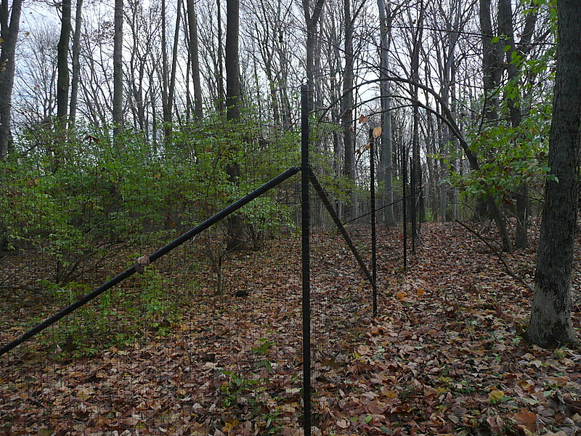
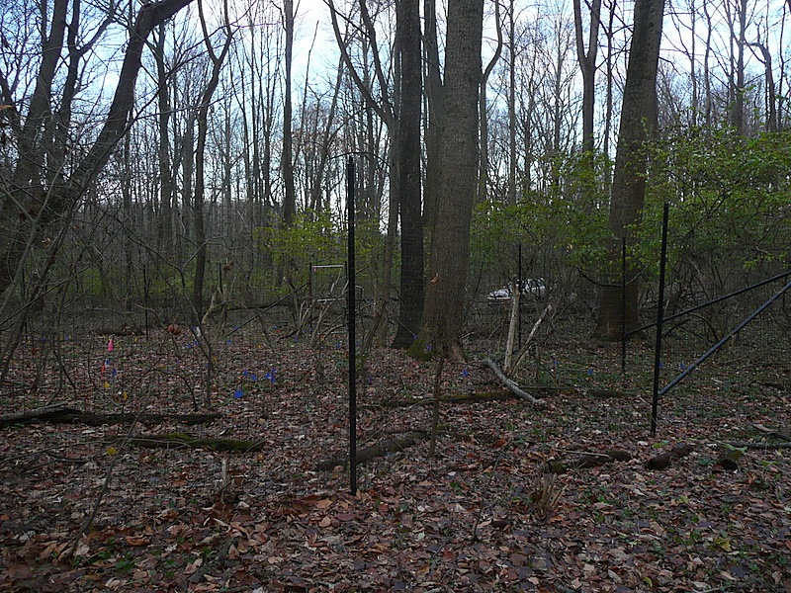
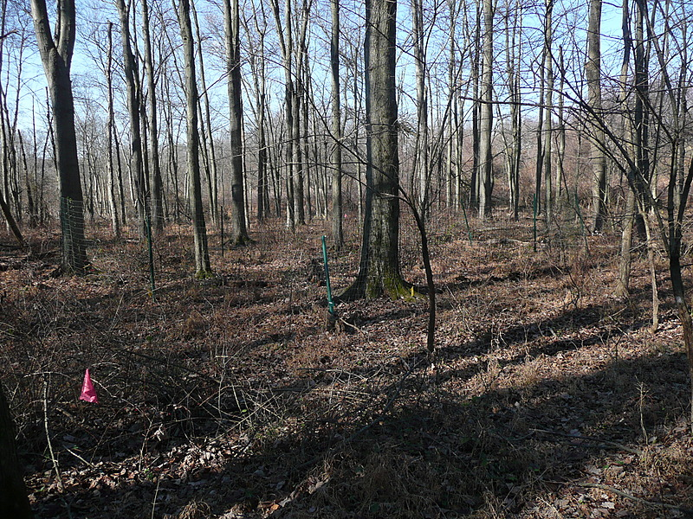
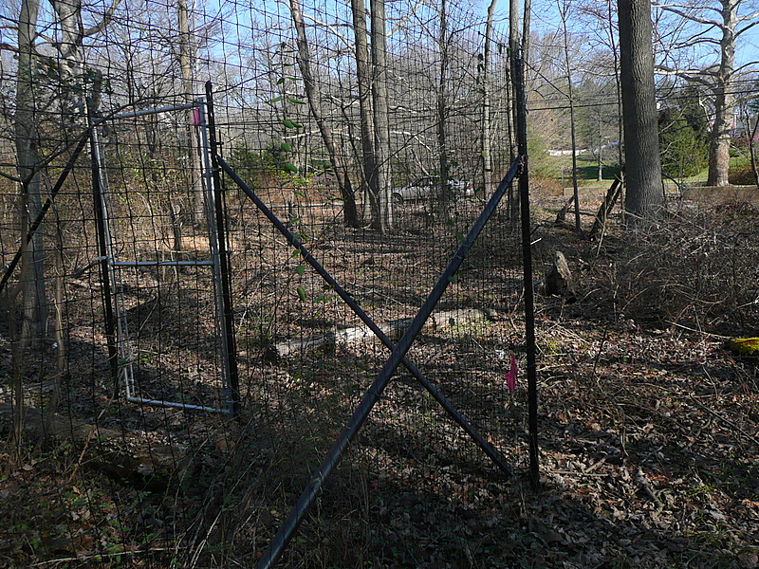
Flood Plain
Old Farm Field

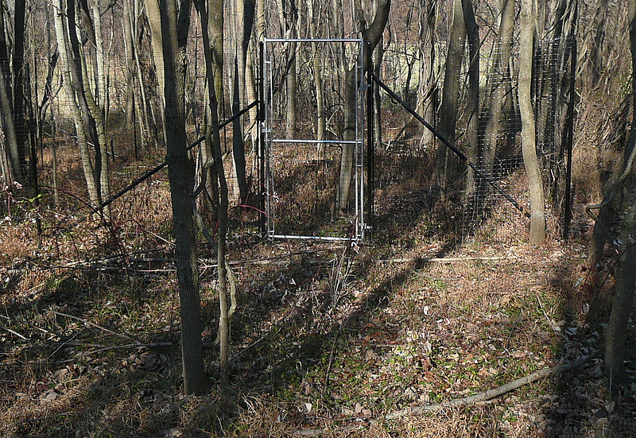
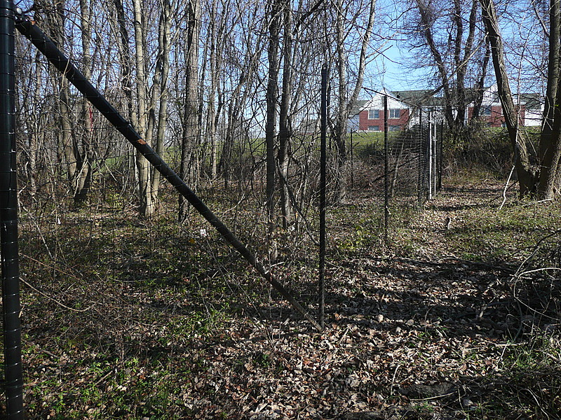

Figure 1. Wild Resources Program supported sites at West Chester University’s Gordon Natural Area, November 2008

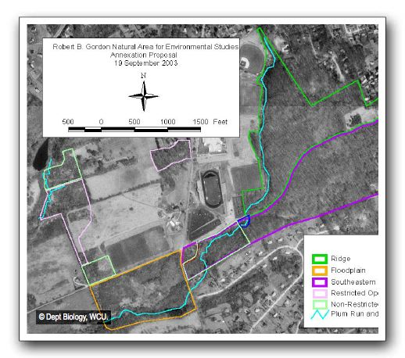
Big Woods
Flood Plain
Old Farm Field
Figure 2. Aerial Photograph of Robert B. Gordon Natural Area (http://www.gordonarea.org/)

Treatment Combinations

Four of the plots in each area were fenced (two with no manipulation of vegetation, two with invasives removed). The purpose of the fence was to exclude deer from the treatment plots. Four plots in the area were not fenced to allow access by deer (two with no manipulation of vegetation, two with invasives removed). Thus, there were two replicates for each treatment plot in each of the three areas (Figure 3).

Preparation of sites

In the plots where invasive species were removed, the invasive species (Amur honeysuckle, Japanese stilt grass, privet (Ligustrum), jetbead, (Rhodotypos scandens (Thunb.) Makino) wineberry (Rubus phoenicolasius Maxim.), tree-of heaven, Oriental bittersweet, Japanese honeysuckle, Japanese barberry (Berberis thunbergii DC) were hand pulled on September 7, 2007. Garlic mustard flower/seed heads, multiflora rose, Japanese barberry, Amur honeysuckle and privet were hand pulled on May 30, 2008. Stilt grass and honeysuckle were pulled by July 1, 2008.
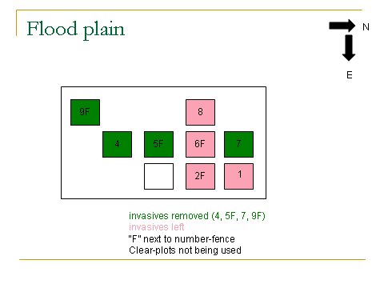
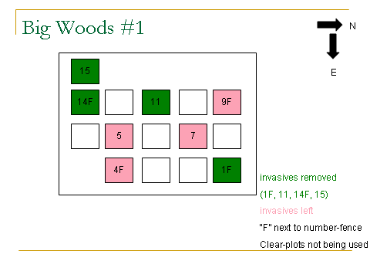
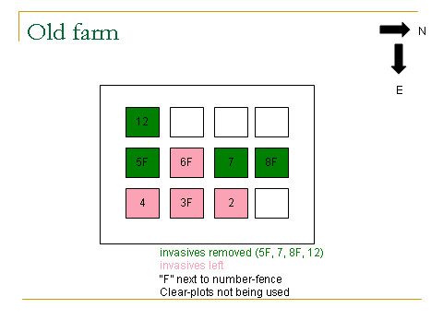
Figure 3. Subplot layout & assigned treatment in three study area in the Gordon Natural Area at West Chester University of PA, Chester Co

Data Collection
All trees (>5in DBH), saplings (<5in>1in DBH); seedlings (< 1in DBH > 1 ft tall) were measured in each of the 24 plots. Ground/canopy coverage were determined by layers (0-2 ft; 2-6ft, 6-16ft, and >16ft) for all species greater than one percent cover before treatments were prescribed. For treatment areas where invasives were removed, the number of seedlings removed was recorded. The number of large woody plants and their location were recorded prior to invasive plant removal, along with measurements of their diameters. The number of seedlings for each plants species was also recorded. The change in baseline species richness and diversity will be evaluated over time (each year beginning in 2009) for each treatment area. Within the 24 ft radius circular plots, three 1m square parcels were established 8 feet from plot center at 180, 300, and 60 degrees (Figure 4). All plant species were identified. The presence and absence of each species were determined in the three parcels. A 15 minute walk through the rest of the 24ft radius circular plots was used to identify other plant species present. Plant presence and absence were also determined in this plot to test the completeness of the three-parcel sampling design.

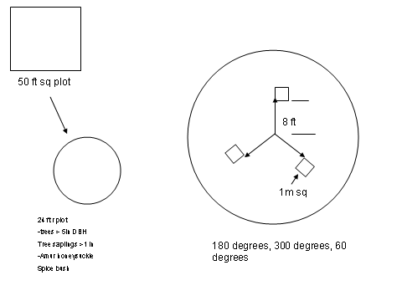
A

C

B
C
C

Figure 4. A) 50 ft square area to encompass a B) 24 ft in radius circular plot and layout of C) three 1m² parcels

Long term data to be collected

Base-line plant species data were collected and will be compared to species diversity conducted at two year intervals for four years.
Results/Discussion:

Data Set 1

Table I (Appendix 1) shows the plot total canopy cover by height for plants and percent ground cover in the 50 X 50 feet areas prior to plant removal. The percent similarity index (PSI) was also calculated for above ground and ground level cover. To calculate the PSI, the mean % cover was calculated for each area (Big Woods, Old Field, Flood Plain) based on the height (above ground). Above ground plant height categories include 0 to 2 feet, 2 to 6 feet, 6 to 16 feet, and 16+ feet. A total of these means was calculated for each area. Then the mean percentage for each height class was divided into the total. The three areas were compared against each other (Big Woods vs. Flood Plain, Flood Plain vs. Old Field, and Big Woods vs. Old Field). The lowest coverage percentage per height class was chosen between the two areas being compared. This was done for all height classes and a sum total was obtained. This indicated the percent similarity between the areas being compared. Similarly, this was repeated for the ground level data based on ground level categories. Ground level categories include lichen, litter/duff, soil, moss, road/trail, rock, stream, trash/junk, and wood.
For the above ground cover, the two most similar areas were the Big Woods and Old Field with 95% similarity. The Flood Plain and Old Field were 84% similar while the Big Woods and Flood Plain were 81%. Big Woods and Flood Plain were the most similar (52%) in ground level cover. The Flood Plain and Old Field had a similarity of 49%. The Big Woods and Old Field were the least similar at 1% (Figure 5).

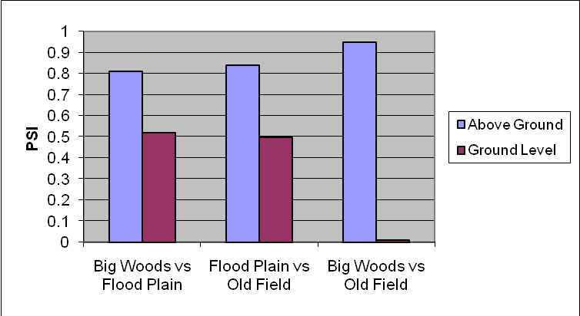
Figure 5. PSI above ground and at ground level for areas in Gordon Natural Area

Data Set 2

Tables I, II, III (Appendix 2) are summary tables of the percent cover by invasive species in 50 X 50 feet plots prior to plant removal in each area (Big Woods, Old Farm Field, Flood Plain). It also shows the number of seedling removed for each species and the number of large woody plants in the plot before removal of invasives.

Analysis 1
First we compared the total number of plant species in each area (Figure 6), categorized as native species only, exotic species only, and all species combined. The three areas differed markedly in virtually every aspect of their plant coverages below six feet. The three areas varied considerably in their species richness for natives, exotics, and all species combined (see Figure 6). The Old Field had the most species in each of the three categories, with the Flood Plain being intermediate in all categories. All three sites had the same ratio of exotic/native species (2.5 ± 0.1). Of the 24 species detected, only one plant species (Japanese stilt grass, exotic) was found in all three areas. Another 9 species were found in two of the three areas, with 14 species being found in only one area.

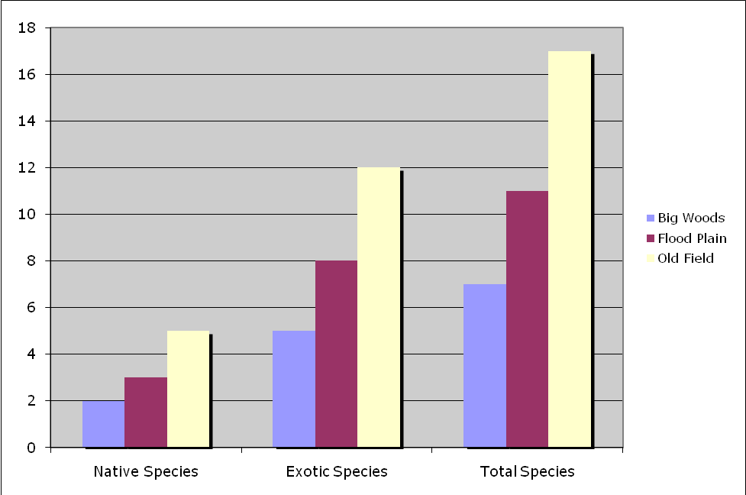

Figure 6. Number of species in each area of the Gordon Natural Area

Analysis 2
We then compared percent coverage below 6 feet for the three areas. Mean coverage for all species combined (native and exotic) ranged from 46% in the Old Field to 79% in the Big Woods, with the Flood Plain being intermediate (59%). Pairwise comparisons were made using the Proportional Similarity Index (see Table II, Appendix 1). The PSI was calculated in two ways to compensate for the fact that the mean coverages by species for a given area did not total 100%. The first analysis included an additional coverage category (Empty) for the average percentage of each area without any plants. This resulted in mean coverages totaling 100%. In the second analysis, the mean coverages for each area were divided by the total coverage for that area, resulting in new percentages for the plants that totaled 100%.
Both PSI analyses gave the same qualitative results (Figure 7). The two most similar areas were the Flood Plain and Old Field (58% and 33% similar, PSI 1 and PSI 2, respectively). The Big Woods and the Old Field were the least similar (23% and 2%). Intermediate in similarity were the Big Woods and Flood Plain (28% and 12%). It should be noted that even the two most similar sites differed by two-thirds according to the more conservative PSI 2 analysis.

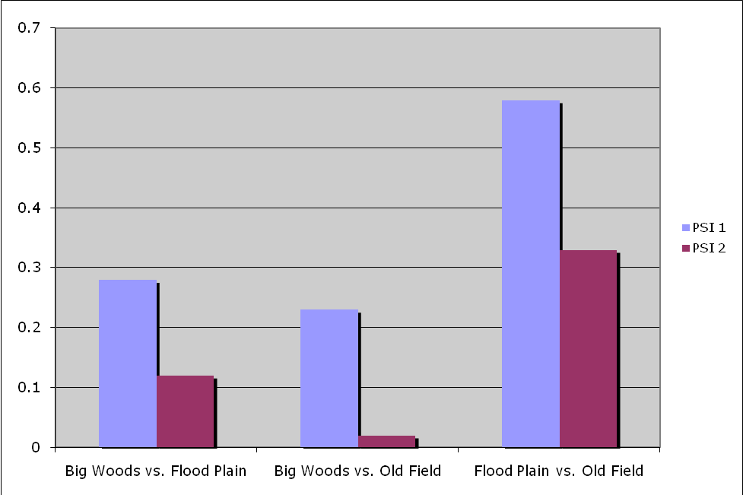
Figure 7. PSI based on species in the Gordon Natural Area

Data Set 3
Data set 3 evaluates the presence and absence of each plant species in the three one square meter parcels and in the rest of the circular plot (24 feet in radius). These data was collected to test the accuracy of using only the three 1m square parcels to detect plant species present in the entire 24 foot radius circular plot. Table III (Appendix 1) shows that approximately 30% of all exotic and native species combined were missed if the entire circular plot was not evaluated. Table IV shows that approximately 40% of native species were missed by evaluating only the three small parcels. Table V, shows that approximately 14-19% of the exotic species were missed by not evaluating the entire circular plot. Therefore, based on the percentage of plant species missed, the entire circular plot or a larger area of the circular plot should be evaluated.

Spatial Distribution
Table VI (Appendix I) shows the spatial distribution based on species which was not analyzed in this paper. It lists the species in each of the three areas, their azimuth in reference to the plot center, and their distance from the plot center. It also measures their diameter at 1.0 ft and diameter at 4.5 ft. Furthermore, it lists the number of seedlings for each species where seedlings are present.

Literature Cited

Bureau of Forestry DMAP goals and strategy. (n.d.) Retrieved November 4, 2008 from the World Wide Web http://www.dcnr.state.pa.us/forestry/dmap/dmap_justification.aspx

D’Antonio, C.M., Jackson, N.E., Horvitz, C.C., Hedberg, R. Invasive plants in wildland
ecosystems: Merging the study of invasive processes with management needs.
Frontiers in Ecology and the Environment. 2004; 2(10): 513-521.

Elias, S.P., Lubelczyk, C.B., Rand, P.W., Lacombe, E.H., Holman, M.S., Smith Jr, R.P.
Deer browse resistant exotic-invasive understory: An indicator of elevated human
risk of exposure to Ixodes scapularis (Acari Ixodidae) in southern coastal Maine
woodlands. Journal of Medical Entomology 2006; 43(6):1142-1152.

Greipsson, S., DiTommaso, A. Invasive non-native plants alter the occurrence of
Arbuscular mycorrhizal fungi and benefit from this association. Ecological
Restoration 2006; 24(4):236-241.

Henderson, S., Dawson, T.P., Whittaker, R.J. Progress in invasive plant research.
Progress in Physical Geography 2006; 30(1):25-46.

Hoffmeister, T.S., Vet, L.E.M., Biere, A., Holsinger, K., Filser, J. Ecological and
evolutionary consequences of biological invasion and habitat fragmentation.
Ecosystems 2005; 8(6): 657-667.

Holt, Jack and Janet Ebert. 2007. Plant survey of the Gordon Natural Area, south campus, West Chester University of Pennsylvania, Unpublished report. 16pp.

Horsley, S.B., Stout, S.L., DeCalesta, D.S. White tailed deer impact on the vegetation
dynamics of a northern hardwood forest. Ecological Applications 2003; 13(1):
98-113.

Invasive Plants in Pennsylvania. (n.d.) Retrieved June 3, 2009 from the World Wide Web: http://www.dcnr.state.pa.us/Forestry/wildplant/invasivelist.aspx

Myers, J.A., Vellend, M., Gardescu, S., Marks, P.L. Seed dispersal by white-tailed deer:
Implications for long-distance dispersal, invasion, and migration of plants in
eastern North America. Oecologia 2004; 139: 35-44.

Pennsylvania Deer Management. 2008. Pennsylvania Game Commission. Retrieved from the World Wide Web November 2, 2008: http://www.pgc.state.pa.us/pgc/lib/pgc/pdf/2008_deer_management.pdf

Rawinski, T.J. Impacts of white-tailed deer overabundance in forest ecosystems: An
overview. Northeastern Area State and Private Forestry: Forest Service, U.S.
Department of Agriculture. June 2008. http://www.na.fs.fed.us/fhp/special_interests/white_tailed_deer.pdf

Riiters, K.H., Wickham, J.D., O’Neill, R.V., Jones, K.B., Smith, E.R., Coulston J.W.
Wade, T.G., Smith, J.H. Fragmentation of continental United States forests.
Ecosystems 2002; 5(8): 815-822.

Robertson, D.J., Robertson, M.C., Tague, T. Colonization dynamics of four exotic plants
in a Northern Piedmont natural area. Bulletin of the Torrey Botanical Club 1994;
121(2):107-118.

Rossell Jr., C.R., Patch, S., Salmons, S. Effects of deer browsing on native and non-
native vegetation in a mixed oak-beech forest in the Atlantic Coastal Plain.
Northeastern Naturalist 2007; 14(1): 61-72.

Schweiger,, E.W., Diffendorfer, J.E., Holt, R.D., Pierotti, R., Gaines, M.S. The
interaction of habitat fragmentation, plant, and small mammal succession
in an old field. Ecological Monographs 2000; 70(3): 383-400.

Simberloff, D. Eradication: Preventing invasions at the outset. Weed Science 2003;
51(2): 247-253.

Vitousek, P.M. (1986). Effects of alien plants on native ecosystems. In Biological
Invasions of North America and Hawaii. (pp. 29-41). Honolulu, Hawaii. University of Hawaii Press.

Special Issue: Deer eating the future of Pennsylvania’s Forest. (n.d.) Retrieved Nov 4, 2008 from World Wide Web: http://www.upenn.edu/paflora/id13.htm

Westbrooks, R.G. New approaches for early detection and rapid response to invasive
plants in the United States. Weed Technology 2004; 18: 1468-1471.

Western Pennsylvania Conservancy. (n.d.) Proper management of deer population critical to protecting wildlife and forest ecosystem. Retrieved Dec 11, 2008 from the World Wide Web: http://www.wpconline.org/dailyphotos/deer.htm.

Willams, S.C., Ward, J.S. Exotic seed dispersal by white-tailed deer in southern
Connecticut. Natural Areas Journal. 2006; 26: 383-390.

Appendix 1

Appendix 2

