**MPH SAB 2021-2022 Executive Board**

The mission of the MPH Student Advisory Board, better known as MPH SAB, is to support the Department of Health by serving as a liaison between students and faculty/staff in order to foster a sense of community and professionalism.

**Faculty Advisor:** Chiwoneso Beverley Tinago, PhD, MPH, CHES®

**Executive Board Members**

|  |
| --- |
| **MPH SAB President: Danielle DiGiorgio**  Danielle is a third year MPH student in the Community Heath Track. She is on the path to graduate in 2022 (3-year track). Aside from academics, she works full time as a Drug and Alcohol Prevention Specialist in Chester County. When she isn’t occupied with school or work, she enjoys staying active, whether it be playing sports, hiking or hanging out the beach. |

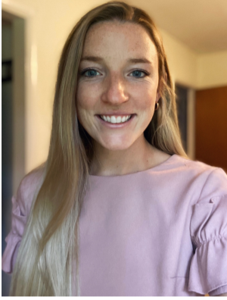

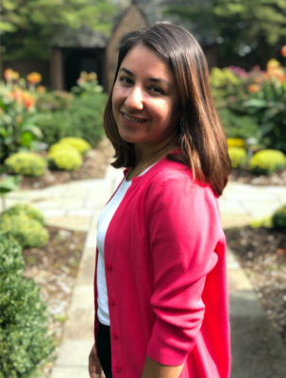

|  |
| --- |
| **MPH SAB Vice President: Sinja Sharma**  Sinja is a second year Community Health student in the MPH program, on path to graduate in May 2022. Sinja currently dedicates her time as a volunteer at the Chester County Health Department where she uses her Public Health skills as a contact tracer for COVID-19. When she isn’t occupied with school or work, she enjoys reading and being outdoors, especially if it involves hiking, travelling, or participating in adventure sports! |



|  |
| --- |
| **MPH SAB Secretary: Rashad Freeman**  Rashad is a United States Air Force Veteran, native of Philadelphia. He received his B.A. degree from California State University, Los Angeles with a major in Communicative Disorders, minor in Psychology. Currently, he is a second year Master of Public Health student on the Community Health Track. After completion of his degree, he hopes to continue education to pursue a Doctor of Philosophy degree in Public Health. His research interest is centered around Adverse Childhood Experiences (ACEs) and their potential influence on health behavior and health outcomes. |

|  |
| --- |
| **MPH SAB Health Care Management Track Representative:**  **Marguerite Lena**  My name is Marguerite Lena, and I grew up in Santa Monica, CA. I graduated in May 2021 from Marquette University in Milwaukee, WI with a B.S. in Biomedical Sciences, and a Minor in Biology. At Marquette, I competed within the Big East Conference and played Division 1 for the last 4 years while also sitting as the first Student-Athlete Advisory Committee Vice President of Diversity, Equity & Inclusion. I have continued my collegiate athletic career at WCU as a graduate transfer on the Women’s Soccer Team in addition to working as a graduate assistant in the Academic-Athletic Mentor Program where I work with student-athletes in supporting their academic endeavors. I am now pursuing a Master of Public Health on the Health Care Management Track with the goal to increase accessibility and equity within the healthcare system. |

|  |
| --- |
| **MPH SAB APHA Liaison: Daniel Hofmann**  Dan is a second-year MPH student in the Community Health track. Dan completed a B.S. in Neuroscience from the University of Cincinnati in 2015. Their interests include Cancer and Chronic disease prevention, and the two pink parrots that are sometimes seen on zoom calls. As of December 2021, Dan has the privilege of serving as the American Public Health Association campus liaison for the SAB. |

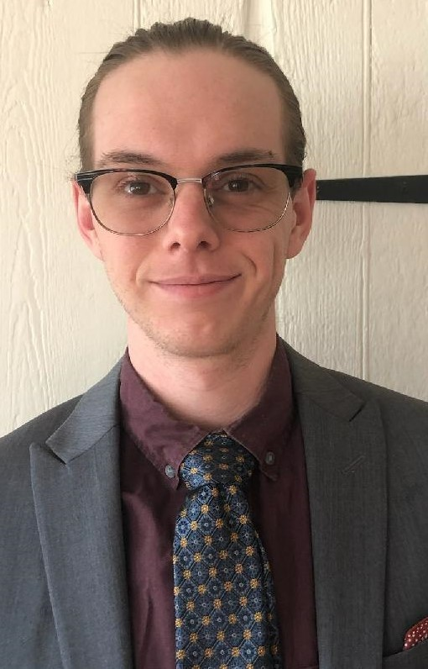

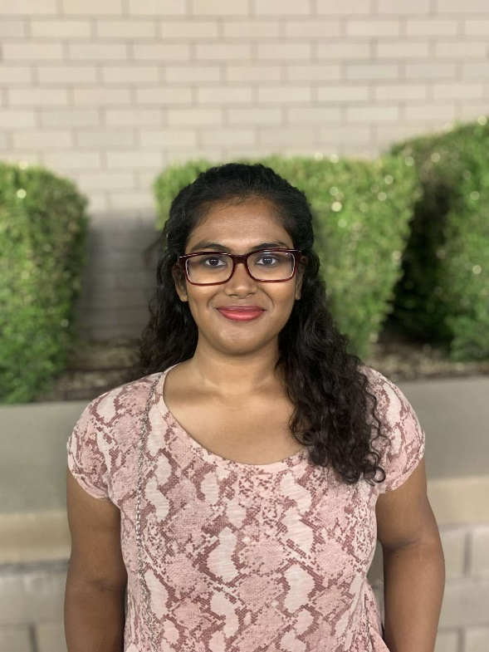

|  |
| --- |
| **MPH SAB Social Outreach Manager: Ragha Mohan**  Hello! My name is Ragha Mohan and I am an international student from India and raised in Kuwait. Being a third culture individual, I was able to soak up the culture of the best of both worlds. I completed my undergraduate degree in Psychology from the University of Wyoming and am currently an MPH Candidate in the Community Health track.  I currently serve as the Graduate Assistant at the Lawrence A. Dowdy Multicultural Center and the ReFRame Student Leader at the Wellness Promotion Center on campus. In my leisure time, I like to read novels, cook, watch shows, and travel. |