**WCU Beta Xi Chapter Delta Omega Executive Board 2022-2023**

**Faculty Advisor:** Chiwoneso Beverley Tinago, PhD, MPH, CHES®

***Introducing the Inaugural WCU Beta Xi Chapter Delta Omega Executive Board Members***

|  |
| --- |
| **WCU Beta Xi Chapter Delta Omega President:**  **Victoria Pauline**  Victoria Pauline is a recent MPH graduate and fellow alum of WCU! She was inducted into Delta Omega in May 2021. Victoria currently works as a Project Coordinator at the National Council for Mental Wellbeing. In this role, she supports a SAMHSA funded Training and Technical Assistance (TTA) Center for integrated care, working closely with a variety of integrated care experts focusing on the planning, development, implementation, and evaluation of nation-wide TTA for organizations undergoing the integration of primary care, mental health, and substance use recovery services. Victoria is passionate about mental health and positively impacting the lives of others to ultimately improve health outcomes. During her time as an undergraduate and graduate student at WCU, she explored her public health interests through research and working closely with peers and mentor, Dr. Tinago. The research focused heavily on maternal and child health, and adolescent wellbeing. These topic areas have played a crucial role in driving her professional interests and career development as a public health professional. Serving as a Delta Omega Honorary Society member, not only reflects her commitment to the field, but also demonstrates her unique areas of interest and passion for continued learning. She is thrilled to serve as the President of the Beta Xi Chapter at WCU for this upcoming academic year! |

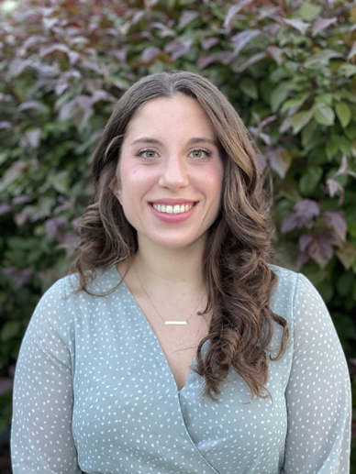

|  |
| --- |
| **WCU Beta Xi Chapter Delta Omega Vice President: Ashley Cifarelli**  Ashley Cifarelli was inducted into Delta Omega Beta in 2019. She received her B.S. in Public Health, minor in Nutrition (2018) in addition to an MPH in Healthcare Management (2019) from West Chester University of Pennsylvania. Ashley has been working with Penn Medicine since 2017 beginning at Chester County Hospital and currently working as a Junior Project Manager, Radiation Oncology in Philadelphia. She currently resides in Philadelphia with her boyfriend, and her two cats. In her spare time, Ashley enjoys going to the farmer’s market, hitting the gym, cooking, and enjoying the outdoors. |

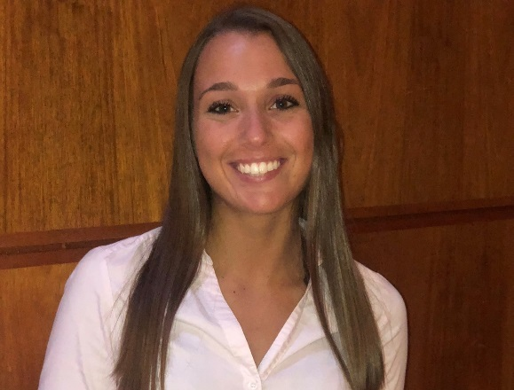

|  |
| --- |
| **WCU Beta Xi Chapter Delta Omega Treasurer : Doris Swarn**  Doris is a second year Healthcare Management student in the MPH program, on path to graduate in December 2021. Aside from academics, she works full time as a Health and Safety Coordinator. When she isn’t occupied with school or work, she enjoys staying active and loves volunteer, cook, and sew! Doris was inducted to the Delta Omega Honor Society in May 2021. |

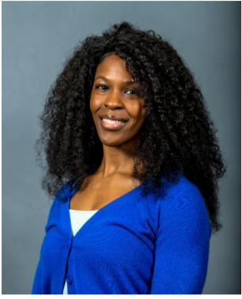

|  |
| --- |
| **WCU Beta Xi Chapter Delta Omega Secretary : Sunita Amin**  *I am currently working as a Senior Engagement Consultant with Cigna Health Care, based in the Mid-Atlantic region, responsible for consulting with employers and brokers in the development of strategic health improvement plans, spearheading customer engagement initiatives, coordinating all open enrollment activities, and educating customers to be informed consumers of health benefits. I am extremely passionate about employee population health, preventive care, and reducing health disparities in specific communities. Currently, I am building a Social Determinants of Health pilot program to reduce transportation barriers in the local market area. I hold a Bachelor of Science in Nutritional Sciences from Penn State University as well as a Master of Public Health from West Chester University. I am also a Certified Health Education Specialist, trained within the core seven areas of competency of health promotion and health education and hold my Virginia Life, Health & Annuities Insurance License. I was inducted to Delta Omega in 2018. I currently reside in Arlington, Virginia with my husband—where we love to go on runs by the national monuments in Washington D.C. and visit local museums and restaurants!* |

