**Rhythmic Concepts Masterclass Dave Allen**

**Triplet Groupings:**

Example 1: Twos (using 3rds)

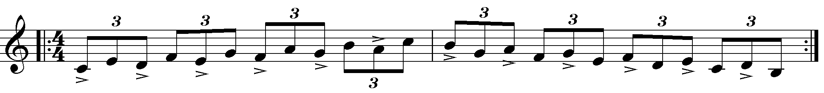

Ex 2. Fours (Using 7th chords)

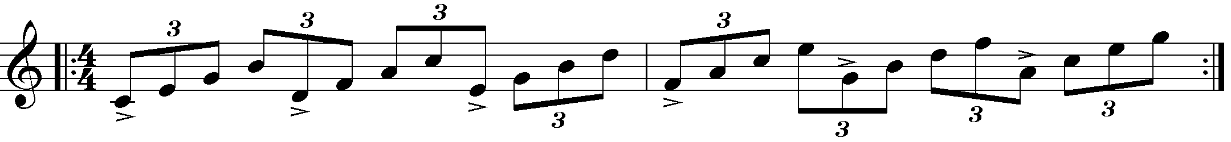

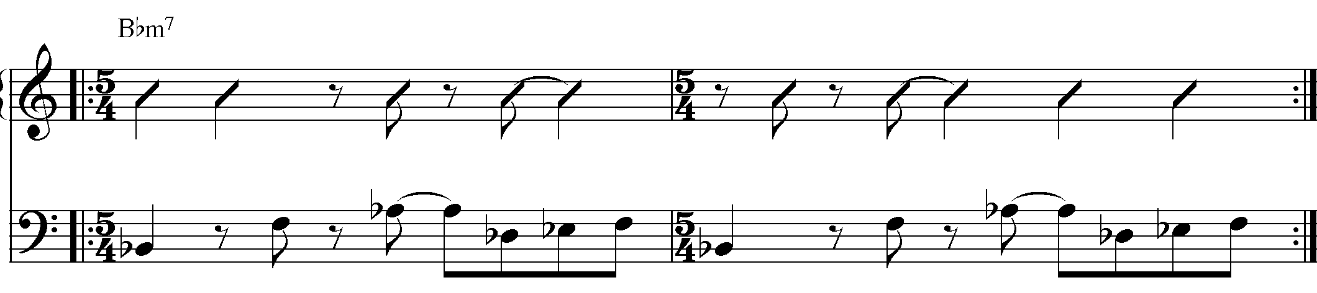

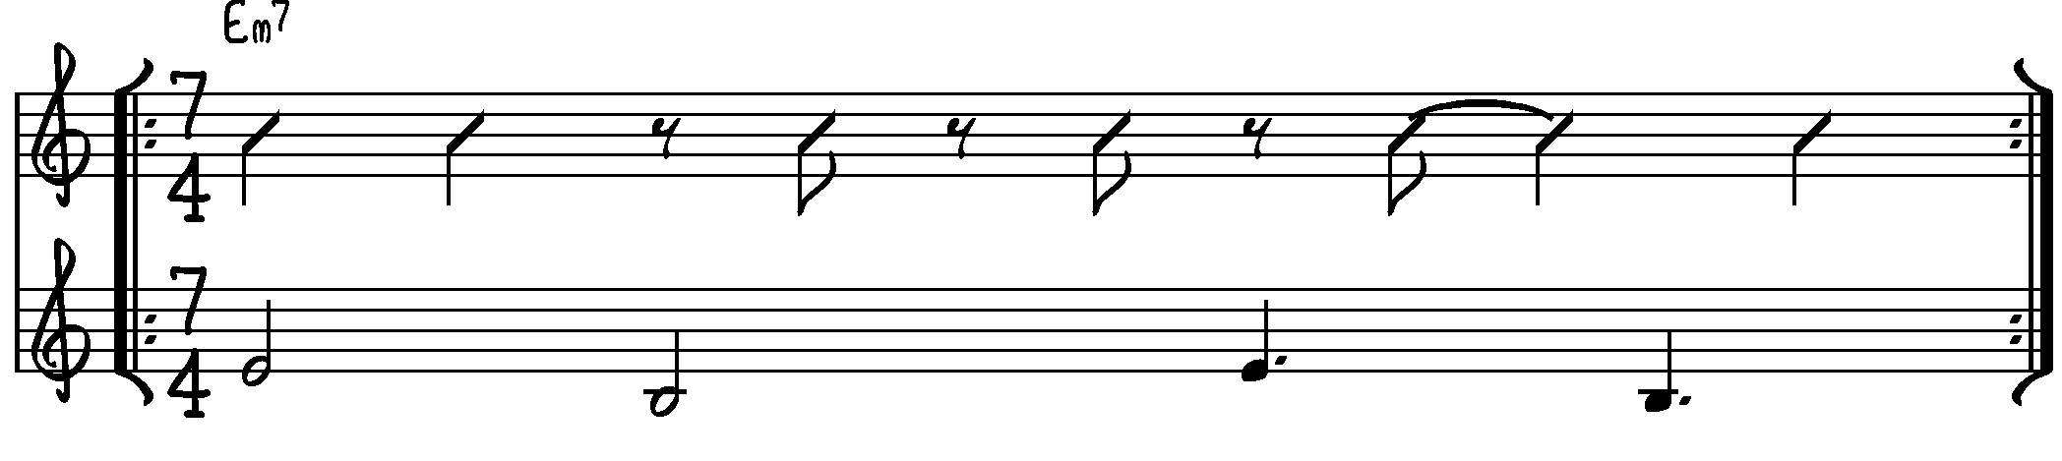

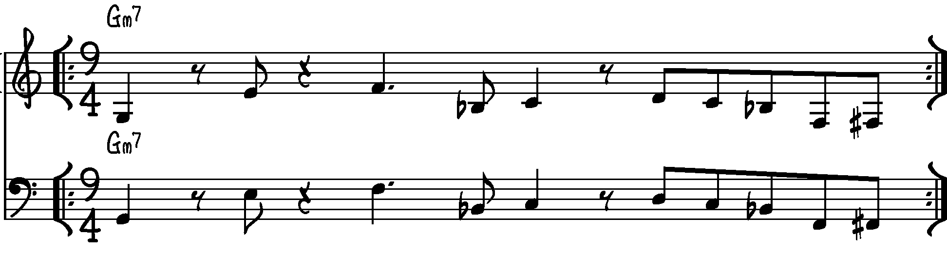

**Pulsion (A section only) Dave Allen**







