**How to Revise/Edit a Policy that Already Exists**

**in the WCU Policy Library SharePoint**

**WCU Policy Library SharePoint:** <https://wcupa.sharepoint.com/sites/President/polpro/Forms/AllItems.aspx>

**Public Facing Policy Site:** <https://wcupa.edu/policies/>

**What is the difference between a revision to a policy and an edit?**

* An **edit** to the policy would not change the context of the policy itself and pertains to small changes in items such as metadata within the SharePoint Library, fixing a typo (i.e. grammatical, spelling, punctuation, etc.), new Policy Owner.
* Does not constitute communication email be generated to alert University Community (refers to the SharePoint Library).
* Does not require review by Office of Labor Relations prior to making edits, **jump to page 2 of this document.**
* A **revision** to the policy would change the context of the policy and/or affect any member of the University Community (faculty, staff, administration, students), prospective students, or the general public. Examples of such major revisions include, but are not limited to, removing a section (or portion) and/or adding a section to the policy.
* Communication email must be generated to alert the University Community to the revisions (refers to the SharePoint Library).
* Policy revisions must be reviewed by Office of Labor Relations and approved prior to signature and upload to the Public Facing site.

**Prior to making Revisions to the Policy document within the SharePoint Library:**

All revisions to any policy will be considered to be proposed revisions until formally approved by the Office of Labor Relations. Proposed revisions should be completed on a document separate from the one located in the SharePoint Library. Please take a moment to review the following suggestions for this process.

**Option 1:** Print a hard copy of the existing policy from the Public Facing Site and make proposed revisions by hand to the document.

**Option 2:** Edit an electronic version of the document by saving a copy of the Policy with a different name.

* In both instances, the document will be reviewed by several individuals, including whomever is assigned to officially implement these revisions to the SharePoint Library version of the policy.

**To easily identify revisions, we suggest the following method:**

* Anything that should be removed from the policy should not be deleted from the document, rather edit to reflect a “strike through” feature on the font.
* Anything added to the policy should be added in a different font color.
* Questions or important revisions to be reviewed should be visually different, possibly with a highlight and different font color.
* Be forthcoming in the meaning of any and all visual indicators you have applied so individuals reviewing the policy know what means what.

**Proposed Revisions have been approved and you’re ready to update the official Policy document. Follow the Below Steps in the SharePoint Library** (link above)

1. Locate and delete the existing **PDF version** of the newly revised policy **(do not delete the WORD version)**.

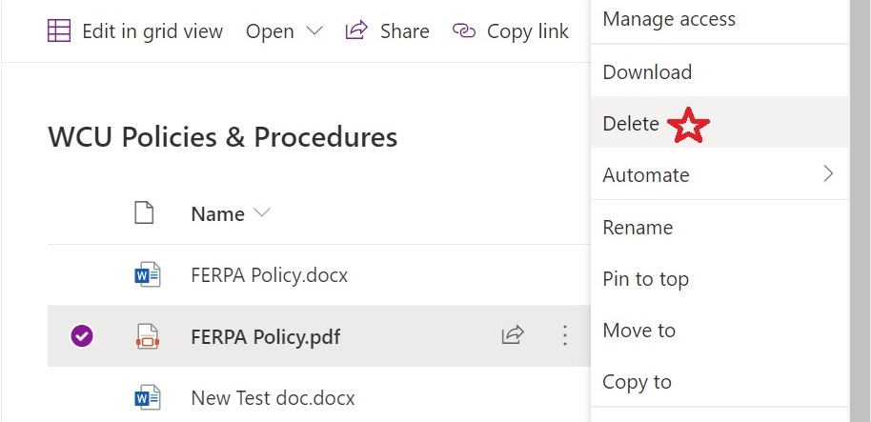

1. Click the 3 dots to the right of the WORD version of the policy → Open → Open in App

This will open the document in the Word application.

* 1. Make your edits, additions, deletions, etc.
  2. Double check **Properties** (Author & Title) and **Alt Text** (for digital signatures and images/rescinded text boxes are assigned; **update if necessary**.
  3. Click the SAVE icon in the upper left corner of the window to save the document.   
     **This will save the document back to the SharePoint library and create the new version.**
  4. Click the X in the upper right corner of the document to close it.

1. Find the newly edited policy in the list. If any of the properties need to be changed click the 3 dots to the right of the document name → Mouse over to “More” → Click “Properties”

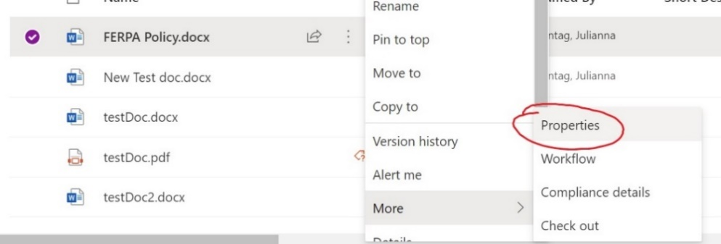

1. A box will appear, Click “Edit All” → Update all required boxes (column info) with appropriate information **(see checklist below step 5)**. Then Click “Save.”

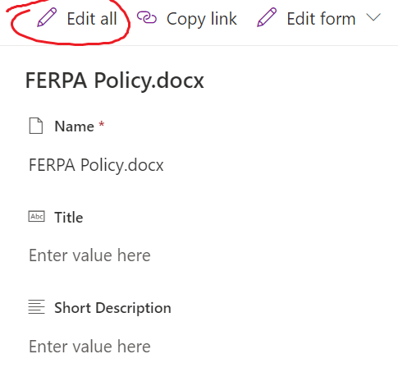

1. Locate the policy on the main list. Click the 3 dots to right of the document name → Mouse over to “Automate” → Click “Convert Document to PDF”

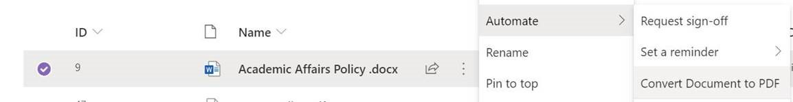



**\*Checklist of Required Information to Update in Step 4**

(List items in **BOLD** font must be updated, all others can be updated as needed)

⬜ Policy Owner

⬜ **Next Review Date**

⬜  **Last Review Date**

⬜ Label

⬜ Status

⬜ Policy Owner Email

⬜ Additional Email Addresses

⬜ Enterprise Keywords

⬜ Division

All other boxes can be filled in to provide additional detail as user sees fit.