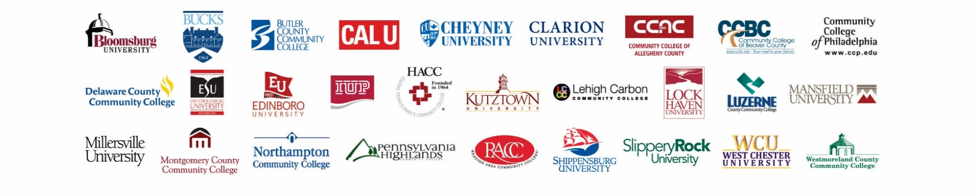

**News**

**Date:** March 30, 2016

**For release:** Immediately

**Contact:** Danielle Gross, Pennsylvania Commission for Community Colleges

(717) 232-7584 or (717) 418-9001

Kenn Marshall, Pennsylvania’s State System of Higher Education

(717) 720-4054 or (717) 329-0809

**PA community colleges, State System universities**

**sign statewide ‘reverse transfer’ agreement**

***Initiative allows former community college students***

***to obtain associate’s degree with credits they’ve already earned***

**Harrisburg –** Students who began their studies at a community college in Pennsylvania before transferring to a university within Pennsylvania’s State System of Higher Education might already have earned enough credits to receive their first degree. And now there’s an easy way for them to get it, through the newly launched “reverse transfer” initiative.

The 14 community colleges in the state and 14 State System universities today signed a statewide reverse transfer agreement that will allow students who have earned at least 60 total credits to apply for an associate’s degree from the community college where they started.

Receiving the degree could immediately enhance the student’s earning potential, even as he or she continues working toward a bachelor’s degree or other certification or credential at a State System university.

“The State System universities and the community colleges are natural partners,” said State System Chancellor Frank T. Brogan. “This agreement is another example of how we can work together on behalf of students all across the Commonwealth. It’s a win-win for everyone.”

“Collaborating with the State System on this agreement is the next step in the commitment of Pennsylvania’s community colleges to increase student completion rates to benefit both students individually and the Commonwealth as a whole,” said Luzerne County Community College President Thomas P. Leary, who also serves as chair of the Pennsylvania Commission for Community Colleges.

A student who earns an associate’s degree is more likely to complete the work necessary to receive a bachelor’s degree. “If their studies toward a bachelor’s degree are interrupted for any reason, with this program, they will still have their associate’s degree, which will benefit them as they prepare to enter the workforce or will help enable them to move up the career ladder,” said Elizabeth Bolden, president and CEO of the Pennsylvania Commission for Community Colleges.

Many students who initially enroll at a community college do so with the intent of eventually earning a bachelor’s degree, staying long enough to earn an associate’s degree before transferring to a four-year college or university. Some leave before earning a degree, either to transfer or to go directly into the workforce.

The Reverse Transfer Program gives those who transferred without a credential a pathway to their first college degree.

“Several State System universities already have reverse transfer agreements in place with their neighboring community college. This new agreement expands the program statewide, making it available to many more students across Pennsylvania,” said Millersville University of Pennsylvania President John Anderson.

Students who began their postsecondary education at any community college in Pennsylvania and earned a minimum of 45 credits before transferring to any State System university can participate in the new program. Eligible credits may include those earned through Prior Learning Assessment (PLA), Advanced Placement (AP), College Level Examination Program (CLEP), Credit by Exam and the military.

A student must have enrolled at a State System university within five years of leaving the community college and have earned at least 15 additional credits at a State System university to be considered for the program. Their State System credits will be transferred back to the community college and applied to the requirements for the associate’s degree.

The State System universities will identify eligible students once they complete the 60 total credits and invite them to participate in the reverse transfer program. If interested, the eligible students will fill out a release form and their State System university transcript will be sent to the community college for review and evaluation.

If approved, the community college will award the degree. Students will not be charged either a graduation or transcript fee by either institution involved.

The first degrees could be awarded through the program as early as this summer. Many students likely already are eligible. Others could be once the current semester ends in May.

“The reverse transfer agreement is particularly helpful for students called to military service,” said Jessica Shingara, a business management major at Millersville University and former student at Harrisburg Area Community College who spent five years in the U.S. Navy, where she was stationed aboard the USS John Paul Jones. “Having long breaks from school can add stress to an already stressful situation, and having this program promotes an easy transition from serving to studying.”

***Pennsylvania’s State System of Higher Education*** *is the largest provider of undergraduate and graduate education in the Commonwealth, with about 107,000 degree-seeking students and thousands more who are enrolled in certificate and other career-development programs. Collectively, the 14 universities that comprise the State System offer more than 2,300 degree and certificate programs in more than 530 academic areas. Nearly 520,000 State System university alumni live in Pennsylvania.*

*The State System universities are Bloomsburg, California, Cheyney, Clarion, East Stroudsburg, Edinboro, Indiana, Kutztown, Lock Haven, Mansfield, Millersville, Shippensburg, Slippery Rock and West Chester Universities of Pennsylvania. The universities also operate branch campuses in Oil City (Clarion), Freeport and Punxsutawney (IUP), and Clearfield (Lock Haven), and offer classes and programs at several regional centers, including the Dixon University Center in Harrisburg and in Center City in Philadelphia.*

*The* ***Pennsylvania Commission for Community Colleges*** *is a voluntary membership association for Pennsylvania’s community colleges, which collectively are the largest providers of undergraduate education in the state, serving more than 313,000 students in 2014-15.*

*Pennsylvania’s community colleges are Bucks County Community College, Butler County Community College, Community College of Allegheny County, Community College of Beaver County, Community College of Philadelphia, Delaware County Community College, HACC – Central Pennsylvania’s Community College, Lehigh Carbon Community College, Luzerne County Community College, Montgomery County Community College, Northampton Community College, Pennsylvania Highlands Community College, Reading Area Community College and Westmoreland County Community College. The colleges operate 26 campuses and 84 instructional sites and centers, serving students from every county in the Commonwealth.*