**Project ASTRO WCU**

**Resource Center**

*West Chester University has materials that can be loaned out to teachers and astronomers to aid in classroom activities and observations.*

**Who may borrow?**

Any teacher or astronomer that is a participant of the program may borrow resources for a period of up to two weeks. The borrower is responsible for all equipment while in their possession. The teacher (or representative) must also pick up equipment and return it. WCU is unable to deliver equipment.

Note:

* The solar telescope is valued at $2500.
* The sun spotters are valued at $350 each. Two may be borrowed at a time.
* The celestial spheres are valued at $400 each.
* The Mars globes are valued at $100 each.
* The bowls of night are valued at $30 each.
* The Galileoscope kit is valued at $750 total, $75 per scope. Contains 10 scopes and instructions.
* The tripods are valued at $25 each.

**Reserving Equipment**

E-mail Karen Schwarz at [kschwarz@wcupa.edu](mailto:kschwarz@wcupa.edu) to reserve any of the observing equipment. Make sure to specify which pieces of equipment you’ll need and how many. The equipment is on loan for no more than two weeks. You must give a pick up and return date when you make your reservation.

**Pick up and Drop off**

Most of the materials can fit in the trunk of a car. Equipment may only be picked up and dropped of M-F between the hours of 8am and 5pm.

**Responsibility**

The borrower is responsible for all equipment while in their possession. The individual will assume full responsibility for any loss or damage to the materials borrowed, as determined by the WCU staff.

**Project ASTRO Resources**

**Solar telescope**

* A special purpose telescope used to observe the sun
* 70mm Helios Solar Telescope with a built-in filter

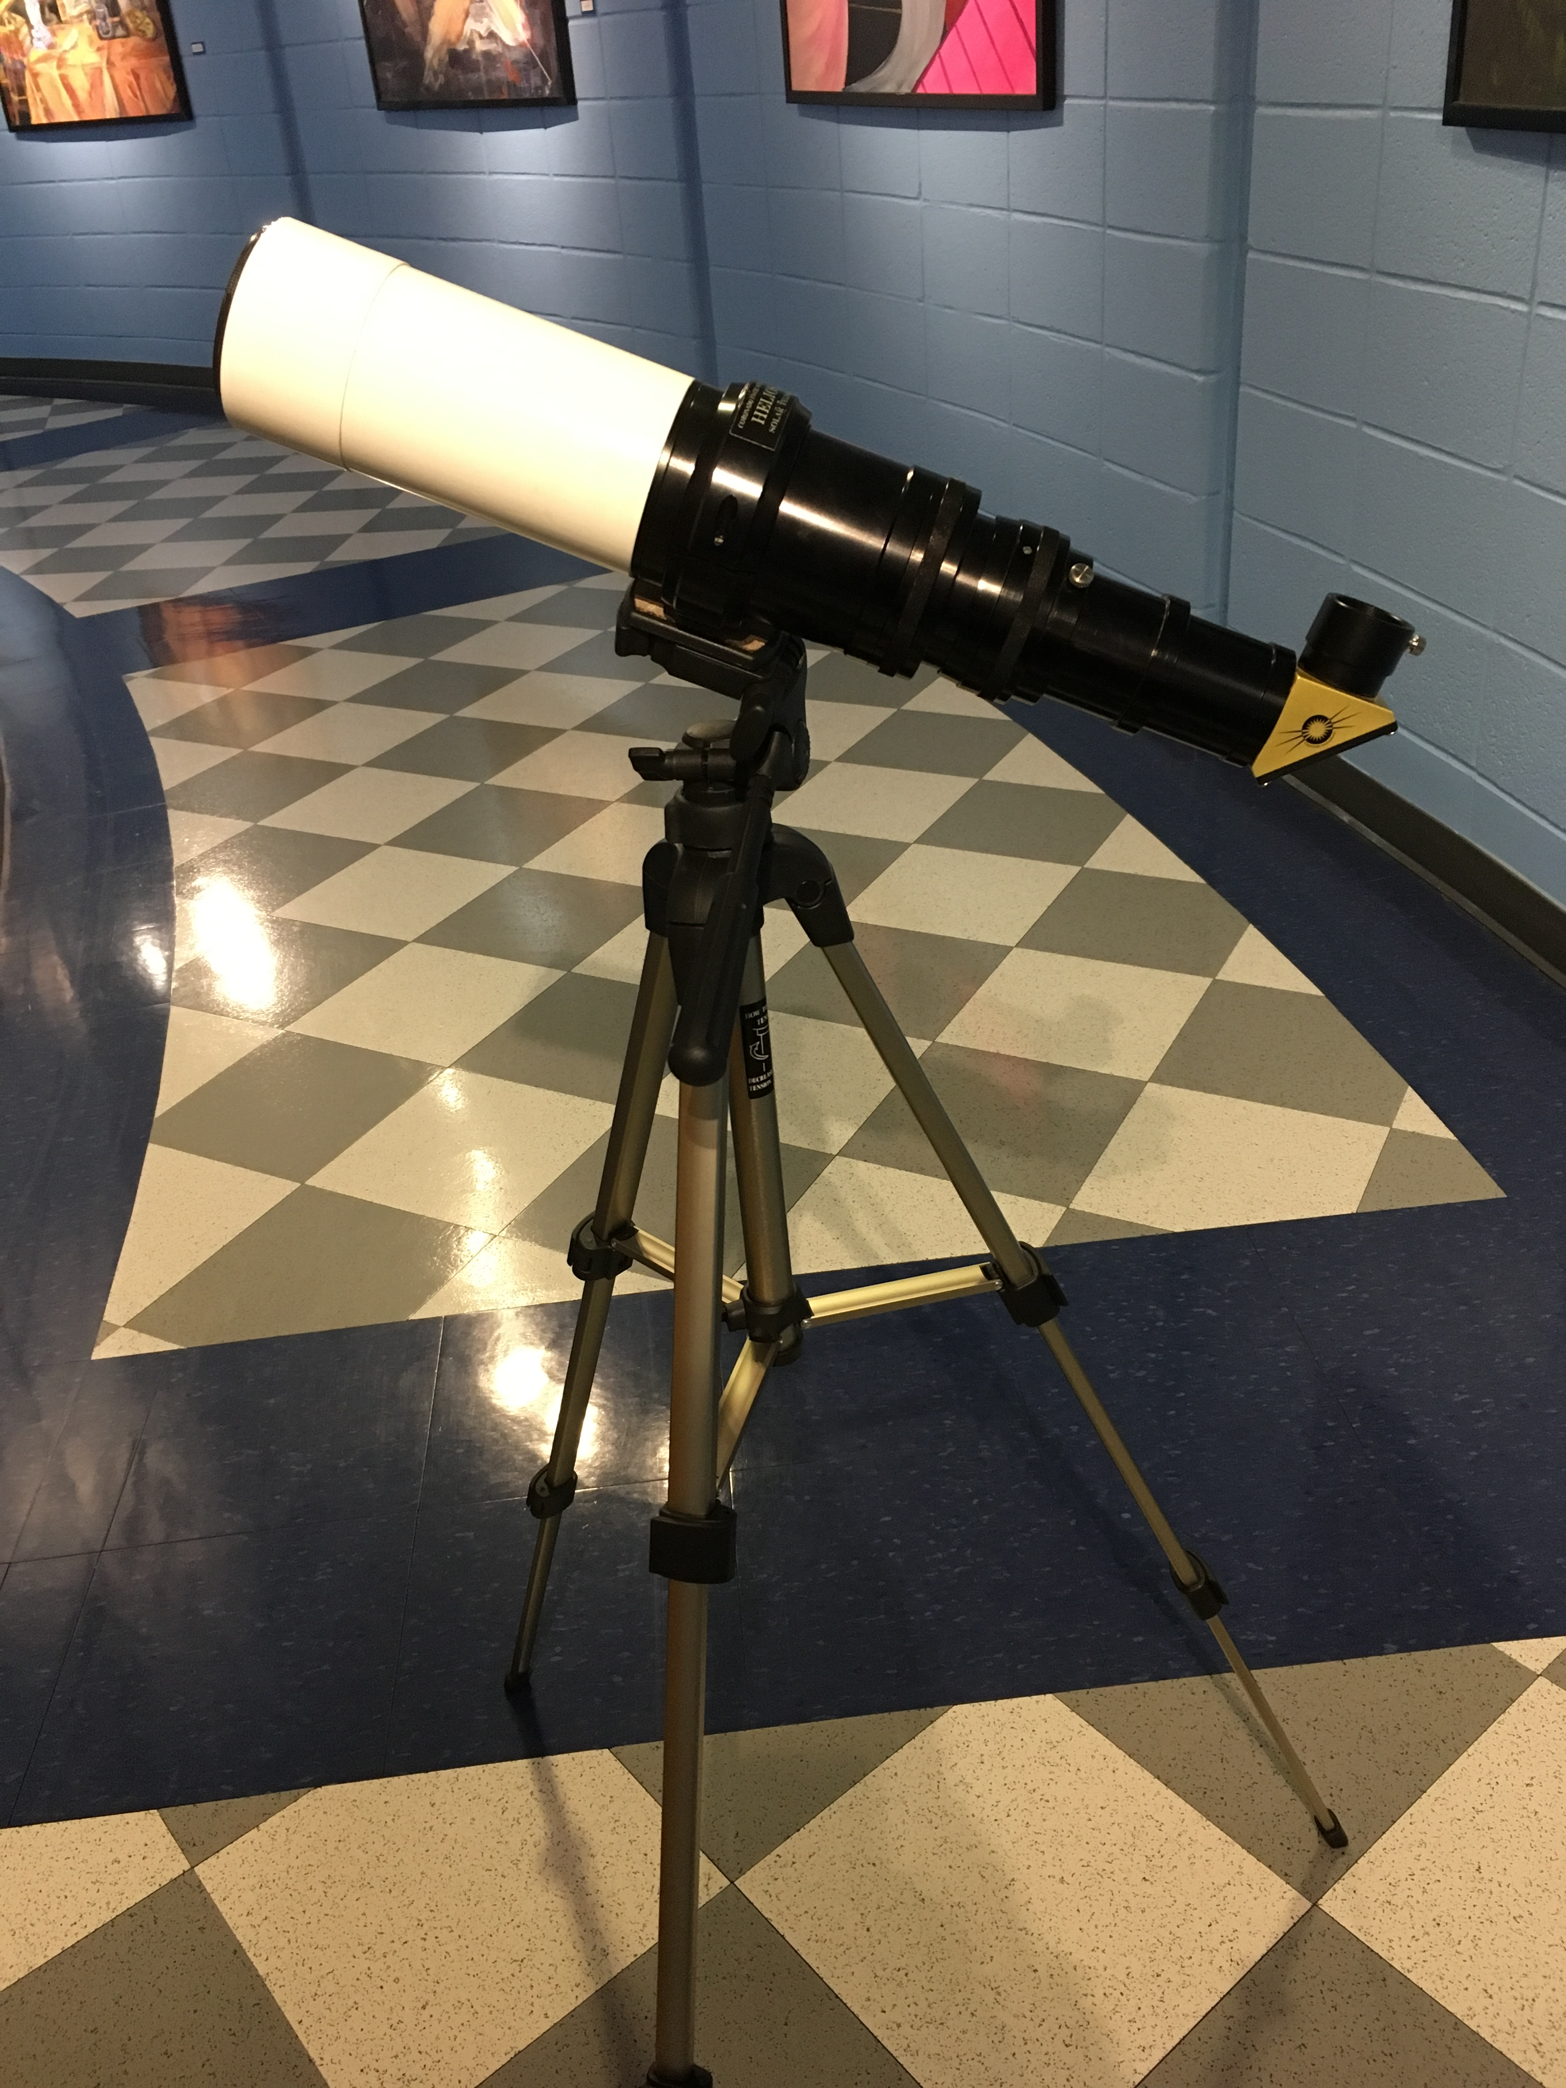

**Sun spotter**

* Allows several people to safely observe the sun
* Projects a solar image on a viewing screen

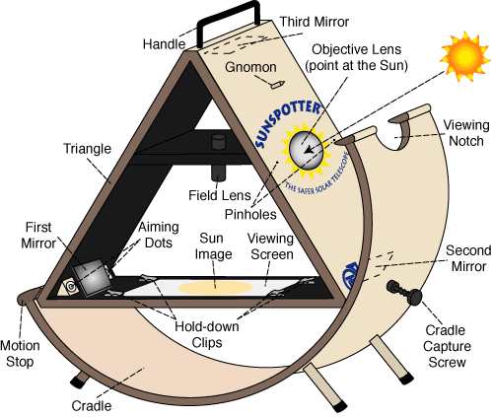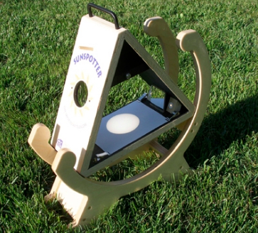

**Celestial spheres**

* Provides the ability to determine the position of stars

and planets on the sky from a given point on the earth’s

surface

* Comes with globe stand.

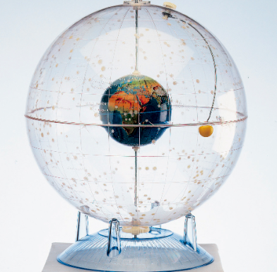

**Mars globes**

* Model of the planet Mars with visual relief
* Comes with globe stand

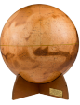

**Bowl of night**

* Identifies the celestial sky for any month and time of

the year located in the Northern Hemisphere

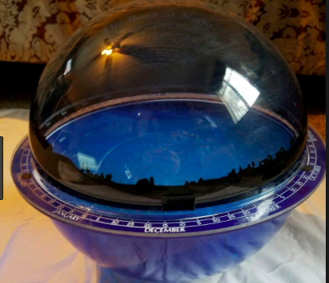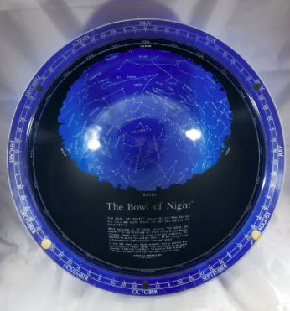

**Galileoscope kit**

* Small refractor telescopes
* Kit comes with all 10 telescopes assembled with

instructions for assembly and disassembly

