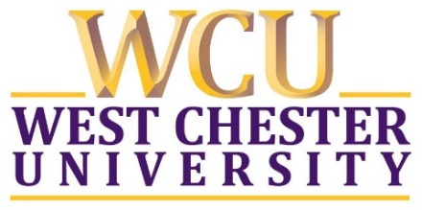

Registration Open Now

Join us in celebrating the 20th anniversary of the
Applied Statistics Program at West Chester University.
Friday, April 14, 2023

Afternoon Applied Statistics Symposium
Sykes Student Union Ballrooms
To present on a topic as part of the symposium, please
contact Dr. Scott McClintock at smcclintock@wcupa.edu.
Evening Reception
WCU Alumni & Foundation Center
6:00 pm
Visit go.wcufoundation.org/events/csm-event to register.

If you are unable to attend, please consider making a contribution to the M.S. Applied Statistics Operating Fund
in honor of this milestone anniversary at go.wcufoundation.org/fund-search.

If you or your company are interested in sponsoring the anniversary events, please contact Pamelia Villagra, Director of Corporate & Foundation Relations, at pvillagra@wcufoundation.org.

