$10,000 Pyramid

Game Template Instructions

When to use $10,000 Pyramid in the Classroom?
Integrating $10,000 Pyramid into a class-period is a type of Game-based learning. This game template can be used for just about any content area to review content categories with a series of terms to guess using clues. Not only can the game be great for review, but also the game-like learning style builds motivation and enthusiasm among the students.

How to play Instructional $10,000 Pyramid?
- This is a game where teams of 2 take turns giving clues for their teammate to guess as many words as possible within the time limit. There are 2 rounds, 6 categories per round. Each team is given 30 seconds per category to correctly guess 6 words. The guessing team gets 1 point for each correctly guessed word during the 30 seconds.
- Flip a coin to determine which team goes first and gets to choose their first category. Play then continues by the other team choosing a category and playing.
- Any player giving illegal clues will have that word disqualified and move to the next word in the category. Illegal clues are as follows: Clues that contain any part of the word, clues that begin “Starts with _” or “Rhymes with _”
- If a player has a hard time giving clues, or guessing clues, either player can pass a word, and can return to it if time allows.
- The team with the most points at the end of each round will then proceed to the Winner’s Circle.
- Gameplay is reversed in the Final Pyramid. The player giving clues must list off clues so that their teammate can guess the category. The Clue giver may not use their hands and must give their clues as a list of items, not descriptions. The guessing team gets increasing amounts of points for each correctly guessed word during the 30 seconds.

How to edit the Template?
External Needed Materials: 30 second timer/stopwatch
- Before editing any content begin the Presentation slide show from the beginning and navigate through the slides in order to see how things appear initially. When you are playing you will be clicking on specific items to reveal new content or returned to previous slides.
  - You can also watch the navigation video to see what is clickable and how the game will look later.
- EDIT RED CIRCLED TEXT ONLY!
Slide Number(s) | Step/Editing Step | Slide Screenshot
1 | Nothing to Edit | 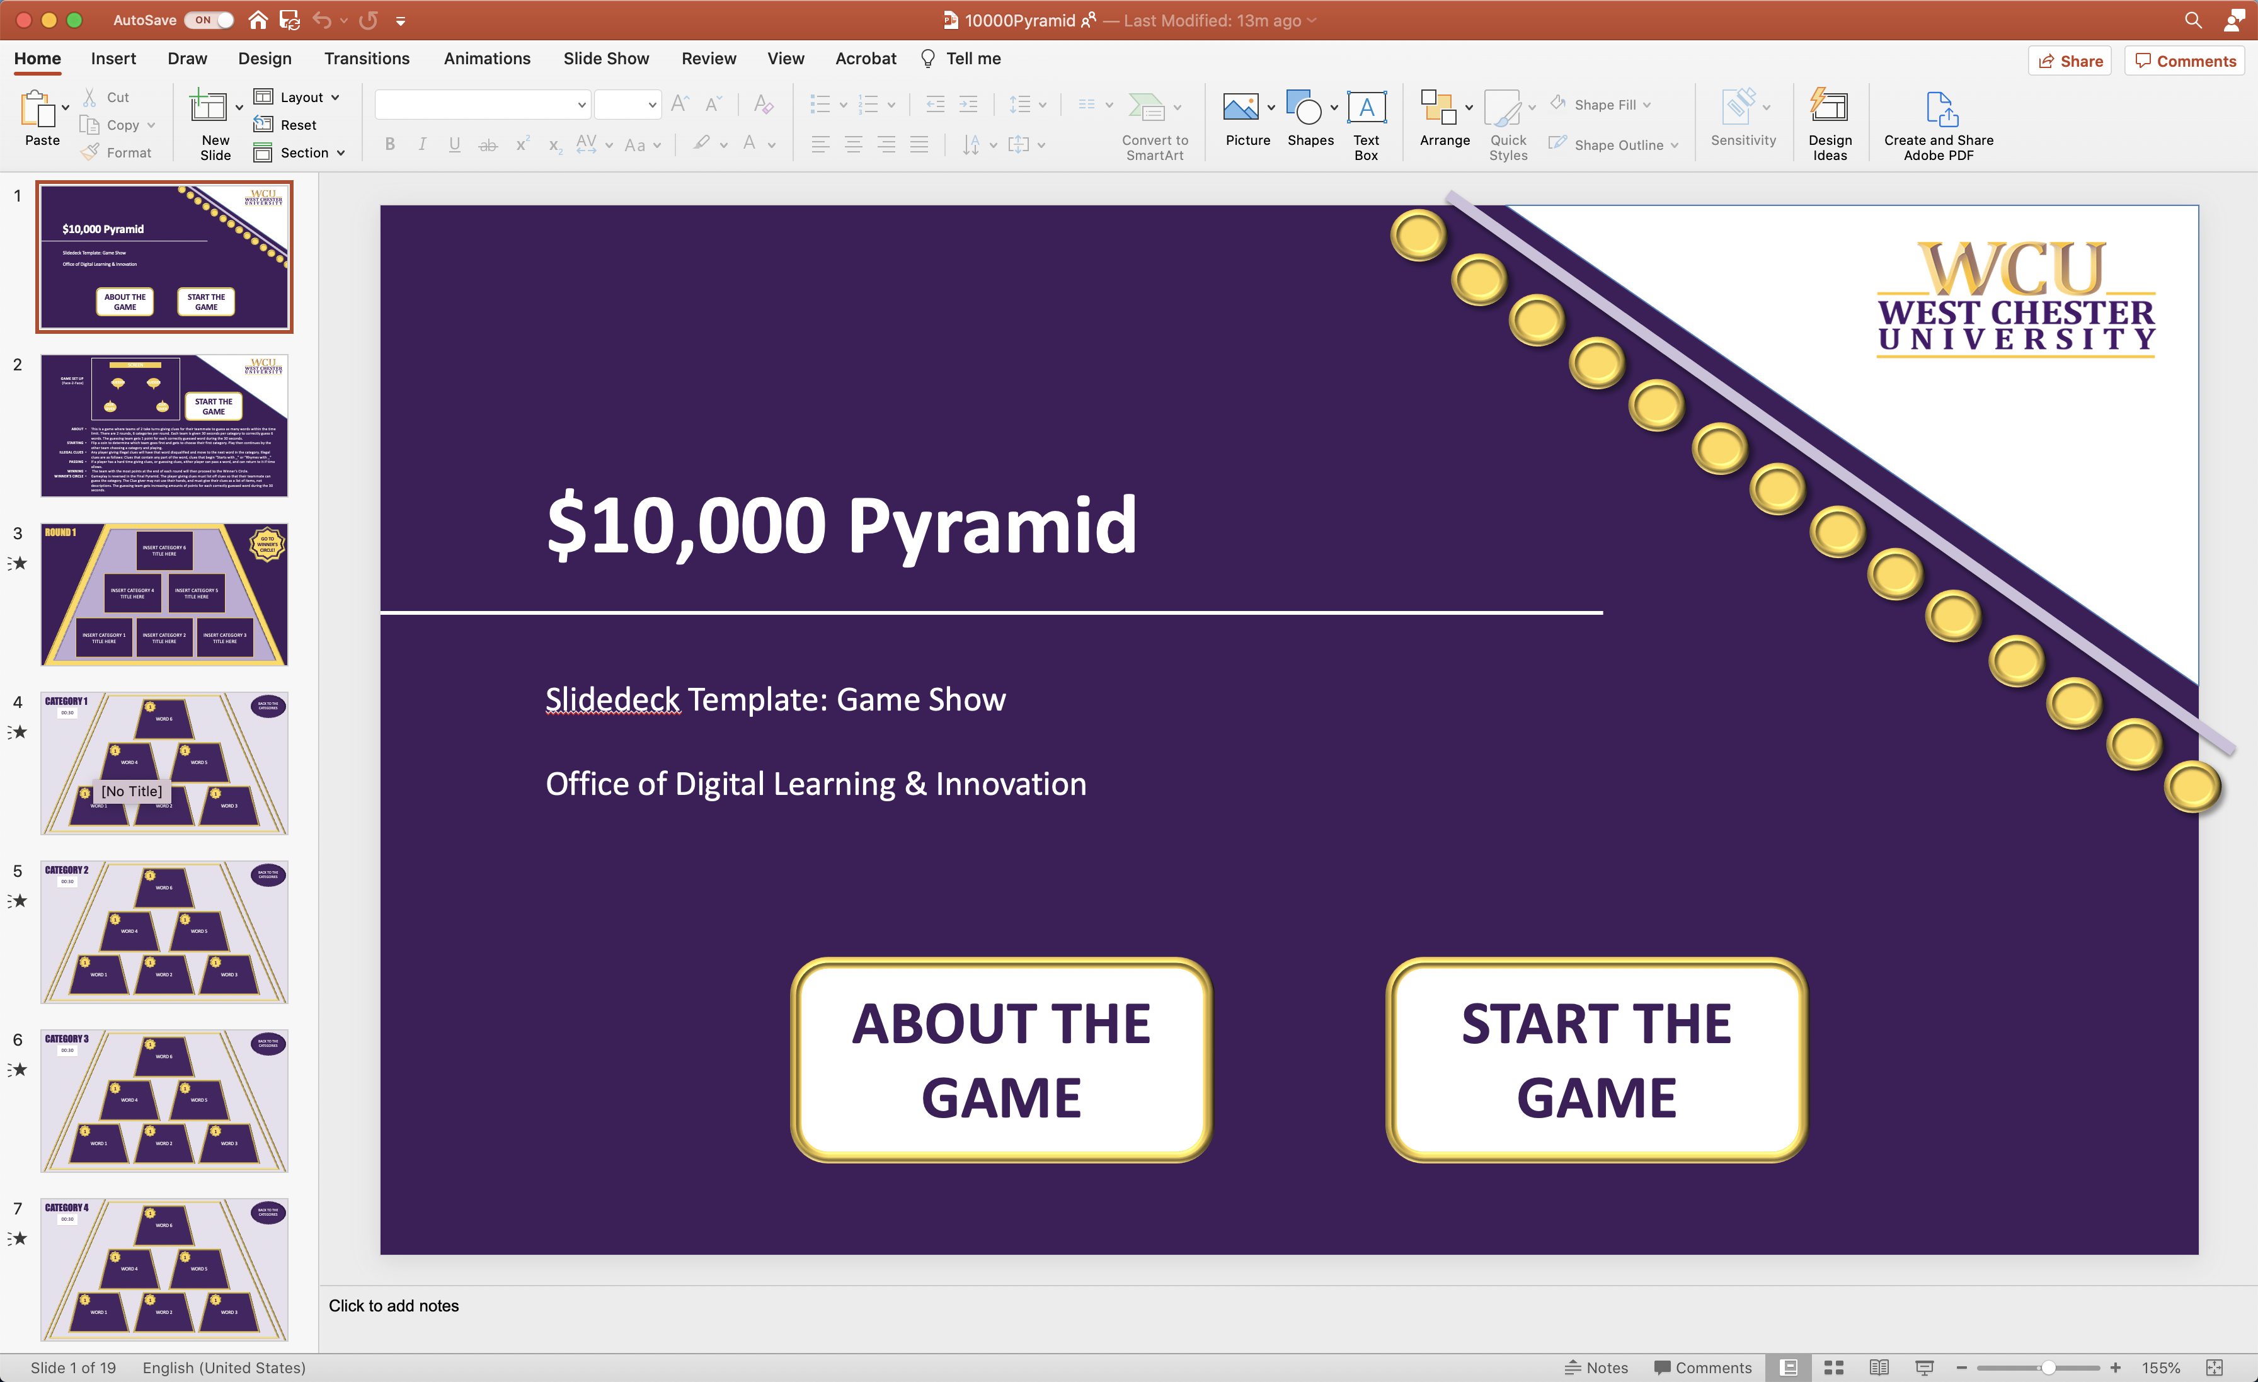
2 | Nothing to Edit | 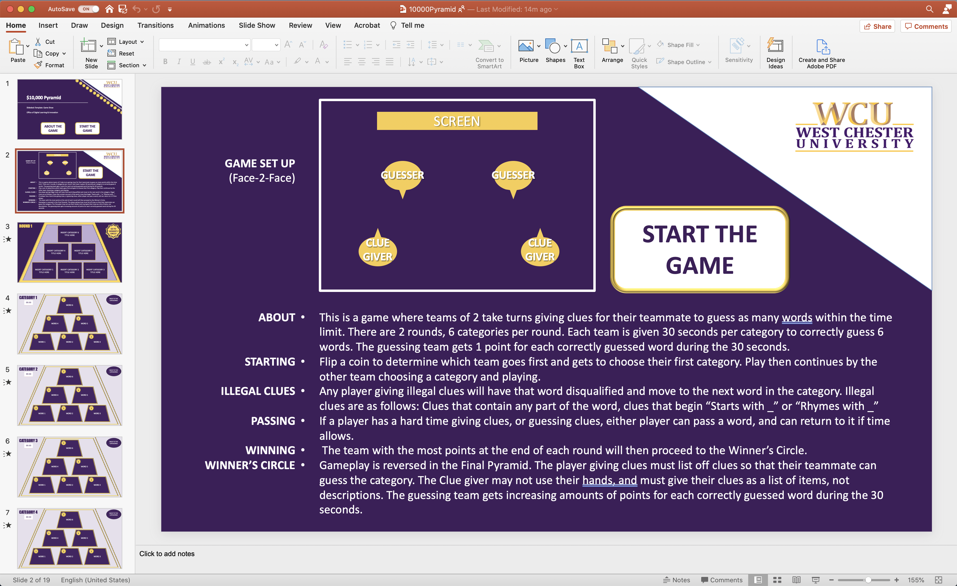
3 | Slide #3 Categories: Click on each rectangle to edit the text found inside. Each of these rectangles are linked to specific slides, so pleases do not delete or move them. Simply click once and replace the text with a content category that will be paired with six related terms for players to guess for Round 1. | 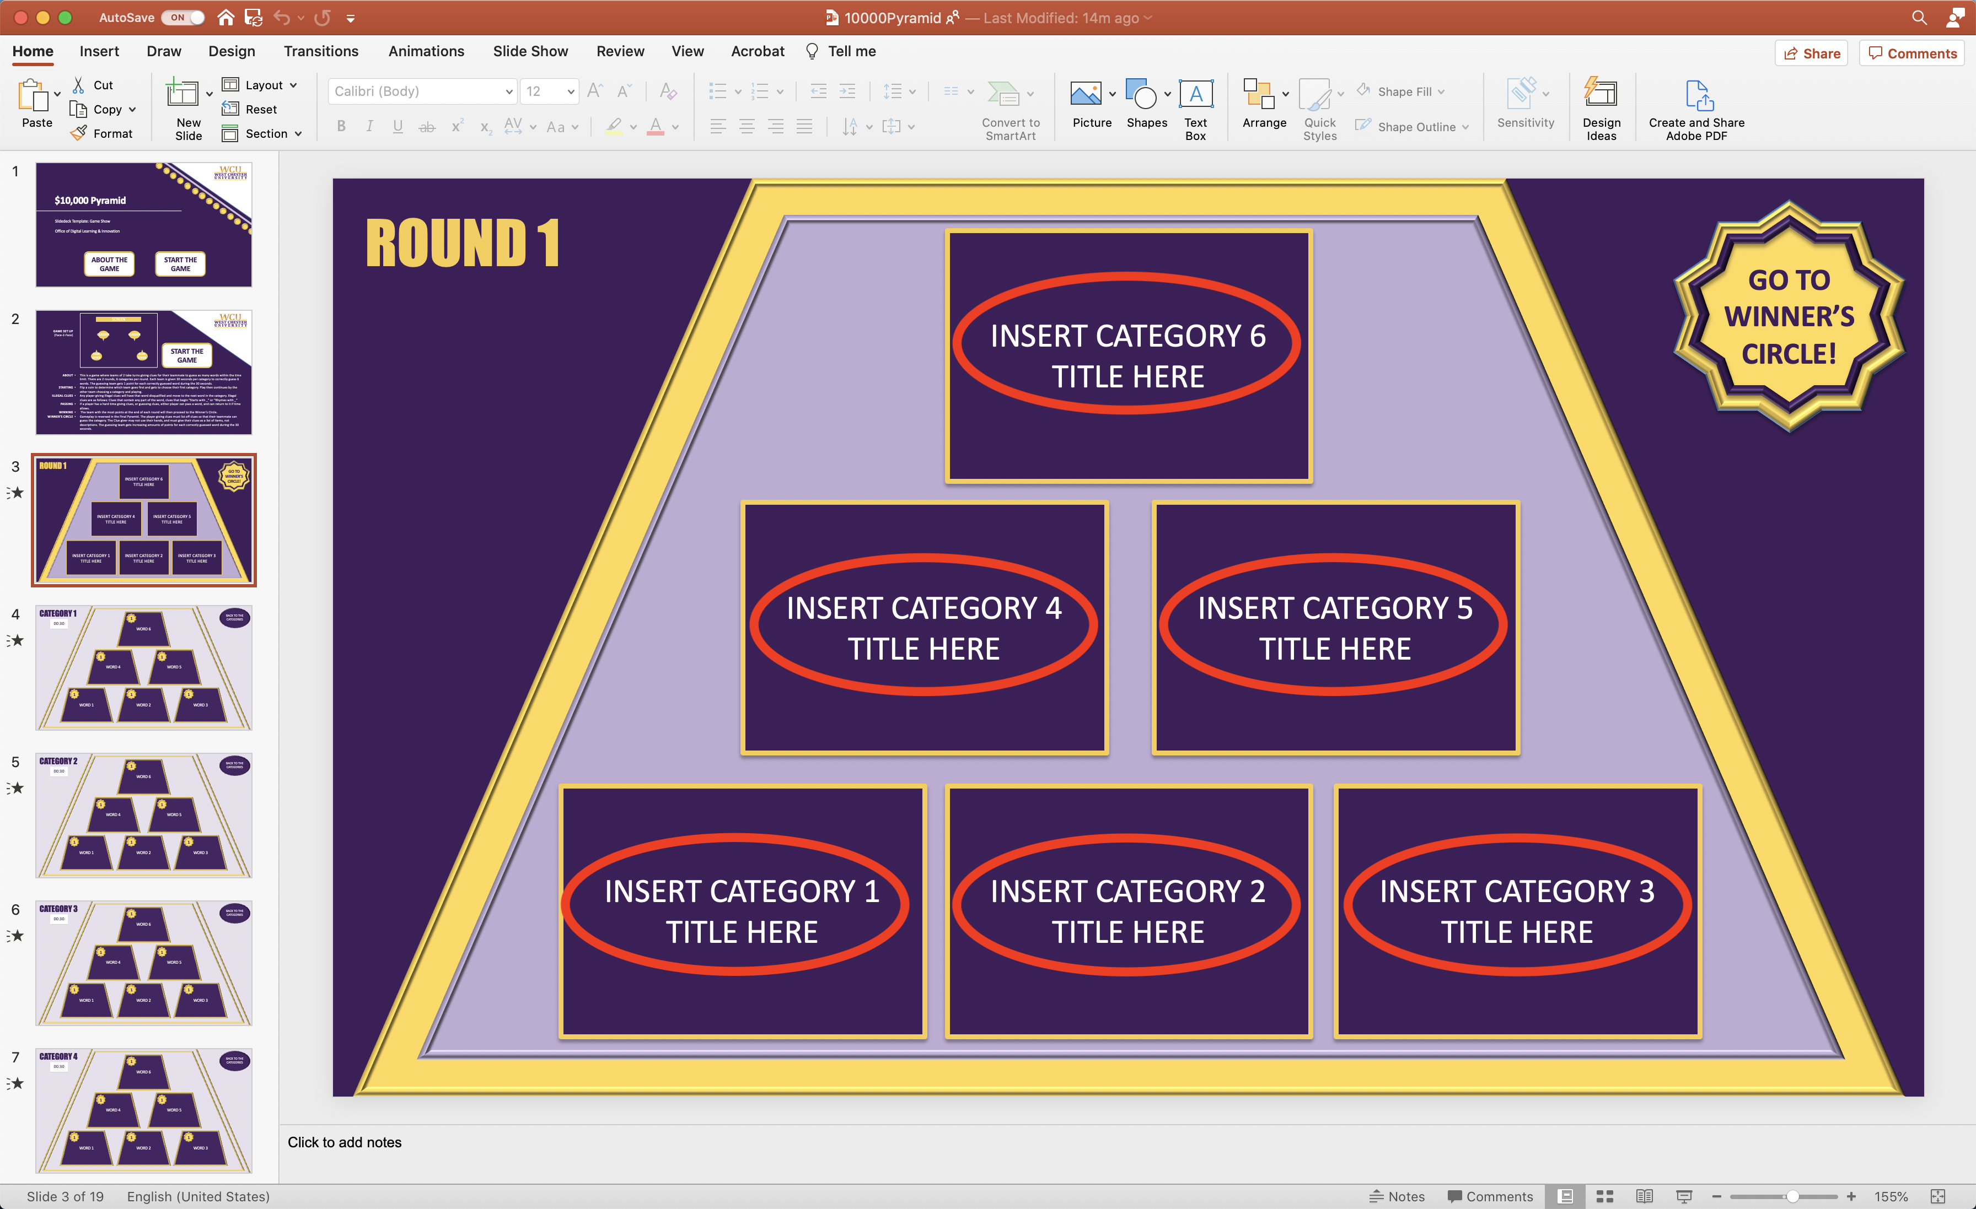
4-9 | Slides #4-9 Words: Each slide is associated to its matching category you labeled on slide #3. Click on each trapezoid to edit the word the team is attempting to guess that fits the category. Each of these trapezoids are linked to specific slides, so pleases do not delete or move them. | 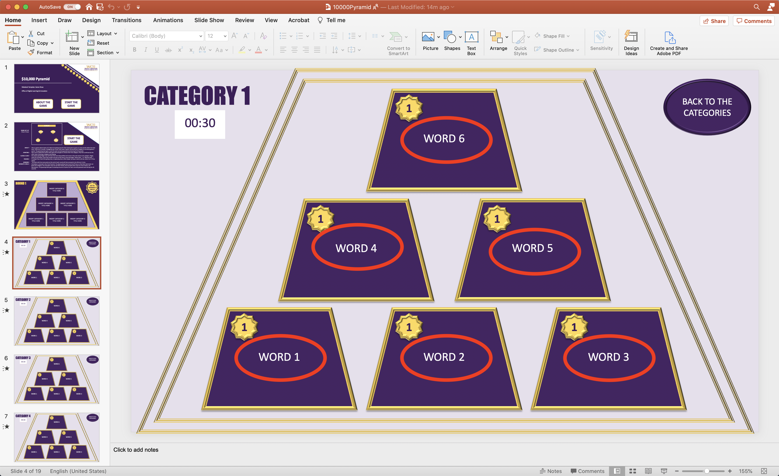
10 | Slide #10 Winner’s Circle: click on each trapezoid to replace the text in order to fill in the round’s winner circle categories the team will guess. Before the players were identifying terms with clues, now they are using terms to identify the category. | 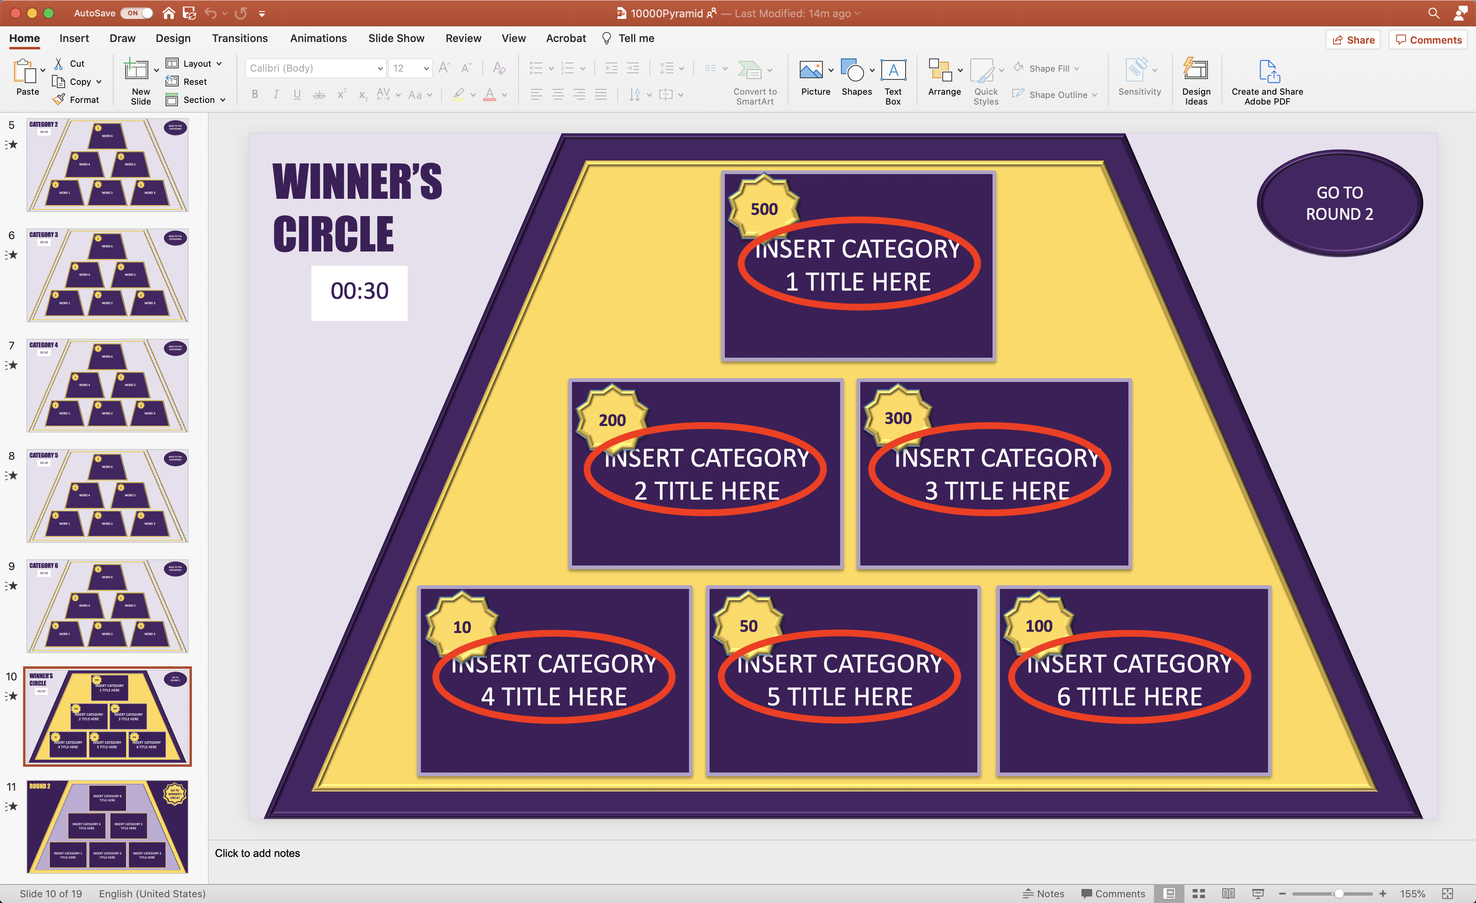
11 | Slide #11 Categories: Click on each rectangle to edit the text found inside. Each of these rectangles are linked to specific slides, so pleases do not delete or move them. Simply click once and replace the text with a content category that will be paired with six related terms for players to guess for Round 2. | 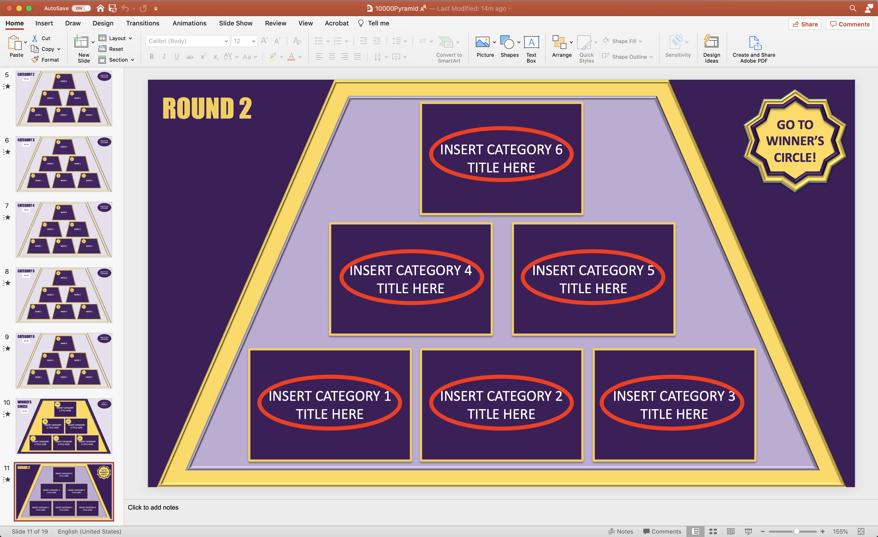
12-17 | Slides #12-17: Words: Each slide is associated to its matching category you labeled on slide #11. Click on each trapezoid to edit the word the team is attempting to guess that fits the category. Each of these trapezoids are linked to specific slides, so pleases do not delete or move them. | 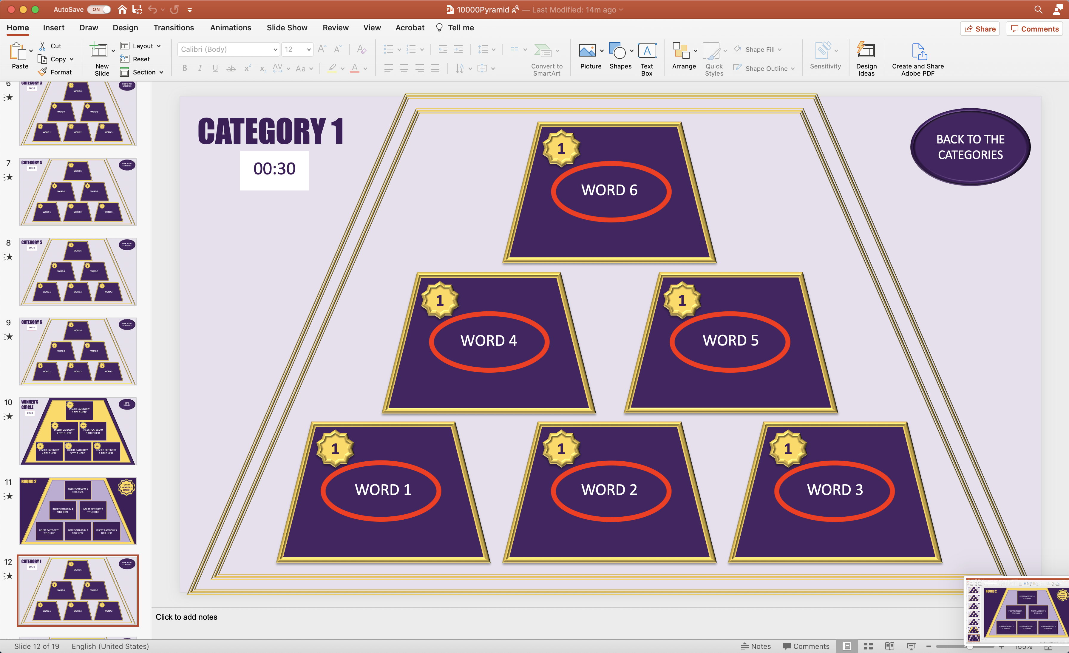
18 | Slide #18 Winner’s Circle: click on each trapezoid to replace the text in order to fill in the round’s winner circle categories the team will guess. Before the players were identifying terms with clues, now they are using terms to identify the category. | 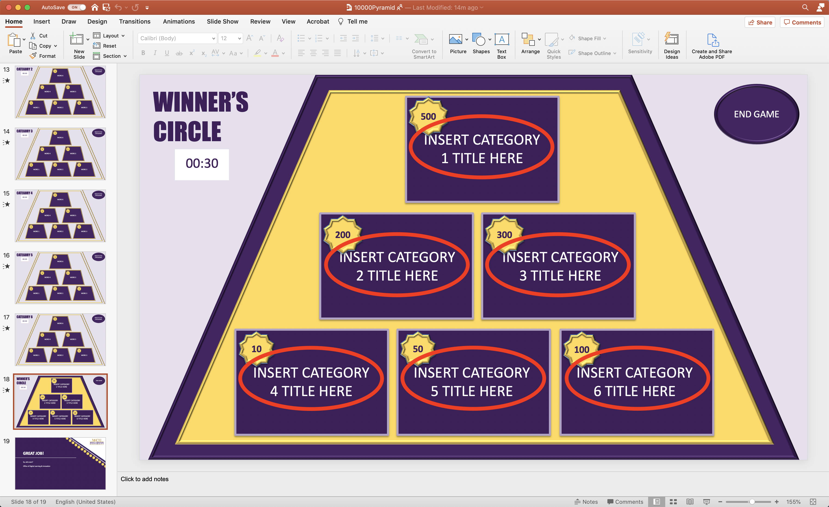
19 | Nothing to Edit | 