Family Feud

Game Template Instructions

When to use Family Feud in the Classroom?
Integrating Family Feud into a class-period is a type of Game-based learning. This game template can be used for just about any content area to review content categories with a series of terms to guess using clues. Not only can the game be great for review, but also the game-like learning style builds motivation and enthusiasm among the students.

How to play Instructional Family Feud?
- Divide the class into two teams.
- One member of each team faces the other in a face-off as the teacher reads the question off the game board.
- The team that buzzed in with the correct answer receives control of the board and has the option of playing or passing control to the other team.
- The team that has the control tries to reveal all the correct answers to the question before receiving three strikes. (If the answer is not on the board.
- If the team receives three strikes without clearing the board, control is passed to the other team.
- The team that now has the control can give one answer in the hopes that it is found on the board.
- If it is, points are added to the team’s score.
- If not, the other team gets the points.
- Points are collected as each team finds its answers to the question on the board. Keep score on your own.
- Continue the game repeating steps two through seven.
- Each team tries to collect the most points. The team with the most points wins the game!

How to edit the Template?
External Needed Materials: 30 second timer/stopwatch
- Before editing any content begin the Presentation slide show from the beginning and navigate through the slides in order to see how things appear initially. When you are playing you will be clicking on specific items to reveal new content or returned to previous slides.
  - You can also watch the navigation video to see what is clickable and how the game will look later.
- EDIT RED CIRCLED TEXT ONLY!
Slide Number(s) | Step/Editing Step | Slide Screenshot
1 | Nothing to Edit | 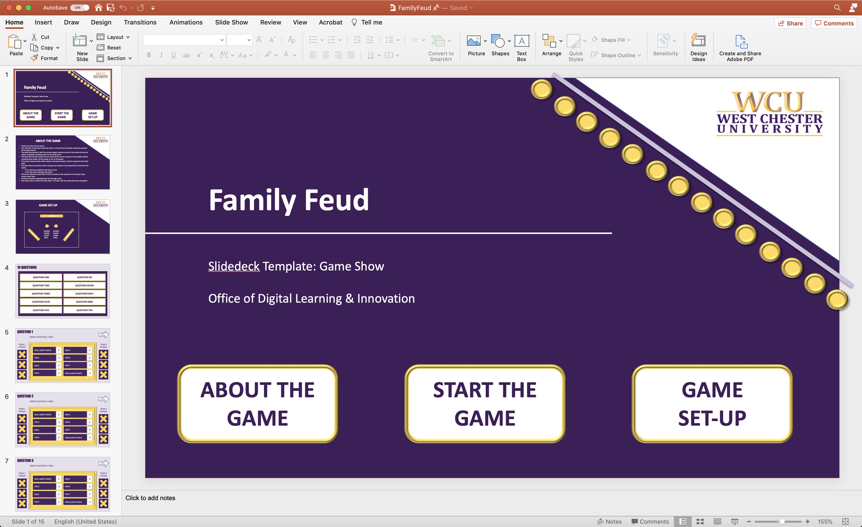
2 | Nothing to Edit | 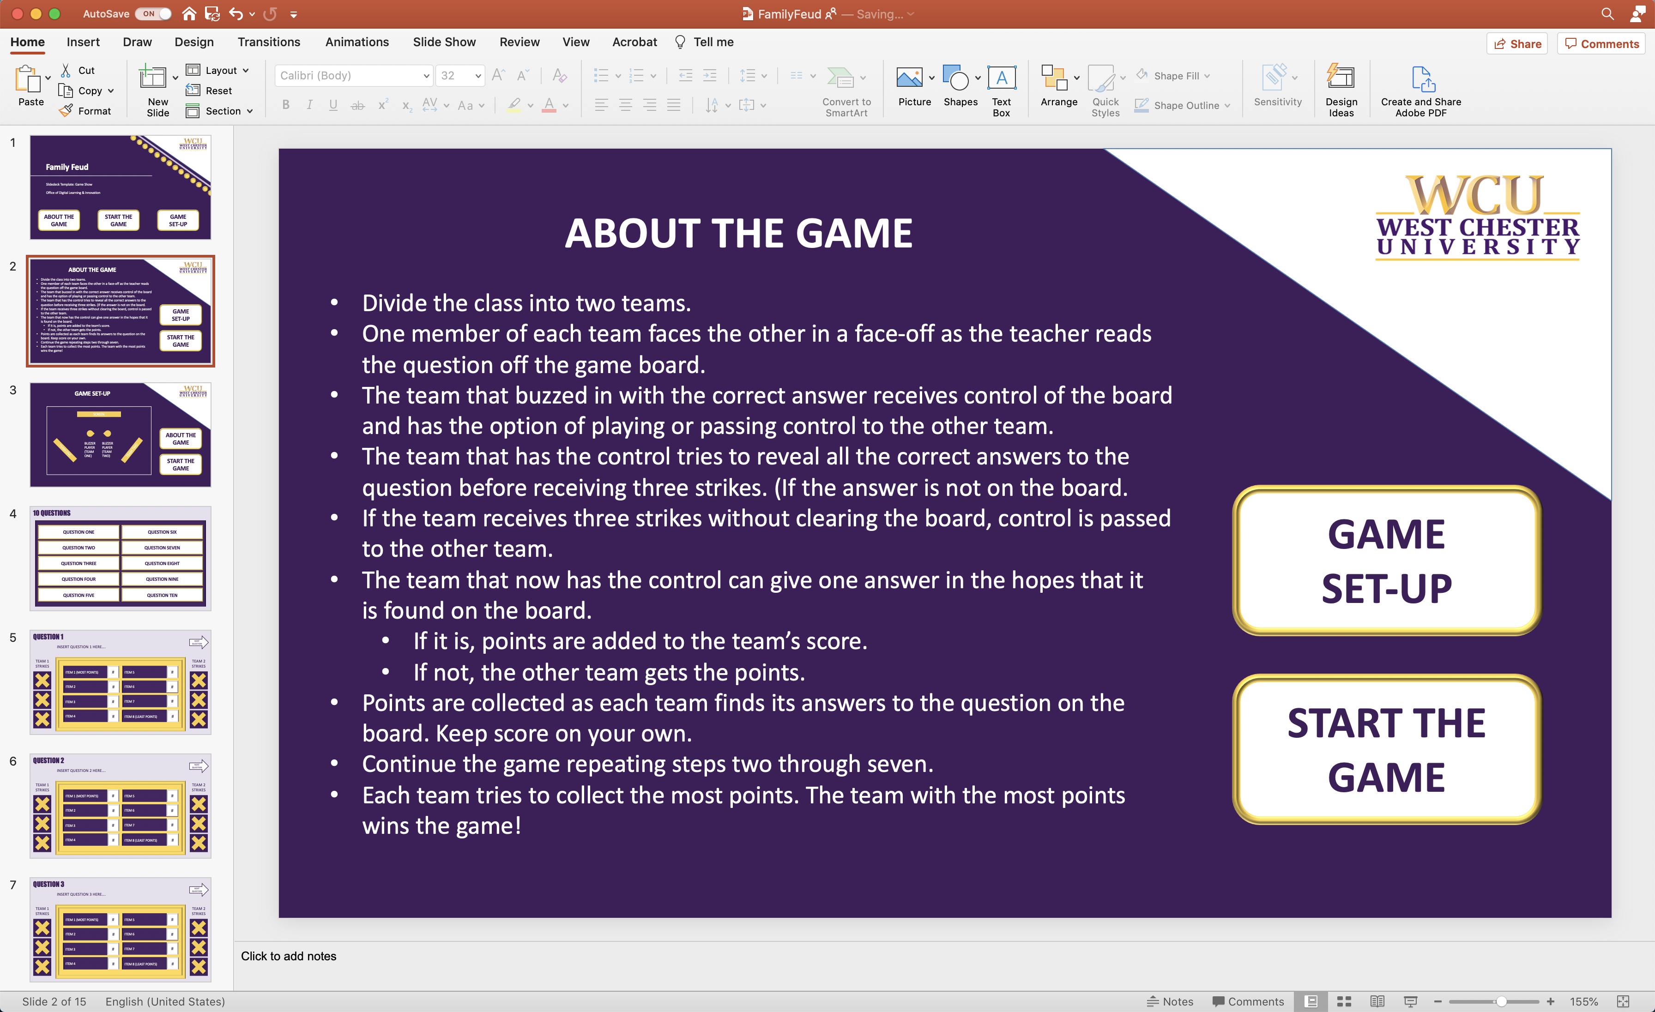
3 | Nothing to Edit | 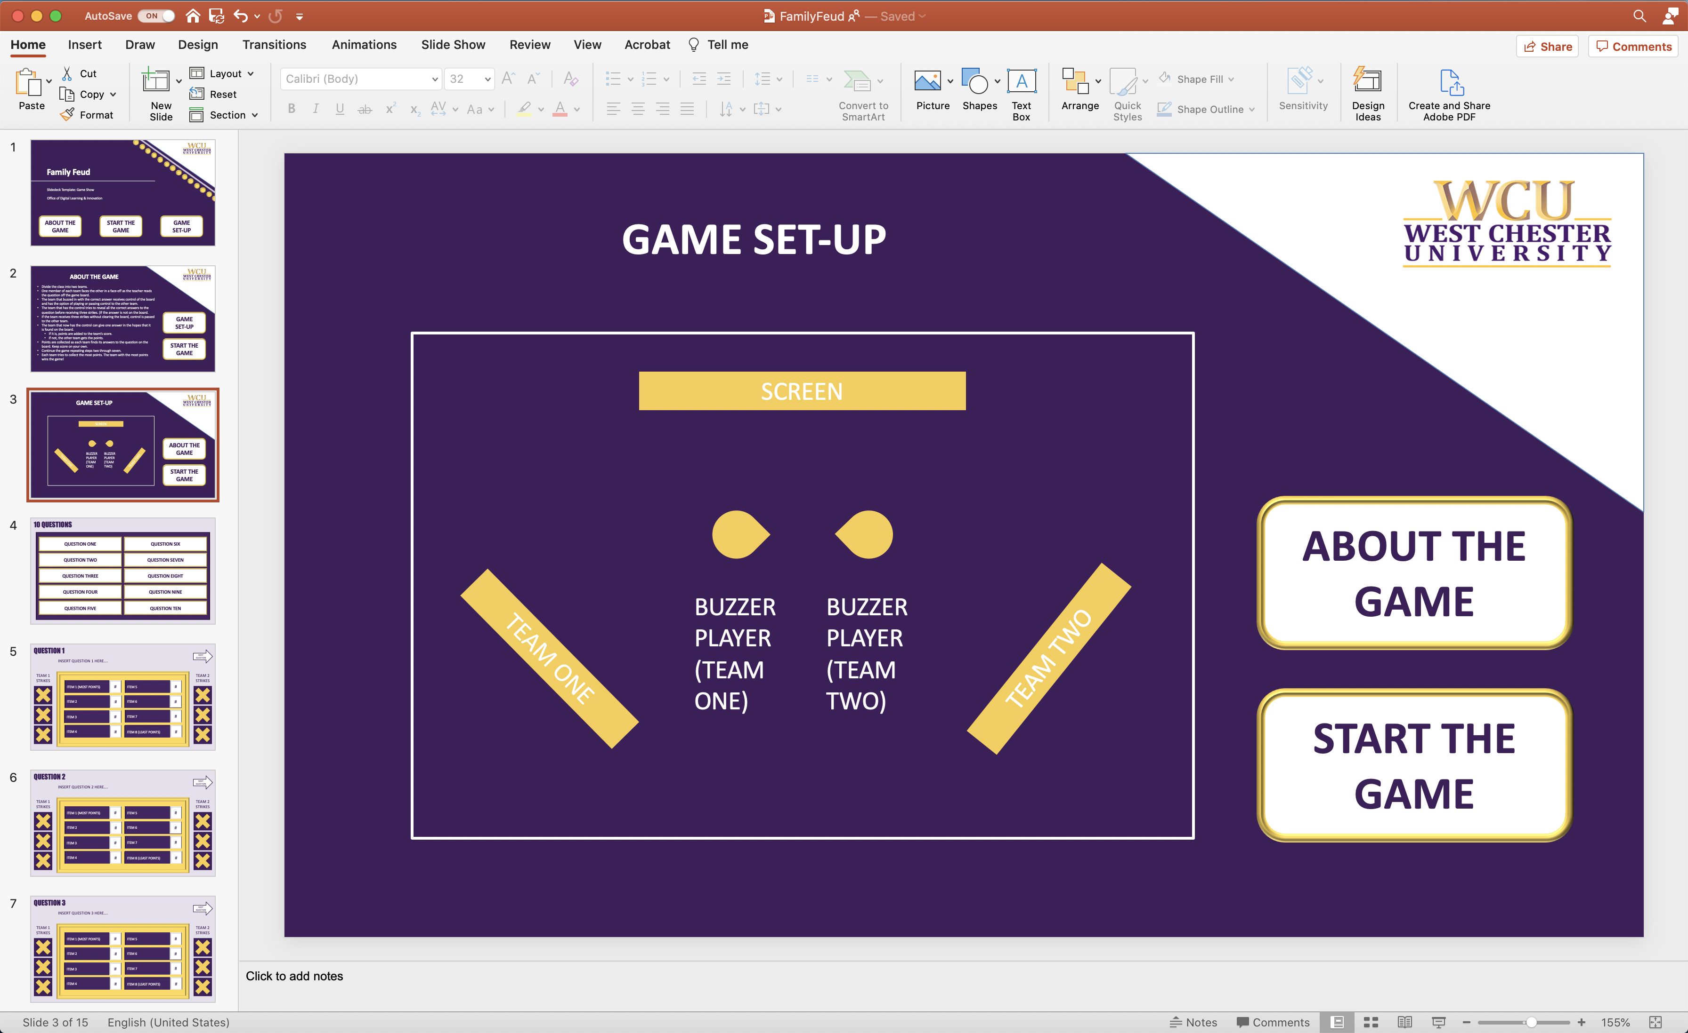
4 | Click on each rectangle to edit the “Question #” text. Replace text with your question. Repeat this for each question rectangle. You can change the font size, but please keep the size and position of the rectangle the same. Each of these rectangles are linked to specific slides, so pleases do not delete or move them. | 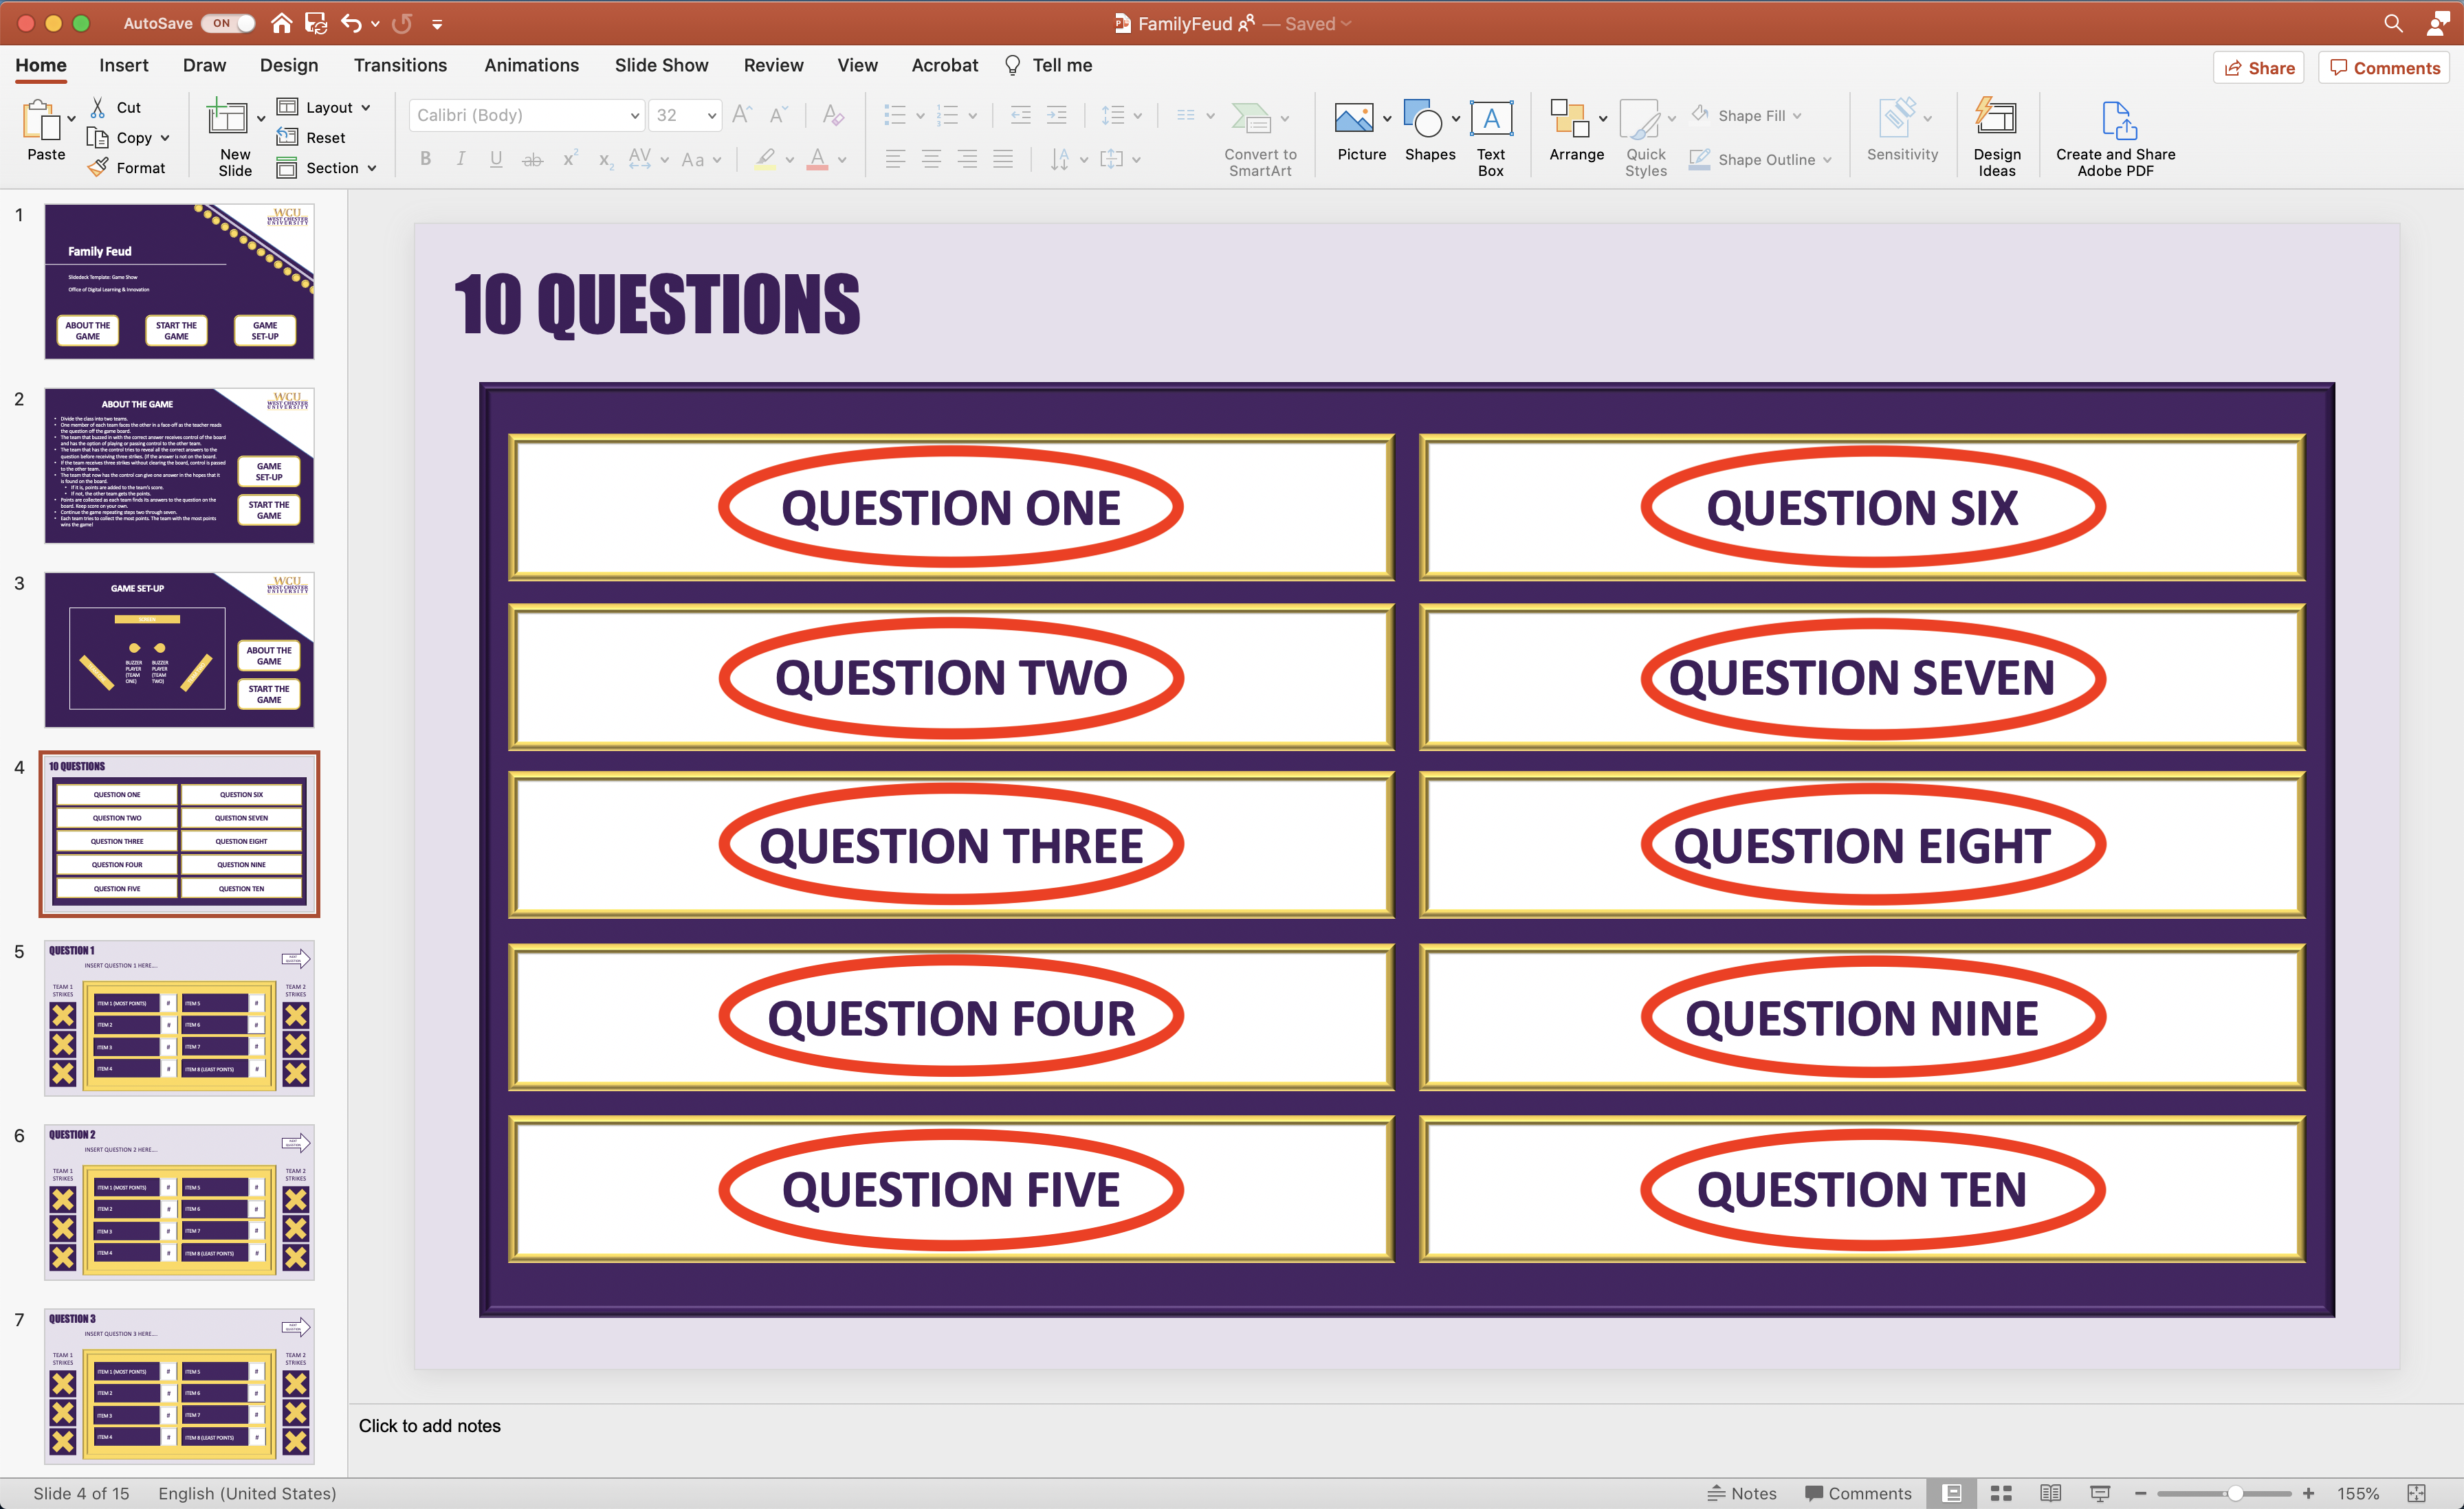
5-14 | - Click the text “Insert Question #” to edit and replace with the appropriate question that corresponds to the question on slide 4. For example, slide 5’s question will match “Question One” on Slide 4. Slide 6’s Question will match “Question Two” on Slide 4. Each of these rectangles are linked to specific slides, so pleases do not delete or move them.  - Click “Item #” to edit the item that corresponds to the question on the slide. These items are ranked by value, so the most important “item” is in the top left position, and the least important is in the bottom right.  - Click “#” to edit the value of each item to the right of it. Give each item a value of points depending on its importance to the question. | 1.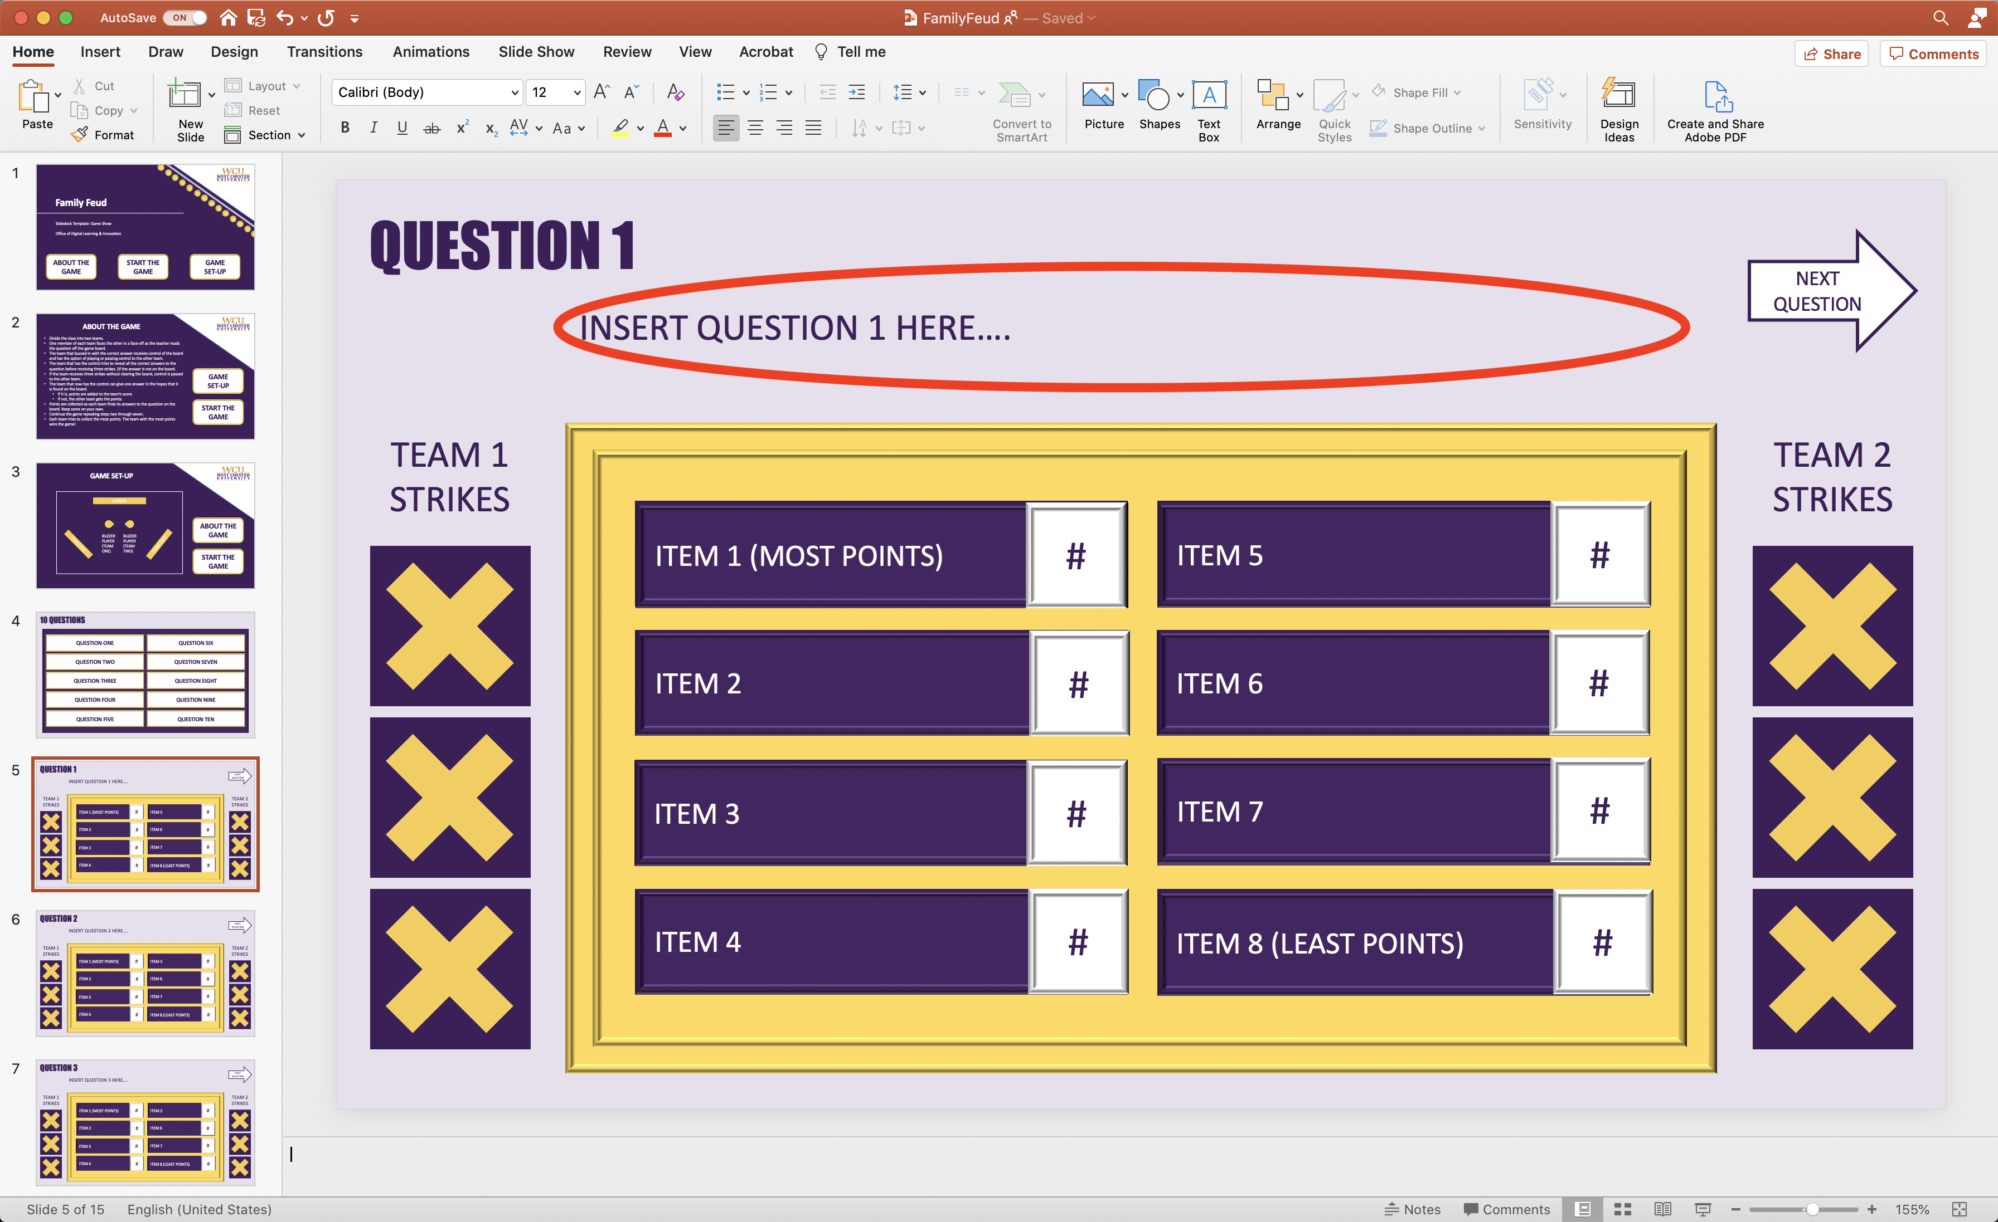  2.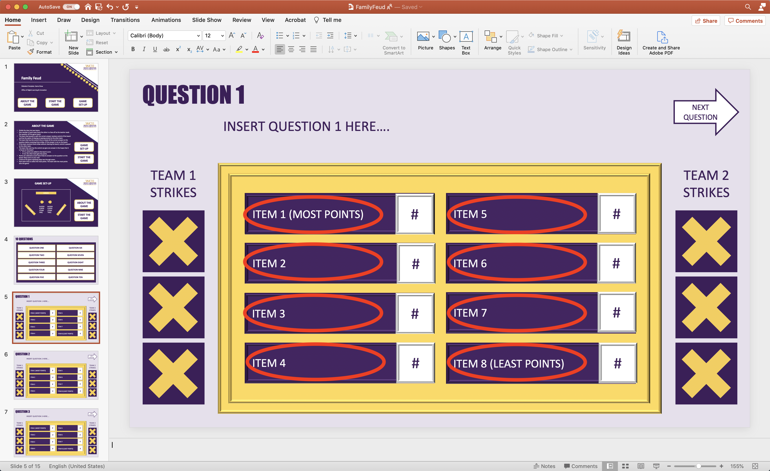  3.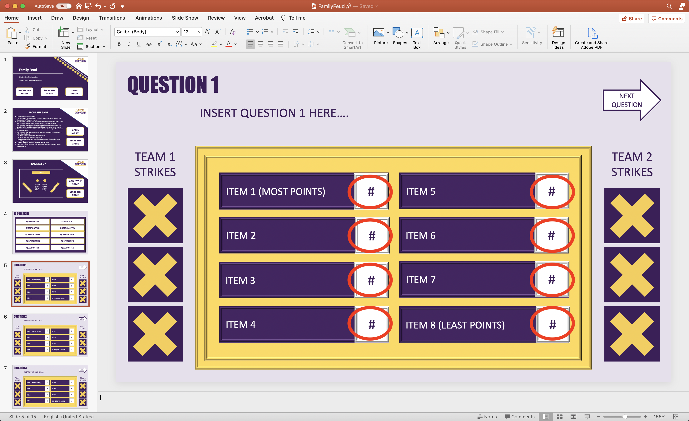
15 | Nothing to Edit | 