Hollywood Square

Template Instructions

When to use Hollywood Square in the Classroom?
Integrating Hollywood Squares into a class-period is a type of Game-based learning. This game template can be used for just about any content area to review a series of terms, questions, procedures and more. Not only can the game be great for review, but also the game-like learning style builds motivation and enthusiasm among the students.

How to play Instructional Hollywood Squares?
- Divide your class into two teams. Team X and Team Z
- Once you start the game, you will need to click through the introduction of characters until you reach the slide with all characters.
- Flip a coin to determine which team goes first.
- The team picks a square.
- Click on the character in that square to see their question. For review have the team state/guess their answer before revealing the character’s answer.
- Click “Answer” to see the answer given by that character.
- The team must agree or disagree with the answer the character has given.
- If the team is correct, they will get the square. If the team is wrong, their opponent will get the square.
- Click on the home button on the slide with the character answer to return the slide with all characters on it ("Home").
- Click the light purple "X" or "Z" in the gold box to highlight the team that won that square.
- To win, the team either gets three in a row (across, vertical or diagonal) or has 5 squares.
- Calculate who won and click “End the Game” when you have revealed and answered all questions.

How to edit the Template?
- Before editing any content begin the Presentation slide show from the beginning and navigate through the slides in order to see how things appear initially. When you are playing you will be clicking on specific items to reveal new content or returned to previous slides.
  - You can also watch the navigation video to see what is clickable and how the game will look later.
- EDIT RED CIRCLED TEXT ONLY!
Slide Number(s) | Step/Editing Step | Slide Screenshot
1 | Nothing to Edit | 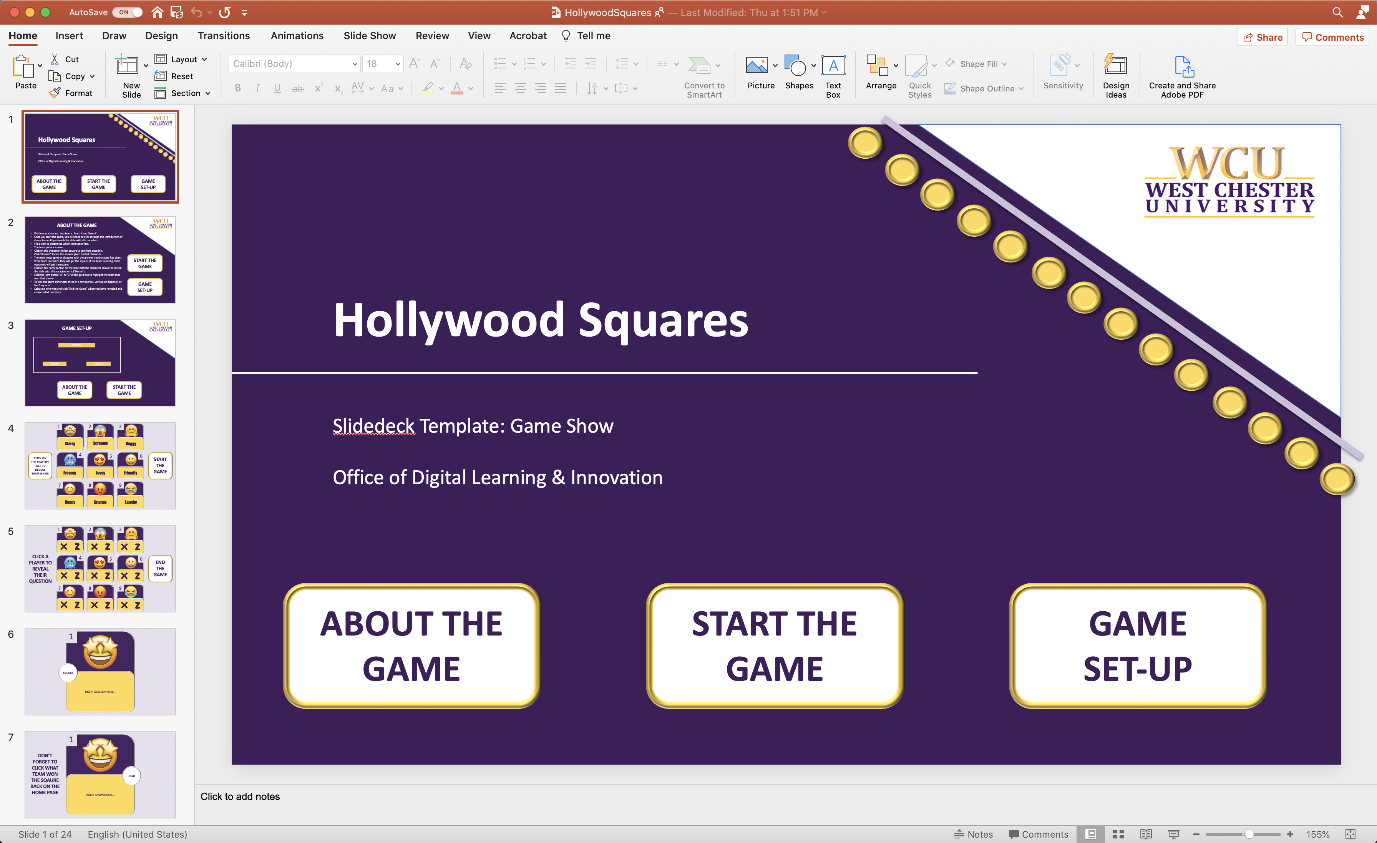
2 | Nothing to Edit | 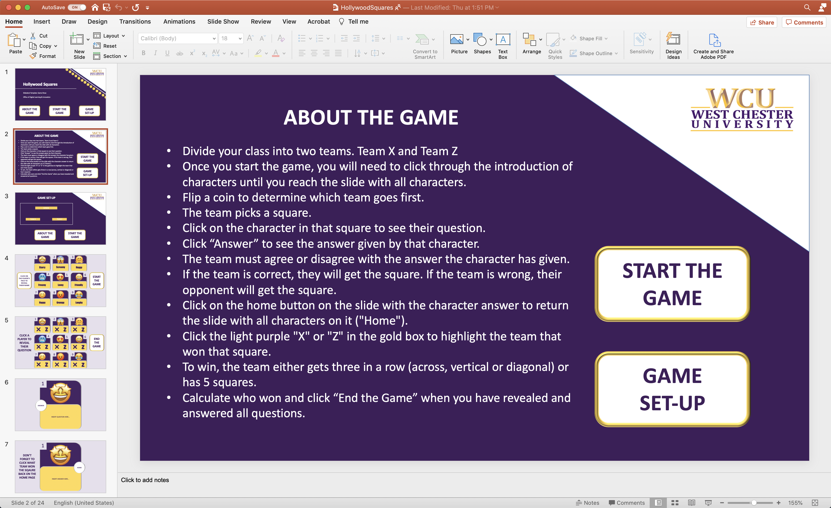
3 | Nothing to Edit | 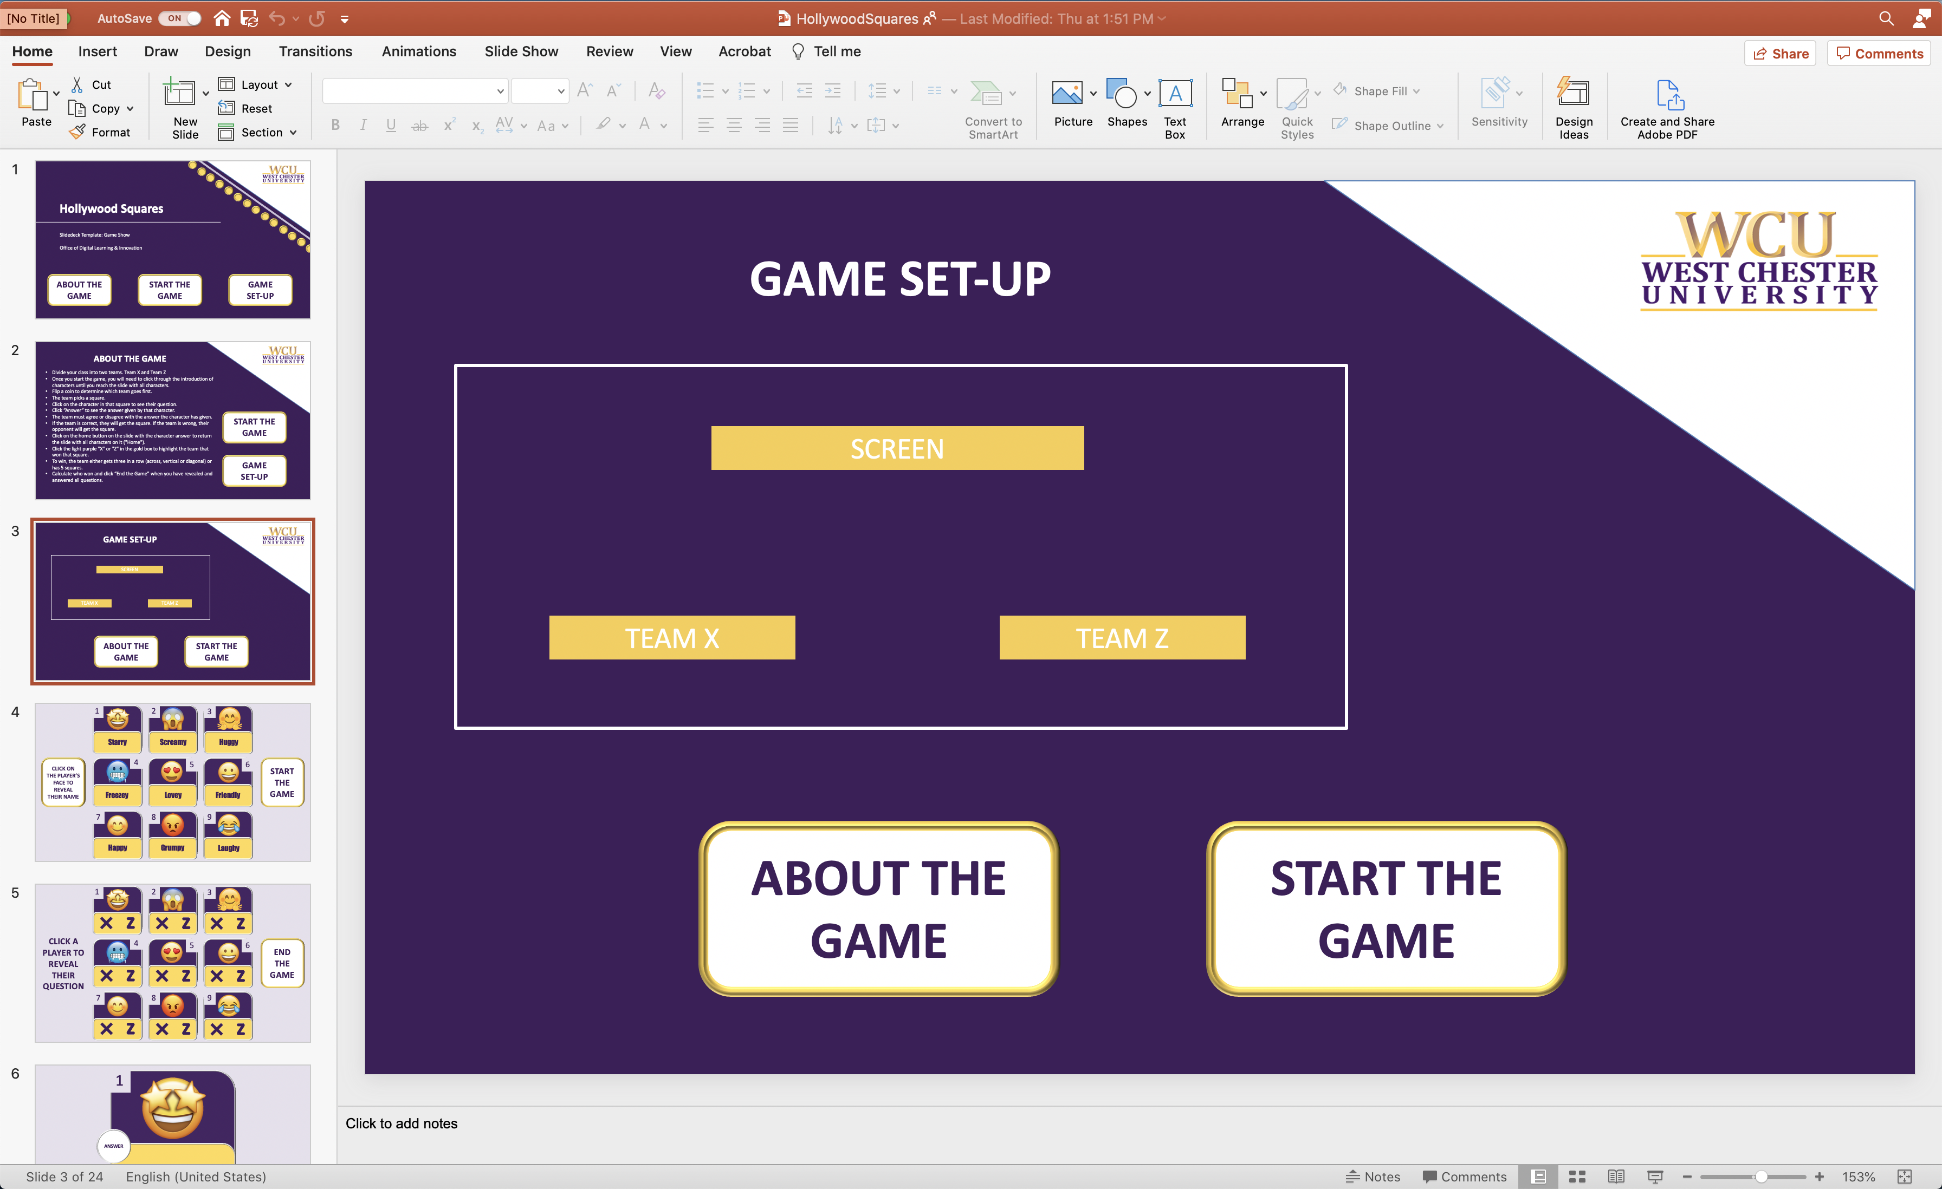
4 | - If you would like to Edit the characters: each character image is linked to its name, so when it is clicked the name appears. To change each character image, you will need to know how to link the name to the image. SEE BELOW FOR DETAILED INSTRUCTIONS.  - To edit the character names: click on the name and replace the text. Make sure not to delete the text box because it is linked to other content on the slide. | 1.  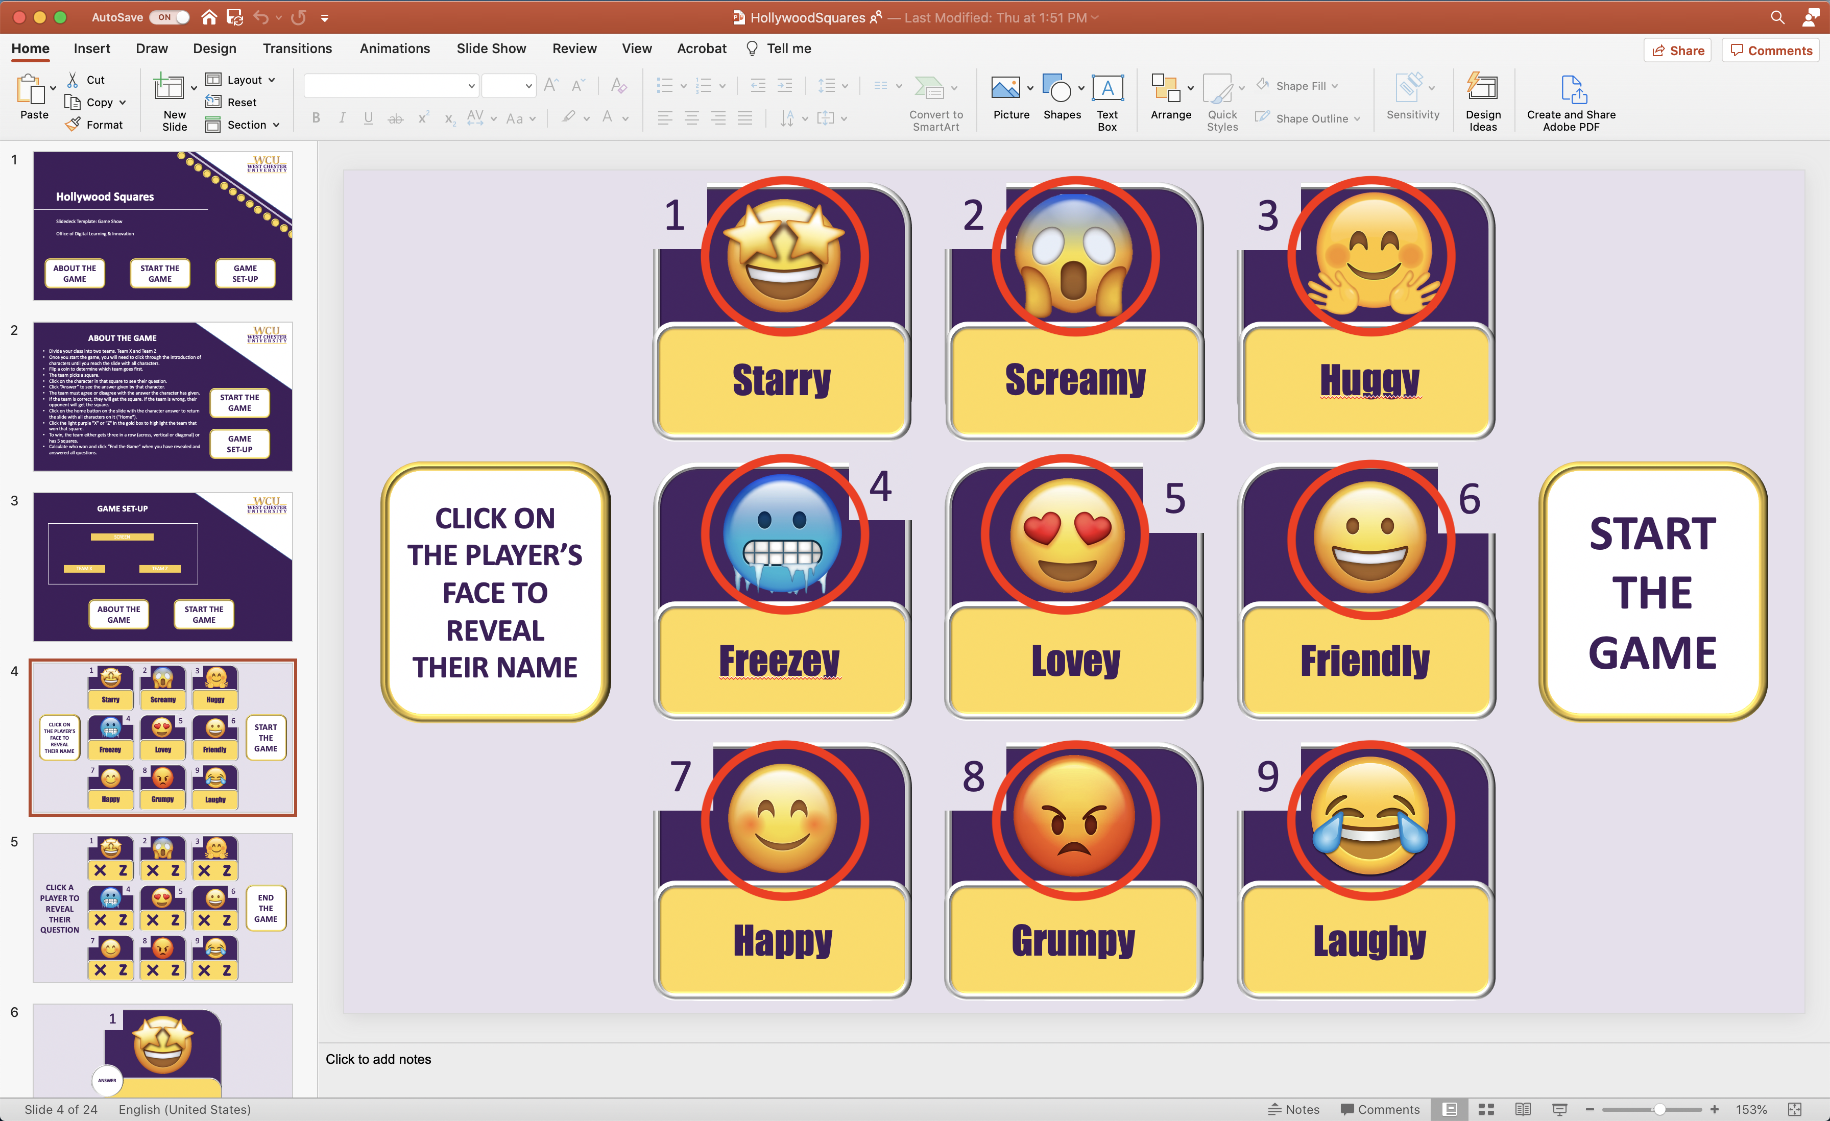  2.  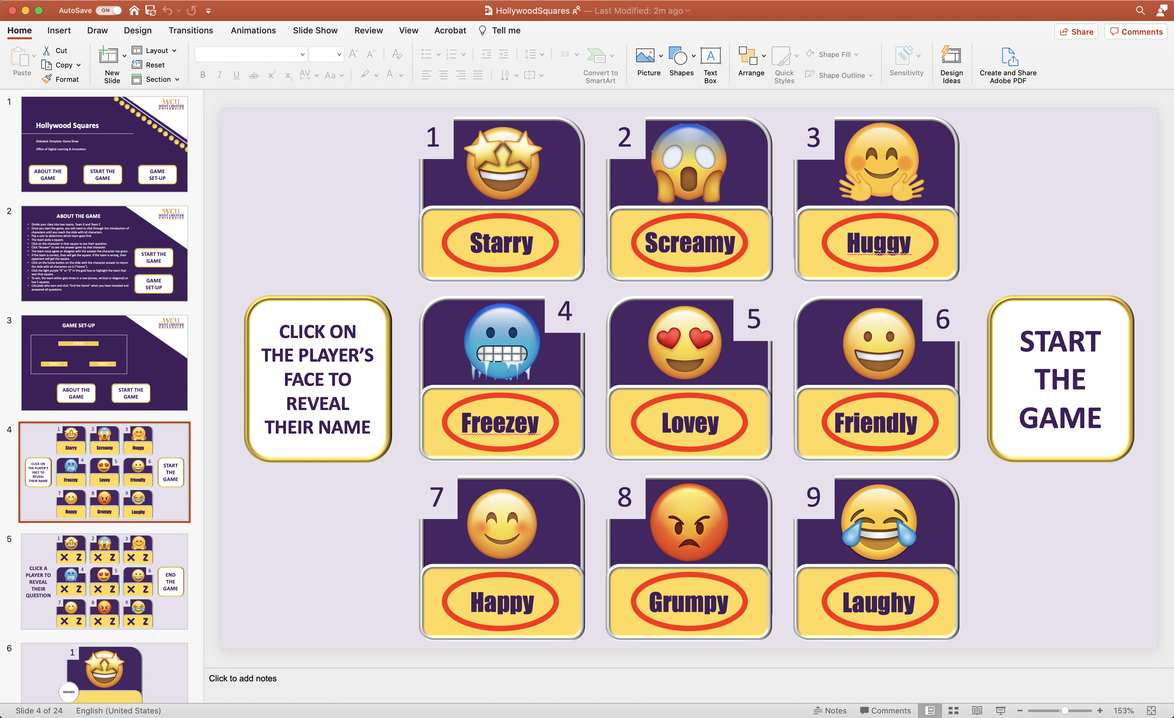
5 | Nothing to edit (unless changing characters)  Follow slide 4 instructions to edit the characters. Please make sure you understand how link slide items to specific slides before editing these. If you do not, please contact the Office of Digital Learning and Innovation at distanceed@wcupa.edu | 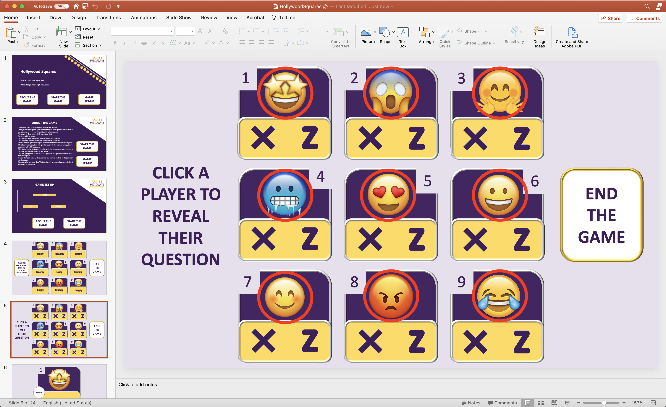
6, 8, 10, 12, 14, 16, 18, 20, & 22 | Click “INSERT QUESTION HERE...” to edit and replace the text with a course appropriate question.  Have students answer the question before revealing the character’s answer by clicking “ANSWER” | 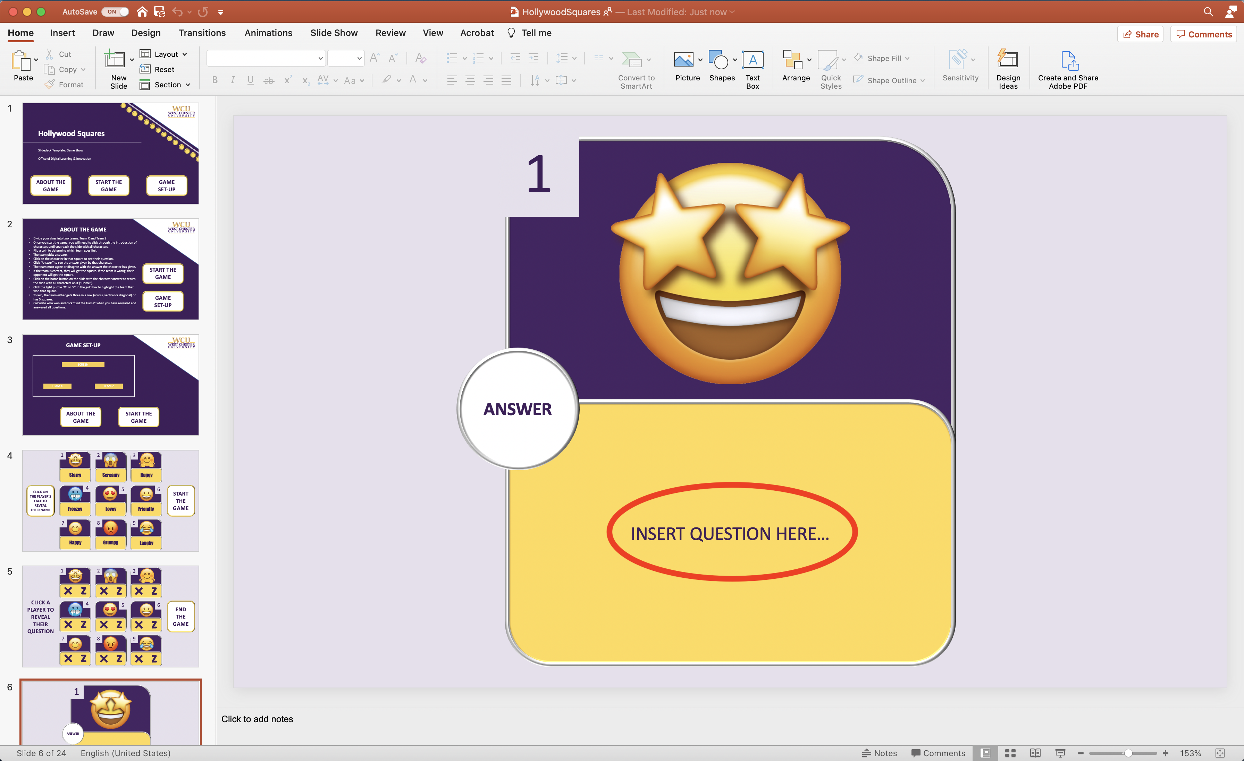
7, 9, 11, 13, 15, 17, 19, 21, & 23 | Click “INSERT ANSWER HERE...” to edit and replace the text with the character’s answer. This does not have to be the correct answer to the question because students will be working with their team to determine if they agree or disagree with it. | 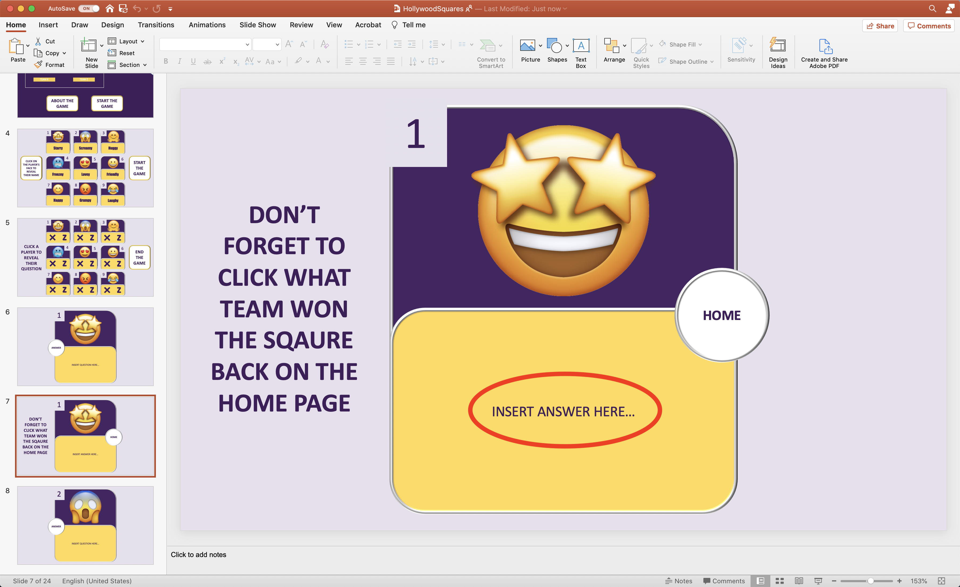
24 | Nothing to Edit | 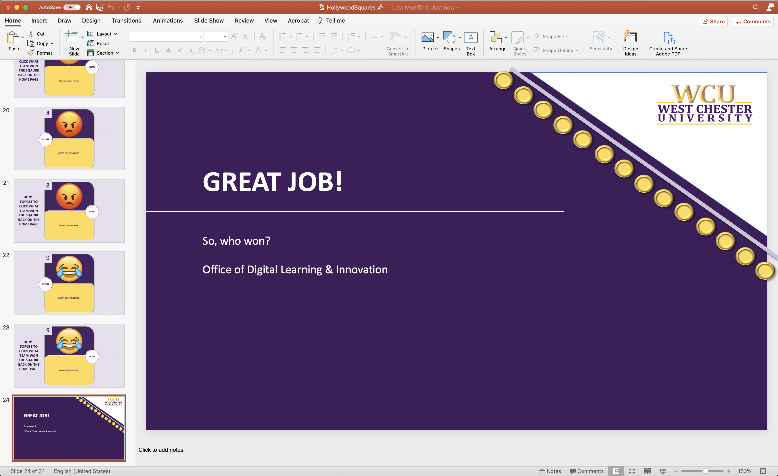

How to edit the Characters?
Step | Slide Screenshot
- Select all Character images and delete them. | 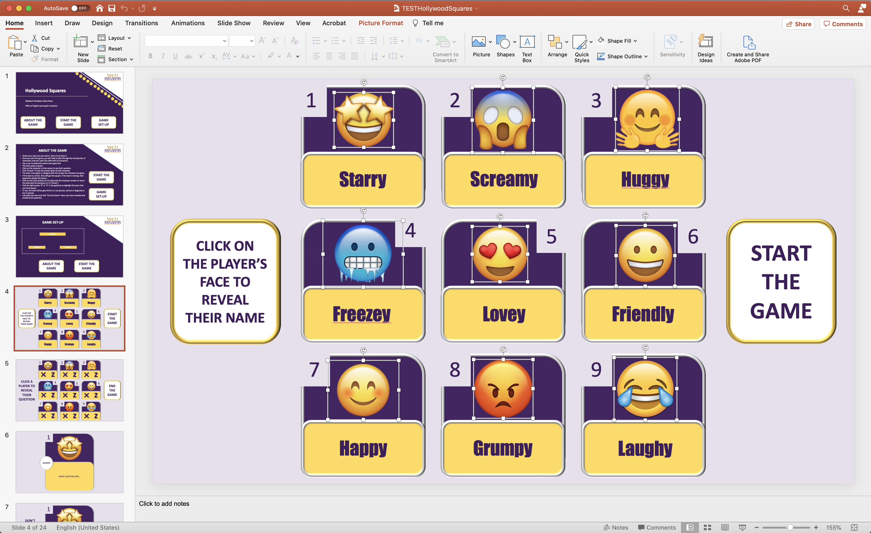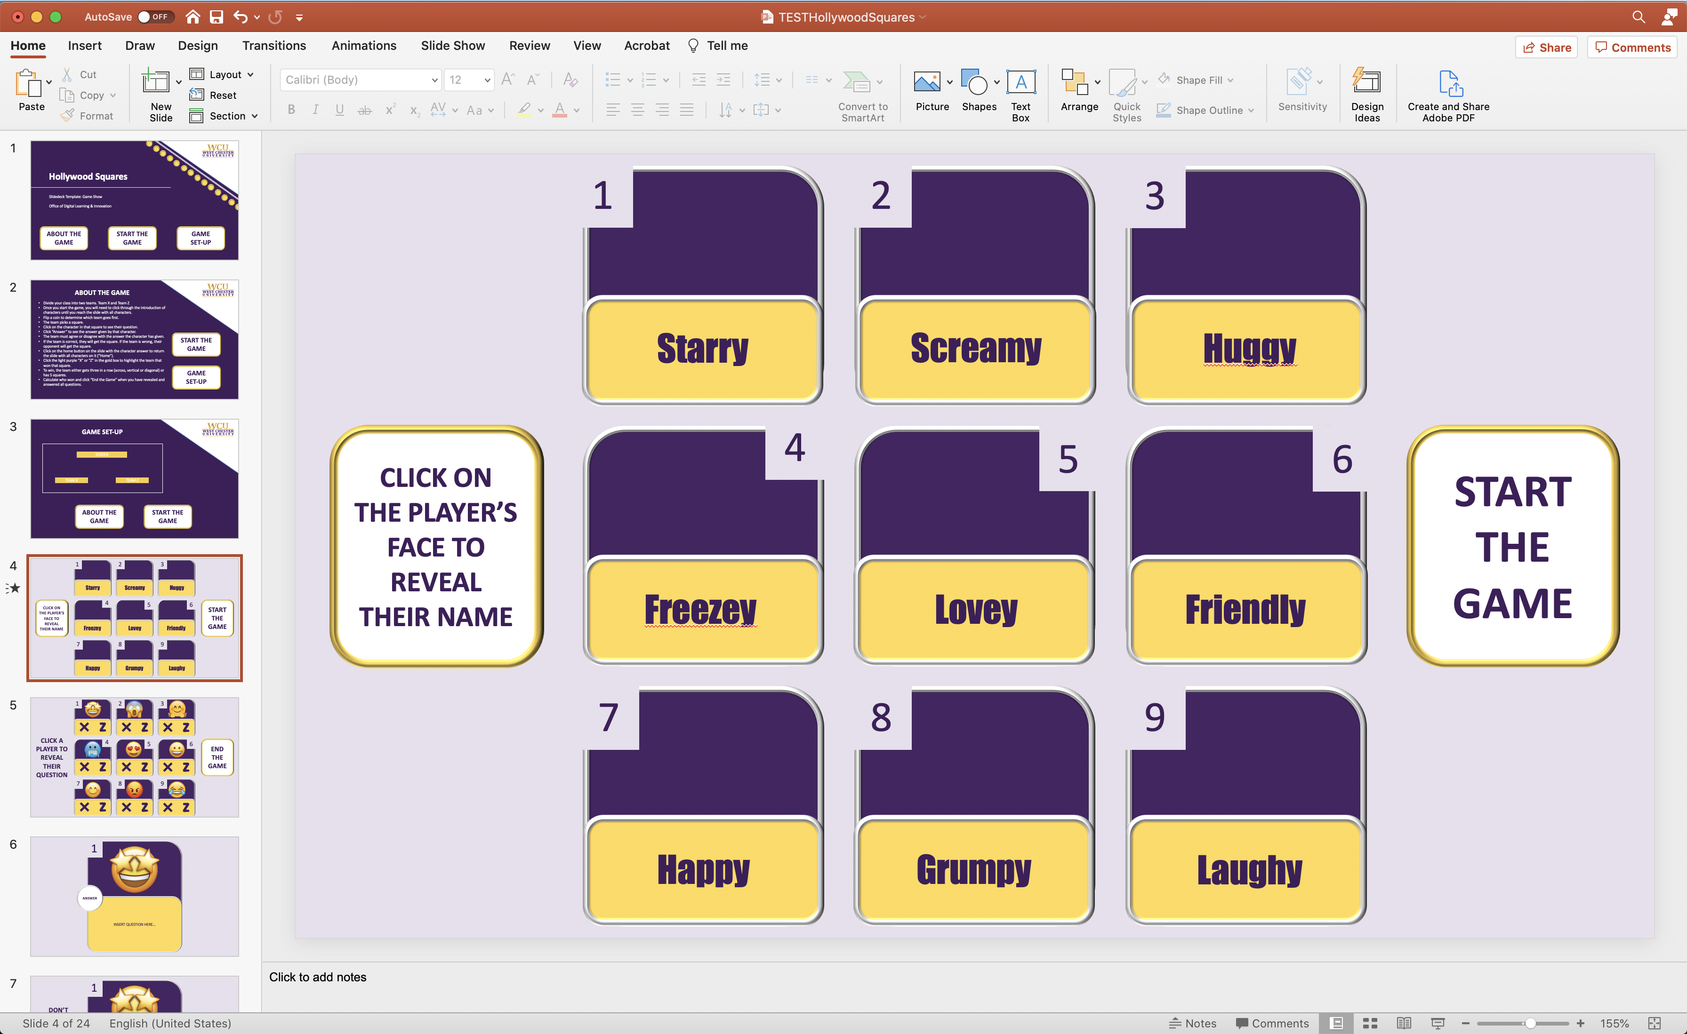
- Drag and drop new character images in appropriate squares. Adjust size when needed. | 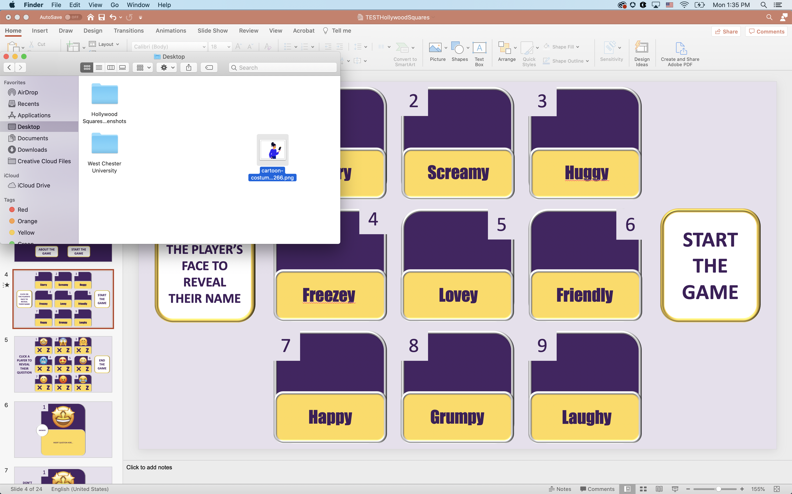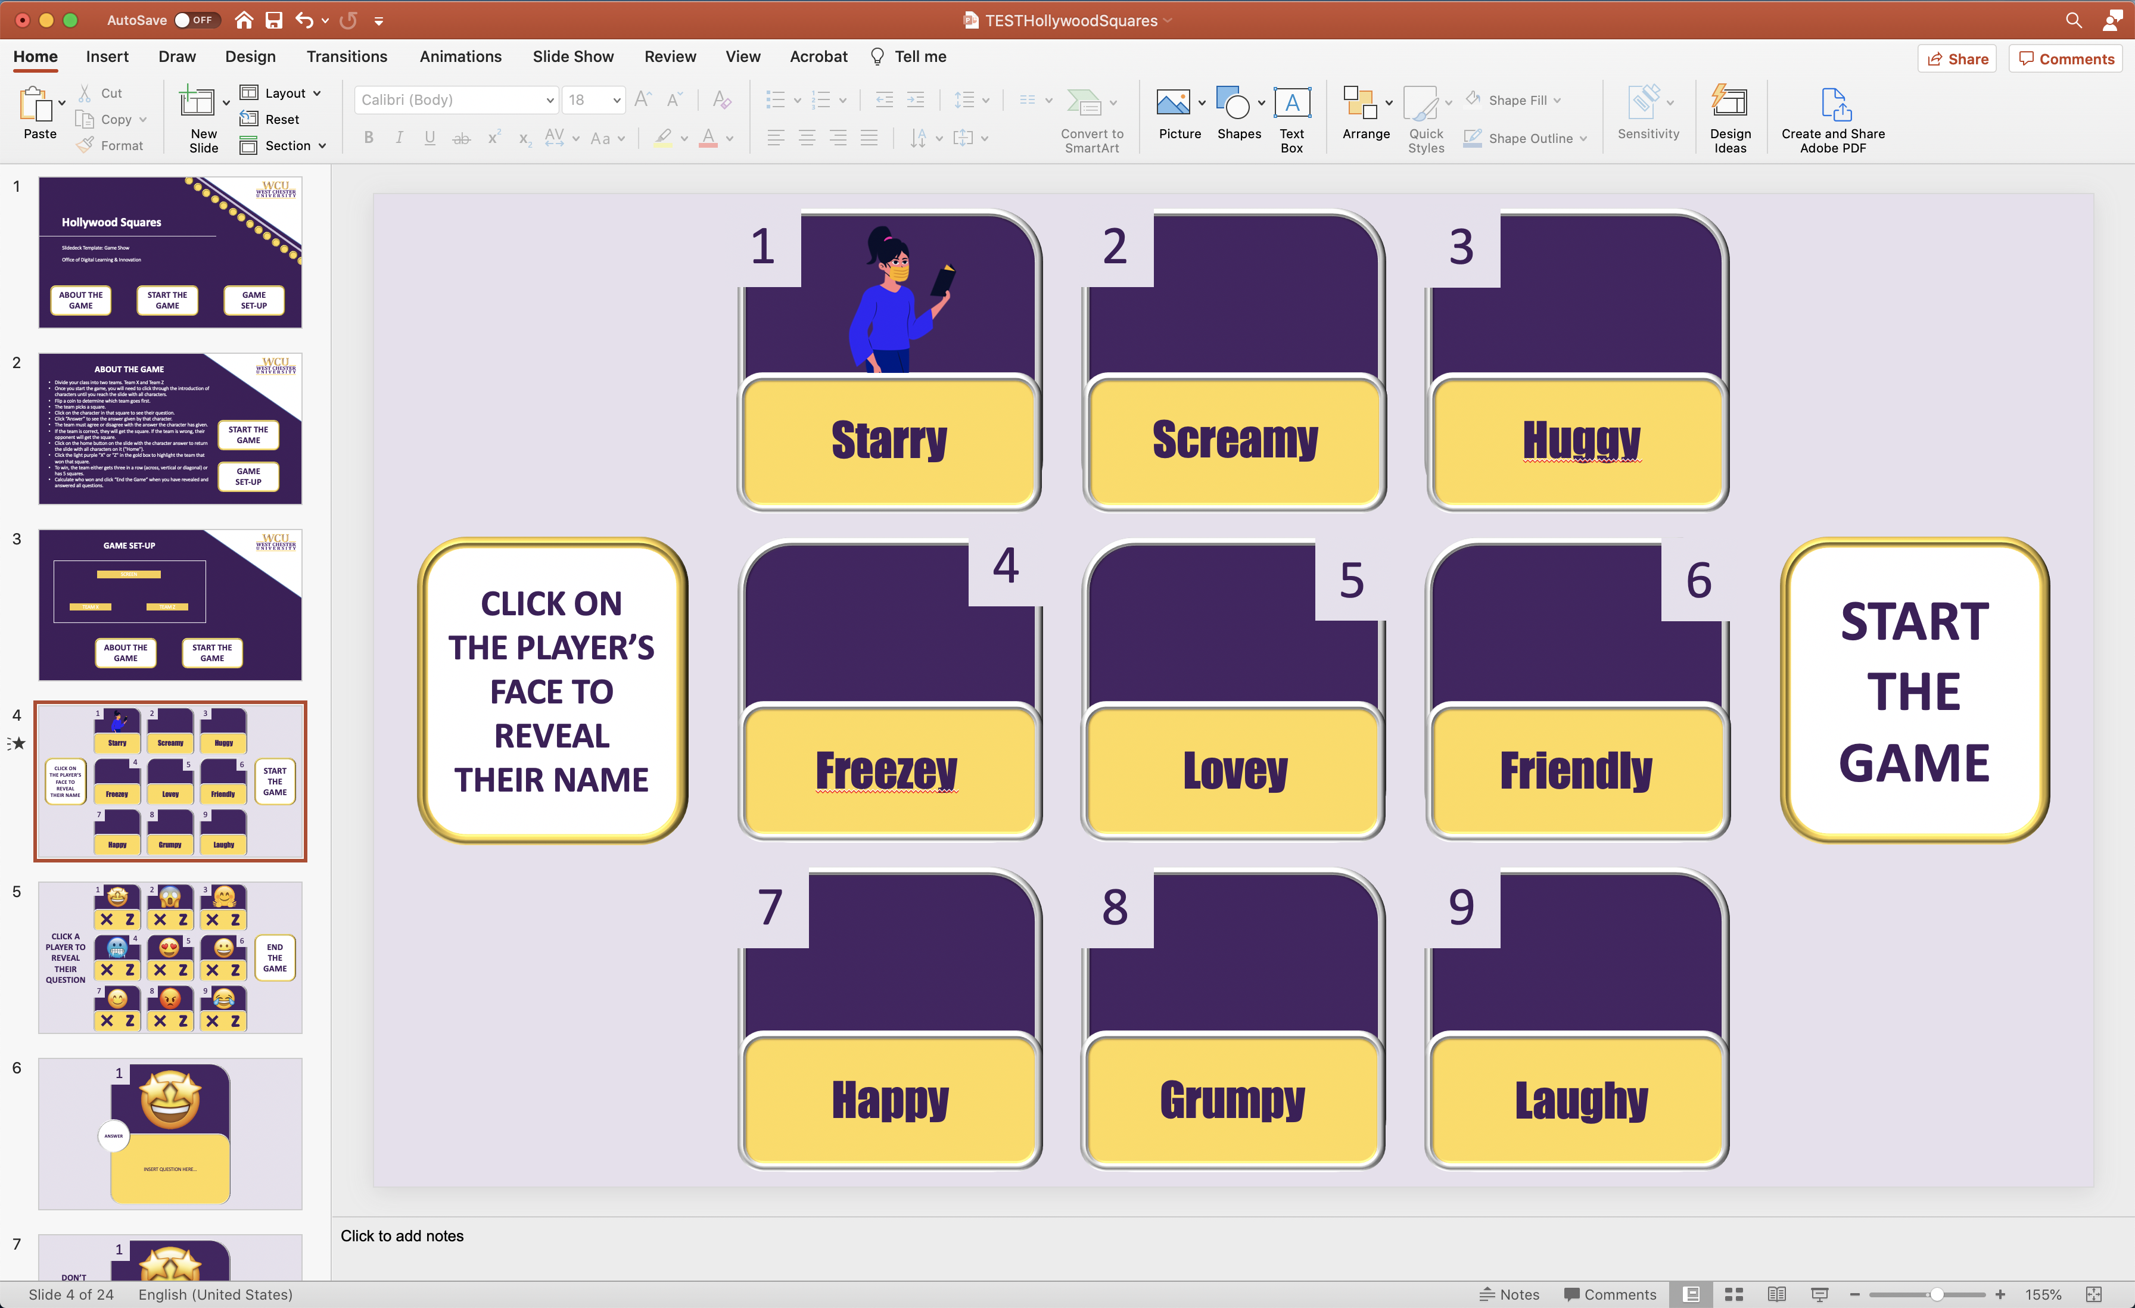
- Click on “Animations” in the top PowerPoint edit menu bar. | 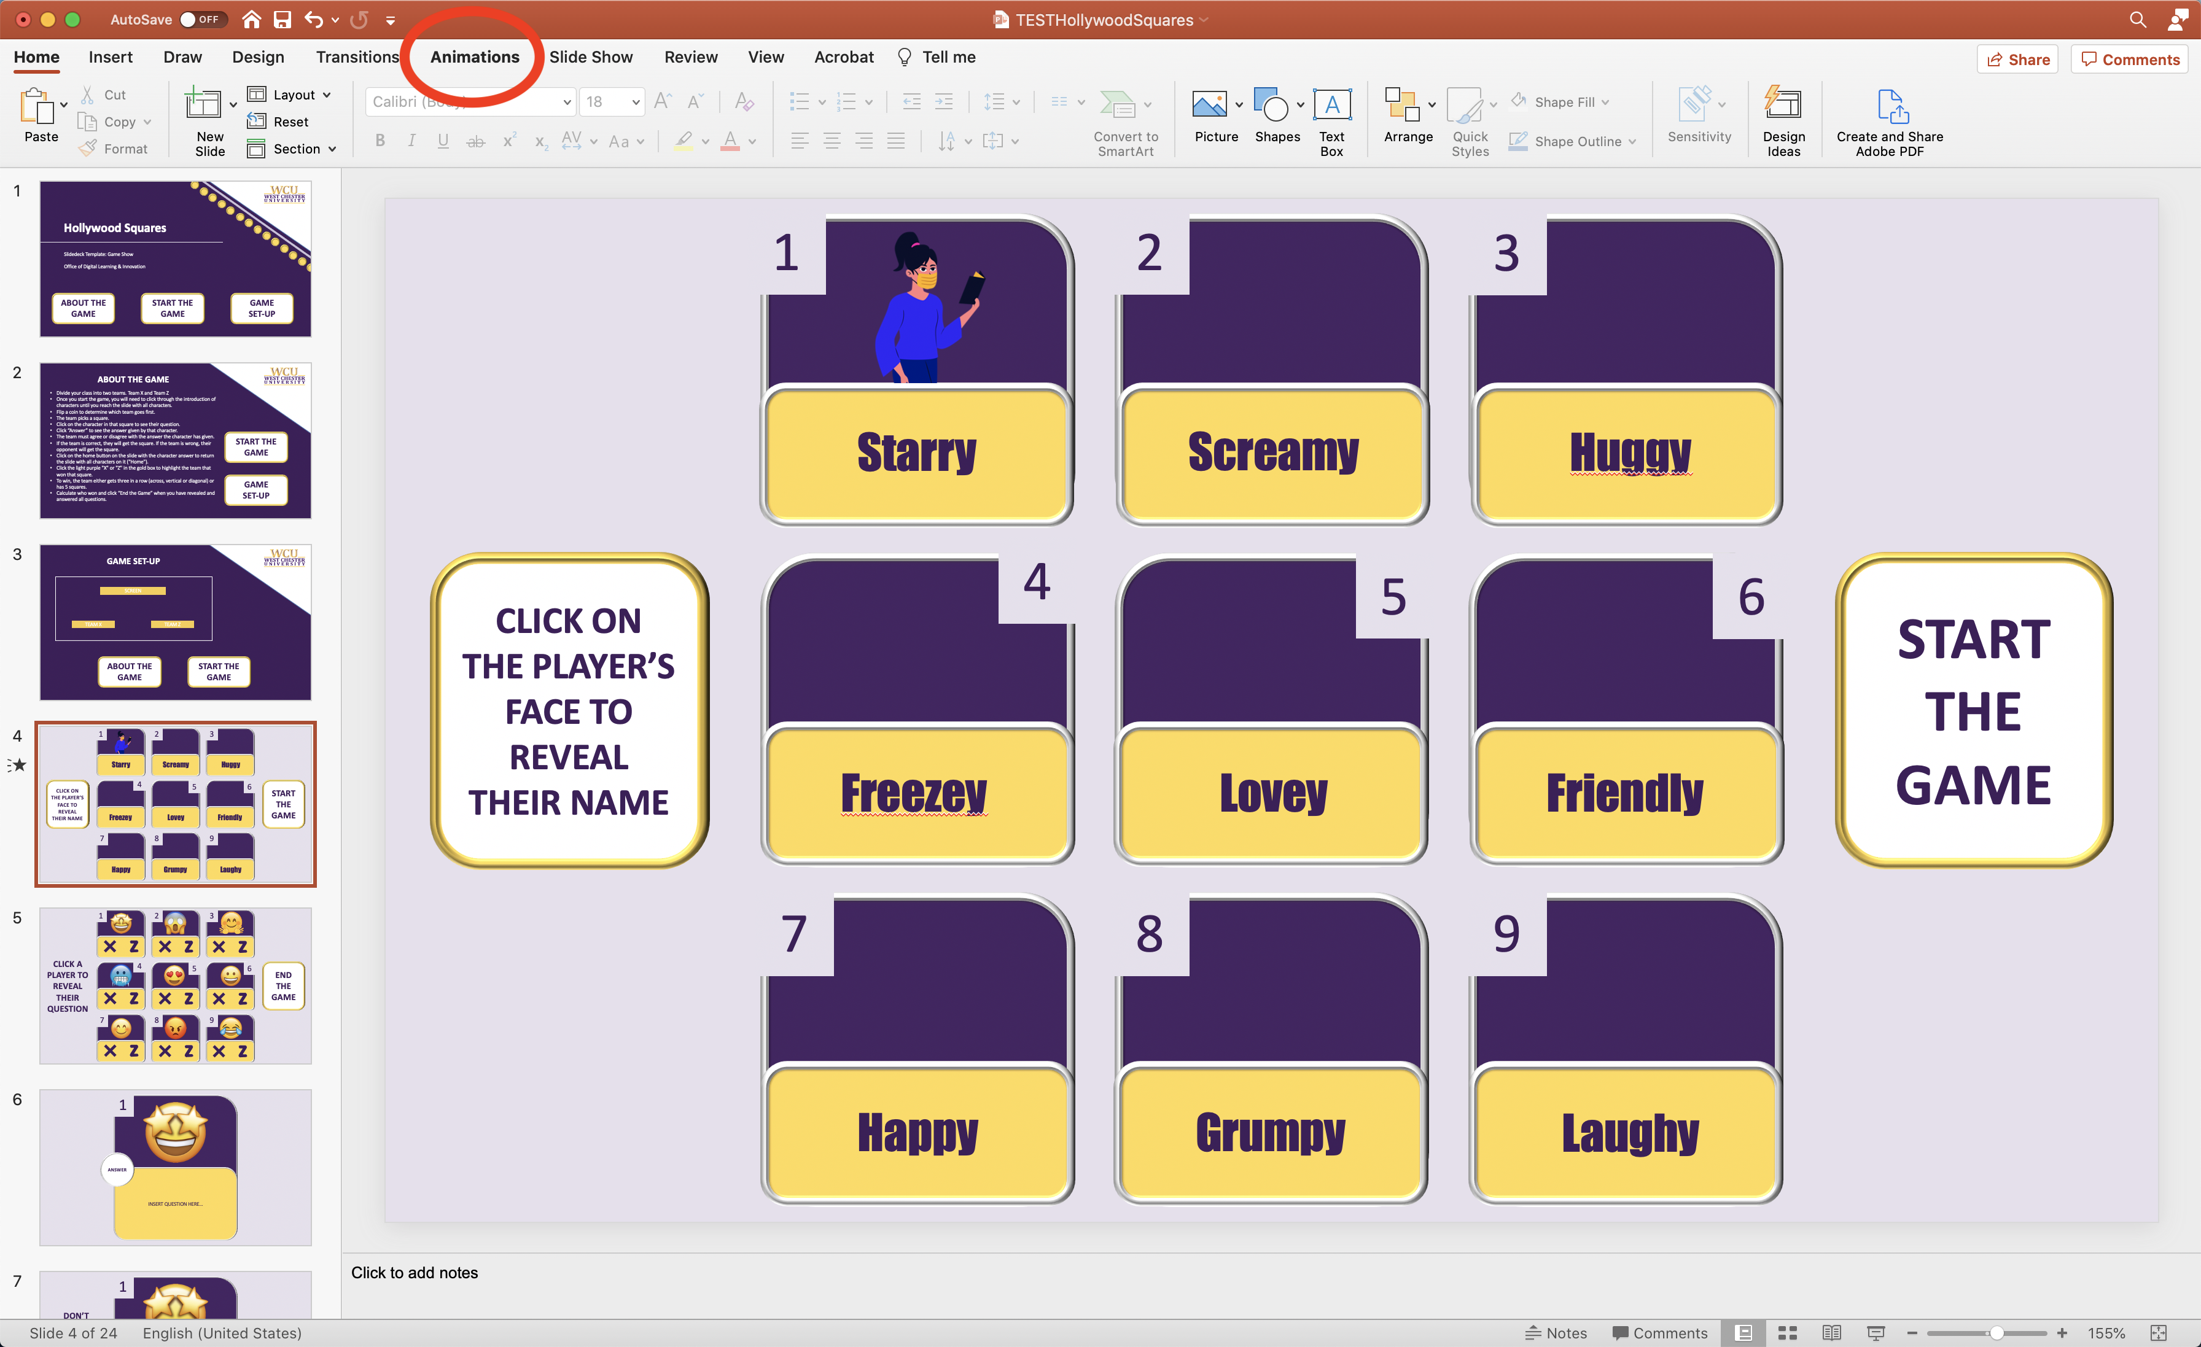
- Click “Animation Pane” to reveal the side animations panel menu (listing all existing animations). | 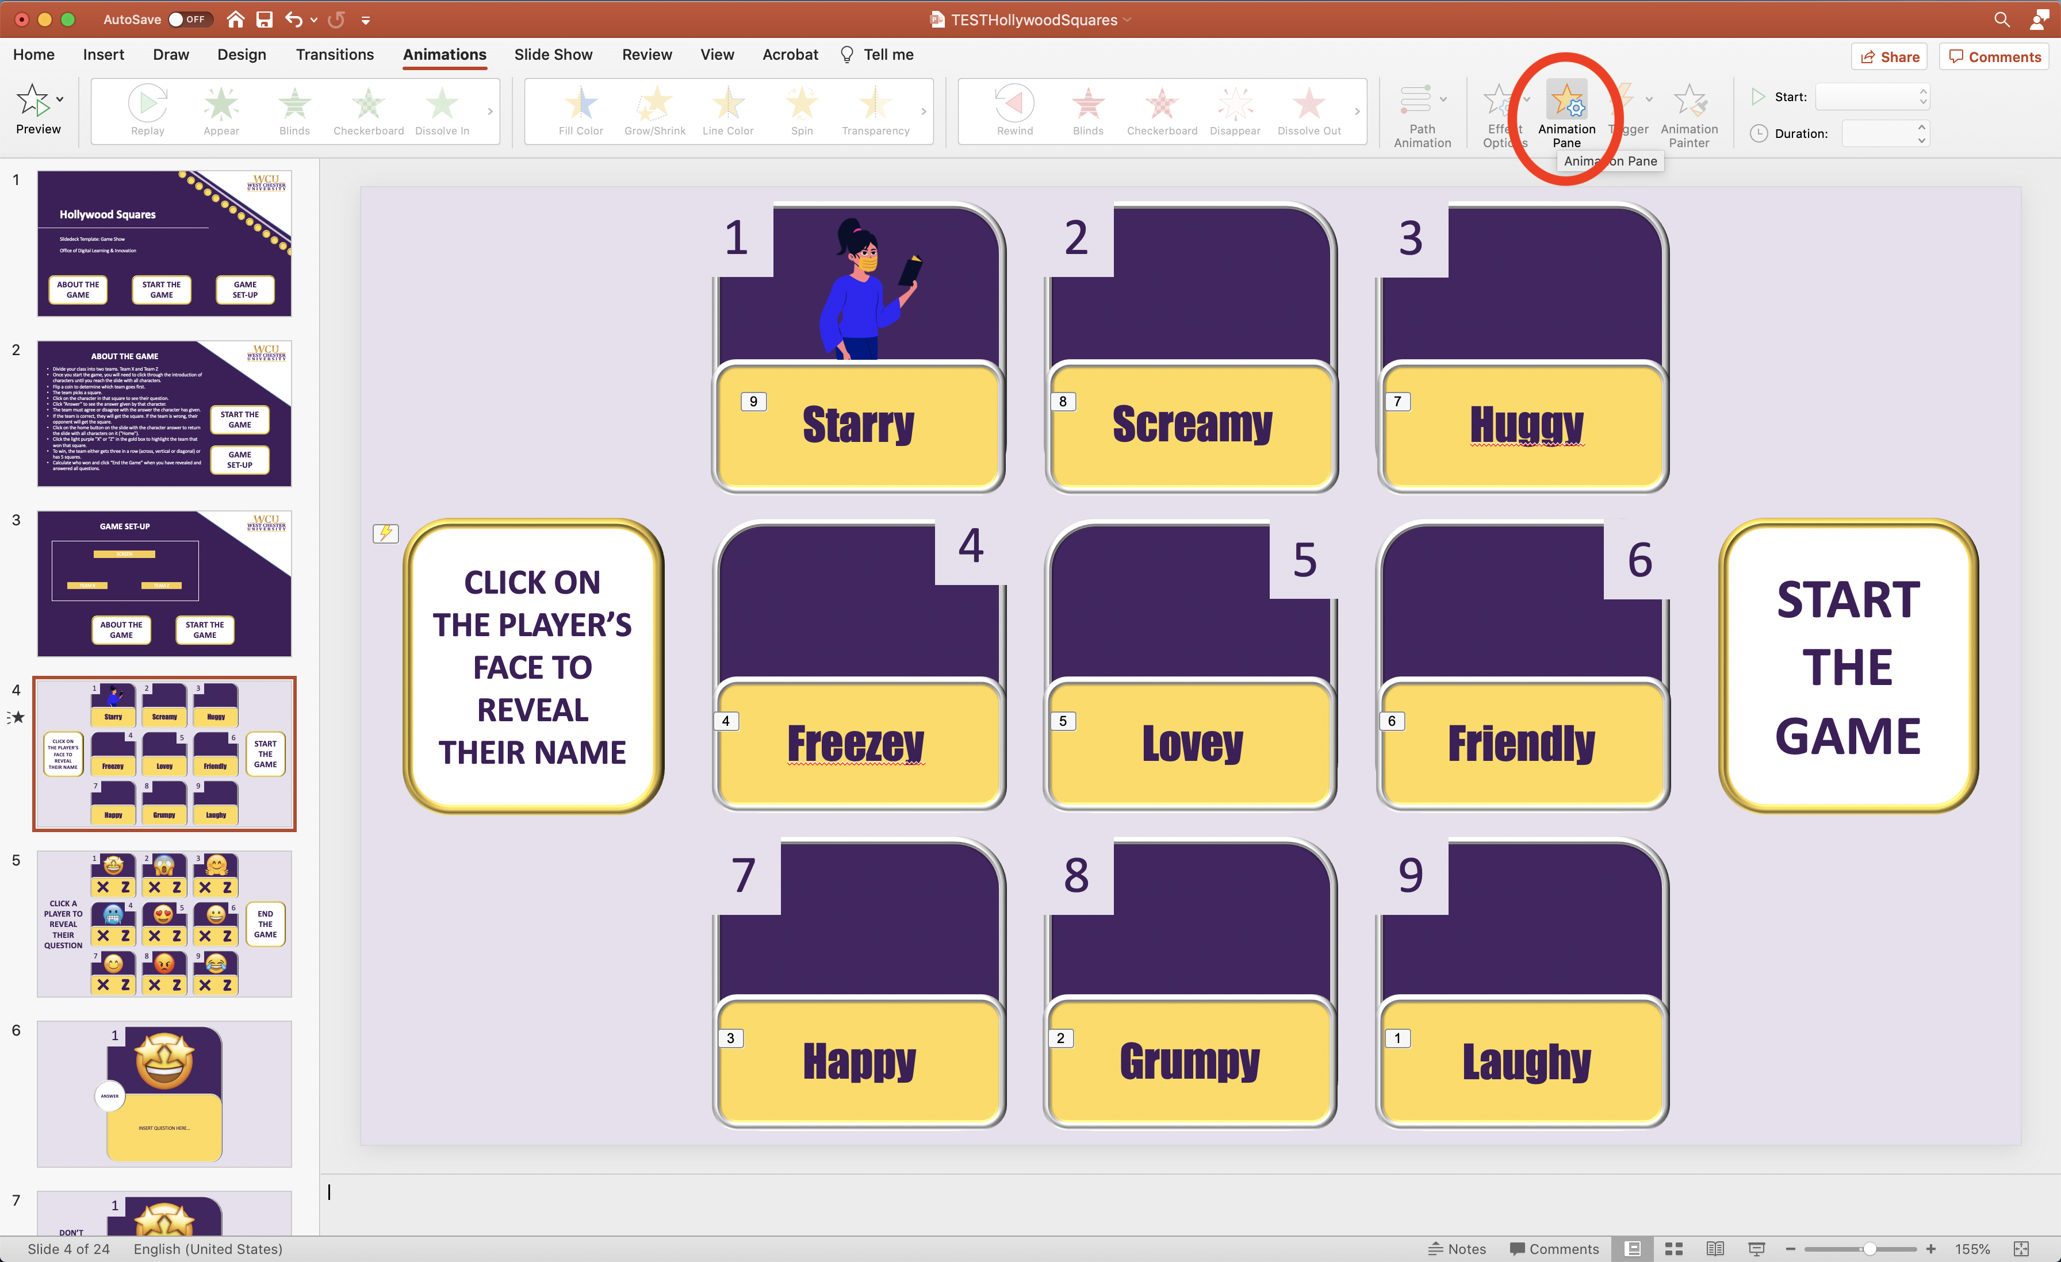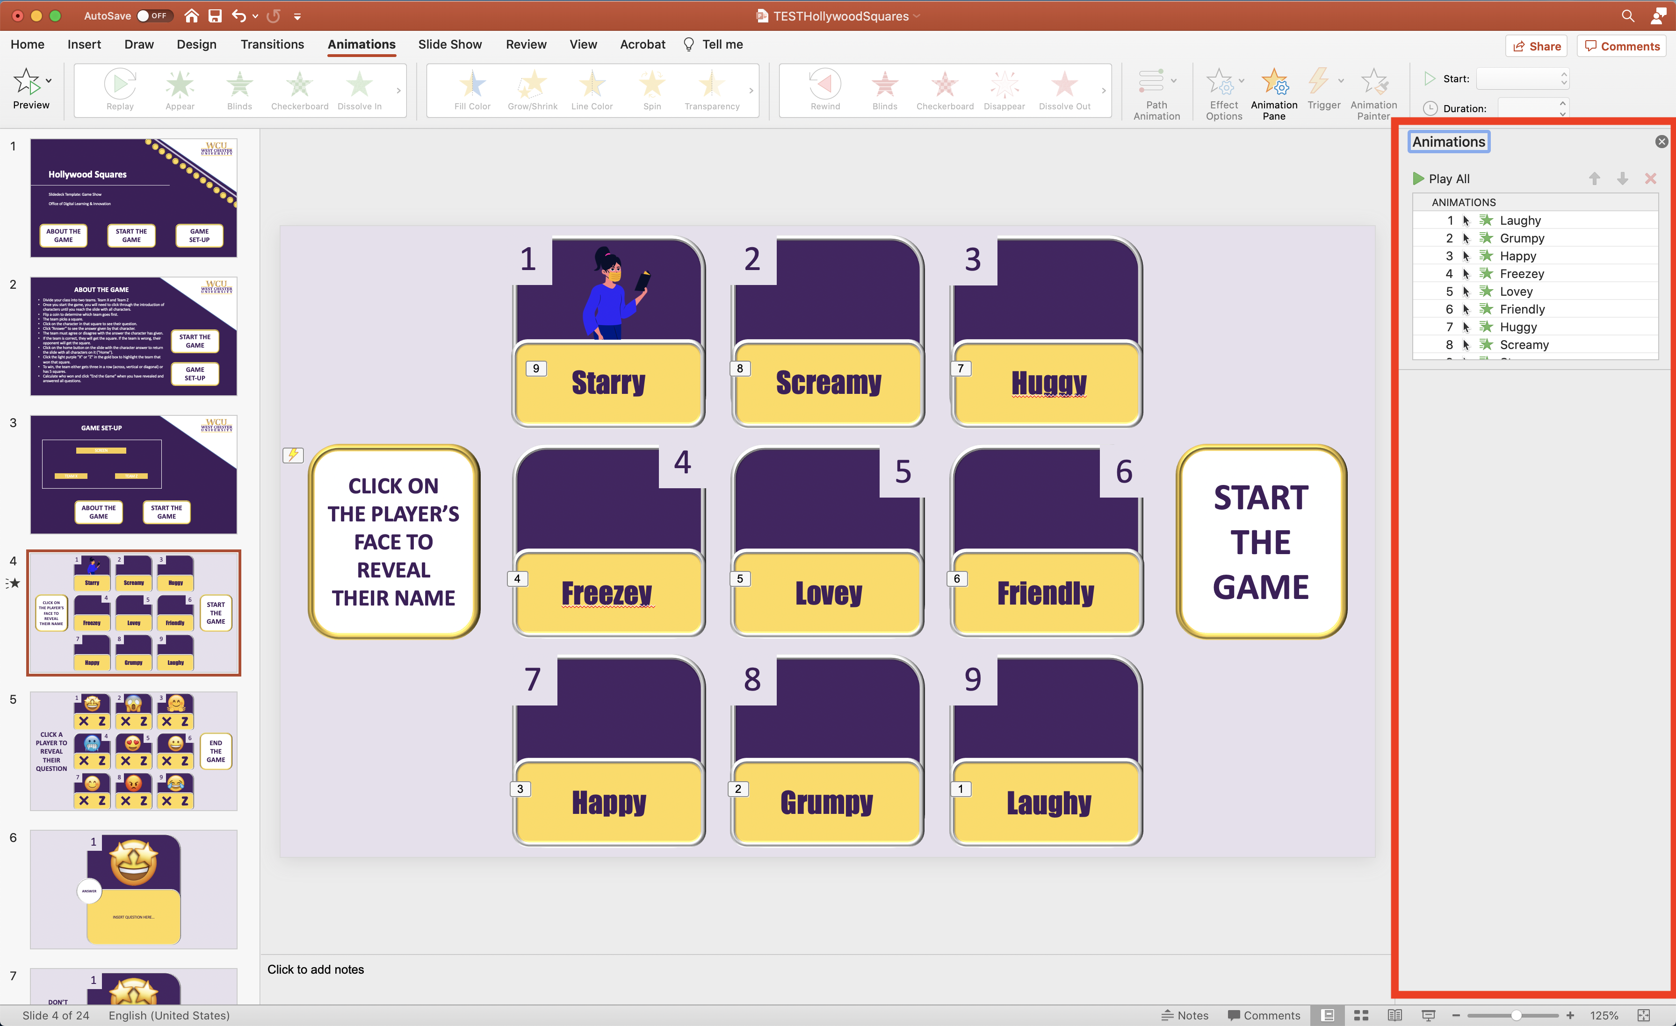
- Select the character name text box. | 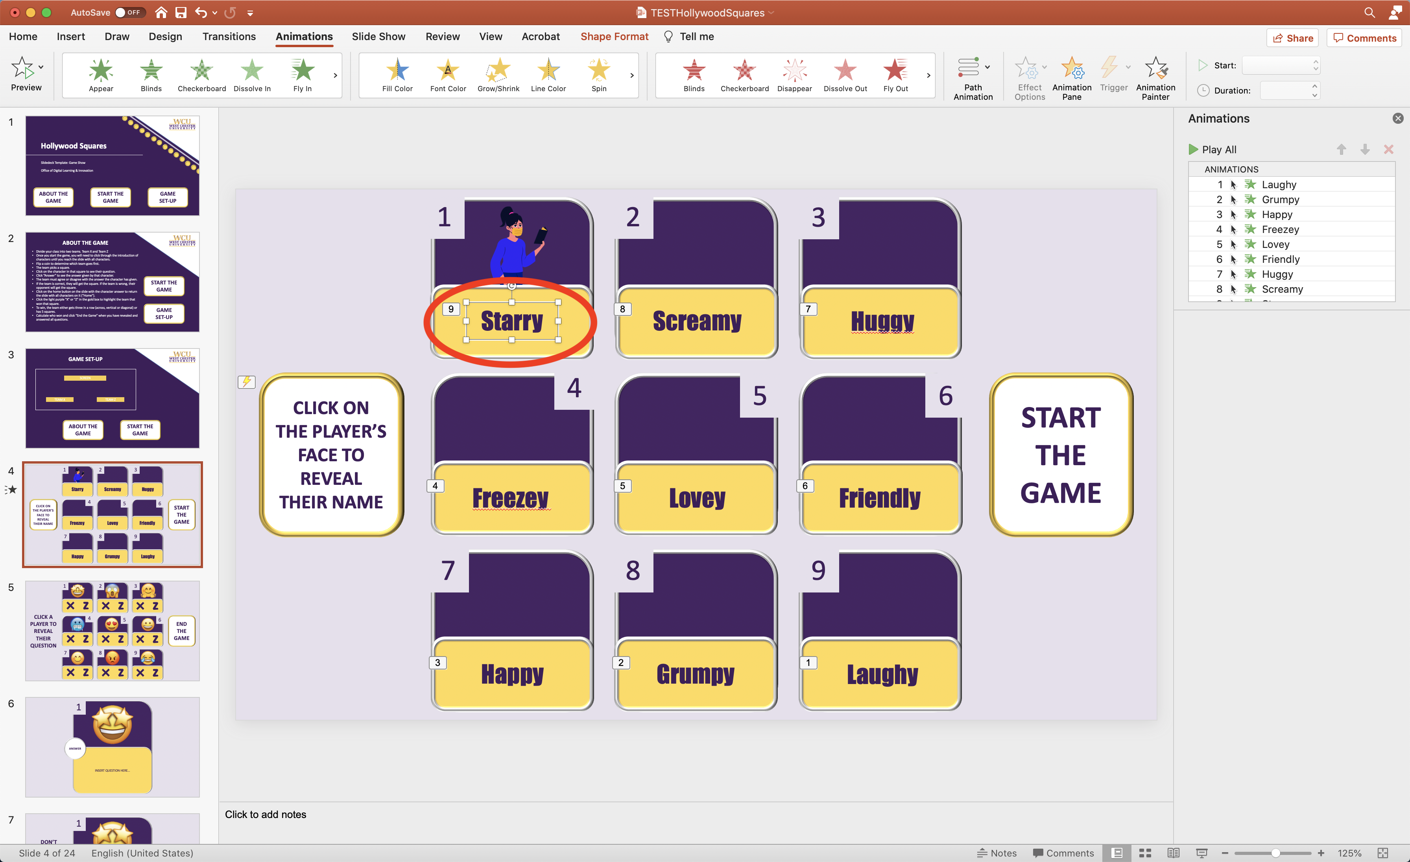
- Click “Appear” in the green star animation options near the top left corner. | 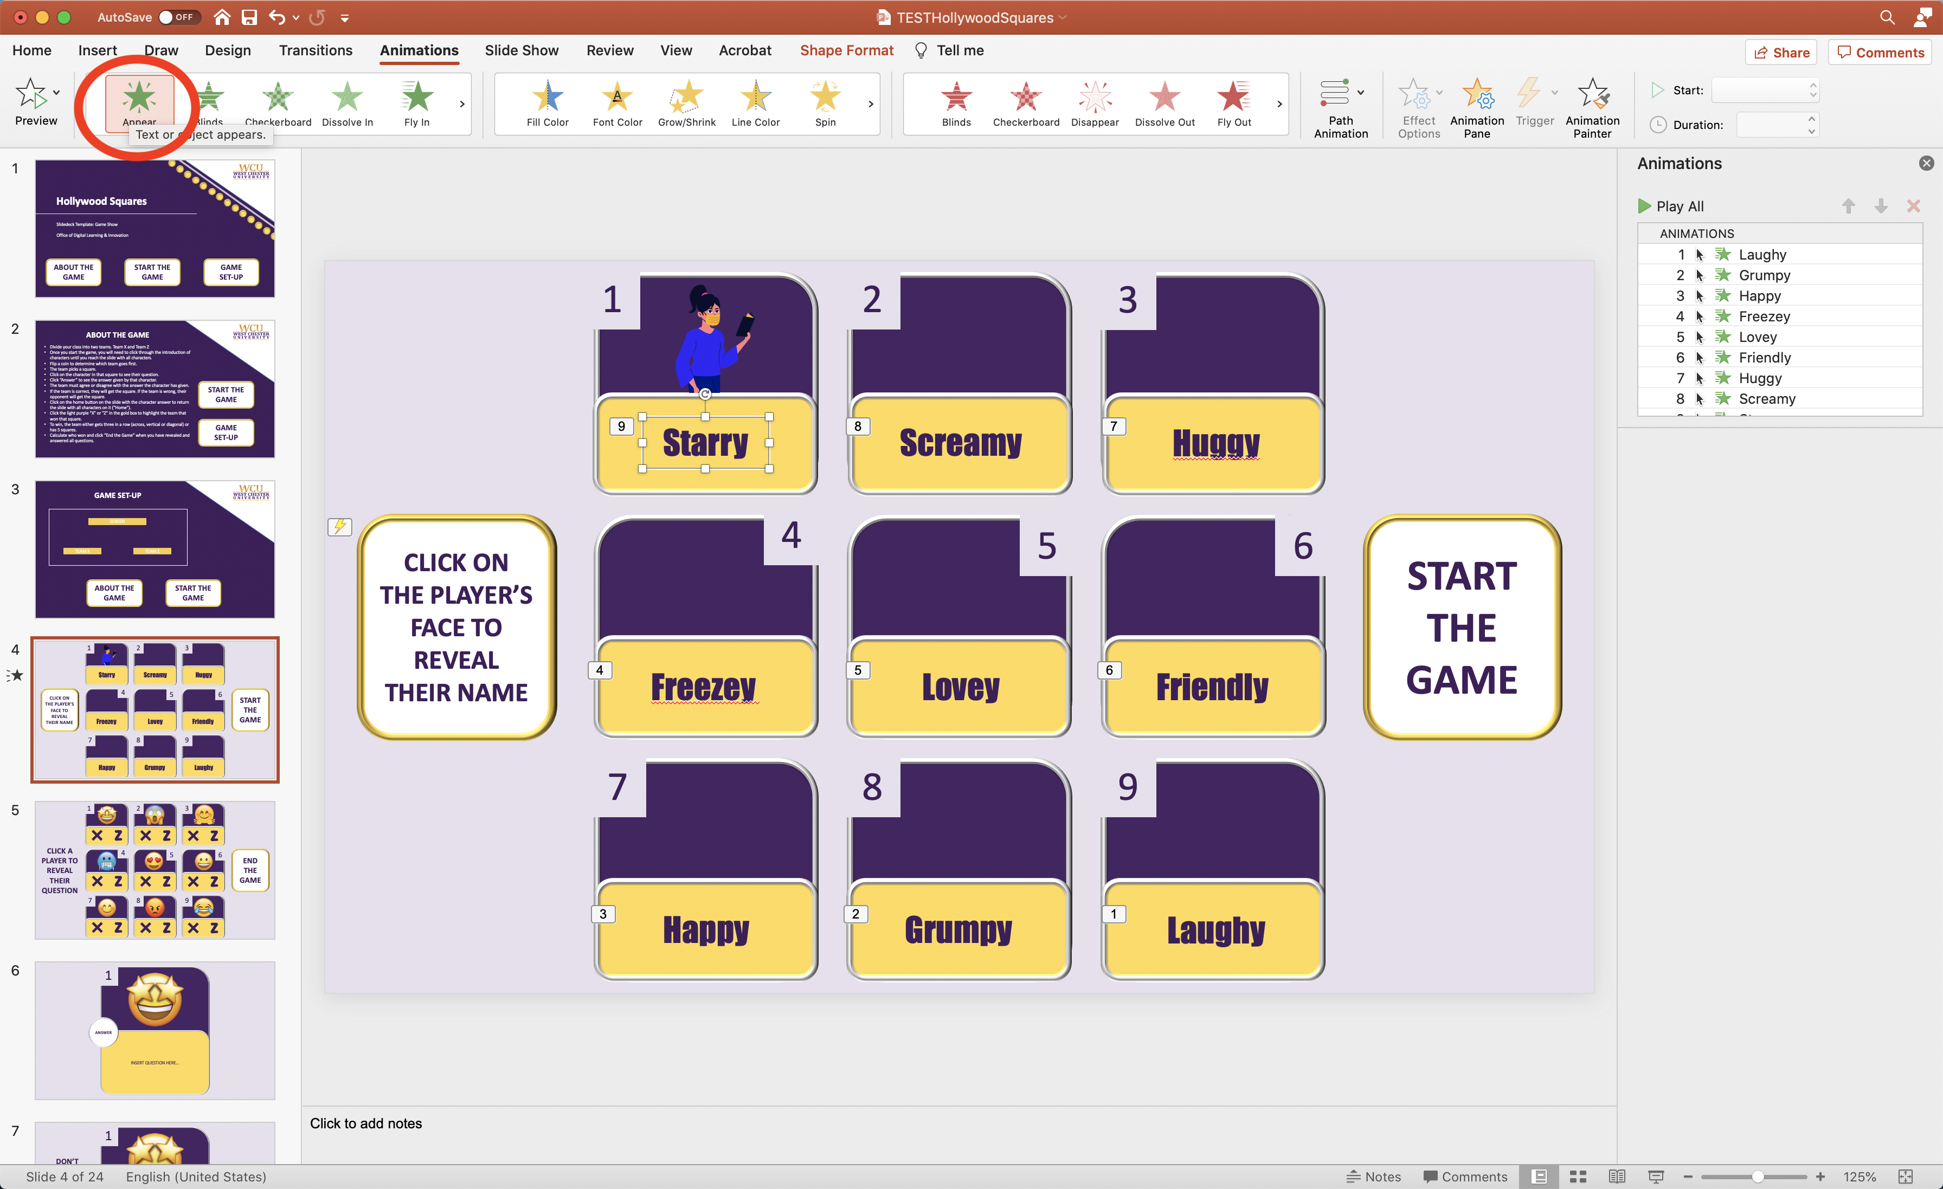
- Click “Triggers” to reveal the drop-down menu on the right side on the screen. | 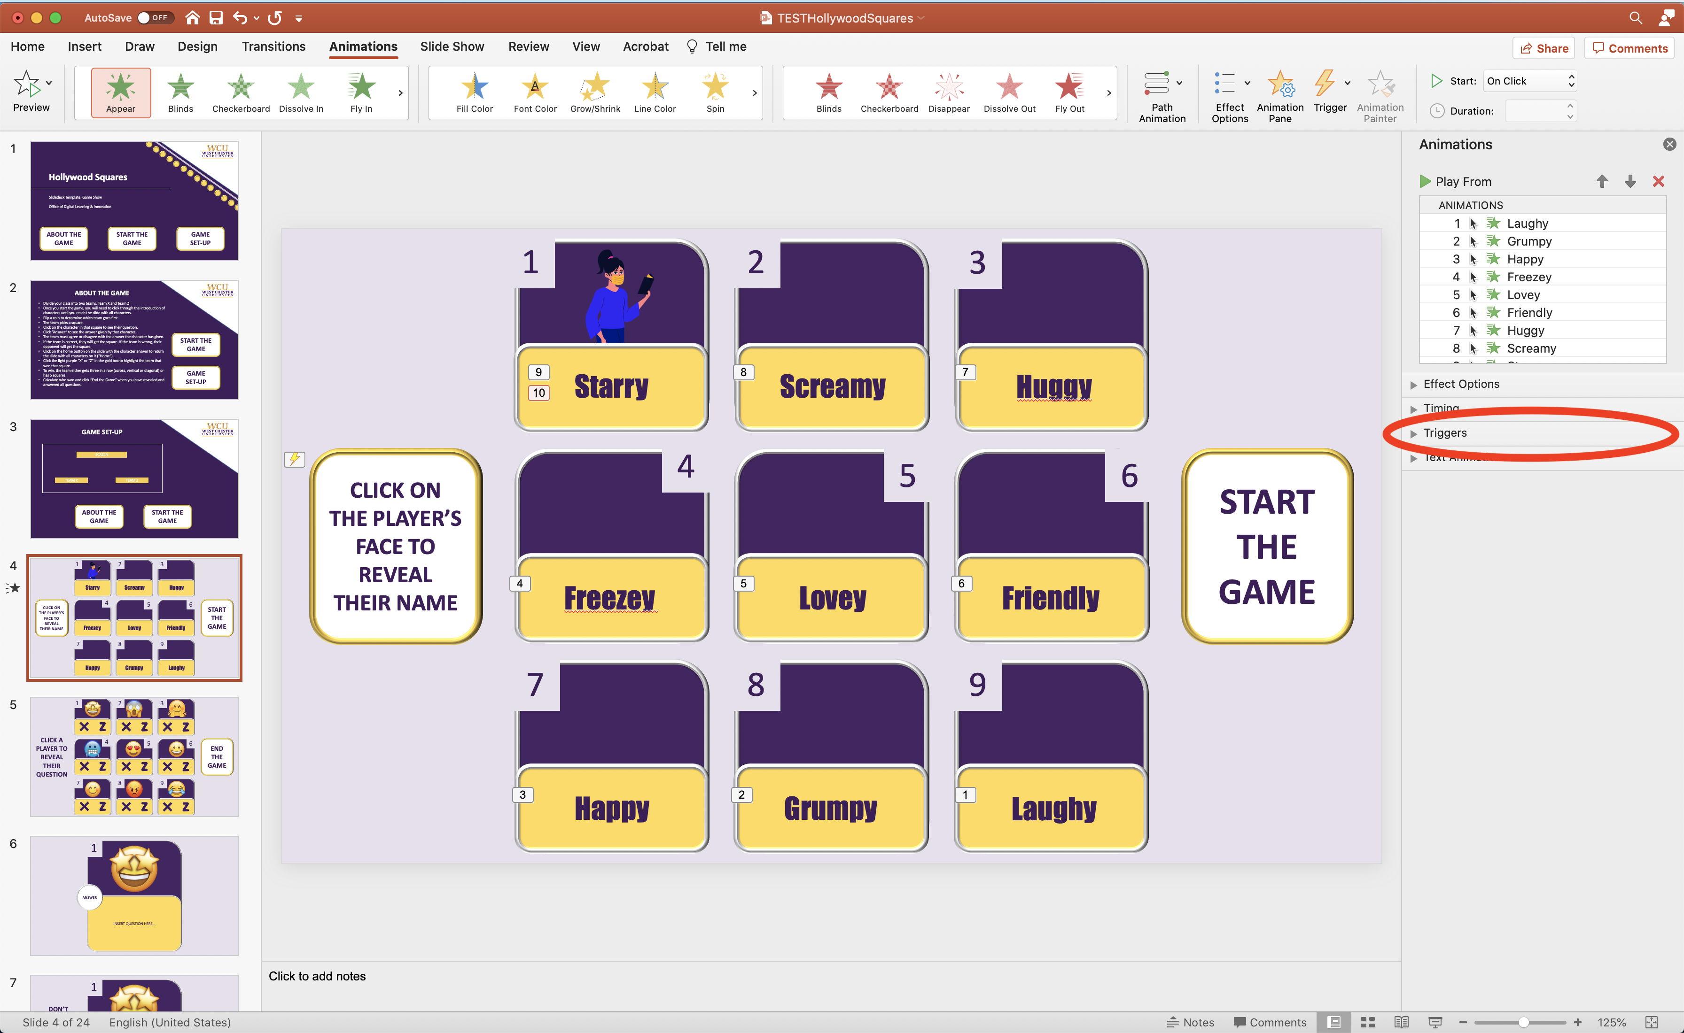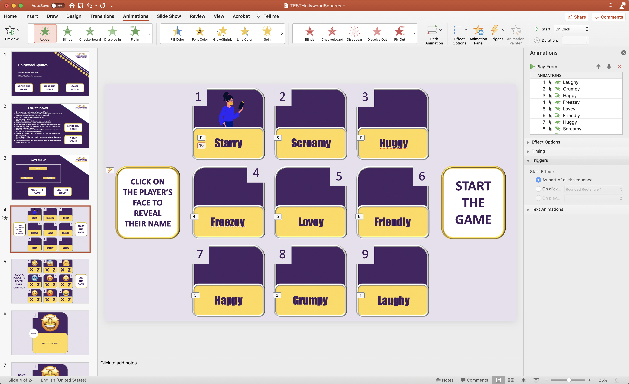
- Select the “on click” option. | 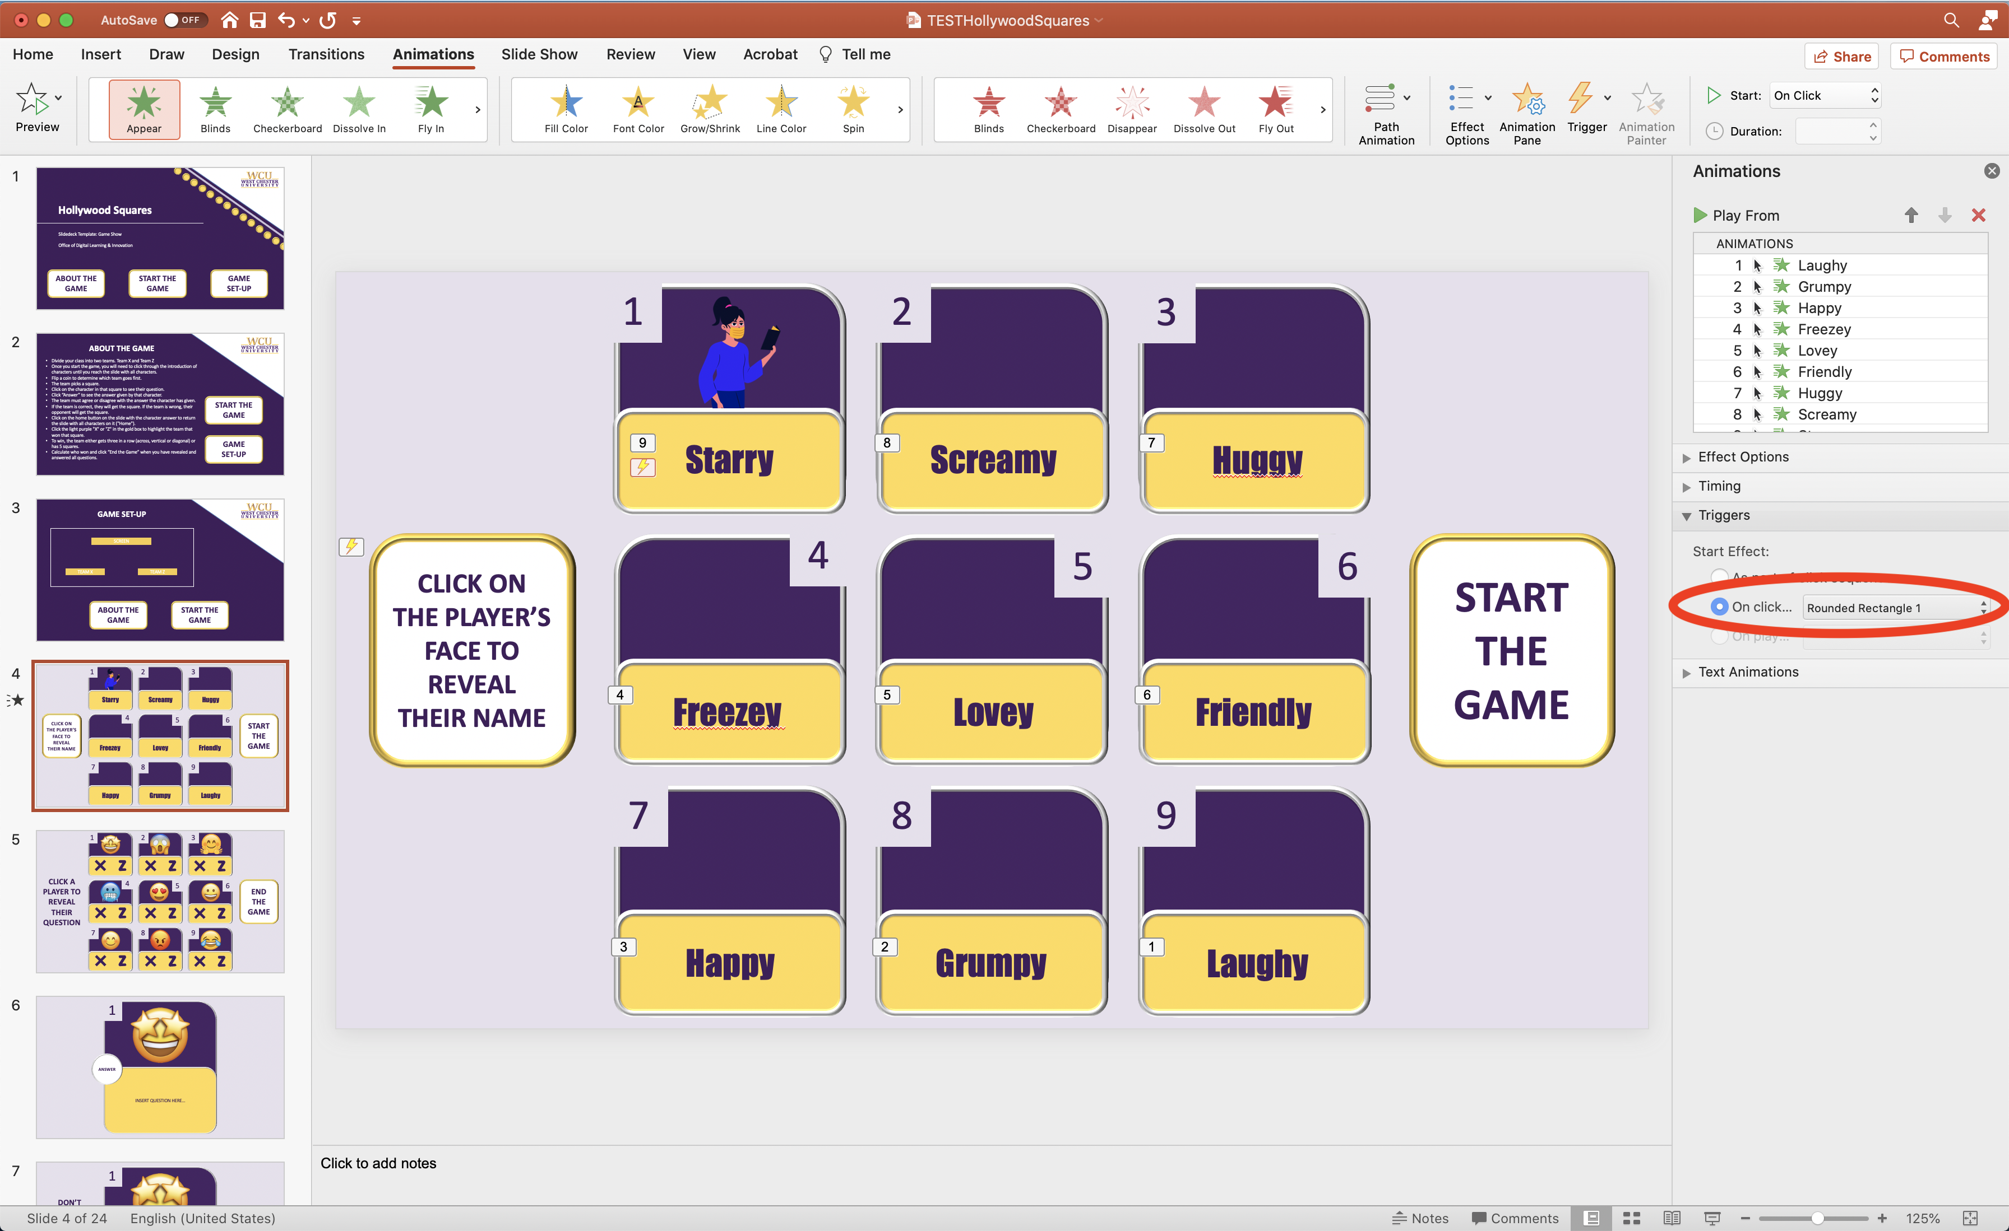
- Select the drop-down menu immediately to the right of “on click” and click the new character image number to select that image as this animations trigger.  - If you cannot determine which item is the character image, select the image and add an animation to it to know what image number it is (it will display in the animation panel on the right. Delete this animation once you know what number object it is.).  - This means when the character image is click during the presentation it will make the character’s name appear. | 