Jeopardy

Game Template Instructions

When to use Jeopardy in the Classroom?
Integrating Jeopardy into a class-period is a type of Game-based learning. This game template can be used for just about any content area to review content categories with a series of questions. Not only can the game be great for review, but also the game-like learning style builds motivation and enthusiasm among the students.

How to play Instructional Jeopardy?
- Play individually or in groups.
- Pick a category and a point value.
- Click on the chosen box for the question.
- Students must give the answer in the form of a question before proceeding. The faculty may want to set a time limit for answering the question.
- To see if a student or group is correct, click again for the answer.
- Click the “Back to Board” button on the slide to return to the main board.
- If the student or team is correct, they are awarded the point value of the question. Keep score on your own.
- The dollar values disappear after each question.
- Continue until all questions have been answered. The team with the most points wins.

How to edit the Template?
External Needed Materials: 30 second timer/stopwatch
- Before editing any content begin the Presentation slide show from the beginning and navigate through the slides in order to see how things appear initially. When you are playing you will be clicking on specific items to reveal new content or returned to previous slides.
  - You can also watch the navigation video to see what is clickable and how the game will look later.
- EDIT RED CIRCLED TEXT ONLY!
Slide Number(s) | Step/Editing Step | Slide Screenshot
1 | Nothing to Edit | 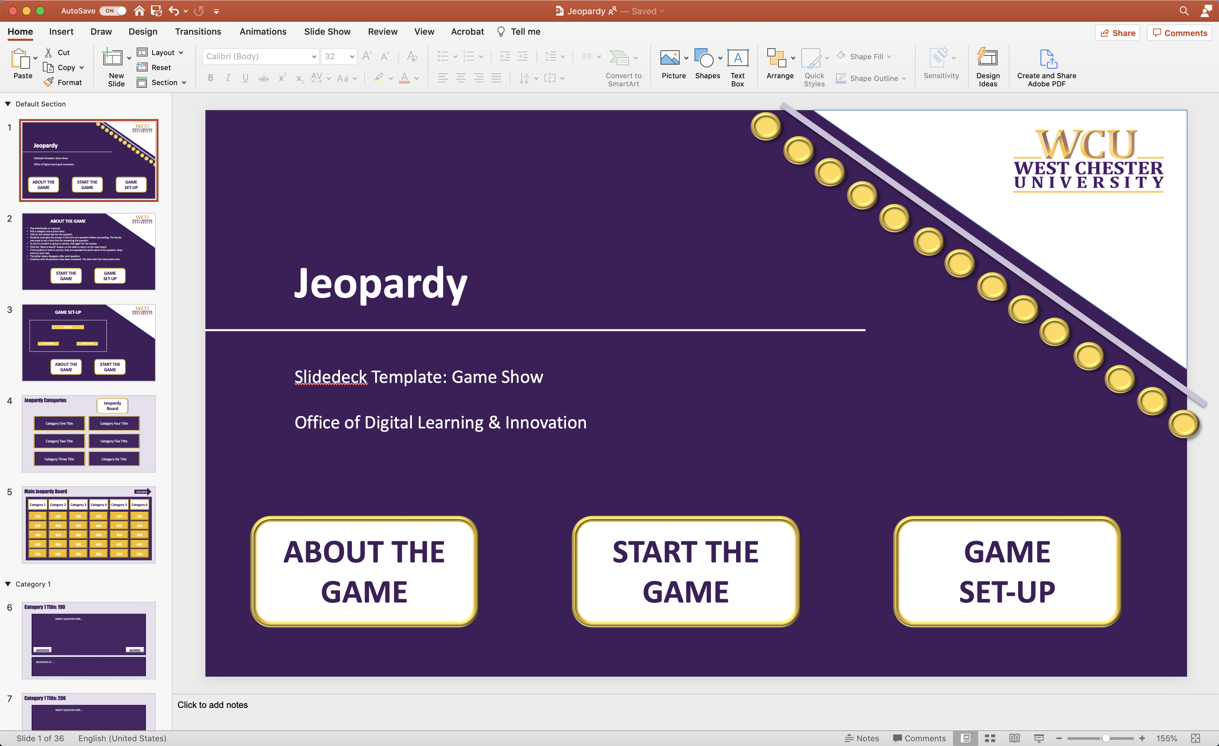
2 | Nothing to Edit | 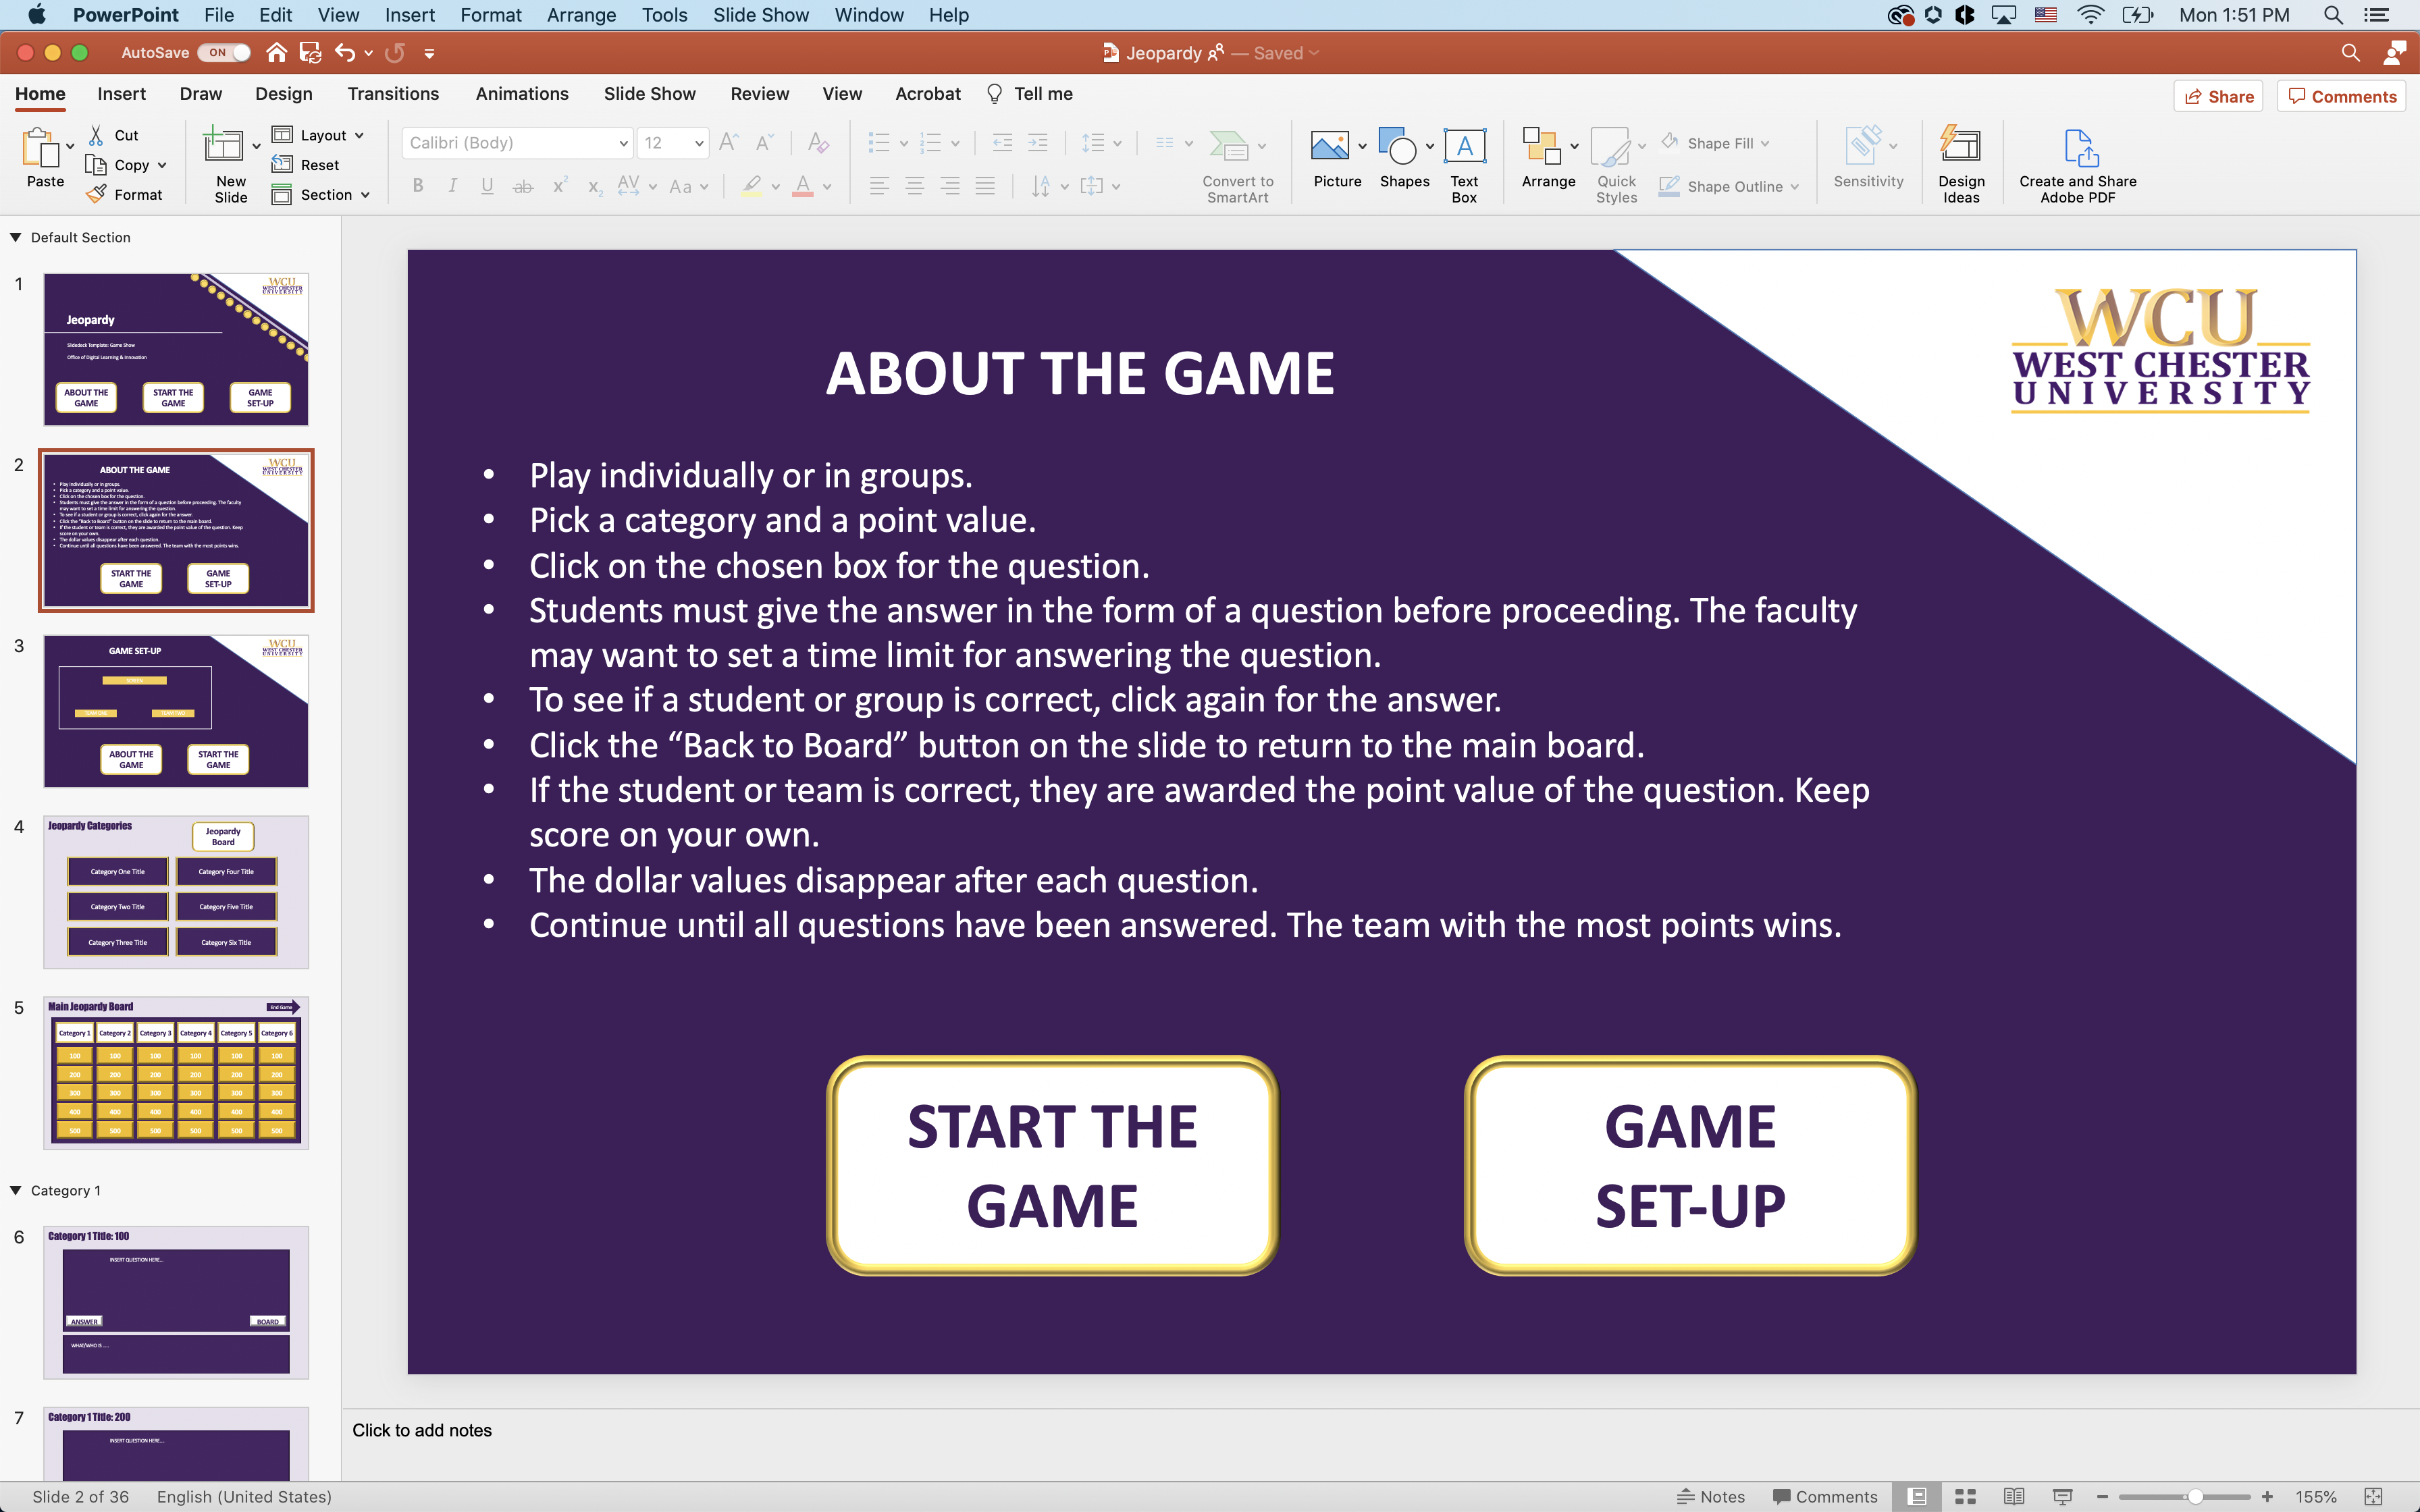
3 | Nothing to Edit | 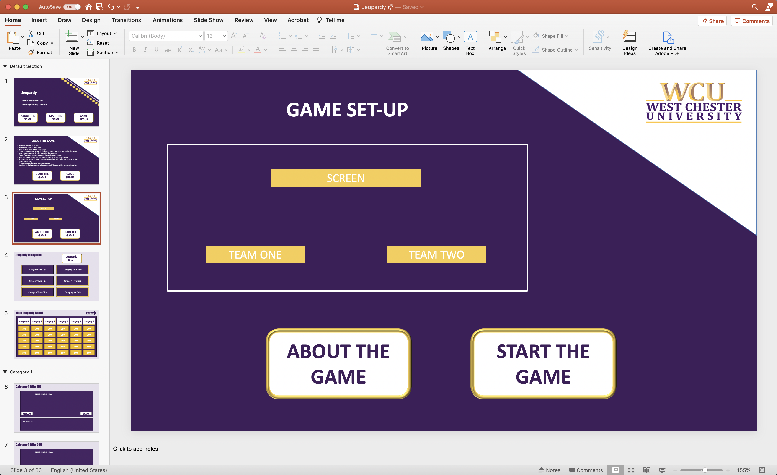
4 | Click on “Category # Title” to edit and replace the text with each category title of your choosing for the game. | 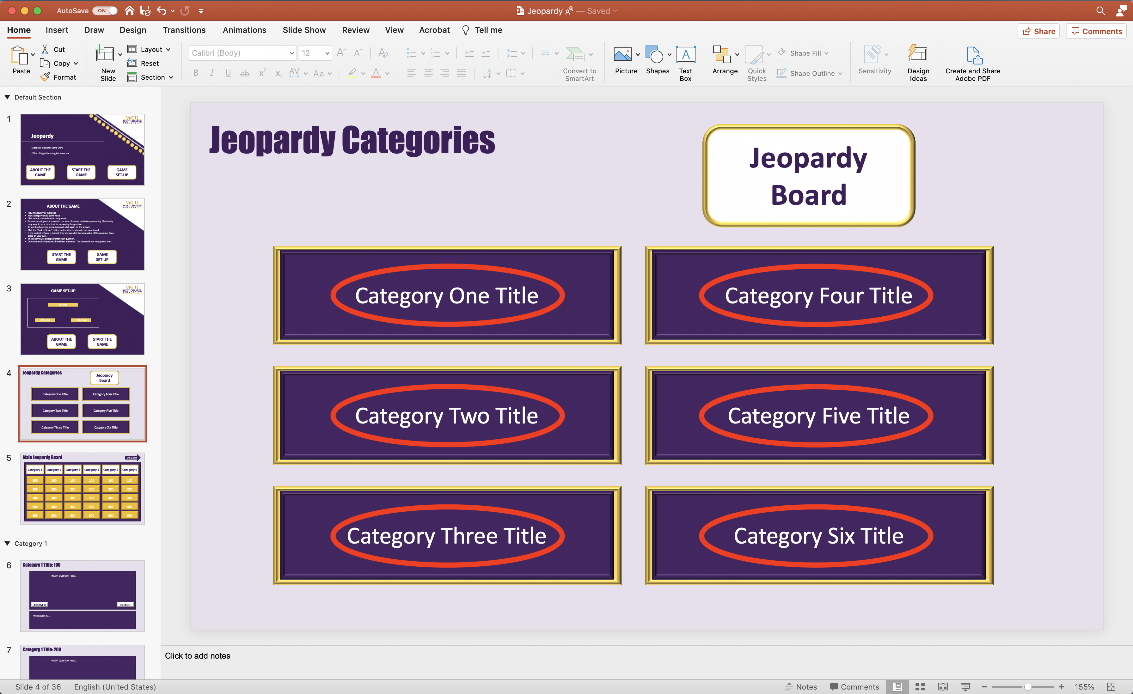
5 | If wanted, Add the category title to replace “Category #” but clicking on the text in each rectangle. Please keep the rectangle the current size, but you can change the font size.  Each of value rectangle is linked to specific slides, so pleases do not delete or move them. | 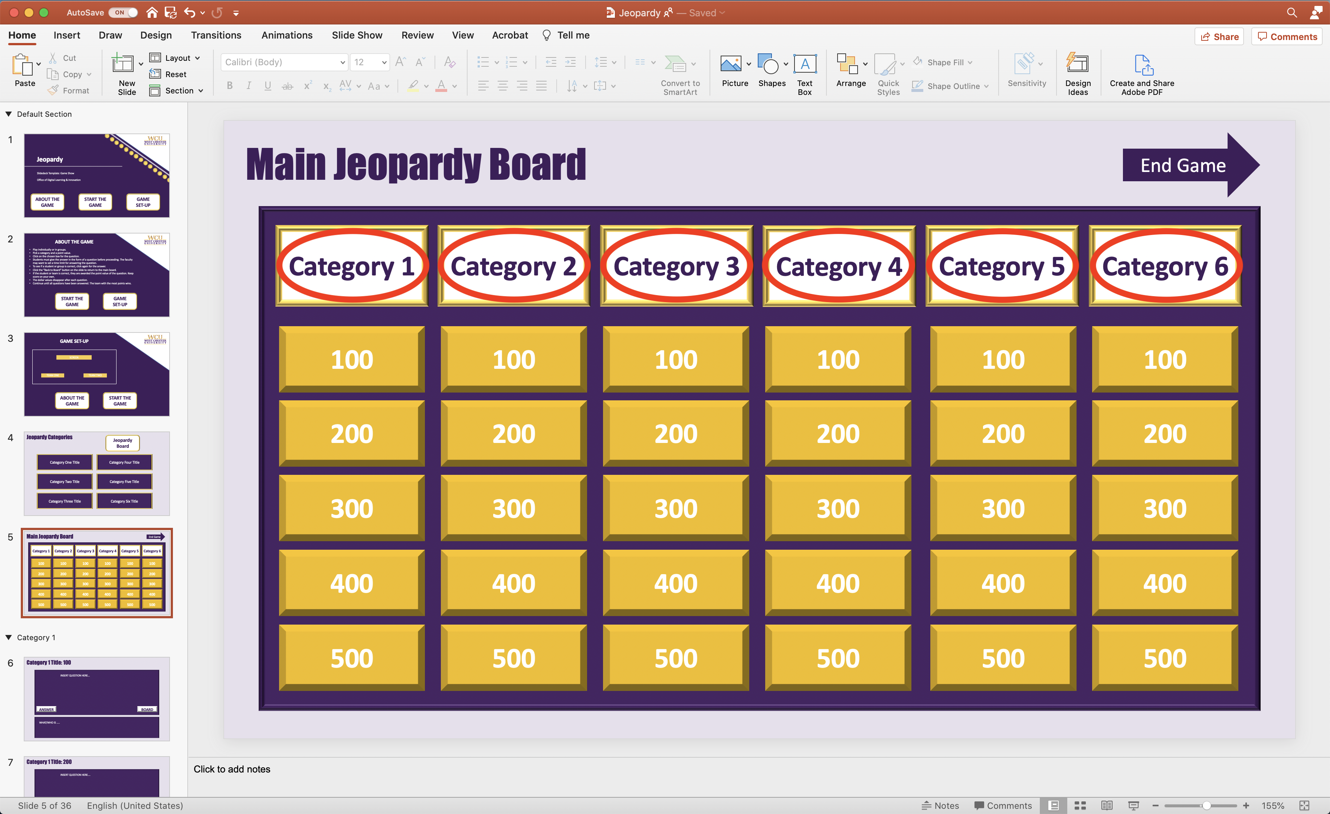
6-35 | - Click on “INSERT QUESTION HERE...” to edit and replace the area with your question (stated as a statement).  - Click on “WHAT/WHO IS...” to edit and replace the area with the answer (stated as a question).  - Repeat for each category and value within each category (Slides 6-35). | 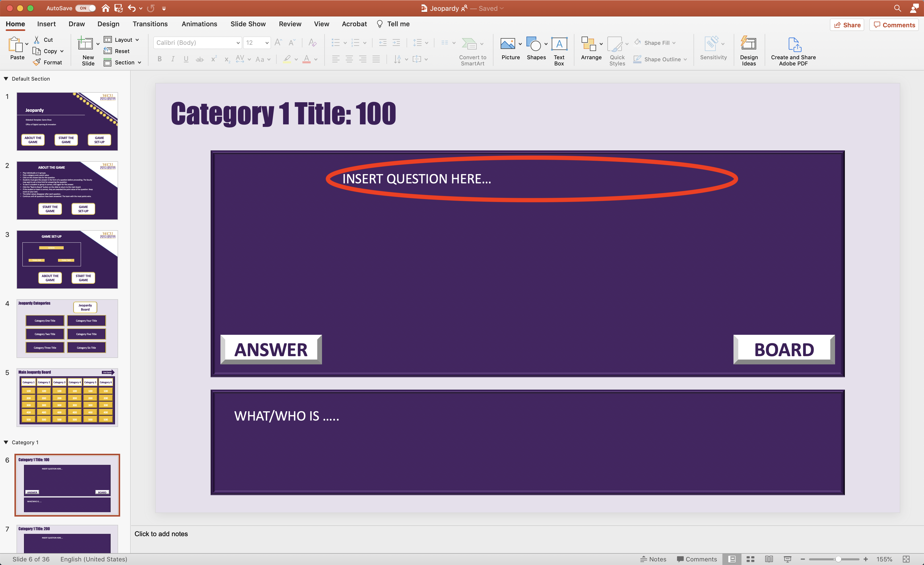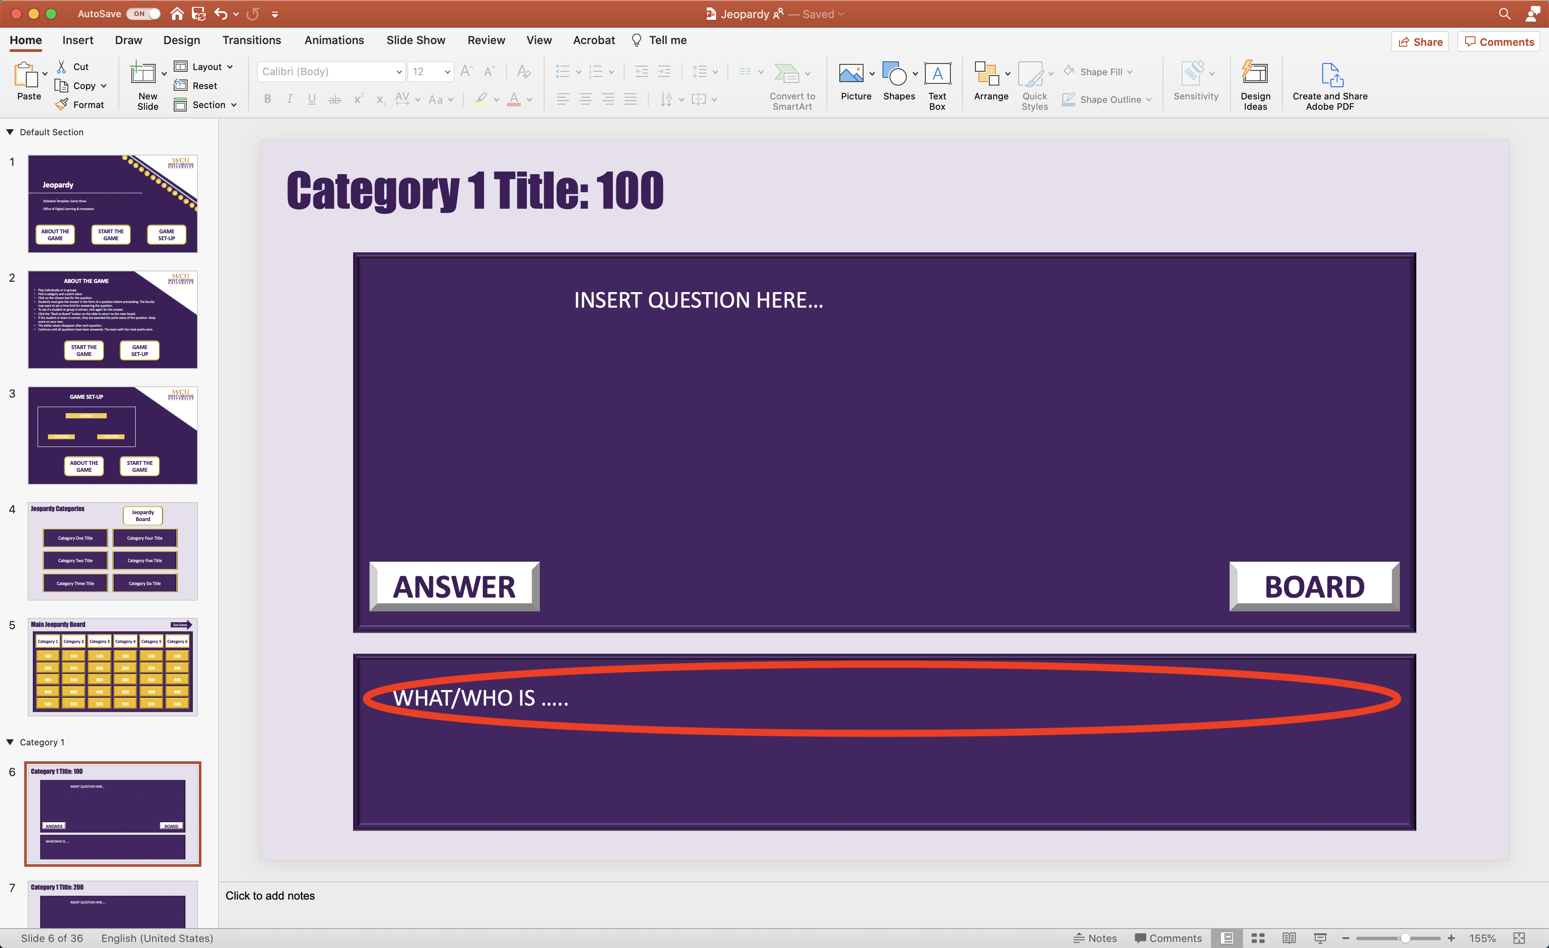
36 | Nothing to Edit | 

