Who Wants to be a Millionaire?

Game Template Instructions

When to use “Who Wants to be a Millionaire?” in the Classroom?
Integrating the game into a class-period is a type of Game-based learning. This game template can be used for just about any content area to review content categories with a series of questions. Not only can the game be great for review, but also the game-like learning style builds motivation and enthusiasm among the students.

How to play Instructional Jeopardy?
- Play individually or in groups. If you play in groups, you will want to play multiple games, or you may want to alternate questions between the groups.
- Start the game and click on the $100 question.
- Have the student give the answer to the question.
- Click the option they choice to reveal if it is correct or not.
- If a student would like to use 50/50, phone a friend or ask the audience, click on the appropriate button. Then follow the slides.
- When the correct answer is selected, a new slide appears, click “to all questions” to get back to the main game board.
- As questions are answered correctly, the amount will be filled in with purple. Click on the appropriate dollar value. The amounts will continue to fill as you work up to $1 Million.
- The game is over when a question is missed, or a player/team reaches the $1 Million mark.

How to edit the Template?
External Needed Materials: 30 second timer/stopwatch
- Before editing any content begin the Presentation slide show from the beginning and navigate through the slides in order to see how things appear initially. When you are playing you will be clicking on specific items to reveal new content or returned to previous slides.
  - You can also watch the navigation video to see what is clickable and how the game will look later.
- EDIT RED CIRCLED TEXT ONLY!
Slide Number(s) | Step/Editing Step | Slide Screenshot
1 | Nothing to Edit | 
2 | Nothing to Edit | 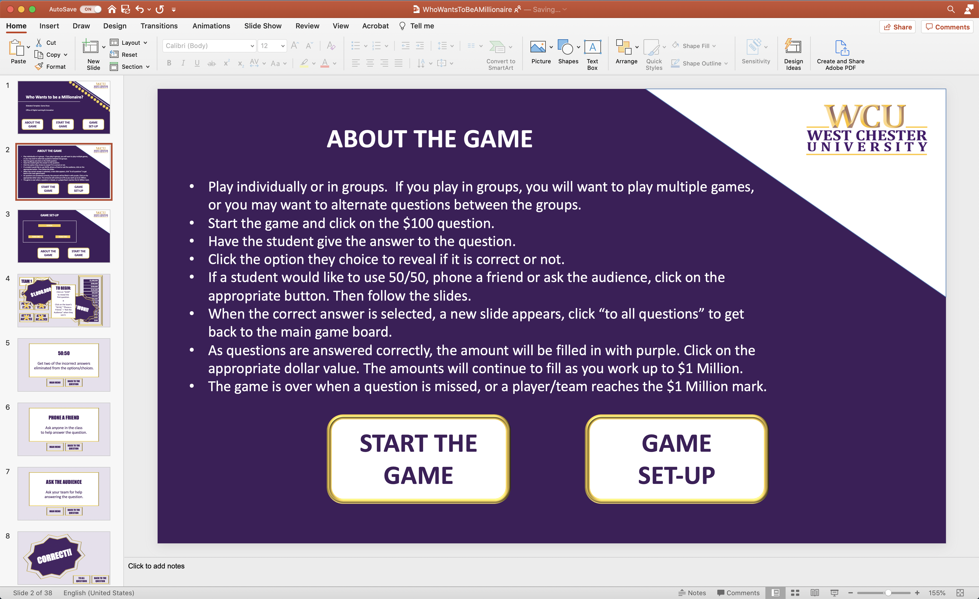
3 | Nothing to Edit | 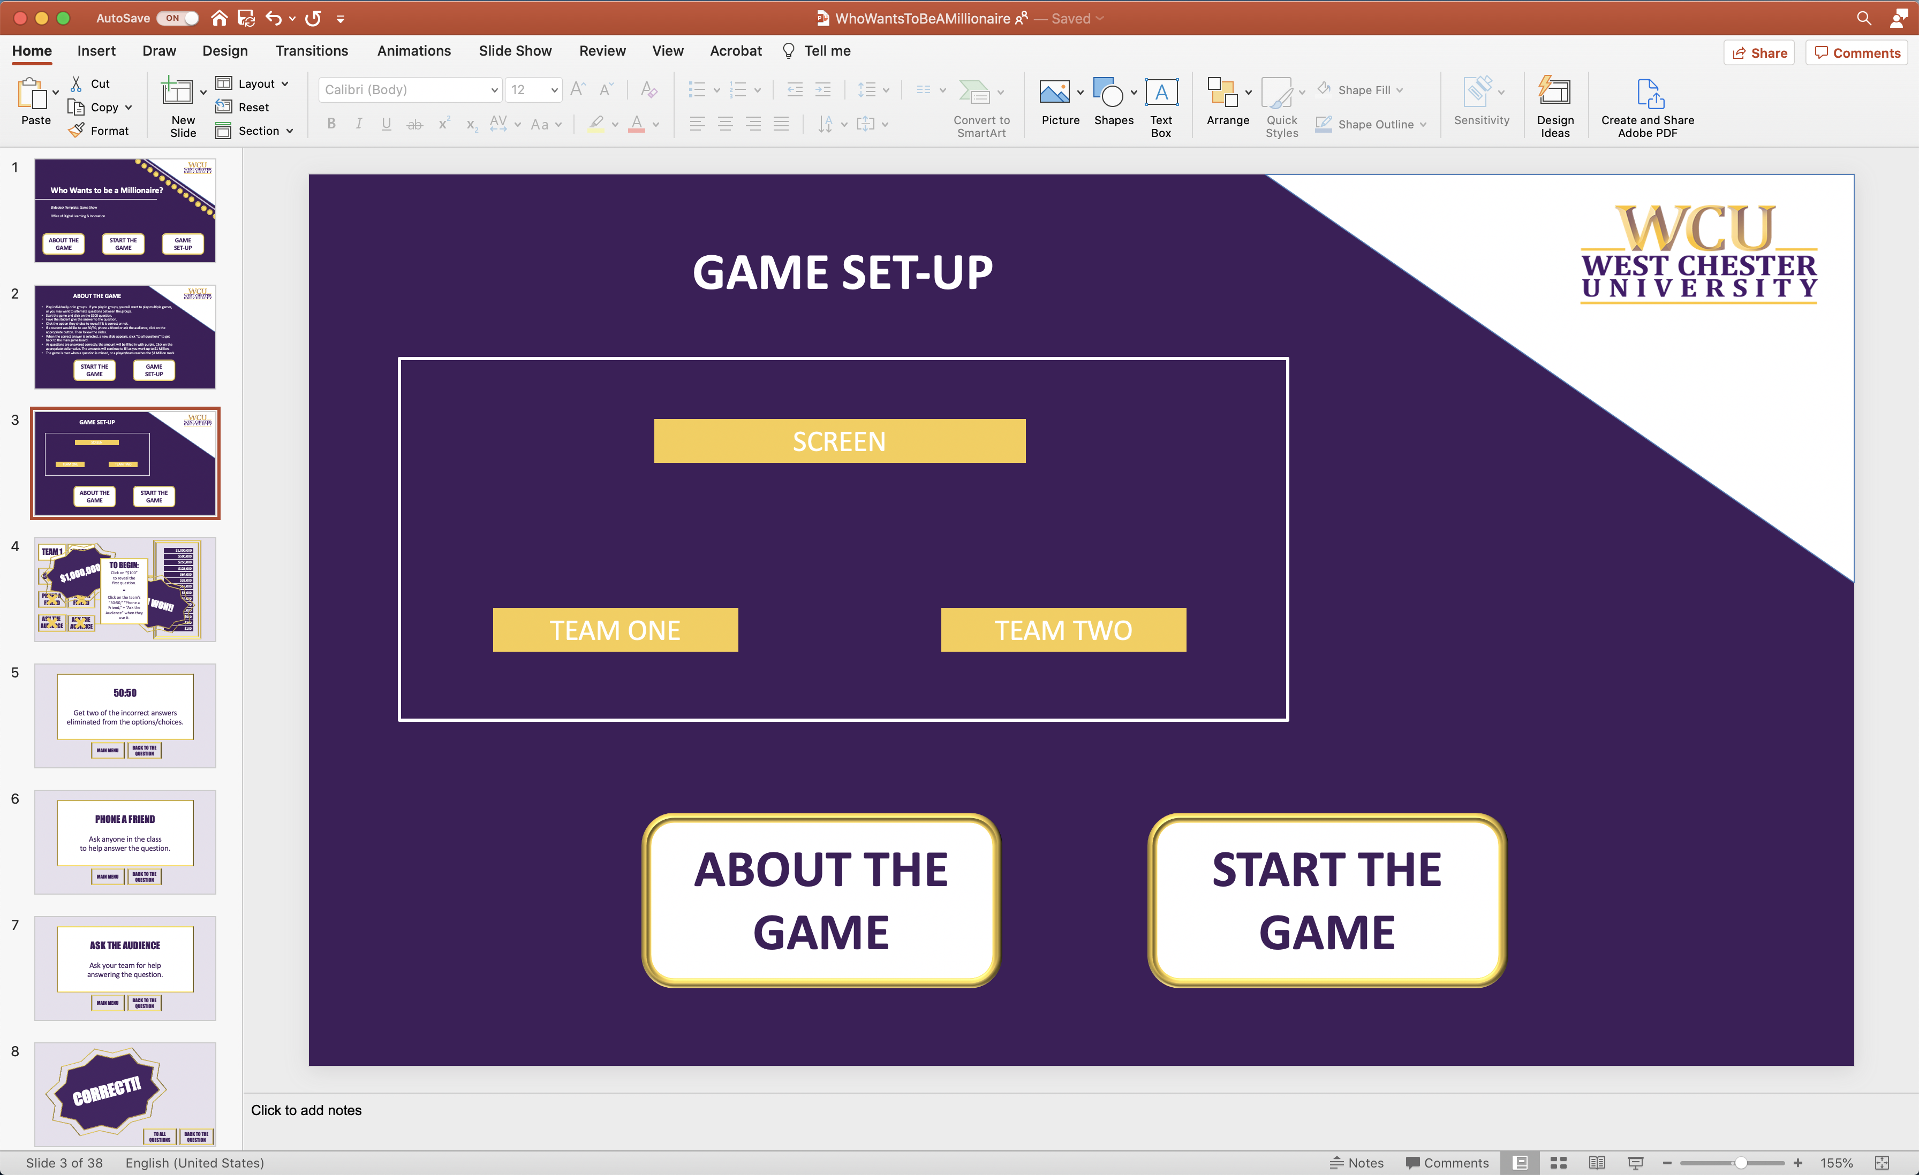
4 | Nothing to Edit | 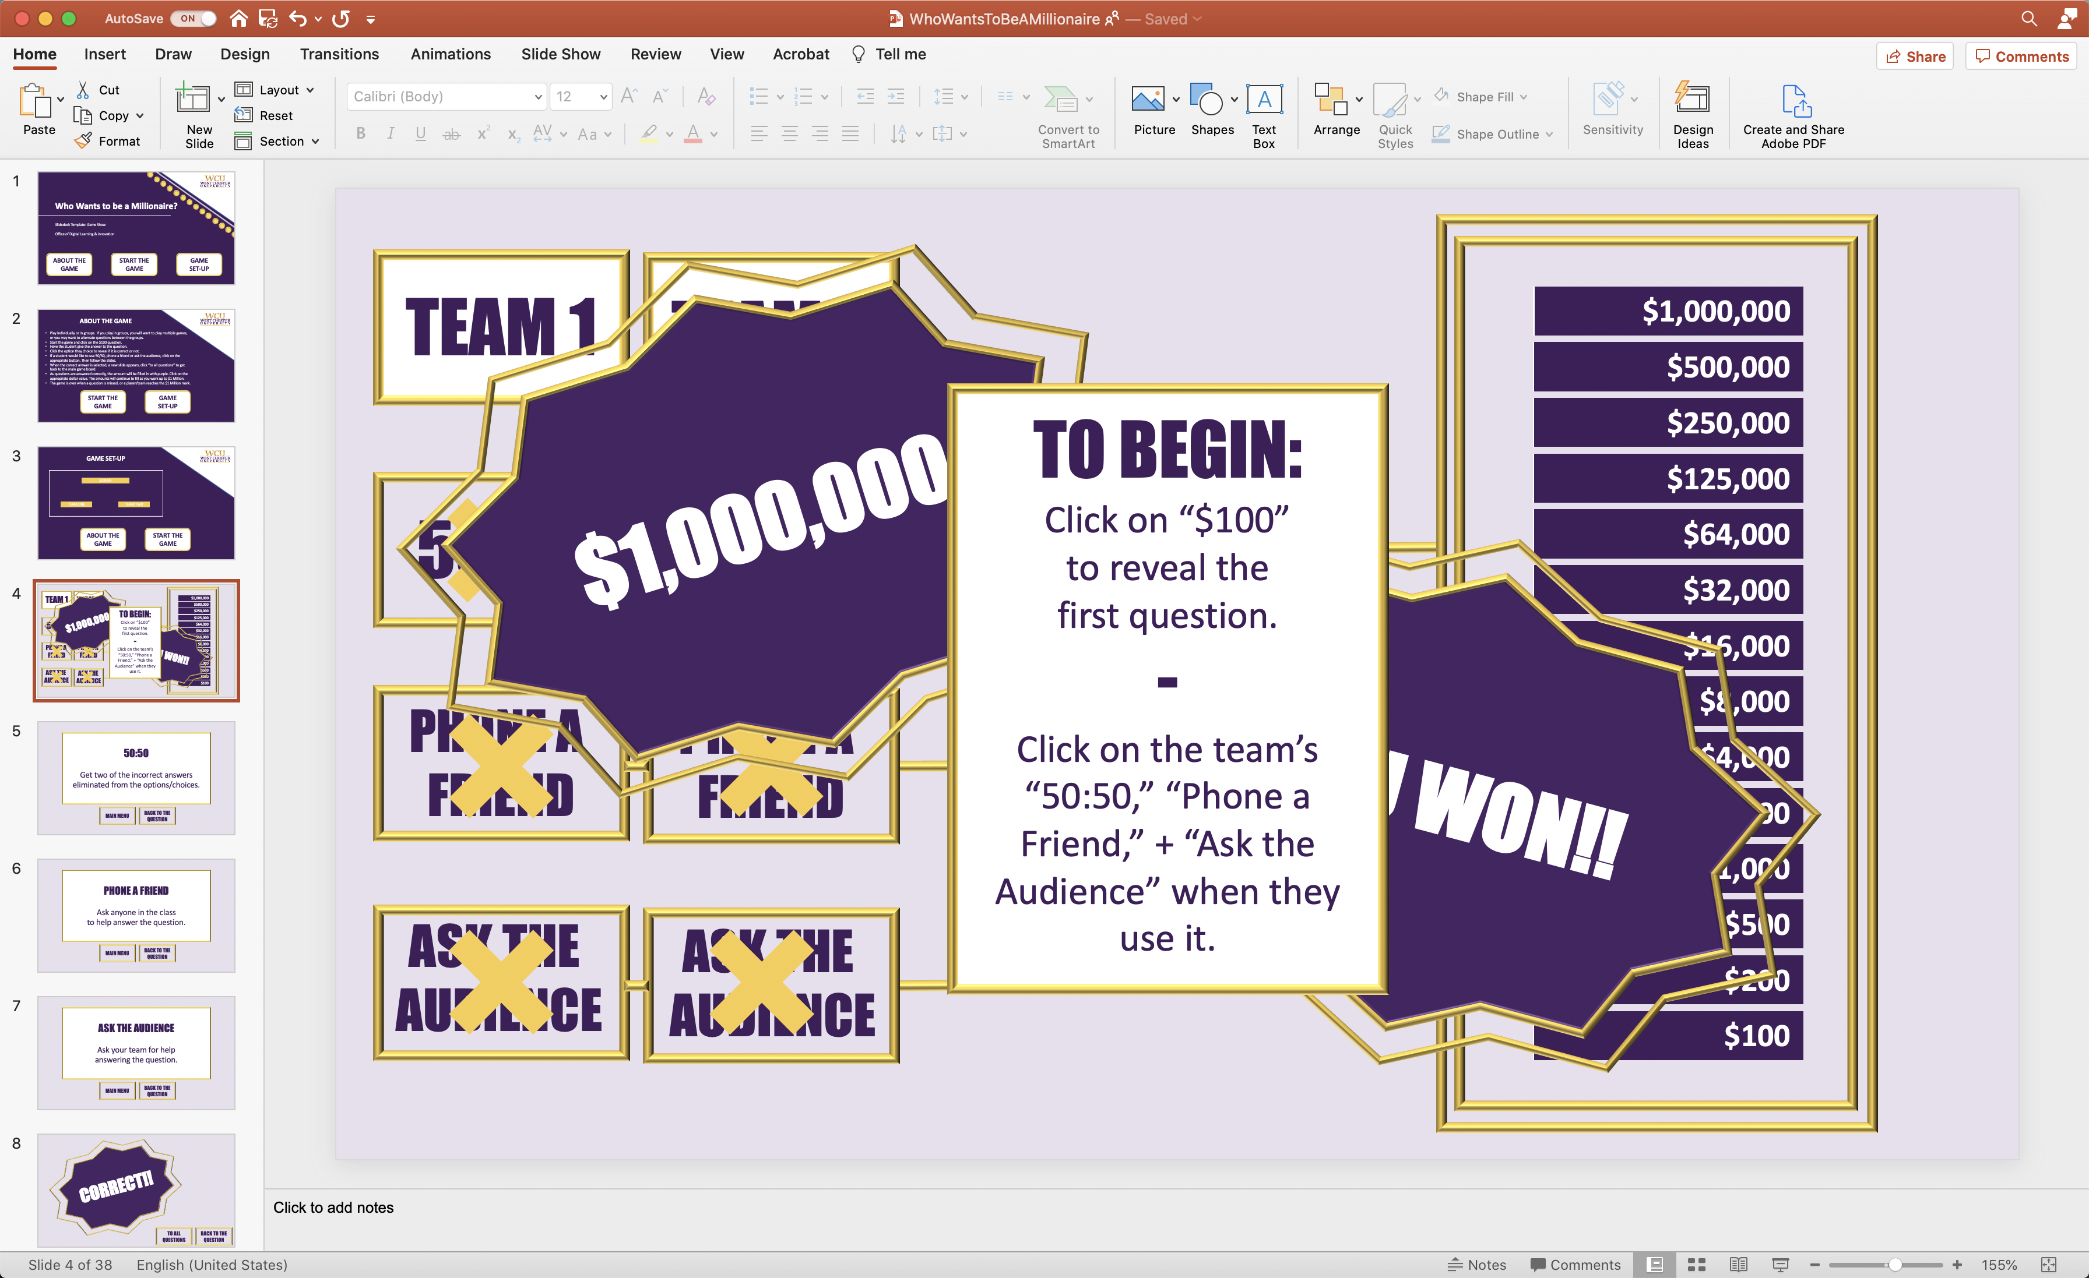
5-9 | Nothing to Edit | 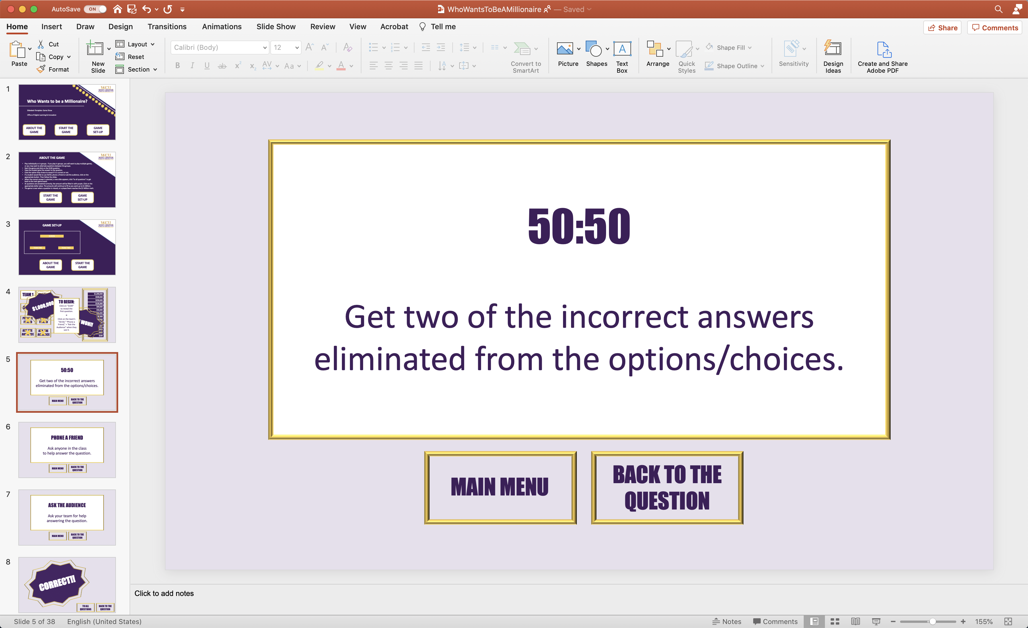
10, 12, 14, 16, 18, 20, 22, 24, 26, 28, 30, 32, 34 | - Click on “Insert QUESTION Here...” to edit and replace the area with your question.  - Locate and click on “Insert ANSWER Here...” to edit and replace the area with the CORRECT answer to the question.  - Click on “Insert OPTION Here...” to edit and replace the area with an incorrect answer to the question (3x).  - Repeat this process for each main question slide for each differently marked value (the even numbered slides from 10 through 34). | 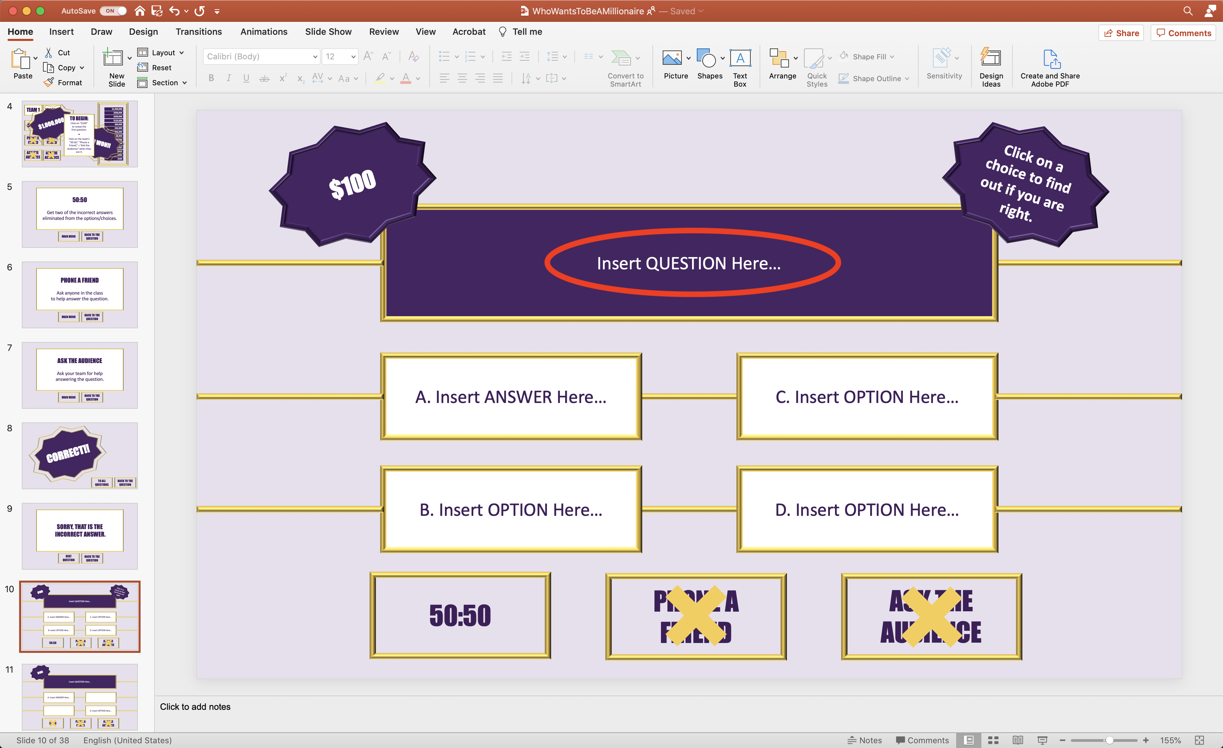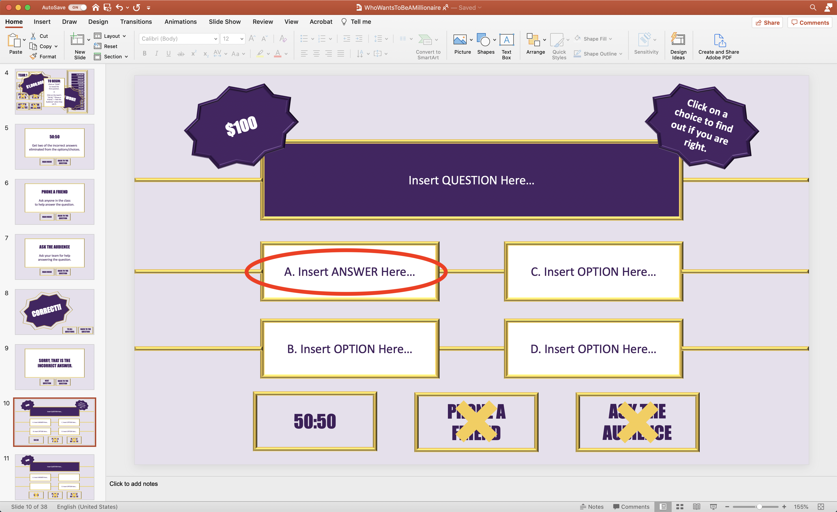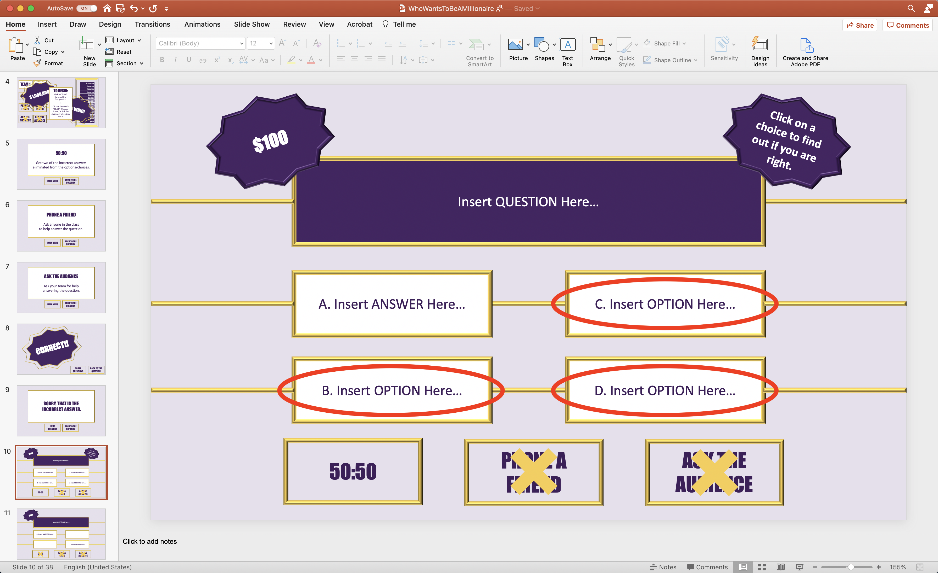
11, 13, 15, 17, 19, 21, 23, 25, 27, 29, 31, 33, 35 | - Click on “Insert QUESTION Here...” to edit and replace the area with your question. Make sure it matches the question from the slide right before it.  - Locate and click on “Insert ANSWER Here...” to edit and replace the area with the CORRECT answer to the question. Make sure it matches the correct answer from the slide right before it.  - Click on “Insert OPTION Here...” to edit and replace the area with an incorrect answer to the question. Make sure it matches the option from the slide right before it.  - Repeat this process for each 50:50 marked question slide for each differently marked value (the odd numbered slides from 11 through 35). | 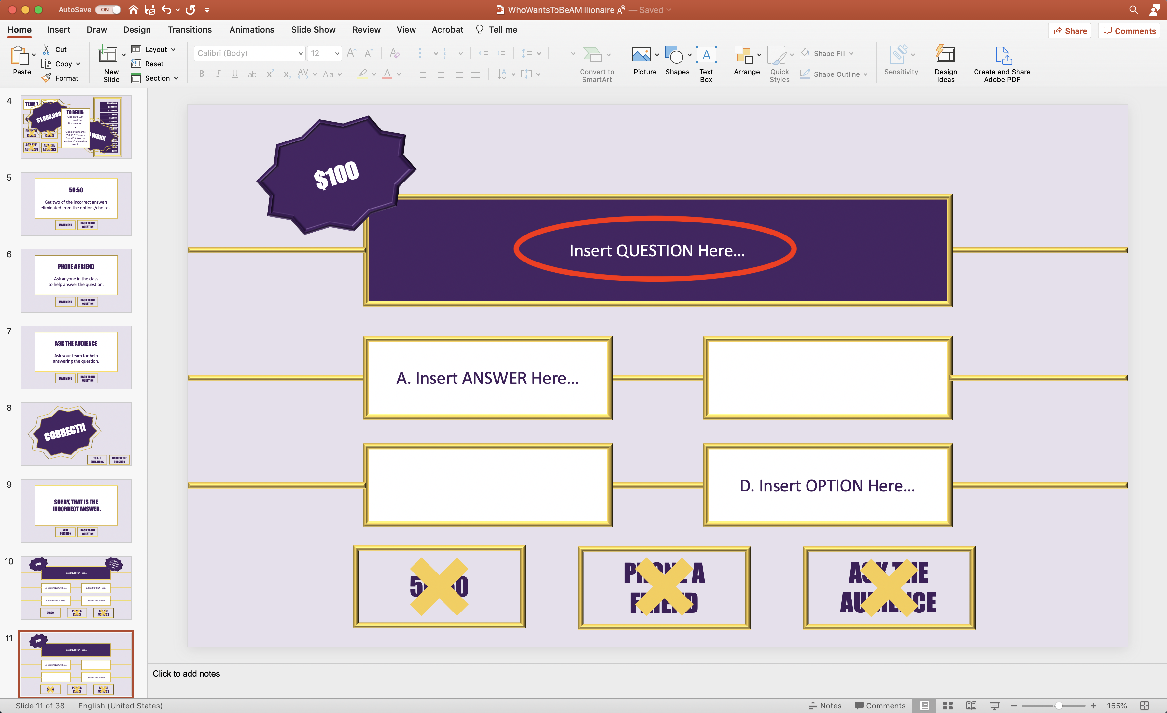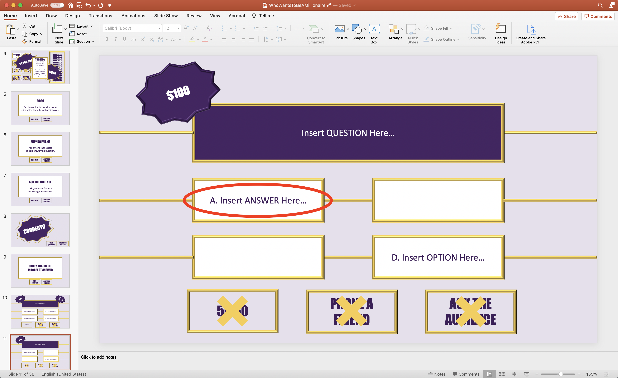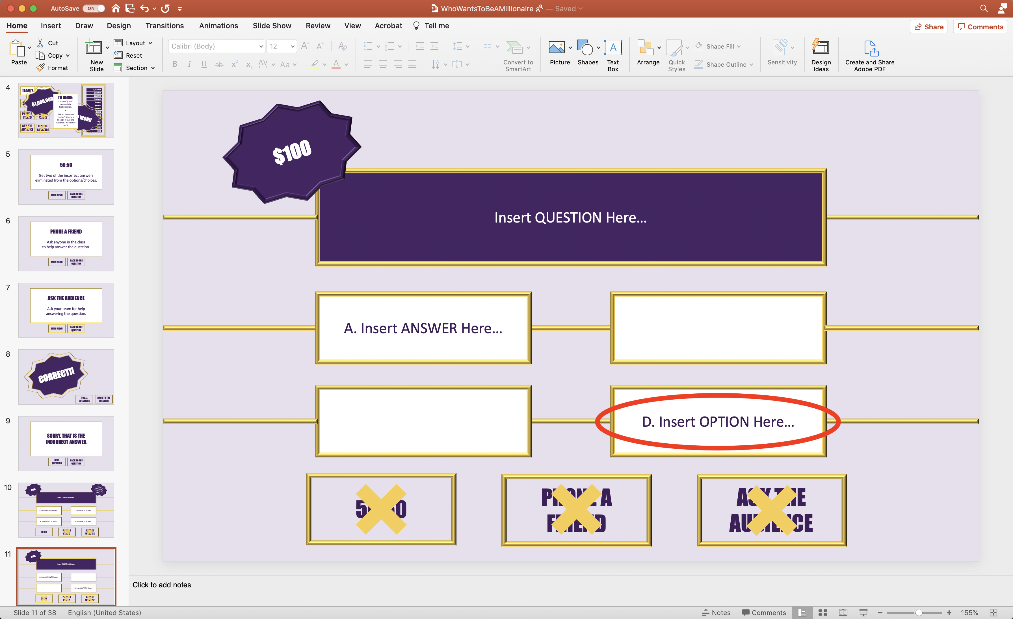
36 | Nothing to Edit | 