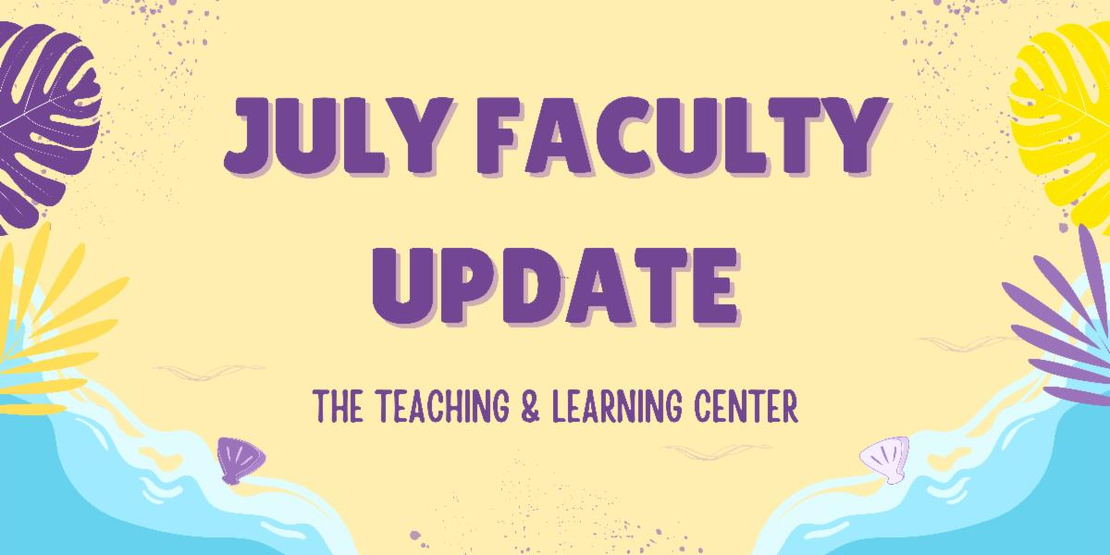

An Update About the TLC
The TLC has reorganized into three specialized areas: Digital Learning and Innovation (led by Marc Drumm), Inclusive Excellence and Accessibility (led by Amber Alvord), and Reflective Practice and Scholarship (led by Tom Pantazes). You will receive the same trusted instructional design support, plus more targeted workshops and resources. Read our blog post to learn more about the new structure.

Open Calls and Initiatives

(Due Jul 31) Pedagogical Innovations Faculty Learning Community
The Teaching and Learning Center (TLC) and the Office of Research and Sponsored Programs (ORSP) are pleased to invite expressions of interest for the 2025-2026 Pedagogical Innovations Faculty Learning Community (FLC). Selected participants will join an interdisciplinary community of peers to design and implement studies examining innovative teaching strategies.

This year-long program requires participants to attend monthly meetings throughout the fall and spring semesters featuring structured opportunities for peer consultation, collaborative problem-solving, and scholarly exchange. Expressions of interest are due Thursday, July 31. For complete program details and submission guidelines, please visit the TLC website.

(Due Aug 18) Fall ACUE Courses: Registration Open
PASSHE is pleased to offer fall courses for faculty in partnership with the Association of College and University Educators (ACUE). These courses are part of ACUE's Effective Online Teaching Practices (EOTP) pathway. In EOTP courses, faculty will learn and implement evidence-based teaching practices proven to boost student persistence and completion, aligning with PASSHE's future institutional initiatives of course and program sharing.

The EOTP pathway provides WCU faculty with an alternative option for DE certification or recertification. For DE certification, faculty must complete courses in the series along with the capstone module in the OFD program. For DE recertification, completion of courses in the series is sufficient.

Registration is open now until Monday, August 18. To apply, please visit PASSHE's ACUE registration webpage and click Apply Now.

(Due Sep 5) Fall Teaching Circle Opportunities: AI, Classroom Conversations, and Community Learning
A teaching circle is a group of faculty who collectively explore a teaching topic of interest and work together to create products reflecting their learning experience. They offer structure and accountability to help you improve your teaching practice. There are multiple teaching circle opportunities for the fall semester:
- Generative AI Lesson Plan will explore creating a lesson to teach students about generative artificial intelligence.
- Classroom Conversations: Discussions, Debates, and Dialogues will explore these conversational approaches as pedagogical strategies.
- Community Engaged Learning, offered in partnership with the Center for Civic Engagement & Social Impact (CCESI), will focus on preparing community-engaged learning opportunities.
To learn more about each circle and register to participate visit the TLC Professional Learning Communities webpage.

(Ongoing) Call for Mentors
Are you looking for a university-level service opportunity? Do you want to make a significant difference in a colleague’s career development? Do you want to increase your own job satisfaction? Consider becoming a mentor with WCU’s Faculty Mentoring Program. The Faculty Mentoring Committee seeks faculty to serve as mentors for untenured faculty, faculty seeking promotion, and adjunct faculty. See our website for more information about qualifications and expectations, to read about recent FMC events, or sign up to participate in mentor training.

Upcoming Events

(Virtual) NEW: H5P Site License and Summer Workshops
The Teaching and Learning Center is pleased to announce that we have procured a university-wide site license for H5P. H5P is a user-friendly platform that allows faculty to create interactive quizzes, presentations, and multimedia content to promote student engagement. Check out the H5P: Getting Started KnowledgeBase article for more details about H5P and its features.

The university-wide license allows us to add an unlimited number of authors to our account who will be able to create interactive activities that can be embedded or linked in D2L courses and connected to the gradebook. Contact Jessica Drass at jdrass@wcupa.edu to be added to our H5P license.

H5P Summer Workshops
The Teaching and Learning Center will be offering three, hour-long workshops during the month of August for faculty who are interested in learning the basics of using H5P. Each workshop will cover the same content so you only need to register for one.

Workshop Dates
- Wednesday, August 6, 11:00am – 12:00pm
- Monday, August 11, 2:00pm – 3:00pm
- Tuesday, August 19, 12:00pm – 1:00pm
All workshops will be held online via Zoom. If you are interested in attending a workshop, please RSVP by submitting the H5P Summer 2025 Workshops Registration Form at your earliest convenience. If you have any questions, contact Jessica Drass at jdrass@wcupa.edu.

Stay Connected

Connect With Us
The Teaching and Learning Center is far more than just a newsletter! Our website hosts a variety of teaching resources and our full Event Calendar. To get in touch, feel free to send us an email, or schedule a consultation to speak live with one of our designers.

