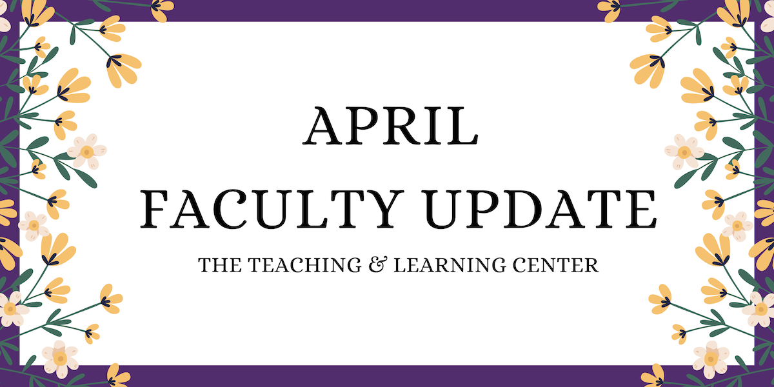

After 20 amazing years with us, Pat Brander has retired! Pat has been with the university since before the early days of the Office of Distance Education, and she's played a key role in our growth into today's Teaching & Learning Center.

Her hard work and kindness have made a huge impact on everyone she worked with, whether they were faculty, staff, or students.

All of us at the TLC will sorely miss her friendly face and positive energy, especially in this first month without her support, but we’re excited for her as she moves on to this next chapter in her life.

# Open Calls & Initiatives

## (Ongoing) Call for Mentors

## Are you looking for a university-level service opportunity? Do you want to make a significant difference in a colleague’s career development? Do you want to increase your own job satisfaction? Consider becoming a mentor with WCU’s Faculty Mentoring Program. The Faculty Mentoring Committee seeks faculty to serve as mentors for untenured faculty, faculty seeking promotion, and adjunct faculty. [Learn more about qualifications and expectations](https://wcu-tlc.org/pd/call-for-faculty-mentors/), read about [recent FMC events](https://wcu-tlc.org/pd/faculty-mentoring-committee-panels-on-scholarly-productivity-and-promotion/), or [sign up to participate in mentor training](https://wcupa.co1.qualtrics.com/jfe/form/SV_6J68tOnrJHyuajk).

## (Ongoing) Fall 2025 Student-Faculty Teaching Collaboration Program

Are you interested in getting student feedback and perspectives on your teaching practices? Do you want to boost your teaching confidence or reignite your passion for teaching? If so, consider participating in the [Student-Faculty Teaching Collaborations Program](https://www.wcupa.edu/tlc/student-faculty-collab.aspx) during the Fall 2025 semester! This program pairs you with two WCU students who will provide frequent and varied feedback on one of your courses from their perspective.

To learn more, [visit our website](https://www.wcupa.edu/tlc/student-faculty-collab.aspx), or [review program information on our blog](https://wcu-tlc.org/tag/student-faculty-teaching-collaboration-program/). To apply, review the [Student-Faculty Teaching Collaborations Call for Applications](https://wcupa.co1.qualtrics.com/jfe/form/SV_cLMrRwBREjOeV70).

## (Due Apr 16) Call for Proposals: Quality Matters Summer Camp

The TLC is consolidating our year-long Quality Matters (QM) course review into a three-week QM Summer Camp from June 2 to June 20, 2025. This streamlined format will promote cohort collaboration, consolidate course preparation, and allow you to focus on teaching during the academic year. At the end of the summer camp, your course will be ready for QM review. Faculty who earn certification are eligible for a stipend.

The deadline for applications is **Wednesday, April 16**. Read the [full call for proposals](https://wcupa.sharepoint.com/:w:/s/AA/ded/ERITppetIi1Ou9WjzeUUzYYBAyJb1k187B0jHAq4onyipg?e=S58CY3) for more information, or [submit an application](https://wcupa.co1.qualtrics.com/jfe/form/SV_6A4v7MYGyERH4km) today! If you have any questions, please contact the TLC.

# Upcoming Events

## (Virtual) AI in Action @ WCU

30-minute interactive webinars to inspire and motivate you to consider new ways to engage with AI in your teaching, scholarship, and service. Each session will feature a different WCU presenter. All sessions start with a 5 minute introduction, followed by a 15 minute presentation, and end with 10 minutes of questions and discussion. Each webinar will be recorded for later viewing.

Visit the [AI in Action blog post](https://wcu-tlc.org/pd/ai-in-action-wcu/) to register to attend an upcoming virtual session or view previous session recordings. If you're willing to share your own experiences working with generative AI, complete [our interest form](https://wcupa.co1.qualtrics.com/jfe/form/SV_1YVWtISHaJVHo22) or reach out to us at [tlc@wcupa.edu](mailto:tlc@wcupa.edu?subject=)!

## (In-person: May 8) 2025 Celebration of Teaching

Incredible teaching happens every day across WCU! Join us on **Thursday, May 8** for a series of four events to sample and discover new WCU teaching innovations, dialog with peers on teaching topics, and celebrate the teaching excellence that happens across WCU. The day's events will include mini-workshops, our 10th annual Teaching Excellence Showcase, a virtual keynote presentation from spring book club author [Robert Talbert](https://rtalbert.org/), and the TLC Teaching Awards Ceremony. [Learn more on the TLC blog!](https://wcu-tlc.org/pd/2025-celebration-of-teaching/)

# Program Updates

## Seeking Faculty Teaching Exemplars

The TLC is seeking faculty interested in sharing examples of learning activities which work well in remote synchronous classes to enhance the Online Faculty Development Program (OFD) remote synchronous module. We are looking for faculty with example activities that fit one of these concepts:

* Community Building Activities
* Chat
* Polling
* Individual Problem Solving
* Socratic Seminar
* Debate
* Video
* Games
* Entrance/Exit Tickets

If you have an example and are willing to work with us to create a short video about it, please contact Tom Pantazes ([tpantazes@wcupa.edu](mailto:tpantazes@wcupa.edu)).

## Online Faculty Development Program

Need to earn or renew your CAPC distance education credential? Faculty can now self-enroll into the OFD program’s D2L site using the [Discover feature](https://wcupaprod.service-now.com/kb?id=kb_article_view&sysparm_article=KB0010869)! Start working whenever it fits your schedule.

# Stay Connected

## Connect with Us

The Teaching and Learning Center is far more than just a newsletter! Our website hosts a variety of [teaching resources](https://www.wcupa.edu/tlc/teaching-resources.aspx) and our full [Event Calendar](https://www.wcupa.edu/tlc/events.aspx). To get in touch, feel free to [send us an email](mailto:tlc@wcupa.edu?subject=), or stop by our [drop-in hours](https://www.wcupa.edu/tlc/drop-in.aspx) to speak live with one of our designers.