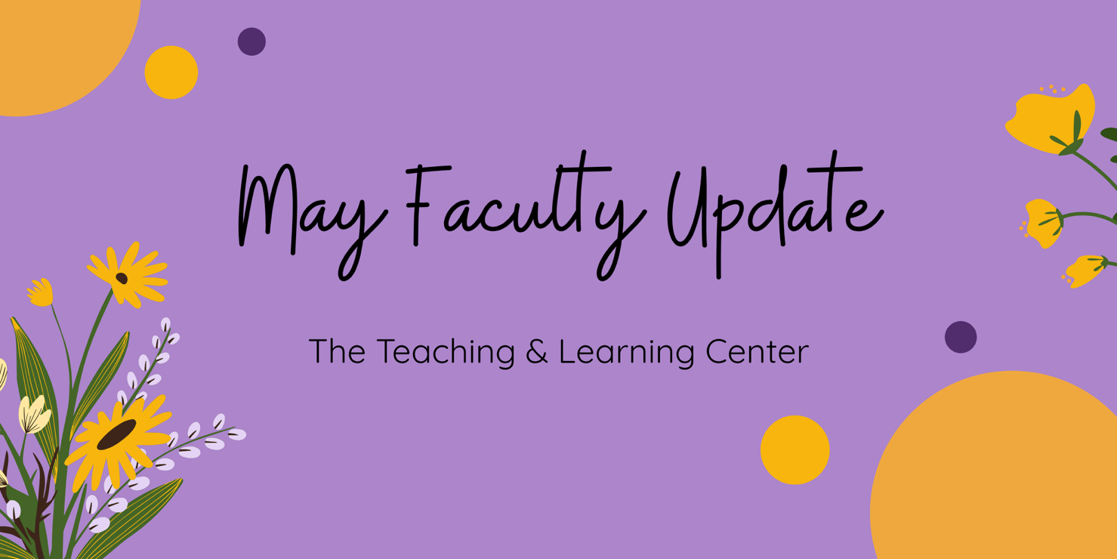

# Open Calls & Initiatives

## (Due May 16) Fall 2025 Student-Faculty Teaching Collaboration Program

Are you interested in getting student feedback and perspectives on your teaching practices? Do you want to boost your teaching confidence or reignite your passion for teaching? If so, consider participating in the [Student-Faculty Teaching Collaborations Program](https://www.wcupa.edu/tlc/student-faculty-collab.aspx) during the Fall 2025 semester! This program pairs you with two WCU students who will provide frequent and varied feedback on one of your courses from their perspective.

To learn more, [visit our website](https://www.wcupa.edu/tlc/student-faculty-collab.aspx), or [review program information on our blog](https://wcu-tlc.org/tag/student-faculty-teaching-collaboration-program/). To apply, review the [Student-Faculty Teaching Collaborations Call for Applications](https://wcupa.co1.qualtrics.com/jfe/form/SV_cLMrRwBREjOeV70) by **Friday, May 16**.

## (Due May 16) Registration Extended for ACUE Courses

Registration for Summer 2025 ACUE courses has been extended through **Friday, May 16**! Seats are still available for the asynchronous Fostering a Culture of Belonging course beginning on June 16. Additionally, registration is now open for Fall 2025 micro courses that may be counted towards ACUE's Effective Online Teaching Practices certification; registration for fall offerings will close on **Monday, August 18**.

To learn more, [see the full advertisement](https://wcupa.sharepoint.com/:w:/s/AA/ded/EQ5QlvXrjptEnaDvHTaGdTcBD8ft7b2VxRuG8GCQmOAUBQ?e=Az3eF0), or register today! Any questions can be directed to Amy Osborne ([aosborne@passhe.edu](mailto:aosborne@passhe.edu)).

## (Due June 2) Summer Teaching Circle: Generative AI Lesson Plan

A teaching circle is a group of faculty who collectively explore a teaching topic of interest and work together to create products reflecting their learning experience. From June 4 to June 25, a summer teaching circle will explore creating a lesson to teach students about generative artificial intelligence.

To learn more and sign up, see the [full program description](https://www.wcupa.edu/tlc/flc.aspx) on our website! Registration will close on **Monday, June 2**.

## (Ongoing) Seeking Faculty Teaching Exemplars

The TLC is seeking faculty interested in sharing examples of learning activities which work well in remote synchronous classes to enhance the Online Faculty Development Program (OFD) remote synchronous module. We are looking for faculty with example activities that fit one of these concepts:

* Community Building Activities
* Chat
* Polling
* Individual Problem Solving
* Socratic Seminar
* Debate
* Video
* Games
* Entrance/Exit Tickets

If you have an example and are willing to work with us to create a short video about it, please contact Tom Pantazes ([tpantazes@wcupa.edu](mailto:tpantazes@wcupa.edu)).

## (Ongoing) Call for Mentors

## Are you looking for a university-level service opportunity? Do you want to make a significant difference in a colleague’s career development? Do you want to increase your own job satisfaction? Consider becoming a mentor with WCU’s Faculty Mentoring Program. The Faculty Mentoring Committee seeks faculty to serve as mentors for untenured faculty, faculty seeking promotion, and adjunct faculty. [Learn more about qualifications and expectations](https://wcu-tlc.org/pd/call-for-faculty-mentors/), read about [recent FMC events](https://wcu-tlc.org/pd/faculty-mentoring-committee-panels-on-scholarly-productivity-and-promotion/), or [sign up to participate in mentor training](https://wcupa.co1.qualtrics.com/jfe/form/SV_6J68tOnrJHyuajk).

# Upcoming Events

## (In-person: May 8) 2025 Celebration of Teaching

Incredible teaching happens every day across WCU! Join us on **Thursday, May 8** for a series of four events to sample and discover new WCU teaching innovations, dialog with peers on teaching topics, and celebrate the teaching excellence that happens across WCU. The day's events will include mini-workshops, our 10th annual Teaching Excellence Showcase, a virtual keynote presentation from spring book club author [Robert Talbert](https://rtalbert.org/), and the TLC Teaching Awards Ceremony. [Learn more on the TLC blog!](https://wcu-tlc.org/pd/2025-celebration-of-teaching/)

## (In-person: May 29) Applying the Quality Matters Rubric (APPQMR) Workshop

This full day, in-person workshop will renew your CAPC Distance Education Training Credential and award you the official Quality Matters APPQMR Certificate of Completion. It is facilitated by WCU instructional designers. The training will be held on **Thursday, May 29** from 8:30am to 4:00pm in Anderson 125; participants must attend the whole day. Lunch will be served. Complete the [APPQMR Interest Form](https://wcupa.co1.qualtrics.com/jfe/form/SV_3jv5ZbMGYIhyZi5), and a member of the TLC will be in contact a few weeks prior to the workshop with official registration information. Space is limited.

## (Ongoing) Online Faculty Development Program

Need to earn or renew your CAPC distance education credential? Faculty can now self-enroll into the OFD program’s D2L site using the [Discover feature](https://wcupaprod.service-now.com/kb?id=kb_article_view&sysparm_article=KB0010869)! Start working whenever it fits your schedule.

# Program Updates

## 2025-26 CELT Professional Development Awards Announced

The Committee for Excellence in Learning and Teaching announces the recipients of its 2025-26 Professional Development Awards to the following faculty members:

* Brie Radis and Casey Bohrman, “Empowering Change: Financial Social Work for Economic Justice and Well-Being”
* Kasey Trill, Julie Kurkowski , Danielle Yocom , Michelle Dasilva, and Nancy Barker, “Integration of Workplace Violence Simulations Across the Nursing Curriculum”
* Heidi Lee, “Experiencing Liveness and Presence in a Music History Course: Redesigning an Arts Distributive Course at WCU”
* Ashlee Brown and Alyssa Blasko, “The Learning Lab: Demonstrating Best Practices in Special Education”

## Inaugural Faculty Success Fellows

The Teaching and Learning Center, in partnership with the Office of Research and Sponsored Programs and Office of Equal Opportunity and Compliance, are pleased to announce our inaugural Faculty Success Fellows, Brie Radis and Tiffany Bennett.

Professors Radis and Bennett will each participate in a 10-week [National Center for Faculty Development and Diversity (NCFDD) Summer Faculty Success Program](https://www.ncfdd.org/sessions/fspsummer2025), an online professional development opportunity designed to empower faculty members with the skills and strategies needed to enhance their scholarly productivity, balance their workload, and achieve academic excellence. Congratulations, Brie and Tiffany!

## New eTextbook: *Programming with Java*

The Pennsylvania Alliance for Design of Open Textbooks ([PA-ADOPT](https://paadopt.org/)) is pleased to announce the immediate availability of their eleventh free and open eTextbook: *Programming with Java* by Dr. Ashik Ahmed Bhuiyan, Assistant Professor of Computer Science, and Dr. Md Amiruzzaman, Assistant Professor of Computer Science, at West Chester University. For more information, [check out our blog](https://wcu-tlc.org/etextbook/new-etextbook-programming-with-java/)!

# Stay Connected

## Connect with Us

The Teaching and Learning Center is far more than just a newsletter! Our website hosts a variety of [teaching resources](https://www.wcupa.edu/tlc/teaching-resources.aspx) and our full [Event Calendar](https://www.wcupa.edu/tlc/events.aspx). To get in touch, feel free to [send us an email](mailto:tlc@wcupa.edu?subject=), or stop by our [drop-in hours](https://www.wcupa.edu/tlc/drop-in.aspx) to speak live with one of our designers.