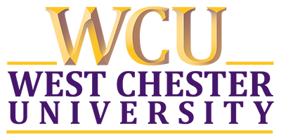

**CENTER FOR COMMUNITY SOLUTIONS**

**POST-PROJECT SURVEY**

**Community Partner:**

**Student Partner:**

**Please rate your overall experience in working with West Chester University’s Center for Community Solution (CCS):**

**Negative Positive**

1 2 3 4 5 6 7 8 9 10

**What went well in your CCS project experience?**

**What challenges, if any, did you have in your CCS project experience?**

**What did the CCS do well?**

**What could the CCS do to improve its services?**

**Would you refer the CCS fellow community partners and/or students?**

**Is there information that you would like to obtain toward further collaboration and partnership with the CCS and/or the University? If yes, please describe.**

**Does the CCS have permission to include your comments in its Annual Report(s) and/or on its website?**

Yes

No

**Please share any additional feedback that you would like to provide.**