The RAM initiative is a relatively new program at West Chester University, bringing students with intellectual disabilities, ages 18-24, to campus in very small numbers, to participate in a two-year inclusive post-secondary education experience. The RAM initiative is ‘inclusive’ in that RAM students learn, live, and interact with all students, faculty, staff and administrators on campus, not in segregated environments. The students take classes on either an Audit or For Credit basis and have a non-traditional application/admissions process. RAM Initiative students are full- time students, have full privileges of the university, and are eligible for Pell Grants and Federal Financial Work Study programs (if financially eligible by filling our a FASFA form).

**Who**: Students with intellectual disabilities are those who “have significant limitations in both intellectual functioning and in adaptive behaviors which covers many everyday social and practical skills” (AAIDD, 2017). These students come to the college experience without a traditional academic diploma, nor standardized test scores. We focus on **students whose ages are between 18 and 24 as of the first day of the Fall semester of classes that they begin the program**. These students have completed at least 4 years of high school and have been in Special Education and have had an Individualized Education Program during their school years.

**RAM Initiative Background**

**When**: In Fall 2018 we brought in two pilot students (commuter) who went through the program on a trial basis to help to tweak the process. In Fall of 2019, one student joined the program as a residential student.

**Why**: 1) Individuals with intellectual disabilities have better employment outcomes when they attend post-secondary educational experiences.  
2) Inclusive opportunities with similar age peers provides a positive quality of life experience and ‘finding’ yourself, just like all other students coming to college.  
3) Independent living skills are practiced in real life settings.

**Vision**: Provide inclusive post-secondary education to students with intellectual disabilities, who meet certain criteria, in order to develop citizens who meet the goals of the Americans with Disabilities Act of equal opportunity, full participation, independent living and economic self-sufficiency.

**Goals**:

* Develop students who are empowered, employable and have career aspirations.
* Develop students who are self-learners and life-long learners
* Develop students who are socially effective, healthy, and happy
* Develop students who have independent living skills and have a high participation level in their community

**Why should WCU?:** The university has a history of supporting marginalized and underrepresented groups. As stated in our university mission we are a vibrant community that values its members and we can offer a campus climate of acceptance. WCU is the flagship institution of the PA State System of Higher Education (PASSHE). This pattern of excellence will continue and are applied to the recruitment, training, and retention of high quality peer mentors for students who participate in RAM Initiative. We have vibrant professional preparation programs in special education, social work, psychology, communication disorders, and adapted physical activity, whose students regularly participate in community-based engagement programs with individuals who have intellectual disabilities. We draw upon high quality peer mentors, supportive faculty and staff toenrich our program.

**WCU RAM Initiative Staff**:

* Monica Lepore, Faculty Director
* Bruce Norris, *Staff Advocate*
* Molly Santoro and Sydney Bachmayer, Student Administrators
* Dr. Tabetha Adkins, Dean, University College
* Faculty and Staff of the RAM Initiative Alliance (advocates)
* Supported by Pennsylvania Inclusive Higher Education Consortium, DREAM Partnership and the WCU Foundation

**ANNOUNCEMENT**

[RAM Initiative Application, Due between October](https://www.wcupa.edu/universityCollege/professionalStudies/documents/2020RAMInitiativeStudentApplicationFall2020withFERPAstatement.docx) 1, 2020 and January 11, 2021 for the 3 spots available in Fall 2021.

Please submit by 4pm sent or delivered to  
**WCU**  
**222 Lawrence Center**  
**In care of RAM Initiative**

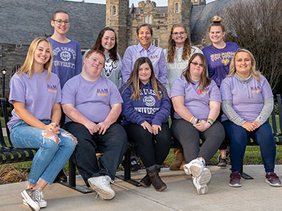



 Seems that there are two of the same photo on the web page; how about putting this one in to substitute for one of them?

